APPENDIX G- Regional Plans & MOU Approval Status Dashboard

This dashboard provides the public with access to all Plans and MOUs with the status of Approved/Approved with Technical changes.

The dashboard is a searchable list of every regional plan, local plan and MOU and gives you the ability to:
• Search by Keyword;
• Filter by EDR, LWIA, Document Type, and Approval Status;
• Filter by dates to find documents active during a specific time; and
• Preview and download documents that are Approved/Approved with Technical Changes.

Finding Active Documents:
• Use the Document Effective and Document Expires column to verify you looking at active documents.
• Documents are typically named starting with PY##, this reflects the program year the document was submitted for.

Steps to Access your Regional Plan:
- Access the MOU Dashboard at http://www.illinoisworknet.com/WIOAPlans.
- Navigate to the third drop down box titled Document Type and select Regional Plans. The list will populate with all approved regional plans for the state.
- Download and review the plan that aligns to your EDR.
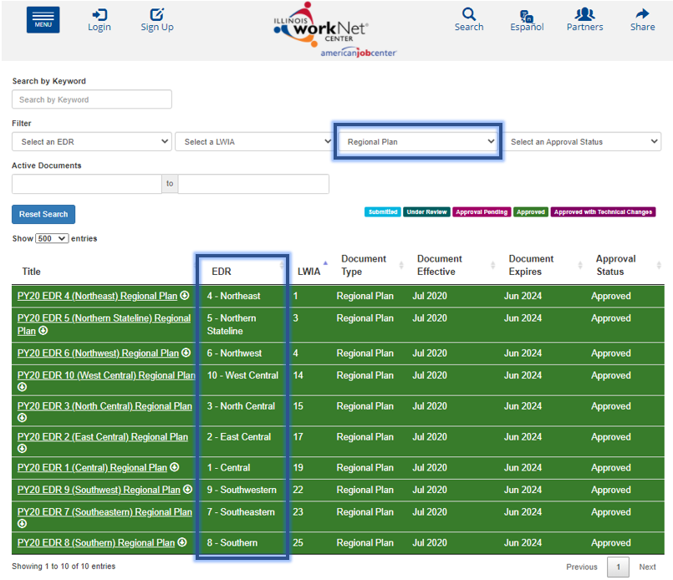

Use the map at the beginning of Appendix F to identify which EDR your LWIA falls in.

