APPENDIX F -LWIA & Economic Development Regional Map
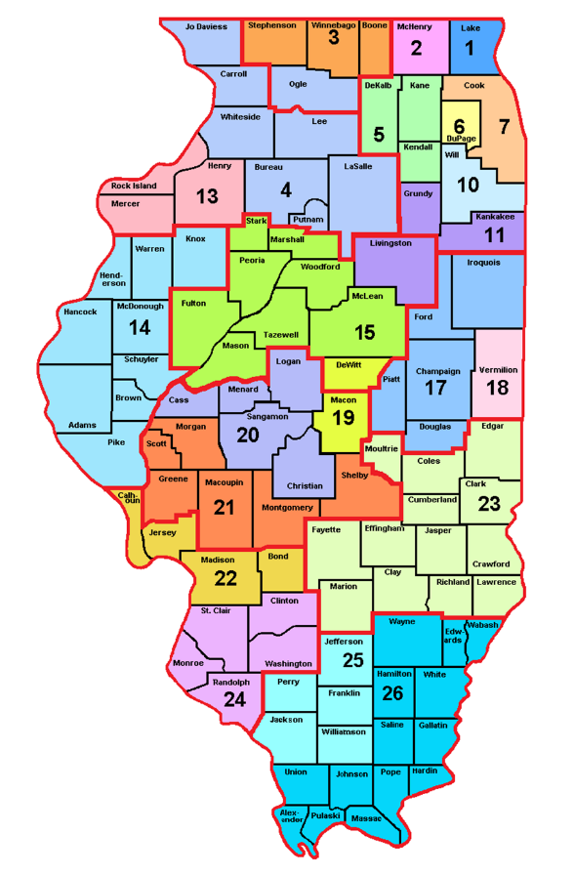

Map Source

