APPENDIX D – Career Pathways and Registered Apprenticeship Definitions
Career Pathways
The best apprenticeships are rooted in a pathway that leads to a career, not just a job. This NOFO aims to target occupations in industries with high demand where an apprentice can learn and earn into an occupation. WIOA defined career pathways as a combination of rigorous and high-quality education, training, and other services that:
- Aligns with the skill needs of industries in the economy of the State or regional economy involved.
- Prepares an individual to be successful in any of a full range of secondary or postsecondary education options, including apprenticeships registered under the National Apprenticeship Act, 29 USC § 50.
- Includes counseling to support an individual in achieving their education and career goals.
- Includes, as appropriate, education offered concurrently with and in the same context as workforce preparation activities and training for a specific occupation or occupational cluster.
- Organizes education, training, and other services to meet the particular needs of an individual in a manner that accelerates the educational and career advancement of the individual.
- Enables an individual to attain a secondary school diploma or its recognized equivalent, and at least one recognized postsecondary credential.
- Helps an individual enter or advance within a specific occupation or occupational cluster (for more information please visit: Career Pathways Dictionary.

Earn While You Learn: Benefits of Work-Based Learning
One form of career preparation is work-based learning. Work-based learning lets individuals build relevant skills via real-life work experiences. Typically, work-based learning aligns classroom and workplace learning; the application of academic, technical and employability skills in a work setting; and support from workplace mentors. Work-based learning is a win-win as it combines to meet a jobseeker or worker’s need to build meaningful, applied skills and an industry’s need to grow its talent. Apprenticeships are a well-known form of work-based learning that typically include five key elements:
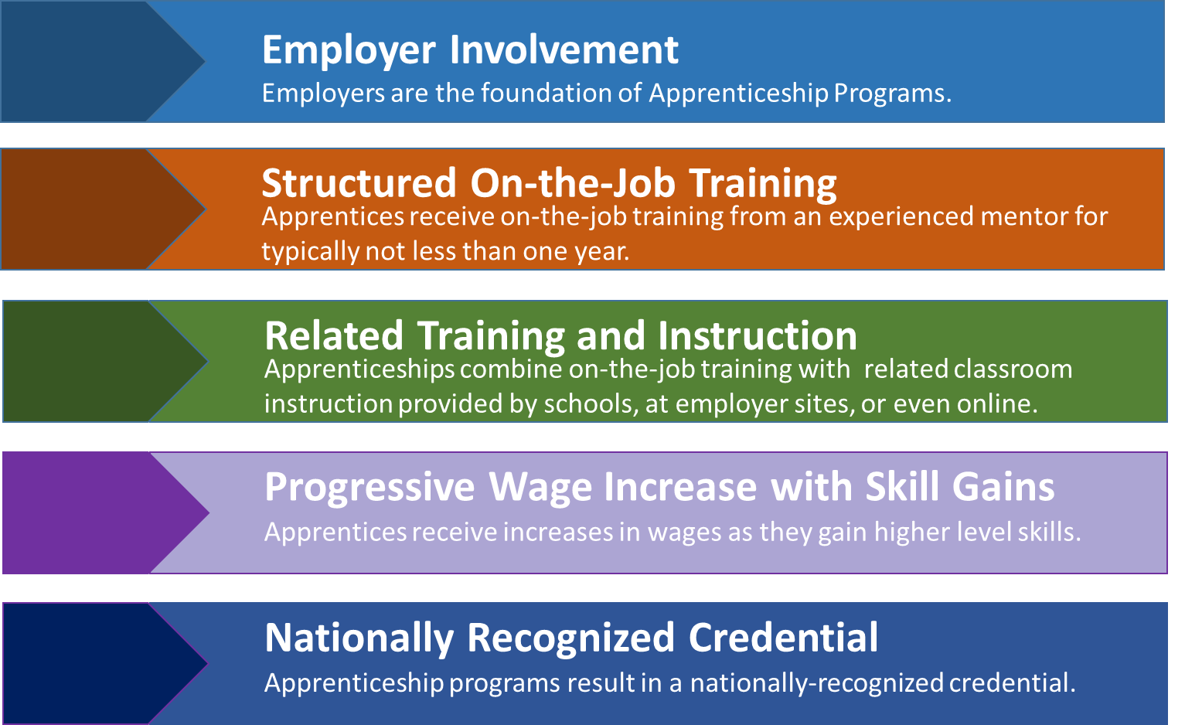
- Business involvement
- Structured on-the-job training
- Instruction related to the apprenticeship
- Rewards for skill gains
- An industry-recognized credential

Registered Apprenticeship: This NOFO requires that individuals that are provided service under this grant enroll in a Registered Apprenticeship program with the U.S. Department of Labor. A “Registered Apprenticeship” with the U.S. Department of Labor includes the five required components:
- Employer Involvement
- Structured On-the-Job Training
- Related Instruction
- Rewards for Skill Gains
- Industry Credentials

As defined by the Office of Apprenticeship of the U.S. Department of Labor, “Registered Apprenticeship” is an effective “earn and learn” model with a long history of providing career ladders and pathways to the middle class, particularly for the building and construction industry but increasingly in other industries as well. Registered Apprenticeships must have five components: business involvement, structured on-the-job training, related classroom and workplace instruction, rewards for skills gains, and an industry-recognized credential at the successful completion of training.

Pre-Apprenticeships: A program that has a documented partnership with an employer and is designed to prepare individuals to enter and succeed in a Registered Apprenticeship or Non-Registered Apprenticeship which includes all of the following:
- Training and curriculum that aligns with the skill needs of employers in the economy of the State or region and that has been designed to prepare participants to meet the minimum entry-level requirements of the Apprenticeship.
- Access to educational and career counseling, and other supportive services as needed by participants.
- Hands-on meaningful learning activities that are connected to education and training activities, such as Career Exploration and Career Development Experiences, and that reinforce foundational professional skills including, at a minimum, those outlined in the Essential Employability Skills framework.
- Upon successful completion of the program, participants are supported to apply for a Registered Apprenticeship or Non-Registered Apprenticeship program, and may receive preference for enrollment.

Pre-apprenticeship is defined in Training and Employment Notice No. 13-12 as ”a program or set of strategies designed to prepare individuals to enter and succeed in a Registered Apprenticeship program and has a documented partnership with at least one, if not more, Registered Apprenticeship program(s).” A quality pre-apprenticeship program is one that incorporates the following elements: (a) approved training and curriculum; (b) strategies for long-term success; (c) access to appropriate support services; (d) promotes greater use of Registered Apprenticeship to increase future opportunities; (e) meaningful hands-on training that does not displace paid employees; and (f) facilitated entry and/or articulation.

The Department recognizes there is a need for pre-apprenticeship activity that creates on-ramps for individuals to successfully enter and complete a registered apprenticeship. This NOFO will only consider grants that include pre-apprenticeships and/or preparation activities for individuals enter an into registered apprenticeship during the grant period.

