Timeline Setting up Multi-Employer VJF
Timeline | Item | Notes | Responsible Party
4 – 6 Weeks Out | Set Date/Time for Event | Work with SIU Staff to set a date and time range for the Virtual Job Fair:  Click or tap here to enter text.  Decide if you want the VJF to be region or industry specific:  Click or tap here to enter text. | Stakeholder
 | Decide on Format for VJF | Choose between multiple days or one day to have VJF.  Click or tap here to enter text.  Decide if you want employers to have a time slot for presentation/ questions etc. or if you want a panel discussion.  Click or tap here to enter text. | Stakeholder
 | Invite Employers to Participate and Have Employers Create Booths | Helpful Resources to send:  - Preparing for a VJF  - Attending a VJF  - Illinois workNet Virtual Job Fair Overview  - Recorded Presentation  - PPT  - Employers must create or log into their Illinois workNet Account. Here is a brief video on how employers can create their account.  - Employers must have an Employer Booth set up in Illinois workNet before the registration page is created in order to participate in the VJF. This video provides a demonstration on how they can submit a booth page.  Click or tap here to enter text. | Stakeholder
 | Designate Time Slots, Order of the Event, and Agenda | If giving the Employer a time slot to present information/ answer questions, ask how long they would like to present for (up to 30 minutes), and make the schedule accordingly.  - Here is an example of a schedule for this type of event. (Links take you to the Employer Booth)  If doing a panel, determine the presentation order and inform the employer of the schedule.  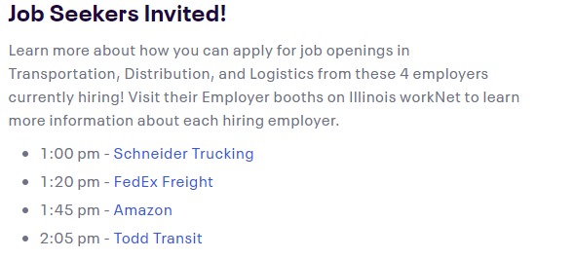  Click or tap here to enter text. | Stakeholder
3 Weeks Out | Let SIU team know of time slots/schedule | Email the presentation schedule to the SIU team to be used to set up the registration page.  Click or tap here to enter text. | Stakeholder
 | Confirm employers have booth set up | Employers must have their booths submitted prior to the creation of the registration page.  https://www.illinoisworknet.com/DownloadPrint/Creating%20a%20Virtual%20Job%20Fair%20Booth%20Final.pdf  Click or tap here to enter text. | Stakeholder
 | Let SIU Team know if you need more employers to participate (if applicable) | If you need 1 or 2 more employers to participate in the event, let the SIU team know and we may be able to give you contacts of some employers who might be willing to participate.  Click or tap here to enter text. | Stakeholder/SIU
 | Schedule Zoom Trainings (if applicable) | If employers are not comfortable with using Zoom set up a time for a 15-minute Zoom training with the SIU team.  Click or tap here to enter text. | SIU
2 Weeks Out | SIU Staff will Conduct Zoom training (if applicable) | Click or tap here to enter text. | SIU
 | SIU Staff will set up the registration page on Eventbrite. | Examples of Registration Pages:  - TDL VJF  - Amazon VJF  Click or tap here to enter text. | SIU
 | SIU Staff will post on Event Calendar and Employer Booth | Examples of Event Calendar postings:  - TDL VJF  - Railworks VJF  Click or tap here to enter text. | SIU
1 Week Out | Send employers the Zoom meeting information. | After the registration page is created, send an email to the employer letting them know ticket sales have started and give them the meeting information.  - Email template  Click or tap here to enter text. | SIU
 | Post about VJF on Social Media  LWIAs should promote through existing marketing channels for increased awareness. | Use the social media plan (to be made later this week) to post about the event on our social media platforms.  Click or tap here to enter text.  Encourage employers to promote their event through their website, social media, etc.  Click or tap here to enter text. | SIU
2 Days Before | Send reminder emails | Send an email to the employers reminding them of the event.  - Email Template  Make sure they do not have any last minute questions about the event.  Click or tap here to enter text. | SIU
 | Get presentation materials from employers to send to SIU Staff | If the Employer is planning to share a video or PowerPoint, have them send you a copy and forward it to the SIU team. (This is used in the event of technical difficulties.)  Click or tap here to enter text.  Find out who is presenting from their company so we can make the appropriate people co-hosts during the event. Send this information to the SIU team.  Click or tap here to enter text. | SIU/Stakeholder

