Attachments and Instructions

- DISASTER RECOVERY -- DISASTER RELIEF EMPLOYMENT/ TEMPORARY JOBS WORKSITE SUMMARY
Complete the Disaster Recovery -- Disaster Relief Employment/ Temporary Jobs Worksite Summary (attached). Indicate worksites that have been identified and will participate in Disaster Recovery. Worksites must be selected as described in Training and Employment Guidance Letter (TEGL) No. 12-19, National Dislocated Worker Grant Program Guidance. The Worksite Summary can be updated and submitted as appropriate.

LWIAs are expected to maintain documentation for each worksite included in the project for both monitoring and auditing purposes. Such documentation should include, at a minimum:
• name and location of worksite;
• public or private property (if private, provide justification for work as required in TEGL 12-19 for prior DOL approval);
• number of participants working on site;
• dates of work on a site;
• description of work performed at the site;
- how the appropriate wage was determined for each position; and
• how this site was approved, per recipient’s established policies and procedures.

All work activities must be related to humanitarian assistance and/or disaster recovery and rebuilding efforts related to the COVID-19 crisis. Note that work on private property is not allowed except with pre-approval/authorization of DOL and DCEO for work intended to remove health and safety hazards to the larger community or to address/alleviate specific economic or employment-related impacts of the disaster, such as clean-up work needed for disaster-affected employers to resume operation; or the work activities necessary to remove health and safety hazards on private lands or around homes or other structures.

Disaster Relief Employment Activities
Humanitarian Assistance: includes actions designed to save lives, alleviate suffering, and maintain human dignity in the immediate aftermath of disasters. This assistance includes activities such as the provision of food, clothing, and shelter. Additional description related to COVID-19 -- Disaster-relief employees may assist in addressing many needs created by this public health emergency and the prolonged social isolation that is necessary to curb it, such as:
- Delivering medicine, food, or other supplies to older individuals and other medically vulnerable individuals (e.g. respiratory conditions and other chronic medical disorders), with appropriate training and precautions. Coronavirus infection has been the most harmful to these populations, and there may be heavy need for such services that traditional volunteer organizations cannot support alone.
- Helping set up quarantine areas and providing assistance to quarantined individuals.
- Organizing and coordinating recovery, quarantine, or other related activities.

Clean-up and Recovery Efforts: includes debris removal, clean-up and repair, demolition, renovation and reconstruction of damaged and destroyed structures, facilities and lands located within the disaster area. Additional description related to COVID-19 -- Clean-up activities can include cleaning schools or sanitizing quarantine or treatment areas after their use. If research determines that coronavirus is more likely to spread under certain physical conditions, funds could additionally be used to help remedy these conditions.

- DISASTER RECOVERY -- DISASTER RELIEF JOBS (FORM)
Complete the Disaster Recovery – Disaster Relief Jobs Form (attached). Identify the needs that DRE will address and area of need, general type of DRE jobs to address needs, what is required to carry out the DRE position, and partners involved. Below is an example of how to complete the form.

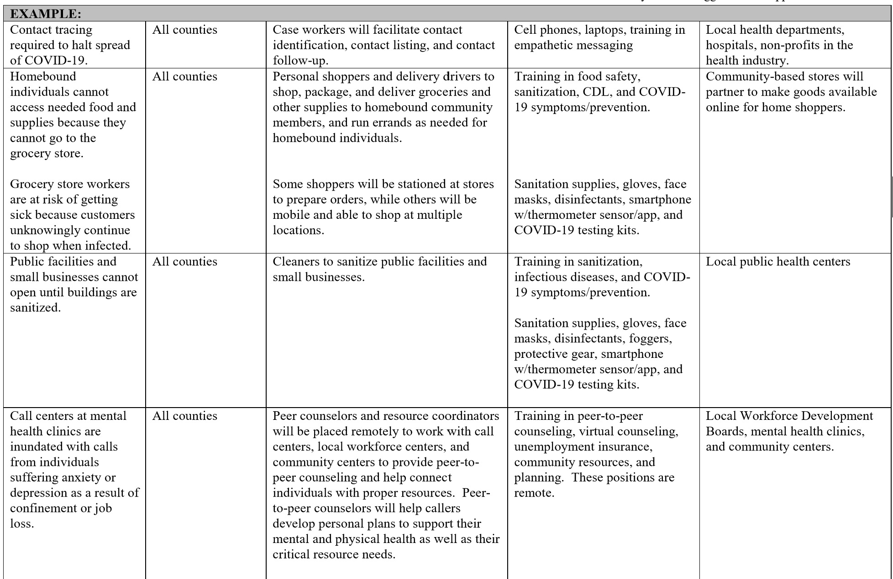

- EMPLOYMENT AND TRAINING SERVICES (FORM)
Complete the Employment and Training Services Disaster Recovery – Disaster Relief Jobs Form (attached). Identify career and training needs, resulting from the disaster, that will be addressed and areas of need; provide a list of career and training services to be provided that address the needs, include credentials earned and length of training (training must be completed during grant term); what is required to carry out the DRE position; and identify community partners, WIOA providers, and other contracted services that will be used to implement the services. Below is an example of how to complete the form.

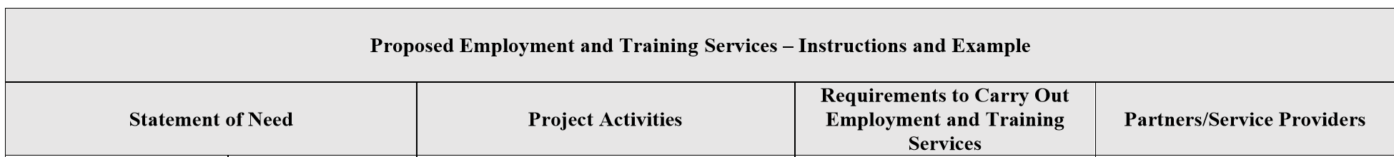
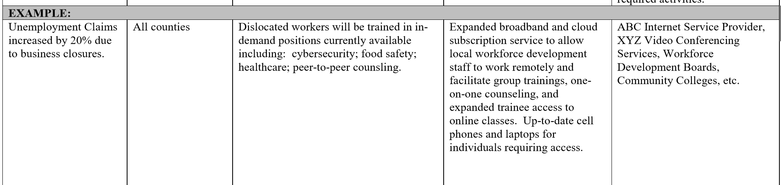

- EMPLOYMENT RECOVERY -- PROJECT OPERATOR EMPLOYER DATA WORKSHEET
Complete the general program operator information (LWIA) on the attached form. Identify dislocations that have occurred in the counties covered by the project. It is not necessary to submit a comprehensive list of every company dislocation with the submission of the application. Dislocations can be added during the term of the grant. List the company name and address; layoff type and date of notification; date related to the layoff including if it is a closure, date(s) of layoff, number of affected workers, and number of anticipated participants in the project; rapid response activities conducted that includes date of contact with the employer, date of contact with the worker(s), number of affected workers contacted, and number of field surveys completed.

- DISASTER RECOVERY AND EMPLOYMENT RECOVERY -- PROJECT GOALS WORKSHEET
Complete the Project Goals chart showing planned participants and expenditures. The chart includes goals for both the Disaster Recovery Grant and the Employment Recovery Grant.

A. DISASTER RECOVERY -- DISASTER RELIEF EMPLOYMENT/ TEMPORARY JOBS
WORKSITE SUMMARY
LWIA #:
Date:
(To be updated as necessary)

Worksite 1 Entity Name: |  |  | Any Work on Private Property (prior DOL approval required):
Address: |  |  | Employer of Record:
County: |  | Estimated # of Months: | Total # DRE Participants at Worksite:
Primary humanitarian assistance and recovery work to be performed:

List DRE Job Titles  (separate line for each Job Title) |  |  | # Participants in Each Job Title | Hourly Wage

Worksite 2 Entity Name: |  |  | Any Work on Private Property (prior DOL approval required):
Address: |  |  | Employer of Record:
County: |  | Estimated # of Months: | Total # DRE Participants at Worksite:
Primary humanitarian assistance and recovery work to be performed:

List DRE Job Titles  (separate line for each Job Title) |  |  | # Participants in Each Job Title | Hourly Wage

Worksite 3 Entity Name: |  |  | Any Work on Private Property (prior DOL approval required):
Address: |  |  | Employer of Record:
County: |  | Estimated # of Months: | Total # DRE Participants at Worksite:
Primary humanitarian assistance and recovery work to be performed:

List DRE Job Titles  (separate line for each Job Title) |  |  | # Participants in Each Job Title | Hourly Wage

Worksite 4 Entity Name: |  |  | Any Work on Private Property (prior DOL approval required):
Address: |  |  | Employer of Record:
County: |  | Estimated # of Months: | Total # DRE Participants at Worksite:
Primary humanitarian assistance and recovery work to be performed:

List DRE Job Titles  (separate line for each Job Title) |  |  | # Participants in Each Job Title | Hourly Wage

Worksite 5 Entity Name: |  |  | Any Work on Private Property (prior DOL approval required):
Address: |  |  | Employer of Record:
County: |  | Estimated # of Months: | Total # DRE Participants at Worksite:
Primary humanitarian assistance and recovery work to be performed:

List DRE Job Titles  (separate line for each Job Title) |  |  | # Participants in Each Job Title | Hourly Wage

Worksite 6 Entity Name: |  |  | Any Work on Private Property (prior DOL approval required):
Address: |  |  | Employer of Record:
County: |  | Estimated # of Months: | Total # DRE Participants at Worksite:
Primary humanitarian assistance and recovery work to be performed:

List DRE Job Titles  (separate line for each Job Title) |  |  | # Participants in Each Job Title | Hourly Wage

B. DISASTER RECOVERY -- DISASTER RELIEF JOBS

LWIA/Project Operator # and Name: | Date:
Statement of Need |  | Project Activities | Requirements to Carry Out Disaster Relief Positions | Partners
Needs: Identify each need resulting from the disaster that the project proposes to address. | Areas Where Need Exists: Identify where this need exists within the project’s proposed service area. | Disaster-Relief Jobs to Address Need: Identify the general types of disaster relief work to address the stated need. Disaster-relief positions may address cleanup resulting from the impact of the disaster event, along with the humanitarian assistance needs created by the disaster. | Training or Supplies Needed for Disaster-Relief Positions: Identify the resources required to carry out the disaster-relief positions. Include training needs, supplies, supportive services, etc | Partners Involved with Establishing the Disaster Relief Positions: Identify the entities involved with establishing the positions, such as project operators, worksite employers, establishments where disaster relief employment will take place, etc.

C. EMPLOYMENT AND TRAINING SERVICES

LWIA/Project Operator # and Name: | Date:
Statement of Need |  | Project Activities | Requirements to Carry Out Employment and Training Services | Partners/Service Providers
Needs: Identify career and training needs resulting from the disaster that the project proposes to address. | Areas Where Need Exists: Identify where this need exists within the project’s proposed service area. | Employment and Training Services to Address Need: Identify career and training services to address the stated need. Include credentials and length of time needed to complete training. Training must be completed within the grant period. | Employment and Training Resources and Supplies: Identify the resources required to carry out the career and training services, such as support technology, subscriptions, and internet access. | Employment and Training Resources and Supplies: Identify the resources required to carry out the career and training services, such as support technology, subscriptions, and internet access.

D. EMPLOYMENT RECOVERY -- PROJECT OPERATOR EMPLOYER DATA WORKSHEET

GENERAL INFORMATION
LWIA/Project Operator Name:
Address: | Date:
Project Counties Covered by LWIA/Project Operator:
Total Number of Participants to be Enrolled in Employment Recovery: | LWIA/Project Operator Funding Level:

Employer Information |  | Layoff Notification |  | Layoff Data |  |  |  | Rapid Response
Company or Military Installation | Address of Facility | Notification Type | Date of Notification | Closure Y/N | Layoff Date(s) | # of Affected Workers | # of Planned Participant | Contact with Employer Date | Contact with Worker Date | # of Affected Workers Contacted | Number of Field Surveys Completed

