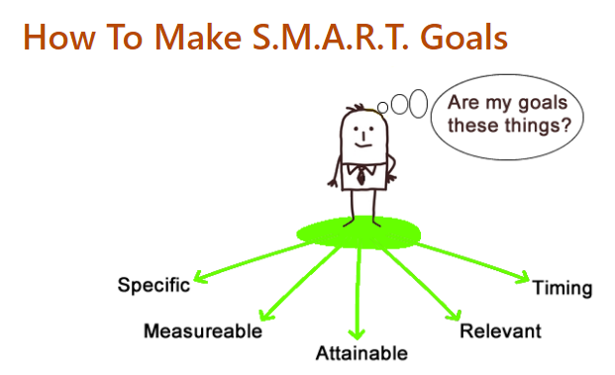
Client’s Name:____________________
Career Navigators Name:_____________________
Date Created:_____________

Set Goal Date:

Completion Date:

S.M.A.R.T. Plan
Short-Term Goals: can be accomplished in a day, a week, or a few months.
Goal | Timeframe

Long-Term Goals: can be accomplished in a semester, a year, five years, or twenty years.
Goal | Timeframe

Specific Goals: Write your specific goals using action words.
For example:
- "Begin training program for mechatronics"
- "Earn MSSC Safety Credential"
Goal | Timeframe

Measureable Goals: Identify your milestones so that you know if you are staying on target.
For example:
- Complete FAFSA
- Apply for training programs
Goal | Date Achieved

Attainable Goals: Ask yourself:
- Are these goals realistic?
- Are you going to have to make some sacrifices to reach the goals?
- Do you have a support system in place to help you reach your goals?
Goal | Realistic – Yes or No | Sacrifice - what | Support – Yes or No

Realistic Goals: Ask yourself:
- Have you researched what it takes to reach your goals?
- Are you committed to the goals?

Choices that will slow me down and strategies to stay motivated: Example – Problem: A fried invites me to take a two-week road trip in the same week as the midterm exam. Solution - Acknowledge that I would love to go, but work with friend to reschedule trip until after semester ends
Problem:
Solution:

Possible Roadblocks to achieving my goals and ways to overcome them: Examples – Problem: Take final exam on May 10 at 1:30 and the babysitter gets sick and cancels. Solution: Arrange for backup child care.
Problem:
Solution:

