

Pilot Program

Employment Opportunities
- Personalized Services
- Individualized Training
- Career Planning

PROCEDURES MANUAL

Illinois Department of Commerce and Economic Opportunity

Governor Director
Bruce Rauner Sean McCarthy

November 2017 (revised)


Pilot Program

STATE OF ILLINOIS
DEPARTMENT OF COMMERCE AND ECOMONIC OPPORTUNITY
EPIC PILOT PROGRAM

I. Program Description
- Program Background
- Targeted Locations
- Targeted Sectors
- Targeted Participants
- Employer Partnerships

II. Program Design
- Intake and Orientation
- SNAP Participant Categories
- Employer Engagement and Work-Based Learning
- Accelerated and Enhanced Training and Work-Based Learning
- Industry-Recognized Credentials

III. Program Requirements
- Training Project Activities
- Work-Based Learning
- Supportive Services
- Career Navigation
- Employment and Retention Services

IV. Program Administration
- Performance and Evaluation
- Allowable Grant Costs
- Employer Partnerships/Worksite Agreements
- Reporting

V. Grant Regulations
- Monitoring Visits
- Accounting and Record Retention
- Audits
- Grant Disbursements
- Payroll Disbursements
- Final DCEO Grantee Report - FDGR

VI. Attachments

I. Program Description

A. Program Background
On August 25, 2014, the U.S. Department of Agriculture, Food and Nutrition Service published a Request for Application (RFA) in response to legislation that authorized employment and training (E&T) pilot projects that would develop and test best practices for increasing the number of SNAP participants who obtain employment and increase their income. The Agricultural Act of 2014 (the Act), Pub. L. 113-79, amended Section 16(h) of the Food and Nutrition Act (FNA), 7 U.S.C. 2025, to authorize funding for this effort.

The Illinois Department of Human Services (DHS) in cooperation with The Department of Commerce and Economic Opportunity (Commerce), the Illinois Community College Board (ICCB), and the Illinois Workforce Innovation Board (IWIB) submitted and were approved to operate a pilot project that would test a newly designed JTED-SNAP Program. This pilot will take a proven workforce development program operated by Commerce known as Job Training and Economic Development (JTED), enhance the model, and offer it to SNAP recipients. Enhancing the model will create stronger work-based learning opportunities that incorporate adult education bridge programs and career and technical education along with enhanced skill assessments and case management. EPIC (aka JTED-SNAP) Pilot Program is the result of the vision identified in the RFA and program design established in partnership with DHS, Commerce, ICCB, and the National Evaluation team.

Illinois was one of ten states selected to be a part of a larger National study to develop and test methods for Employment and Training programs that focus on increasing the number of SNAP work registrants who obtain unsubsidized employment, the earned income of work registrants, and reducing the reliance of work registrants on public assistance. There is a randomized control trial associated with the pilot projects to test a range of innovative and promising approaches and strategies that can be implemented into the existing SNAP E&T program.

USDA Office of Food and Nutrition Services has contracted with a third party evaluator that will conduct the study. Study participants will be randomly assigned to either the SNAP E&T pilot program group and receive the EPIC services, or assigned to the control group that will receive “business as usual” services consisting of the existing SNAP E&T services currently available or services in the community for which they are eligible.

The random assignment will be conducted prior to the program participant referral to the Community Based Organizations (CBOs). CBOs will be responsible for providing data on the participant’s assessments, training, supportive services, case management, work experience activities, and permanent job placement and retention. In addition, CBOs are required to cooperate with the evaluators and participate in the evaluation activities such as, but not limited to, making staff available for interviews, convening focus groups, allowing observation of program operations, reviewing case files on study participants, and providing data on service participation as well as costs associated with program operations.

B. Targeted Locations
EPIC Pilot Program will be conducted in seven Local Workforce Innovation Areas (LWIAs). LWIAs represent the geographic areas used to deliver Workforce Innovation and Opportunity Act (WIOA) services in cooperation with adult education, job training, and human services in Illinois and will be integrated as a career pathway for the participants served in the EPIC Pilot Program. These seven LWIAs (3, 7, 14, 15, 19, 24, 25), provide a representative cross-section of areas needed for a robust evaluation of the EPIC program. They have different mixtures of targeted sectors and economic growth, urban and rural mix, and availability of services needed for serving the targeted SNAP populations. The counties represented in these areas and included in this study are: Adams, Boone, Brown, Clinton, Cook, DeWitt, Franklin, Fulton, Hancock, Henderson, Jackson, Jefferson, Knox, Macon, Marshall, Mason, McDonough, McLean, Monroe, Peoria, Perry, Pike, Randolph, Schuyler, St. Clair, Stark, Stephenson, Tazewell, Warren, Washington, Williamson, Winnebago, and Woodford. See Attachment A for a map of the targeted regions.

C. Targeted Sectors
Illinois will include 11 of its growth industries along with their demand occupations for the EPIC program. Commerce used the Illinois Department of Employment Security (DES) labor market information, including the IDES statewide and LWIA industry and occupational projections, related information on wages, and education and training requirements to identify these industries and occupations. Nine of the sectors are part of the Illinois Pathways initiatives and the priority of the Illinois Workforce Innovation Board (IWIB). These are Science, Technology, Engineering, and Math (STEM)-related sectors: agriculture, architecture and construction, energy, finance, health care, information technology, manufacturing, transportation and logistics, and research and development. In addition, the EPIC Pilot Program will include hospitality and administrative support as growth industries, given the demonstrated success in the JTED program. The RFAs submitted by CBOs for the EPIC Pilot Program must correlate with the Illinois Pathways initiative and serve one or more of the eleven in-demand sectors identified through the Pathways initiative or identified as in demand for this project. Additional information on the Illinois Pathways Initiative can be found at the following link: https://www2.illinoisworknet.com/ilpathways/Pages/default.aspx

D. Targeted Participants
The program will serve two targeted populations that are SNAP recipients:

• Category 1 - Individuals Already Working. For the EPIC pilot this category will serve SNAP recipients that are currently working, but need training to increase their skill base for career advancement, to earn higher wages and benefits, and/or to obtain more work hours. Category 1 participants are defined as:

- Individuals who are gainfully employed and working 30 hours or more per week, but still eligible for SNAP benefits and requiring skill upgrades to move up a career pathway and/or achieve higher earnings. This population is considered to be exempt from the SNAP work requirements, but elect to volunteer for services offered. No more than 15% of those classified as exempt from the work requirements may be served under this grant.
- Individuals working less than 30 hours per week, but still eligible for SNAP benefits that are lacking sufficient skills to advance in a career pathway, achieve higher earning, gain more work hours, or transfer to a higher level position. These individuals will meet the work registrant requirement at Section 6(d) of the FNA. These individuals cannot be required to engage in more than 120 hours of activities per month which includes hours worked along with other activities such as Career and Technical Education (CTE) and adult basic education.

• Category 2 – Unemployed/Underemployed Individuals with Low Skills and/or Limited Work Experience. For the EPIC pilot, Category 2 participants will be defined as individuals with low skills (without a high school diploma or equivalent and/or lacking the basic and technical skills needed to access entry-level occupations in the targeted sectors) or limited work experience (unemployed or underemployed individuals without continuous, full-time work experience in the last year). These individuals will meet the work registrant requirement at Section 6(d) of the FNA and will target Able Bodied Adults without Dependents (ABAWDs) but will also serve other SNAP work registrants with barriers to employment.

E. Program Partnership Roles
CBOs must have established partnerships to align services for the SNAP participants. The roles of each primary partner are defined below; however, this is not an inclusive list of roles or potential partners. CBOs should establish partnerships with economic development, sector partners, CBOs, and other social service agencies to leverage and align services.

Illinois Department of Human Services
- Marketing, outreach, and recruiting SNAP recipients for participation
- Assess SNAP recruitments for appropriate referral
- Collaborate with the local CBOs to engage the SNAP participants in the training services
- Partner with the local CBO career navigator to support engagement and continuation of services and follow-up on performance and compliance

Department of Commerce
- Provide technical assistance on program design, program implementation, financial management and monitoring of the program
- Through Illinois workNet® provide the data system for all participant tracking from the application to the final close-out of the client service file
- Provide marketing tools for communication to both participants and employers
- Provided standardized assessment for interest, capacity, barriers and industry required baseline entry

Employers
- Work with partners to project long-term and short-term needs and career opportunities and job openings
- Identify/develop and use common standards for defining skill requirements as well as a check list system based on pathway model
- Interview and select trainees completing the required training modules and receiving the required industry credentials
- Providing work-based learning opportunities (On-the-Job (OJT), customized training, subsidized work experience, internships)
- Develop and retain training completers
- Provide feedback on performance of the system in meeting employer needs
- Reporting progress

Education and Workforce Partners
- Collaborate with partners in establishing career pathway programs of study including bridge programs
- Collaborate with the LWIA on establishing a referral process for the continuation of training services through a designated career pathway
- Develop open entry and open exit bridge programs that establish personalized plans for students and workers and work with them to enter employment or further training
- Collaborate with partners in marketing and outreach to employers
- Collaborate with partners in providing group orientation to students enrolled
- Collaborate with partners including employers in interviewing and selection
- Assist students in developing individual plan and integrate multiple public and private funding sources for students based on these plans
- Provide personalized instruction, instructional support and transition management services for students from bridge programs through training completion
- Provide stackable credentials
- Reporting progress
II. Program Design
A. Intake and Orientation
Local DHS offices will recruit SNAP recipients and conduct a multi-phase intake process that will:

- Evaluate SNAP recipients career interest by providing information on career training opportunities available in their region through the EPIC Pilot Program;
- Discuss eligibility criteria to be enrolled in sector training available in their area;
- Evaluate barriers to participation;
- Team evaluation to determine what the “Right Fit” is for the SNAP recipient;
- Sign consent form to participate in the Study Pilot Project and be subject to random assignment.

SNAP recipients that complete the intake process will enter a random assignment conducted by Mathematica, a member of the national evaluation team. Recipients will be placed in a core service group (business as usual) or the expanded service group. Individuals assigned to the expanded service group will be referred to the “Right Fit” CBO for EPIC training services.

CBOs administering the EPIC Pilot Program will offer career pathway opportunities for the SNAP recipients referred by the local DHS case managers. SNAP participants referred to the CBO are in the expanded service group and must be immediately engaged and enrolled in the agencies training program The program design must meet the specific skill needs of the local employer and sector (demand driven). In addition, the program must address the skill deficiencies of the SNAP participants including their barriers to participation and completion of the training and their ability to be placed and/or retained in a position, or enrolled in a higher education opportunity. A career plan must be established to guide the participants through a career pathway based on the modules defined under Accelerated and Enhanced Training and Work-Based Learning.

In FY 2010, an estimated four out of five SNAP households did not include anyone with education beyond high school, while an estimated one-third of households did not even include a high school graduate (National Skills Coalition, 2012). To insure appropriate opportunities are offered to these recipients, bridge programs are a priority to include in the training program design, especially for clients that are classified as Category 2 participants. CBOs are required to identify eligibility criteria for participants’ acceptance into the career sector training program(s) that are being offered. Participants referred to CBOs based on meeting the eligibility criteria must be accepted into the training program.

B. SNAP Participant Categories
• Category 1 – Employed But Skill/Wage Deficient (Incumbent Workers)
- SNAP Participants who are working 30 hours or more per week, but still eligible for SNAP benefits based on low wages and require skill upgrades to move up a career pathway and/or achieve higher earnings. These participants are referred by DHS to the CBO. CBOs and their education partners will work with local employers to provide employer-driven curriculum and technical training. This training will improve the skill level of the workers, increase their earnings and potential for advancement, as well as increase the productivity of the participating employers. Success of the program is based on job retention and workers’ increased earnings over time. The CBOs will be paid based on achieving the negotiated performance measures of enrolled in training, completing training, retention, and wage/benefit increase. Attachment B provides examples of Illinois Career Cluster Model’s on how a participant can transition through an integrated career pathway system. Levels four and five of the career cluster “fan” are applicable to this category.
- Individuals working less than 30 hours per week, but still eligible for SNAP benefits that are lacking sufficient skills to advance in a career pathway, achieve higher earning, gain more work hours, or transfer to a higher level position. These individuals will meet the work registrant requirement at Section 6(d) of the FNA and cannot be required to engage in more than 120 hours of activities per month. This includes hours worked along with other activities such as CTE and adult basic education. DHS will identify eligible clients, provide an assessment of their barriers and suitability, and refer them to the appropriate CBO. CBOs and their education partners will work with the SNAP participants to identify their current skills and credentials and determine what skills or credential are needed to advance or obtain a self-sufficient position in the identified industry. CBOs will collaborate with local employers to provide employer-driven curriculum and technical training. This training will improve the skill levels of the SNAP participants who currently are not working at their full capability and allow them to increase their earnings, increase the number of hours worked, and/or advance to a higher level position related to the skills acquired. The program will be evaluated on the completion of training and earned credential, gainful employment in a self-sufficient career pathway, and retention. The CBOs will be paid based on achieving the negotiated performance measures of enrolled in training, completing training, employed, and retention. In Attachment B levels three, four, and five of the career cluster “fan” are applicable to this category.
• Category 2 – Unemployed/Underemployed SNAP Work Registrants. These individuals will meet the work registrant requirement at Section 6(d) of the FNA. These individuals cannot be required to engage in more than 120 hours of activities per month which includes training in bridge programs, CTE and adult basic education and also an hour spent in work experience. The SNAP participants targeted will be Able Bodied Adults Without Dependents (ABAWDs) and other SNAP work registrants that are long-term unemployed or significantly underemployed with one or more barriers to employment. DHS will identify eligible SNAP recipients, provide an assessment of their barriers and suitability, and refer them to the appropriate CBO. CBOs will partner with local community colleges, local employers, social service agencies, industry sector organizations and economic development organizations to provide holistic case management systems to address the needs of the SNAP participants while fulfilling the local workforce demands. CBOs will provide training through developed internal programs and/or in partnerships with community colleges and adult education programs. The CBOs will be paid based on achieving the negotiated performance measures of enrolled in training, completing training, employed, and retention. In Attachment B levels three, four, and five of the career cluster “fan” are applicable to this category.

C. Employer Engagement and Work-Based Learning
CBOs are required to establish partnerships with employers in critical, in-demand industries in cooperation with local and regional economic and community development partners. Employer-led partnerships must include partnership agreements specifying the role of partners including employers and CBOs. These employer partnerships and agreements are essential in identifying the employers that have the commitment and capacity to hire, train (when appropriate) and advance disadvantaged workers with limited skills and work experience. Employer partnerships are also critical to establish quality sites that will offer work experience opportunities and could lead to permanent placement. Attachment C includes a worksite agreement form and assessment form.

D. Industry-Recognized Credentials
The IWIB and Illinois Pathways have identified the industry-recognized credentials in all major career pathways for the nine in-demand sectors identified through the Illinois Career Pathways Initiative. These industry-recognized credentials, including industry certifications, are to be where appropriate in all EPIC career pathway programs for both Category 1 and Category 2 participants. Additionally, industry-recognized credentials for the two additional in-demand sectors identified for this project, hospitality and administrative support, need to be embedded where appropriate in the career pathway programs. For example, in the Information Technology sector, career pathway programs will focus on entry-level certifications such as CompTIA A+ and Network+. For Manufacturing, CBOs are to work with employers to prioritize entry-level certifications such as NCRC, MSSC, NIMS and AWS certifications. Information on the nine in-demand sectors identified in the Illinois Pathways Initiative can be found at the following link: https://www2.illinoisworknet.com/ilpathways/Pages/default.aspx

Additionally, during the course of the EPIC program we will be utilizing the DOL career ladder/lattice tool to identify/develop career pathways/ladders/lattices. Below are the links to the instructions for developing a career lattice and a sample of a career lattice.

Instructions: http://www.careeronestop.org/CompetencyModel/CareerPathway/CPWReviewSamplePaths.aspx

Sample: www.careeronestop.org/CompetencyModel/CareerPathway/ReviewCareerPathways/Hospitality_CPW.pdf

E. Accelerated and Enhanced Training and Work-Based Learning
The EPIC model is to improve the integration of adult education and accelerated training and work-based learning through (1) acceleration and integration of adult education and technical training which can incorporate the Illinois Community College Board (ICCB)-led Integrated Career and Academic Prep System (ICAPS) model and (2) expanded work-based learning for the unemployed with limited work experience through on-the-job training, work experience and transitional employment. Attachment D provides the EPIC Service model and ICAPS model and providers. More information on the ICAPS model can be found at this site: http://icsps.illinoisstate.edu/wp-content/uploads/2014/12/AO-Program-Profiles.pdf.

III. Program Requirements

A. Training Project Activities:
CBOs will utilize established career pathway systems including bridge programs, adult education, and career and technical education that results in industry-recognized credential and/or certification. The training and certifications should lead to middle-skill which require more than a high-school degree or equivalency, but less than a four-year degree. The Illinois Community College Board, Integrated Career and Academic Preparation System (ICAPS) model will be utilized to help support CBOs and their Adult Education and Community College partners in implementing the EPIC Pilot Program. This model draws on the integration of bridge programs with adult education and career and technical learning along with supportive service to better meet the needs of ABAWDs (Able Bodied Adults Without Dependents) and other SNAP E&T participants who are unemployed, underemployed, or skill and wage deficient. Bridge programs are instructional basic skill programs designed to upgrade skill levels of students using three elements: contextualization, career awareness/development, and transition services. The ICAPS model is a blend of Career and Technical Education (CTE) and adult education in an integrated delivery model designed to accelerate the time to complete both education and technical training. There are three models that will support the recipients’ access to high-wage and high-growth employment opportunities:
• Model I: In cooperation with existing adult education/English as a second language (ESL) bridge program models as identified in the Statewide Bridge Definition, provide instruction to those with reading and math levels below the 8.0 Educational Functioning Level (EFL) preparing them for the next component of training, Model II or III.
• Model II: This integrated model blends adult education and CTE instruction and is delivered in an accelerated team-taught format. Individuals in this model may be employed but skill deficient or long-term unemployed, who need to earn their high school equivalency certification, upgrade their basic skills, earn a community college basic certificate and/or obtain an industry-recognized credential. Engaging employers and industry representatives in a sector strategy approach is required and a concurrent work-based learning component managed by the CBO is recommended. CBOs should consider cooperation with existing ICAPS community college–CTE and adult education integrated programs, which have adopted and scaled the evidence-based ICAPS integrated approach model for fully integrating adult basic education/ESL and career and technical training, including contextualized supplemental learning support for underprepared students.
• Model III: For SNAP recipients who are identified as employed that do not experience basic skills barriers, but lacking industry related skills or credentials; or SNAP participants that have successfully completed Models I and II. Community-based organizations will offer enhanced short-term training opportunities to SNAP recipients in key growth industry areas through either in house training or training partners including established ICAPS. This would enable them to advance in their current employment or identify other employment opportunities. In this area, individuals may earn industry-recognized credentials. Engaging employers and industry representatives in a sector strategy approach is required. Accelerated credential attainment through evidence-based practices through prior learning assessment is an area that is being explored and has the potential of benefitting SNAP recipients. For those individuals that pursue the short-term training opportunities, community colleges have robust methodologies for ensuring prior learning credit for work experience and previous training. Further, the state of Illinois is currently engaged in the development of a statewide model for prior learning assessment from which participants in this model would undoubtedly stand to benefit. The ability to translate these short-term opportunities into college credit is a viable long-term strategy for successfully meeting the career pathway goals of participants.

The goal of each of the models is to accelerate completion of adult education content and improve completion rates of career-technical programs for targeted students, and to improve job attainment and job retention and earnings outcomes of SNAP participants.

B. Work-Based Learning
EPIC Pilot Programs will fully integrate basic and technical skill training as well as work-based learning. Work-based learning can be in the form of OJTs, customized training, or internships, (funded by partner organizations) or subsidized work experience. Subsidized work experience is the only work-based learning that can be paid for out of the EPIC Pilot Project and is targeted to the participants that are unemployed or underemployed with limited work experience. The CBO will be responsible for developing employer relationships to establish appropriate worksites that are related to the career pathway the client is pursuing. CBOs must have the administrative and fiscal capacity to administer the program according to the program requirements and have the capability to be the Employer of Record, including the administration of a payroll system. Clients will spend approximately 10-20 hours per week in subsidized work experience and will spend approximately 10-15 hours per week in technical skills training though the accelerated job training defined above. Clients cannot be required to engage in more than 120 hours cumulative of activities per month; however, a client can choose to participate over 120 hours. Also earnings from work-based learning are exempt and will not affect SNAP eligibility. The CBO will determine the wage rate, but it cannot be below the area’s minimum wage rate. CBOs can pay the prevailing wage rate for the related position. CBOs are to determine the hours per week and number of weeks on an individual basis and taking into consideration the budget. For example, CBOs may plan to place participants in work experience for 20 hour per week for approximately eight weeks. It is anticipated that not all participants and/or career sectors will participate in subsidized work experience. Accelerated training will be provided at the employer location, when feasible, depending on employer capacity and class size.

C. Supportive Services
All programs funded under this program must provide supportive services on a needs basis. Supportive services may include transportation assistance, day care expenses, work clothes, tools and supplies, or other items that are required for participation in the program. Applicants must document how the participant will be assessed for supportive services and the internal controls that will ensure the accountability and appropriate expenditure of grant funds. The Supportive Service Form included in Attachment C, should be used or you may use an internal document that captures the same type of information. The supportive service form used must be completed appropriately based on the services provided, included in the clients file, and supported with invoices and receipts.

D. Career Navigation
The EPIC Pilot Program will require a comprehensive career navigation service supported by Illinois workNet and integrated with the DHS systems. An Individual Service and Employment Plan (ISTEP) must be established to guide the participants through a series of activities that supports their career pathway choice. The ISTEP is a part of the online workNet system and must be updated to show the progress of their activities. Case management services should integrate and blend resources from federal and state programs including support services such as transportation, dependent care and other services necessary to participate and be successful in the pilot program. The client flow chart of how they will move from recruitment to placement is included as Attachment E. Career navigation services should include, at a minimum; job assessment, career readiness, accelerated training placement and support, work experience placement and support, job placement, supportive services and necessary follow-up and referral upon completion of the program. Best practices related to participant engagement, coaching, mentoring programs, and counseling services should be incorporated into the participant’s career plan.

Work Readiness Training is available using the Illinois workNet portal www.illinoisworknet.com and is recommended to be utilized to support the work readiness skills needed for employment utilizing Employment 101 which includes the following components:
- Exploring Careers and Training
- Financial Literacy, including opening a bank account
- Workplace Skills
- Job Search Skills
- Resume Writing
- Applying for a Job
- Interviewing Skills
- Career Exploration in related career pathway

E. Employment and Retention Services

Clients served under Category 1 (a) who are currently gainfully employed will receive follow-up services 30, 60 and 90 days after training has been completed to determine if there are barriers to advancement that still exist and monitor if their skill upgrade has resulted in career advancement and/or a pay upgrade. Clients served under Category 1 (b) who are employed, but not working at their full capacity will receive follow-up services 30, 60 and 90 days after training has been completed to determine if there are barriers to gainful employment that still exist and monitor if their skill upgrade has resulted in increased earning, increased hours worked, career advancement or enrollment in higher education.

Clients served under Category 2 will receive job search assistance to include the development of a resume, interviewing skills, establishing a LinkedIn account, assistance with online job boards, and additional soft skills training to prepare them for a “best impression”. The goal will be to transition those clients in work experience positions to a full time unsubsidized position with the employer or a related sector employer; and to place clients exiting training in permanent unsubsidized employment. Those that are not retained will also have the opportunity to be referred to the local WIOA program for additional training services and placement assistance. Clients placed in employment will receive follow-up services 30, 60 and 90 days after their placement to address any existing barriers that could affect their retention. Case management and supportive services will be provided to facilitate retention for all clients served under the EPIC Pilot Program.

For customer enrolled in EPIC services the IDHS Contract Report-Notification of Employment Retention form (#3085) needs to be completed with the customer. This form allows the training provider to follow up with the employer to verify employment. It is the right of the customer to refuse to sign this document but the document needs to be completed with the customers information and uploaded on the progress page in workNet.

IV. Program Administration
Organizations receiving awards are responsible for the day-to-day management of projects under the EPIC Pilot Program. The Department of Commerce and Economic Opportunity, Office of Employment and Training, is responsible for the overall program management.

Grantees must:
1) Participate in the SNAP E&T pilot evaluation and not actively recruit or provide services to control group members.
2) Provide employment related services to program participants, even if the participant determines at a future date they are not interested in the targeted industry or is placed but loses a job.
3) Have the capacity to leverage other funding sources to support services provided in the pilot project and blend resources for efficiency and sustainability.
4) Work with other CBO providers on reassignment of program participants, if necessary.
5) Continue to develop strong employer relationships and methods to recruit employers.
6) Provided a minimum of 80 hours a month of service to the SNAP participant if the participant is considered mandatory.
7) In the workNet calendar tool, established appointment dates at least two months in the future to provide sufficient option for IDHS to schedule appointments for customers.
8) Report back to DHS within 48 hours after the initial client appointment to report status of meeting (using 2151 referral form).
9) CBO must make at least one attempt to reach out to SNAP clients that do not show for the initial appointment to reschedule and engage the client in the EPIC program services.
10) Assess SNAP clients within 5 business days to determine if the referral meets the training program requirements. After the assessment the client must be enrolled or referred back to DHS if they do not meet the training program requirements
11) To satisfy the immediate engagement requirement the customer must be engaged in services within 5 business days after enrollment. 12)Report on the client’s engagement on a monthly basis through the DHS 2151A form.
13) Follow-up with SNAP clients minimally on a weekly base. This can be done via in person meetings, by phone or email, however the follow-up conversation should be documented along with the results of the follow-up conversation in the client’s case notes.
14) Develop a career plan in the SNAP clients Individual Service and Employment Plan and document accomplished activities.
15) CBO must comply with DHS staffing policy required once a month in region 1 and on an “as needed” basis in all other regions. Utilize tools available through workNet to facilitate the staffing requirements.

A. Performance and Evaluation

EPIC Pilot Program is a performance based grant. Grantees will earn funds based on completion of the negotiated benchmarks identified below:

• Category 1 – Employed But Skill/Wage Deficient (Incumbent Workers)

1. Enrolled in Training

2. Competing Training

3. Employed

4. Employment Retention

• Category 2 – Unemployed/Underemployed SNAP Work Registrants

1. Enrolled in Training

2. Competing Training

3. Employed

4. Employment Retention

All funds are earned on a performance basis. The basis is determined by applying the total average cost per participant to the performance measure in the following ratio: 20% applied to Enrolled, 30% applied to Completing Training, 30% applied to Employed, and 20% applied to Retaining Employment. If a Grantee fails to meet any of the performance measures, the grant amount may be decreased by the attributed cost per performance measure and proportionate to the size of the shortfall. Any unearned cash may result in disallowed cost and have to be returned to the Department at close-out. Grantees have to the end of the grant to meet performance and until close-outs to reconcile cash; however, the performance will be monitored and it is up to the department’s discretion to partially distribute or reallocate funds based on performance. EPIC is a pilot project and performance may be realigned based on evaluations during the grant term.

The success of the program will be based on the outcomes of the above negotiated benchmarks along with the following criteria:

• Category 1(a)(b) – Employed But Skill/Wage Deficient (Incumbent Workers)

1. Promotion

2. Entered Higher Level of Credential Training

• Category 2 – Unemployed/Underemployed SNAP Work Registrants

1. Entered Higher Level of Credential Training

Additionally, there will be surveys targeted for the SNAP participants and the employer partners to evaluate the design and implementation of the EPIC Pilot Program. The national evaluation process will also require two surveys to be completed at 12 and 36 months.

B. Allowable Grant Costs
Allowable costs are those that are necessary and reasonable based on the activity(ies) contained in the Scope of Work and are justified in the Budget Narrative. Allowable costs are defined below:
- Training: Costs associated with providing assistance to a participant to acquire or upgrade skills to enable the participant to become employed. These costs are associated with the three training modules and must be directly related to the training benefit received by the SNAP participant whether the grantee is a certified training provider and/or an education partner(s) is providing the training. Cost can include, but is not limited to, instructor wages and benefits, physical cost of instruction, tuition, books, supplies, and fees related to the training.
- Participant Wages: Includes compensation for services rendered, limited to participant wages and benefits, which includes FICA and workers compensation (only). Participants may be placed in work experience for up to eight weeks at a rate no less than the prevailing or area’s minimum wage. The number of hours worked per week may be determined by the local provider, taking into consideration the ability for the participant to concurrently be receiving adult basic education and career and technical training, and that these individuals cannot be require to engage in more than 120 hours of activities per month. It is anticipated that not all participants and/or career sectors will participate in work experience. Participant Wages should be budgeted around 18% of the total budget or $1,600 average cost per participant.
- Supportive Services: Includes, but is not limited to, assistance with transportation, child care, dependent care, and housing that are necessary to enable an individual to participate in training and employment activities authorized under the program. Supportive services will be provided on a case-by-case basis and will not exceed $1,000 per person. This will be expended based on need. It is anticipated that not everyone will require these services, so for budgeting, plan on an average cost of $440 per client.
- Career Navigators: Grant funds will support appropriate staffing (salary and benefits). for the term of the grant for Career Navigators that will provide the following services: the development of participant’s career and education training plans that provides direct linkages to academic and occupational learning; barrier assessment and alleviation; employer coordination and recruitment; placement and retention; coordination of continuing education in a career pathway and other services related to the final outcome of participant placement and retention in a career or placed in higher level education opportunities.
- Administration: Includes, but is not limited to, accounting; budgeting; financial and cash management; procurement and purchasing; property management; payroll; and audit costs. No more than 5% of the total funds may be budgeted and expended for project administration.

Additional Requirements
Grantees will be held accountable to all state rules and regulations governing the use of these grant funds as outlined in the Grant Agreement.
- Grant Expenditures should be made in accordance with generally accepted, sound business practices, arms-length bargaining, and applicable federal and state laws and regulations.
- Grant accounting should be consistent with generally accepted accounting principles.
- Grant funds will only pay for the costs necessary to complete program objectives.
- Costs may be disallowed for duplicative costs incurred for clients who are co-enrolled in more than one program.
- Unnecessary Costs, including but not limited to. the following items are prohibited:
    - Food/Alcohol/Entertainment
    - Gifts/Donations/Fundraising/Promotional Materials
    - Fines/Penalties/Interest Costs

C. Employer Partnerships/Worksite Agreements

The Grantee is responsible for developing employer relationships to establish appropriate worksites for the SNAP participants to be placed. Participants should be placed at a worksite that offers work experience in their career pathway choice and that aligns with the academic and career technical training received. Worksite selection and consideration needs to consider the opportunity for the participant to be placed with the employer in a permanent position after work experience has been completed.

General Worksite Guidelines
The employment of participants in the EPIC program must not occur at worksites where:
- A participant's employment would unfavorably impact current employees (a participant cannot displace all or a portion of a current employee's hours including overtime, wages, employment benefits, or promotional opportunities);
- A participant's employment cannot impair existing contracts for services or collective bargaining agreements;
- A participant's employment would replace the work of employees who have experienced layoffs; and
- An employer has terminated a regular employee or otherwise reduced its workforce with the intention of replacing them with participants subsidized with these funds.

Grantee Monitoring of Worksite
Grantee is responsible for completing a pre-worksite review to determine that the site is appropriate for a work-trainee placement in accordance with the worksite agreement. Grantee is responsible for monitoring the worksite after placement to ensure proper supervision, safety, accountability of work time, and quality of work experience. A Worksite Assessment Form is included in Attachment C.

Worksite Agreements
All participant employment opportunities must have a signed worksite agreement.
- Each worksite agreement must contain, at a minimum, the following items for each worksite included in the agreement:
  - Worksite contact and mailing information;
  - Detailed information on the worksite such as location, working days and hours, activities, job titles and number of positions available under each;
  - Worksite supervisor information;
  - A detailed set of mutual terms, conditions, promises, and
  - Payments that the grantee and contractor have agreed upon; and
  - A listing of participants for each worksite along with their projected start and end date.
- Grantees must ensure worksites adhere to current workplace safety guidelines.
- Grantees must ensure worksites adhere to applicable federal/state wage, labor, and workers compensation laws.
- A “Work Experience Worksite Agreement” template is included in Attachment C and can be used as is or modified to meet local needs.

Illinois workNet
All worksite locations must be entered into Illinois workNet following the instructions provided by the Department. All participant payroll must be entered in Illinois workNet.

D. Reporting
The Grantee’s financial management system shall be structured to provide for accurate, current and complete disclosure of the financial results of the project funded under this grant program. The general ledger must support costs and revenue reported to the Department and must allow tracing of funds to a level of expenditure adequate to insure funds have been expended appropriately.

The Department’s reporting requirements are outlined in the Grant Agreement and at
http://www.illinois.gov/dceo/ServicesGuide/GranteeResources/Reporting/Pages/Grantee-Report.aspxGrantees are required to submit reports to the Department as outlined in the Welcome Package's Reports Deliverable Schedule. Grantees submittal of required reports allows Commerce to monitor the grantees’ progress toward grant defined goals and their due diligence in grant fiscal management and recordkeeping.

If a grantee has not submitted a report by the due date and has not provided proper justification, the noncompliance process will start. The noncompliance process will also start if there are any issues with the report and the grantee is not working to resolve the issue. Additional information on the noncompliance process is located at: http://www.ildceo.net/dceo/Bureaus/Office+of+Accountability/Noncompliance/.

DCEO Grantee Report
In addition to any specific program reporting requirements, grantees are also required to report quarterly on both the progress and the expenditures of the grant project. Grantees must complete and submit the DCEO Grantee Report (DGR) to their Department of Commerce Program contact by the date indicated on the Reports Deliverable Schedule. The report needs to be completed and signed and sent as a PDF electronically to their Commerce contact. The reports can be found at the link provided above. The form and instructions are also included as attachment F in this manual. (Revisions may be made to these report forms, so please reference the Commerce website for the most current version.)

Research Team - Study Grantee Reports

The research team will collect data on the costs of planning and starting up each EPIC pilot and on the costs of ongoing pilot implementation. The data will be collected using an Excel workbook that will be pre-populated and provided by the evaluation team. Pilots will only be asked to complete those sections that apply to their specific program. Data collection will be coordinated through Commerce, who may in turn need to collect data from other levels of pilot implementation (partners and service providers). The cost-benefit analysis component of the Evaluation of the SNAP Employment & Training (E&T) Pilot will provide Congress and other stakeholders with information about the overall, per participant, and per component costs of providing pilot services, and whether the benefits of each pilot exceed its costs. This workbook collects information about the cost of implementing your EPIC pilot to inform these analyses. The evaluation team will also collect information on pilot benefits through other sources.

Supporting Documentation
Grantees are required to provide as supporting documentation a Trial Balance to accompany the DCEO Grantee Report. The Trial Balance will be cumulative to include the grant beginning date, through the date of the quarter end. The accounting system must be able to segregate funding sources, so a Trial Balance can be produced at the grant level. A crosswalk must accompany the trial balance that tie the cost in the trial balance to those reported in the line items on the DGR.

V. Grant Regulations

A. Monitoring Visits
The Department is responsible for periodically monitoring programmatic and fiscal activities. The grantee will be assessed to determine the impact the program has on the target population and the effective and efficient utilization of the funds. These reviews will assess how well project staff are meeting proposed goals in the planned time-frames, how many participants are being served, how the money is being spent, and whether any problems have developed that may hinder the progress of the project. The Department will ensure that periodic on-site monitoring or in-house desk monitoring is conducted during the course of the grant period and upon its completion.

The reviews verify that the grantee's financial management system is structured to provide accurate, current, and complete disclosure of grant expenditures. The review also confirms that all expenditures are in accordance with the provisions, terms, and conditions contained in the grant agreement with the Department. The monitors will also verify that participant files are maintained and contain documentation sufficient to demonstrate that individuals entering the program are eligible to receive services.

CLIENTS FILES:
Each participant must have his or her own file. It is required to have a minimum of the following in each participant file: proof of bridge, ABE, CTE and industry recognized training and related certifications or degrees; work experience wage time sheets signed by the participant, site supervisor and EPIC grantee agency; work readiness training, supportive services received, referral made, etc.

WORKSITE FILES:
You must have on file a worksite agreement and worksite assessment and list of participant placement for each worksite.

Monitoring visits are scheduled in advance by the Department’s monitors.

B. Accounting and Record Retention
The Grantee's financial management system must be able to provide for accurate, current and complete disclosure of the financial status of the grant. The grantee must keep adequate records for tracking funds at the expenditure level, to include youth wages, youth supportive services, staff direct cost and allocated cost to the grant based on an approved cost allocation plan. Grant records shall be maintained for a minimum of three (3) years following the closure of the grant, unless otherwise notified by the Department.

C. Audits
Grantees are required to have an audit completed for their programs as outlined in Part 3.1 of the Grant Agreement. A copy of the audit needs to be sent to the department within 30 days of the Grantee's receipt of completed audit but no later than nine months following the end of the period for which the audit was performed. Reference the Reports Deliverable Schedule in you Grant Agreement for due dates.

D. Grant Disbursements
Disbursement of grant funds from the Department will be made in accordance with a schedule negotiated with the grantee and included in the grant agreement. Such agreements shall provide for the disbursement of all funds prior to the end of the grant term; subject to a determination, by the Department, that satisfactory progress is being made by the grantee to implement grant activities.

Startup cost and one month of anticipated obligations will be forward funded. Cash request after the forward funding should be made based on reimbursement and after the forward funding has been expended. The grants will be initiated at 50% of the negotiated total budget. Funds will follow the SNAP participants. Final grants could be less than the negotiated total or greater than the negotiated total if the agency has capacity to serve more clients than proposed in the grant agreement. Modifications to the grant agreement will be initiated based on the demand for training of SNAP participants.

E. Grant Expenditure Report
All expenditures associated with the grant that are being charged to the budget line items negotiated in the grant agreement must be reported in the Grant Reporting System (GRS). Expenditures must be reported in the system by the 20th of each month. Cash request can be submitted at any time but must be supported by expenditures.

- Administration (1000) - Grant management, accounting; budgeting; financial and cash management; procurement and purchasing; property management; payroll; and audit costs. No more than 5% of the total grant funds may be expended for administrative costs.
- Training (2000) – Cost associated with the three training modules and must be directly related to the training benefit received by the SNA participant. Case management, employer outreach and recruitment, and supportive services,
- Participant Wages (3000) – SNAP Participant wages and the employer cost for the wages to include ONLY FICA and worker compensation
- Supportive Services (4000) – Expenditure to or on behalf of a participant enrolled in training, such as transportation, childcare, housing, or other necessary service to enable an individual to participate in training and employment activities authorized under the program.
- Career Navigators (5000) – Cost associated with the development of participant’s career and education training plans that provide direct linkages to academic and occupation learning; coordination of continuing education, work experience, and support services; placement with employers for work experience and permanent employment; employer relationship facilitation, and follow-up on employment and retention.

These costs must be reflected in your accounting system Trial Balance Report. This form is to be submitted at the same time you submit your Department Quarterly Report (DGR).

F. Payroll Disbursements
The Grantee must complete the provided file in workNet that includes the fields and information identified then upload the file in the Illinois workNet, to meet the payroll reporting requirement. The upload will include the eligible participants hourly wage rate and number of hours worked. Expenditures entered in the GRS under participant wages will equal the payroll entered in workNet plus the employer cost for FICA and workers compensation. The standardized time sheet provided MUST BE USED and is included as Attachment C.

G. Final DCEO Grantee Report
The grantee shall be responsible for completing the Final DCEO Grantee Report (FDGR) which identifies the programmatic and financial status of the grant funds. The FDGR is the same as the DCEO Grantee Report (DGR) discussed in the reporting section however this submittal is marked as the final report. The grantee, upon submission of the FDGR, or within 45 days after the expiration of the grant, whichever is first, shall refund to the Department any balance of funds which were unexpended at the end of the grant period. In addition, the grantee shall repay the Department for any funds determined by the
Department to have been spent in violation of the grant agreement. If the grant should terminate for any reason, the FDGR shall be due within 45 days after the date of termination.

Grant Contact Information

The Department of Commerce and Economic Opportunity is the State agency that administers the Summer Youth Employment and Training Program. If you have any questions regarding the program, contact the following:

Tammy Stone
Program Manager
500 East Monroe, 10th Floor
Springfield, IL 62701-1643
Phone: (217) 557-5549
Fax: (217) 558-2444

Email: Tammy.Stone@illinois.gov

ATTACHMENT A

- EPIC Program Map

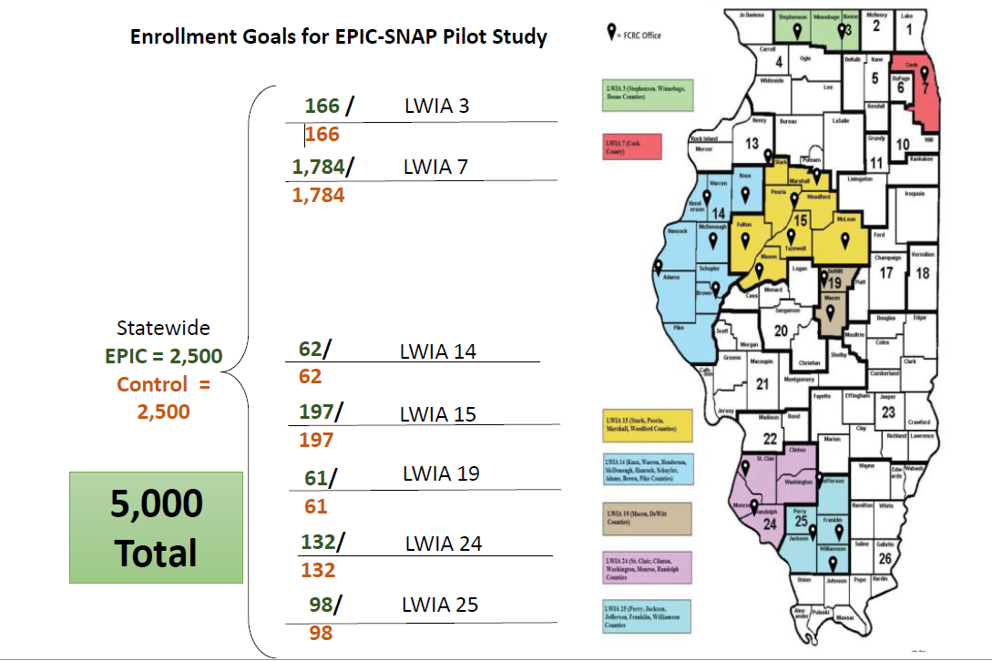

ATTACHMENT B

- Illinois Career Cluster Model

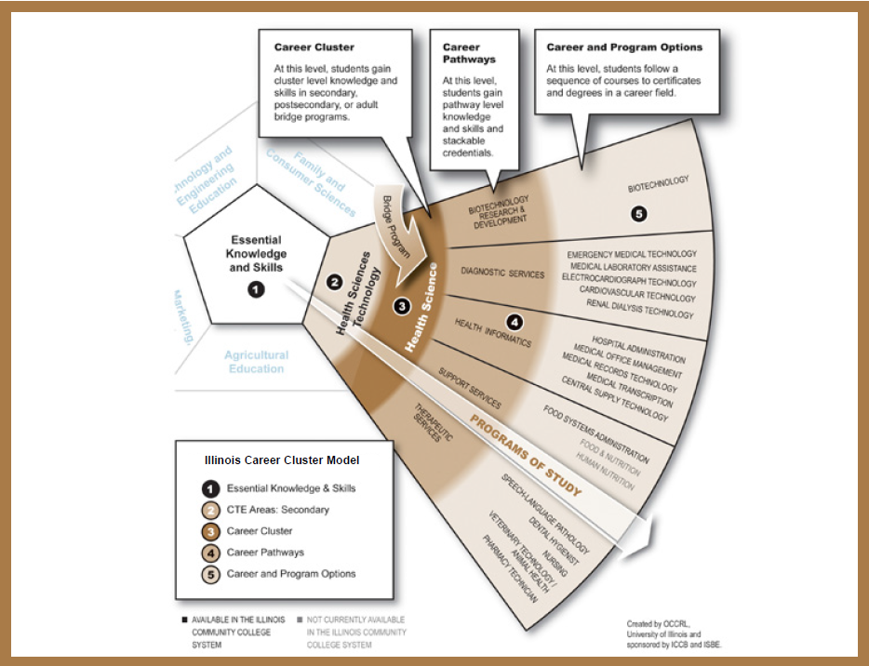

ATTACHMENT C

Time Attendance and Compensation Forms
- Worksite Agreement
- Worksite Assessment
- Bi-Weekly Time Sheet
- Supportive Service Form

This Agreement is made between and
(Herein Referred to as Service Provider)

(Herein Referred to as Worksite Agency)
a □ public, □ non- profit, or □ private for profit organization to provide employment and training services to eligible participants in the EPIC pilot program. Under this Agreement, participants will be provided work experience, which is valuable and meaningful for both the participants and the agency. Work experience will be consistent with each participant’s capabilities and interests and align with the career plan and training provided in the identified industry sector and career pathway. Work experience should also aid in the development of skills and work habits, which will assist the participant in obtaining unsubsidized employment in the future.

Parameters of Program

- Worksite placement opportunities will be contingent on available funding.
- All federal and state labor laws must be followed.
- Trainee’s placement at a worksite cannot cause the displacement of a regular employee.
- Trainees are placed in a planned, structured learning experience in a workplace for a limited period of time to perform duties as outlined in the Attached Job Description which shall by reference be made a part of this agreement.
- Worksite placements that are prohibited include:
- Employment in the adult entertainment industry
- Sale or distribution of packaged liquors
- Sale of firearms
- Organizations with political or religious affiliations
- Hours on the job can vary but are not to exceed the normal and usual hours to complete the job.
- Trainees scheduled to work 7 1/2 continuous hours or more must have an unpaid meal period of at least 20 minutes. The meal period must be given to an employee no later than 5 hours after beginning work.
- Overtime will not be authorized unless normally required for the position and authorized in advance in the work schedule found in the Attached Job Description.
- No lunch hours or breaks are paid unless normally paid to all workers at the worksite in similar positions.
- There will be no paid leave time i.e. vacation/sick/personal days or paid holidays.
- Holidays are paid at regular hourly rate only when the trainee works. The worker will adhere to the worksite’s holiday schedule and/or the Service Provider holiday schedule to be determined by both parties.
- Special equipment or clothing as outlined in this agreement may be provided by Service Provider if required for the job and not normally provided to other employees by the worksite.
Worksite Assurances

The Worksite Agency assures that:
- Trainees receive a structured training opportunity to gain the knowledge and competencies necessary to be successful in the occupation.
- Sufficient work is available to trainees as well as adequate equipment and materials to perform the job as outlined in the job description found in Attached Job Description.
- The address listed below is the only company location where the trainee will complete placement hours. Requests will be made prior to transferring trainee to alternate locations pending approval from Service Provider.
- No other individual is on layoff, or has been terminated from the same or any substantially equivalent job that the trainee will be assigned.
- No current employee shall be displaced (including partial-displacement, such as a reduction in hours or employee benefits) to accommodate a placement at your worksite.
- This placement opportunity is not created in a promotional line that infringes in any way on the promotional opportunities of currently employed workers.
- The worksite placement will not impair any collective bargaining agreement in place.
- Trainees cannot be employed by immediate family members. For the purpose of this agreement, immediate family is defined as spouse, children, parents, grandparents, grandchildren, brothers, sisters or persons bearing the same relationship to the trainee’s spouse.
- Compliance with the Illinois and Federal Fair Labor Standards Act will be adhered to at all times.
- Compliance with all Safety standards established under Federal and State law shall be applied to working conditions of the trainee.
- Compliance with all EEO & ADA laws will be adhered to at all times.
- Confidentiality of trainees placed at the worksite will be maintained at all times and no trainee information will be provided to media outlets or persons outside of Service Provider.
- The Worksite Agency may be responsible for additional costs in the event a trainee works over the agreed upon scheduled hours.
- Timesheets will be accurately verified and submitted to Service Provider within the timeframe established below under “Time Attendance and Compensation” in this agreement.
- Worksite Agency will provide time as identified by the Worksite and Service Provider for the youth to participate in work readiness and career education training conducted by Service Provider.
- No trainee will operate or be transported in privately owned vehicles during working hours.
- No trainee will be allowed to drive any motor vehicle during working hours unless previously agreed upon in this worksite agreement.
- Recognition of program guidelines in that no obligation exists to employ the trainee following completion of placement hours.
- Cooperation with Work Experience Representative and State Officials in monitoring progress of trainees.
- Adherence to all program regulations as outlined by the Service Provider and parameters of program.
- Compliance with Service Provider accident and incident reporting process. All accidents and incidents must be reported within 24 hours.
- Employees will not be employed in building, operating, or maintaining any part of any building, which is used for religious instruction or worship.
- This agreement will not assist with political or lobbying activities or the cost of any salaries or expenses related to any activity designed to influence legislation or appropriation pending before the Congress of the United States.
- Worksite Agency nor its principals are presently debarred, suspended, proposed for debarment, declared ineligible, or voluntarily excluded from participation in the Agreement by any Federal or State Department or agency.

Service Provider Assurances
Service Provider assures:
- To be the employer of record.
- To provide worker’s compensation to all trainees placed at the worksite.
- Prompt payment of trainees’ wages, stipends, supportive services and required fringes such as FICA, and worker’s compensation insurance.
- Service Provider will provide trainees with the required tools and attire needed to perform the job duties assigned if they are not normally provided to other employees by the worksite and funds are available. Include required tools and attire in Attachment Job Description.
- A Work Experience Representative will disseminate information relevant to the program, address work-related concerns and assist trainees in their career development objectives.
- Service Provider will provide a case manager to assist youth in the required work readiness and career education training.
Time Attendance and Compensation
Accurate time and attendance records will be kept by the supervisor on each participant and will reflect the time actually worked by the participant. PARTICIPANTS WILL NOT BE PAID FOR ABSENCES, UNWORKED HOURS {THIS INCLUDES LUNCH ON OR OFF PREMISES} OR RECREATIONAL ACTIVITY. UNDER NO CIRCUMSTANCES SHOULD ANY PARTICIPANT WORK OVER 40 HOURS IN A WEEK (unless authorized under this agreement in the Job Description). Using time sheets provided by the Service Provider, participants shall sign in when reporting to work each day and sign out at the completion of the specified number of hours each day as described in this Agreement. The sign in and sign out record will reflect actual starting and stopping times for hours worked and will reflect the lunch break. No one else will be allowed to sign a participant in or out. Time and attendance records will be signed at the end of each day by the participant and at the end of the two week period by the participant and the supervisor, whose signature will certify its accuracy.
Time Sheets will are due to the Service Provider for payroll preparation by:
(Time Sequence)
Delivered to: via:
(Name of designated Service Provider staff) (Method, i.e., email, pickup, delivery)
Participants will be paid at the rate of $9.00 an hour. Payroll dates are the
and of the month.

If the number of participants or activities of the worksite change, the Worksite Agency agrees to notify the Service Provider immediately so this agreement may be modified.
Worker Trainee Placement Information

# Slots | Job Title | Hours per Week | Number of Weeks | Supervisor

Authorized Signatures

Service Provider reserves the right to terminate the Work Experience Agreement if it is deemed that the Worksite Agency is not providing a positive, safe working environment or fails to adhere to any part of this agreement. This agreement may be terminated by either party, for any reason whatsoever, by giving written notice to the other party.
The worksite agreement can be modified or updated upon mutual consent of both parties.
The Worksite Agency shall be responsible for, and shall indemnify Service Provider, its officers, employees and agents for any injuries sustained by any trainee or third parties, resulting from the negligent acts and/or intentional wrongful acts of the Worksite Agency or its agents, or employees while performing under this agreement.

(1) Service Provider Authorized Representative:
Signature
Service Provider Organization Name/Address:
Name

Address

(2) Authorized Worksite Administrator:
Signature
Worksite Organization Name/Address:
Name

Address

(3) Address of Actual Worksite if different then Organization Address:

Address City Zip Code

TERM: THIS AGREEMENT WILL TAKE EFFECT ON AND TERMINATE NO LATER THAN . (DATE)

WORKSITE INFORMATION
Name of Worksite: _____________________________________________________
Address: _____________________________________________________________
Review Date: _________
GENERAL ASSESSMENT
[Assessment Source: worksite agreement / interview questions / observation]
- Working conditions are safe and sanitary. (Yes / No)
- There is no evidence that individual(s) have been laid off from the same or substantially equivalent job as any worker-trainee’s job (Yes / No)
- There is evidence that the worksite provided job experience, skill acquisition and meaningful work to the worker-trainees (Yes / No)
- There is evidence that the worksite mentored and supervised worker-trainees to ensure skill and experience acquisition adequate to pursue employment (Yes / No)

WORKSITE PROGRAM MANAGEMENT
[Assessment Source: worksite agreement / interview questions / observation]
- There is evidence that the worksite has prepared the mandatory Participant Wage Timesheets Form in a customary businesslike fashion, ensuring accuracy as to the hours worked (Yes / No)
- There is evidence that worksite has provided the worker-trainees with not more than 40 hours per week (Yes / No)
- There is evidence that worksites are accessible to participants. (Yes / No)
- There is evidence that the worksite has abided by all of the Illinois EPIC Program requirements including: (Yes/No)
- Worksites have not employed family members as part of the Illinois EPIC program.
- Worksites are not engaging in a prohibited activity or industry as defined by the worksite agreement.
- Worksites have only placed Illinois EPIC worker-trainees into positions that would not exist but for the Illinois EPIC program. Worksites may not fill positions that were vacated due to layoff or furlough with Illinois EPIC participants, and may not reduce hours of existing employees in order to employ Illinois EPIC worker-trainees.
- Worksites have complied with all applicable labor laws.
- Grantee must ensure worksites for participants adhere to applicable federal/state labor laws.
- Illinois EPIC worker-trainees do not comprise more than 50% of the business' workforce at each worksite.
- Worksites will consider Illinois EPIC worker-trainees for unsubsidized positions at the end the Illinois EPIC program as they are able. [Providing unsubsidized employment for worker-trainees is not a requirement of the program.]
- Worksites have provided a valid DUNS number and Federal Employer Identification Number.

MONITORING QUESTIONS
- The worksite is in compliance with the worksite agreement. (YES / NO)
- The Participant Wage Timesheets are completed accurately and submitted on according to schedule to insure timely payment to the work-trainee and in accordance with the worksite agreement. (YES/NO)

[IF NO – FINDING]
The Worksite is not in compliance with the worksite agreement and/or State Regulations.

[CORRECTIVE ACTION]
The Grantee must either bring the worksite, payments to customer, or job duties into compliance or terminate the worksite from the program. Evidence must be submitted to the Bureau for review of compliance with corrective action measures.

WORKSITE INFORMATION

Name of Worksite: ______________________________________________________
Address: ______________________________________________________________
Worksite Supervisor: ____________________________________________________

Program Assessment
- When did the participant(s) begin working? (Date should not be prior to the execution of the worksite agreement)

- How many work-trainees have been assigned to this worksite?

- How many employees are assigned to this worksite? (Include full-time, part-time, and contractual employees. Do not include work-trainees.)

- Have any of the non-Illinois EPIC employees had their hours reduced or been laid off within the last 120 days?

- How are the participants hours of work tracked? (i.e. timesheets, punch card, time clock)

- Are you satisfied with the worker trainee(s)? (i.e., timely, productive, attitude, etc.)

WORKSITE INFORMATION

Name of Worksite: ______________________________________________________
Address: ______________________________________________________________
Worker Trainee Name: ___________________________________________________

Worker Trainee Evaluation

- What, if any, new skills have been learned as a result of this job/training?

- Are you engaged in any political/religious activities? (i.e. handing out union cards, asking for votes for union activities; participating in religious services, decorating altars, etc.)

- How are your work hours recorded (time card / sign-in sheet / Other (specify))

- What are your work hours?

- When do you receive paychecks (weekly, twice monthly, other)

- Are your paychecks on time?

- When did you begin your work experience? (day/month)

The job duties are in line with the worksite agreement? (Answer this question based on the review of the worksite agreement and on-site job duties.)

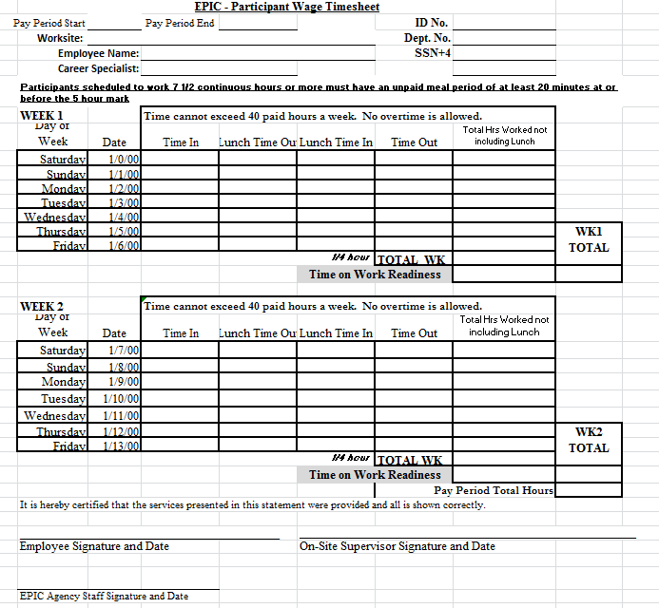

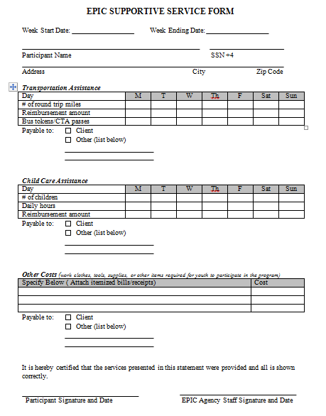

ATTACHMENT D

- EPIC Service model and ICAPS model and provider

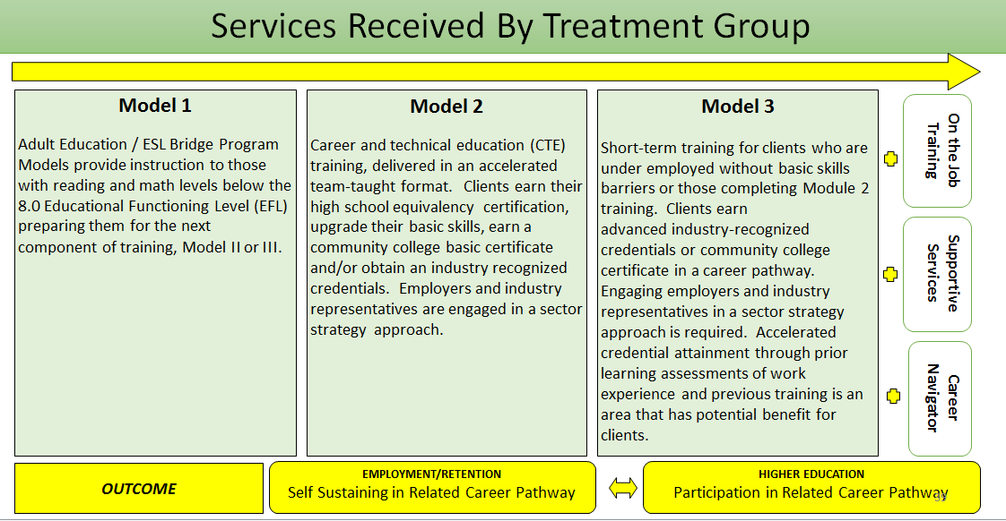

The Integrated Career and Academic Preparation System (ICAPS) is Illinois’ approved model of Integrated Education and Training (IET), one of the new components of the Workforce Innovation and Opportunity Act of 2014 (WIOA). ICAPS began development in 2011-2012 from implementation of the Accelerating Opportunity (AO) initiative put forth by Jobs For the Future (JFF). Beginning with the original 8 programs launching in 2012, Illinois now has 25 established ICAPS programs and has another 3 in development. ICAPS fosters and strengthens partnerships between Career and Technical Education (CTE) and Adult Education (AE) through concurrent enrollment and integration of both technical training and contextualized basic skills instruction in a team taught environment, culminating in educational functioning level gains, high school equivalency certification, transferrable college credit, and industry recognized credentials.

Key Components for Success

- Team Teaching Format
- Contextualized Support Class
- Wrap-around Comprehensive Student Support
- Career Navigator/Transition Services
- Braided Funding Strategies
- Strong Internal and External Partnerships
- Labor Market Information (LMI)
- Robust Strategies for Sustainability
- Institutional Support and Policies
- Institutional and Systemic Culture Change
Industry Sectors / Career Clusters

- ICAPS currently offers programs in these Career Clusters:

- Architecture & Construction
- Business, Management and Administration
- Education & Training
- Health Science
- Information Technology
- Manufacturing
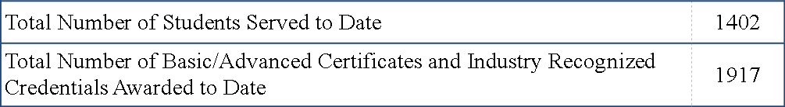
- Manufacturing/Architecture & Construction Transportation, Distribution, & Logistics

Outcomes

- Increased Skill Levels in Reading and Math
- Readiness for Entry-Level, Sustaining Wage Jobs
- Basic and Advanced Certificates
- Industry Recognized Credentials
- Examples:
- AWS Certificate for Welding
- NIMS Certification
- MSSC Quality and MSSC Safety
- First Aid / CPR Certificate
- EPA 608 Certification (HVAC)
- CISCO Certifications (IT)
- State and National Licensure / Certification
- Examples:
- State Licensure for CNA
- National Certification of Pharmacy Technician
- Illinois EMT B State Licensure
- Transferrable College Credit
- 12+ Credit Hours for Most Programs
- Waiver Available for Demonstrated Effective Programs of <12 Credit Hours

ICAPS Programs and Integrated Career Pathways

Established Programs

1. Black Hawk College | Manufacturing / CNC
2. Carl Sandburg College | Welding
3. Richard J. Daley College | CNA, Medical Billing & Coding, Manufacturing / CNC Tech
4. Danville Area Community College | Healthcare, Automotive
5. College of DuPage | Information Technology – CCENT/CCNA
6. Elgin Community College | CNC, Welding, Dental Office Aide, HVAC
7. Harper College | Business Software Specialist. Domestic Refrigeration and Heating
8. Heartland Community College | Welding
9. Illinois Central College | Health Science /Certified Nursing Assistant
10. Joliet Junior College | Manufacturing/Welding
11. Kaskaskia College | Health Science /Certified Nursing Assistant
12. Kishwaukee College | Manufacturing
13. College of Lake County | Automotive Manufacturing, Machine Tool Trades, Gas Metal Arc Welding, HVAC
14. Lake Land College | Manufacturing, Fundamentals in Applied Technology, Health Science
15. Lewis and Clark Community College | Automotive Technology, Emergency Medical Technician, Welding Technology
16. Lincoln Land Community College | Automotive Technology, Healthcare, Manufacturing, Early Childhood Education
17. McHenry County College | Advanced Manufacturing, CNC Machine, Automotive Maintenance Technician, Administrative Office Skills
18. Olive Harvey College | Transportation, Distribution & Logistics
19. Parkland College | Industrial Welding
20. Prairie State College | Manufacturing
21. Rend Lake College | Allied Health / Personal Care Aide
22. Rock Valley College | Manufacturing
23. South Suburban College | Community Health Worker, EMT
24. Southwestern Illinois College | Manufacturing/Precision Machining Technology
25. Waubonsee Community College | Administrative Office Assistant/IT
Programs in Development

1. John A. Logan College | HVAC
2. Morton College | Automotive / Maintenance and Light Repair
3. Triton College | Engineering Technology / Design

ICAPS State Leadership Team:
Illinois
Community
College
Board
Project Lead: Jennifer Foster, Deputy Director, Adult Education & Workforce
Jennifer.Foster@illinois.gov 217-785-0171

Project Coordinator: Brian Durham, Deputy Director, Academic Affairs
Brian.Durham@illinois.gov 217-524-5502

Project Manager: Josh Beneze, Associate Director, Adult Education & Workforce
Josh.Beneze@illinois.gov 217-785-0251

ILLINOIS COMMUNITY COLLEGE BOARD
ADULT EDUCATION AND LITERACY
INTEGRATED CAREER AND ACADEMIC PREPARATION SYSTEM (ICAPS)
PROGRAMS

REGION I

AREA PLANNING COUNCIL 508
RICHARD J. DALEY COLLEGE  (Certified Nursing Assistant; Medical Billing & Coding; Manufacturing/Computer Numerical Control Tech)  Project Lead  Jean Johnson  Dean, Continuing Education  7500 South Pulaski Road  Chicago, IL 60652  Telephone: 773-838-7544  E-Mail: jjohnson2@ccc.edu  Project Coordinator  TBA | OLIVE-HARVEY COLLEGE  (Transportation, Distribution, & Logistics)  Project Lead  Robert Reimer  Dean Adult Education  1000 South Woodlawn Avenue  Chicago, IL 60652  Telephone: 773-291-6308  FAX: 773-291-6693  E-Mail: rreimer@ccc.edu  Project Coordinator  TBA

REGION II
Area Planning Council 502 | Area Planning Council 509
COLLEGE OF DUPAGE  (Information Technology/Network Systems)  Project Lead  Daniel Deasy  Manager, CE Ops/Grant Program Compliance  425 Fawell Boulevard  Glen Ellyn, IL 60137  Telephone: 630-942-4021  E-Mail: deasyd@cod.edu  Project Administrator  John Kronenburger  Associate Dean, Technology  425 Fawell Boulevard  Glen Ellyn, IL 60137  Telephone: 630-942-3614  E-Mail: kronenburgerj@cod.edu | ELGIN COMMUNITY COLLEGE  (Computer Numerical Control; Welding; Dental Office Aide; HVAC)  Project Lead  Peggy Heinrich  Dean of Adult Education  1700 Spartan Drive  Elgin, IL 60123-7193  Telephone: 847-214-6911  E-Mail: pheinrich@elgin.edu  Project Coordinator  TBA
Area Planning Council 510 | Area Planning Council 511
SOUTH SUBURBAN COLLEGE  (Community Health Worker, EMT, MIS/Basic Computer Networking)  Project Lead  Jane Ellen Stocker  Vice President of Enrollment & Adult Education  15800 S. State Street  South Holland, IL 60473  Telephone: 708-210-5762  E-Mail: jstocker@ssc.edu  Project Coordinator  Matthew Beasland  Adult Education, Database and Grant Compliance  15800 S. State Street  South Holland, IL 60473  Telephone: 708-896-2000 ext. 2385  E-Mail: mbeasland@ssc.edu | ROCK VALLEY COLLEGE  (Manufacturing – MET/CNC)  Project Lead  Amanda Smith  Director, Adult Education & Literacy  4151 Samuelson Road  Rockford, IL 61109  Telephone: 815-921-2009  FAX: 815-921-2019  E-Mail: a.smith@rockvalleycollege.edu  Project Coordinator  Rich Gocken  Dean, Business, Computer Information Systems  4151 Samuelson Road  Rockford, IL 61109  Telephone: 815-921-3171  E-Mail: r.gocken@rockvalleycollege.edu
Area Planning Council 512 | Area Planning Council 515
WILLIAM RAINEY HARPER COLLEGE  (HVAC)  Project Lead  Andrea Fiebig  Director of Adult Educational Development  1200 West Algonquin Road  Palatine, IL 60067  Telephone: 847-925-6371  E-Mail: afiebig@harpercollege.edu  Project Coordinator  TBA | PRAIRIE STATE COLLEGE  (Manufacturing - CPT)  Project Lead  Kim Kunce  Dean, Adult Education  202 S. Halsted Street  Chicago Heights, IL 60411  Telephone: 708-709-3684  E-Mail: kkunce@prairiestate.edu  Project Coordinator  John Schlueter  Coordinator, Adult Basic and Secondary Education  202 S. Halsted Street  Chicago Heights, IL 60411  Telephone: 708-709-7910  E-Mail: jschlueter@prairiestate.edu
Area Planning Council 516 | Area Planning Council 523
WAUBONSEE COMMUNITY COLLEGE  (MS Office Specialist)  Project Lead  Ne’Keisha Stepney  Assistant Dean, Business and Career Technologies  Route 47 @ Waubonsee Drive  Sugar Grove, IL 60554  Telephone: 630-466-7900  E-Mail: mcermak@waubonsee.edu  Project Coordinator  Jeri Dixon  Dean for Adult Education  18 South river Street  Aurora, IL 60506  Telephone: 630-801-7900 ext. 4110  E-Mail: jdixon@waubonsee.edu | KISHWAUKEE COLLEGE  (Manufacturing - CPT)  Project Lead  M. Joanne Kantner  Dean, Adult Ed. & Transition Programs  21193 Malta Road  Malta, IL 60150  Telephone: 815-825-2086 ext. 3760  E-Mail: joanne.kantner@kishwaukeecollege.edu  Project Coordinator  Tricia D. Wagner  Director, Adult Education  21193 Malta Road  Malta, IL 60150  Telephone: 815-825-2086 ext. 3180  E-Mail: Tricia.Wagner@kishwaukeecollege.edu
Area Planning Council 528 | Area Planning Council 532
MCHENRY COUNTY COLLEGE  (Advanced Manufacturing Certificate; CNC Machine Certificate; Automotive Maintenance Technician Certificate; Administrative Office Skills Certificate)  Project Lead  Terri Berryman  Executive Dean, Workforce and Community Development  8900 U.S. Highway 14  Crystal Lake, IL 60012-2761  Telephone: 815-479-7588  E-Mail: tpierce@mchenry.edu  Project Coordinator  Barbara Sitkiewicz  ICAPS Navigator  8900 U.S. Highway 14  Crystal Lake, IL 60012-2761  Telephone: 815-455-8586  E-Mail: bsitkiewicz@mchenry.edu | COLLEGE OF LAKE COUNTY  (Automotive Manufacturing; Machine Tool Trades; Gas Metal Arc Welding; HVAC)  Project Lead  Leticia Muñoz-Swift  Transitions Coordinator  19351 West Washington Street  Grayslake, Illinois 60030-1198  Telephone: 847-543-2672  E-Mail: aceagv@clcillinois.edu  Project Coordinator  TBA
Area Planning Council 504 | Area Planning Council 527
TRITON COLLEGE  (STEM – Engineering Technology / Design)  Project Lead  Luisa Hernandez  Executive Director of Bridge to College and Careers  Adult Education  2000 Fifth Ave.  River Grove, Illinois 60171  Telephone: 708-456-0300 Ext. 3331  E-Mail: luisahernandez@triton.edu  Project Coordinator  Dr. Henry C. Bohleke  Dean of Business and Technology  2000 Fifth Ave.  River Grove, Illinois 60171  Telephone: 708-456-0300 Ext. 3395  E-Mail: henrybohleke@triton.edu  * In Development – Launching Fall 2016 | MORTON COLLEGE  (Automotive – Maintenance and Light Repair)  Project Lead  Anna Nakashima  Assistant Dean, Adult Education, Community Programming, and Outreach (AECPO)  3801 S. Central Ave.  Cicero, Illinois 60804  Telephone: 708-656-8000 Ext. 2368  E-Mail: anna.nakashima@morton.edu  Project Coordinator  Dr. Ellen Crowe  Dean, Career and Technical Education  3801 S. Central Ave.  Cicero, Illinois 60804  Telephone: 708-656-8000 Ext. 2334  E-Mail: ellen.crowe@morton.edu  * In Development – Launching Fall 2016

REGION III
Area Planning Council 503 | Area Planning Council 505
BLACK HAWK COLLEGE  (Manufacturing/Computer Numerical Control)  Project Lead  Glenda Nicke  Dean of Adult and Continuing Education  301 Avenue of the Cities  East Moline, IL 61244-4038  Telephone: 309-796-8222  E-Mail: nickeg@bhc.edu  Project Coordinator  Bianca Perkins  Director of Adult Education  301 Avenue of the Cities  East Moline, IL 61244-4038  Telephone: 309-796-8240  E-Mail: perkinsb@bhc.edu | PARKLAND COLLEGE  (Industrial Welding)  Project Lead  Tawanna Nickens  Dean, Adult Education & Workforce Development  2400 W. Bradley Ave.  Champaign, IL 61821-1899  Telephone: 217-351-2390  E-Mail: tnickens@parkland.edu  Project Coordinator  TBA

Area Planning Council 507 | Area Planning Council 514
DANVILLE AREA COMMUNITY COLLEGE  (Healthcare; Automotive)  Project Lead  Laura M. Williams  Director of Adult Education  2000 East Main St.  Danville, IL 61832  Telephone: 217-443-8878  E-Mail: lwms@dacc.edu  Project Coordinator  TBA | ILLINOIS CENTRAL COLLEGE  (Health Science/CNA)  Project Lead  Kay Sutton  Dean, College & Career Readiness  5407 North University  Peoria, IL 61635-0001  Telephone: 309-690-6886  E-Mail: ksutton@icc.edu  Project Coordinator  TBA

Area Planning Council 518 | Area Planning Council 525
CARL SANDBURG COLLEGE  (Welding)  Project Lead  Michelle Johnson  Director of Adult Ed/Institutional Effectiveness  1150 W. Carl Sandburg Dr.  Galesburg, IL 61401  Telephone: 309-344-1631  E-Mail: mljohnson@sandburg.edu  Project Coordinator  TBA | JOLIET JUNIOR COLLEGE  (Healthcare - CNA)  Project Lead  Emilie McCallister  Director, Adult Education  214 N. Ottawa Street  Joliet, IL 60432  Telephone: 815-280-1321  E-Mail: emccalli@jjc.edu  Project Coordinator  Gina De Rosier-Cook  Instructional Coordinator  214 N. Ottawa Street  Joliet, IL 60432  Telephone: 815-280-1357  E-Mail: gderosie@jjc.edu
Area Planning Council 526 | Area Planning Council 540
LINCOLN LAND COMMUNITY COLLEGE  (Automotive Technology; Healthcare; Early Childhood)  Project Lead  Lyn Buerkett  Director, Adult Education and Literacy  5250 Shepherd Road  Springfield, IL 62794  Telephone: 217-786-4534  E-Mail: Lyn.Buerkett@llcc.edu  Project Coordinator  Lisa Heyen  Adult Education Coordinator  5250 Shepherd Road  Springfield, IL 62794  Telephone: 217-786-4534  FAX: 217-786-2495  E-Mail: lisa.heyen@llcc.edu | HEARTLAND COMMUNITY COLLEGE  (Welding)  Project Lead  Tammy Truitt  Director of Adult Education  1500 W. Raab Road  Normal, IL 61761  Telephone: 309-268-8180  E-Mail: tammy.truitt@heartland.edu  Project Coordinator  Robert Shaw  CTE  1500 W. Raab Road  Normal, IL 61761  Telephone: 309-268-8862  E-Mail: Robert.shaw@heartland.edu

REGION IV
Area Planning Council 501 | Area Planning Council 517
KASKASKIA COLLEGE  (Health Science/CNA)  Project Lead  Gregory Labyak  Vice President of Instructional Services  27210 College Road  Centralia, IL 62801  Telephone: 618-545-3015  E-Mail: glabyak@kaskaskia.edu  Project Coordinator  Debbie Clark  Education Coordinator, Adult Education and Literacy  27210 College Road  Centralia, IL 62801  Telephone: 618-545-3112  E-Mail: dclark@kaskaskia.edu | LAKE LAND COLLEGE  (Welding)  Project Lead  Leslie DeVore  Associate Vice President for Instruction  5001 Lake Land Boulevard  Mattoon, IL 61938  Telephone: 217-234-5211  E-Mail: ldevore@lakeland.cc.il.us  Project Coordinator  Dirk Muffler  Director of Adult and Alternative Ed.  5001 Lake Land Boulevard  Mattoon, IL 61938  Telephone: 217-234-8383  E-Mail: dmuffler@lakeland.cc.il.us
Area Planning Council 521 | Area Planning Council 522
REND LAKE COLLEGE  (Healthcare – Personal Care Aide, Manufacturing - CPT)  Project Lead  Christina Hutcheson  Director, Adult Education & Family Literacy  468 North Ken Gray Parkway  Ina, IL 62846  Telephone: 618-437-5321  E-Mail: hutchesonc@rlc.edu  Project Coordinator  Ali Whittington  Adult Basic Education Instructor  468 North Ken Gray Parkway  Ina, IL 62846  Telephone: 618-437-5321 ext. 1342  E-Mail: whittingtona@rlc.edu | SOUTHWESTERN ILLINOIS COLLEGE  (Precision Manufacturing Tech. / CNC)  Project Lead  Lisa Atkins  Director of Adult Education  2500 Carlyle Avenue  Belleville, IL 62221  Telephone: 618-235-2700 ext. 5273  E-Mail: lisa.atkins@swic.edu  Project Coordinator  Jeff Campbell  Adult Basic Education Department  2500 Carlyle Avenue  Belleville, IL 62221  Telephone: 618-235-2700 ext. 5104  E-Mail: jeff.campbell@swic.edu
Area Planning Council 536 | Area Planning Council 530
LEWIS AND CLARK COMMUNITY COLLEGE  (Automotive Technology; Emergency Medical Technician; Welding Technology)  Project Lead  Dr. Linda Chapman  Vice President Academic Affairs  5800 Godfrey Road  Godfrey, IL 62035  Telephone: 618-468-4010  E-Mail: lchapman@lc.edu  Project Coordinator  Valorie K. Harris  Associate Dean of Adult Education  5800 Godfrey Road  Godfrey, IL 62035-2466  Telephone: 618-468-4100  E-Mail: vharris@lc.edu | JOHN A LOGAN COLLEGE  (HVAC)  Project Lead  Karla Tabing  Director of Adult Basic Education  700 Logan College Road  Carterville, IL 62918  Telephone: 618-985-3741 Ext. 8539  E-Mail: karlatabing@jalc.edu  Project Coordinator  Jason Stutes  CTE Faculty  700 Logan College Road  Carterville, IL 62918  Telephone: 618-985-3741 Ext. 8251  E-Mail: jasonstutes@jalc.edu  * In Development – Launching Fall 2016

ATTACHMENT E

- Client Flow Chart

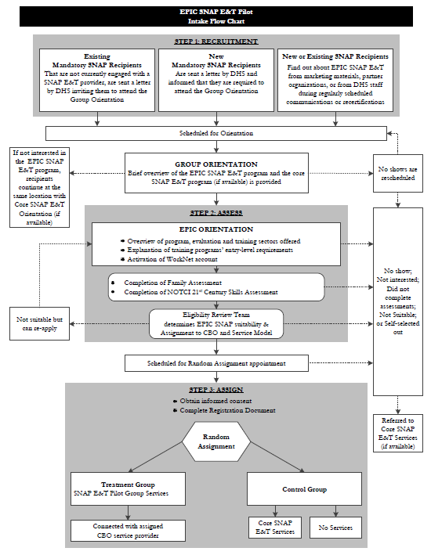

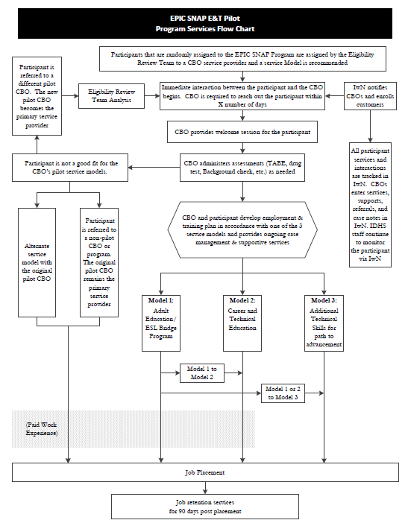

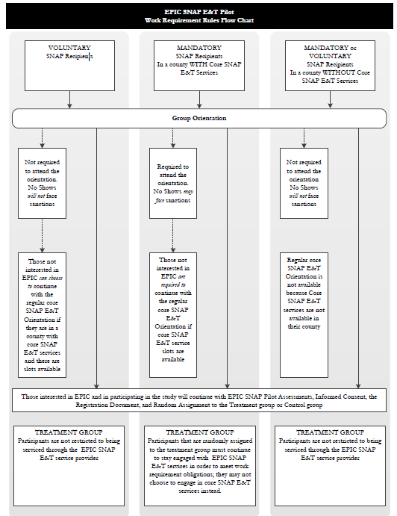

ATTACHMENT F

- Commerce Grantee Reports

http://www.illinois.gov/dceo/ServicesGuide/GranteeResources/Reporting/Pages/Grantee-Report.aspx

- Evaluation/Study Grantee Reports

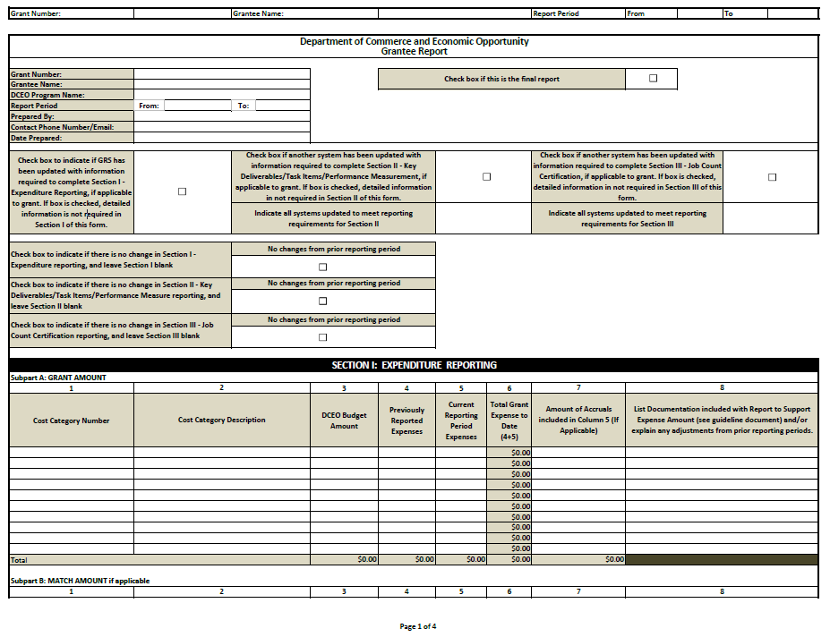

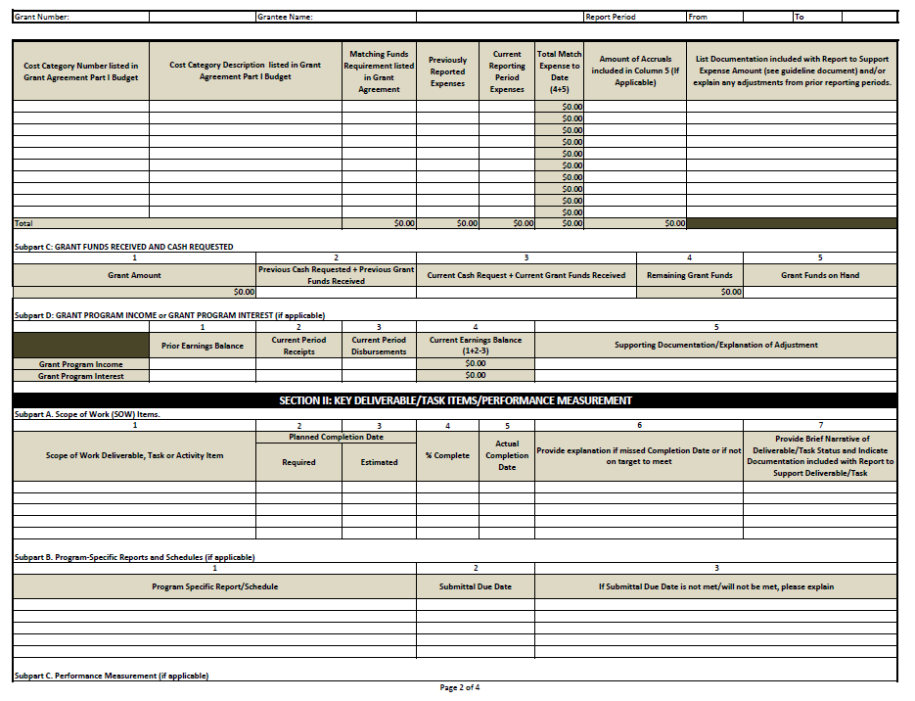

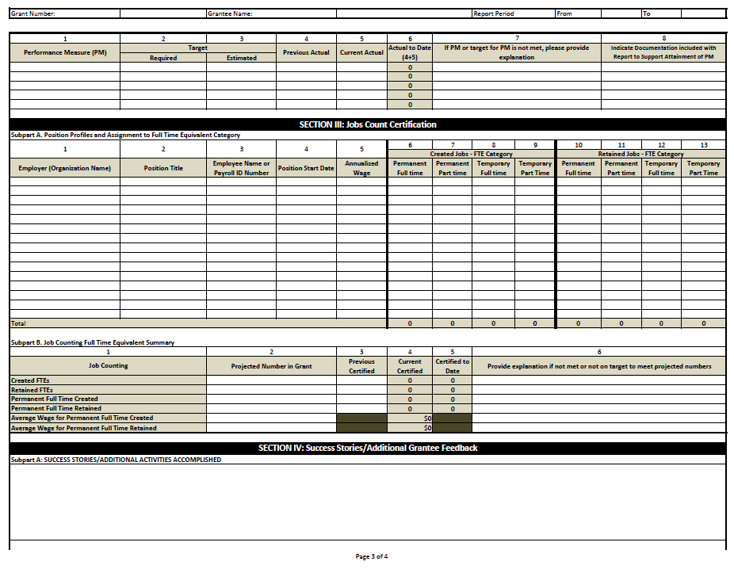

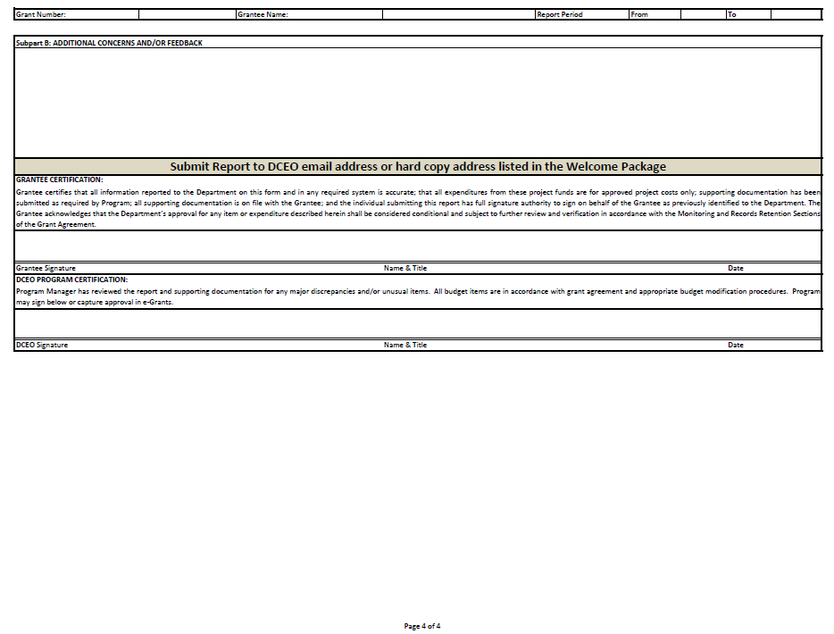

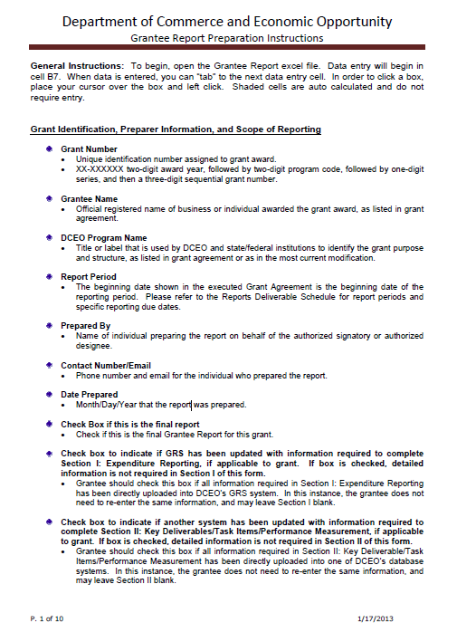

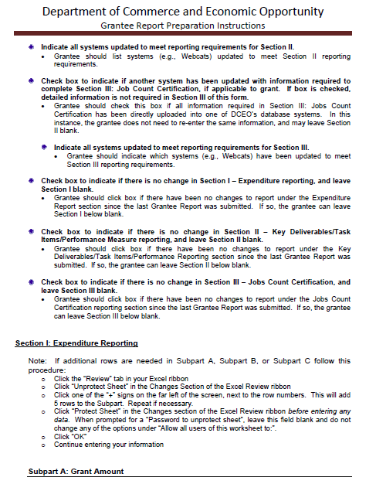

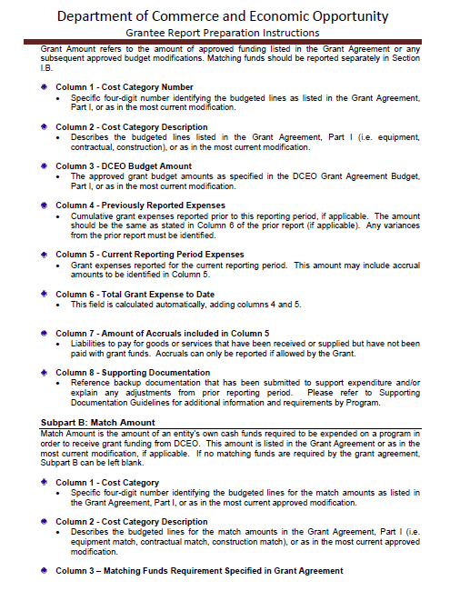

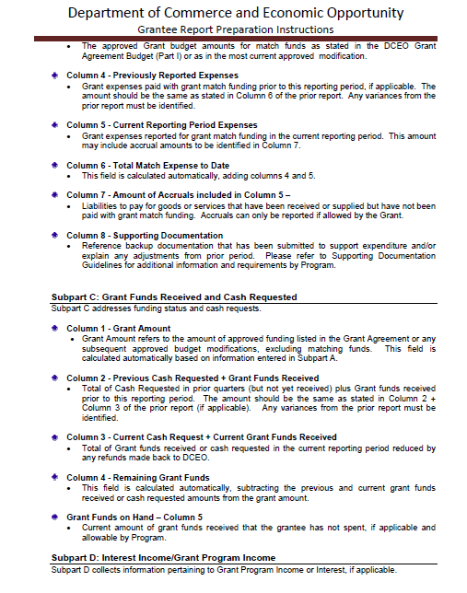

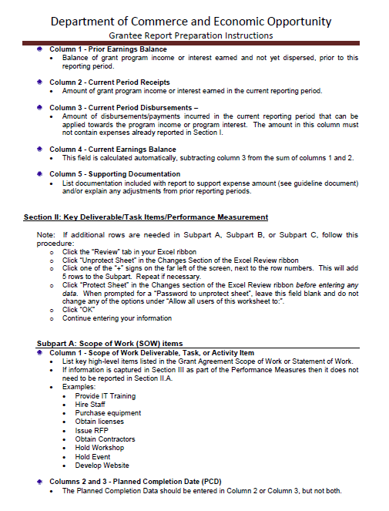

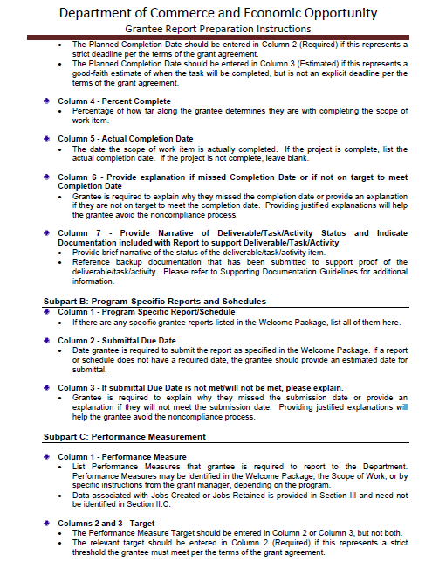

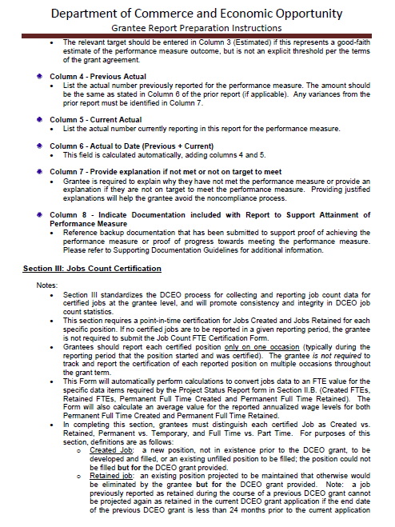

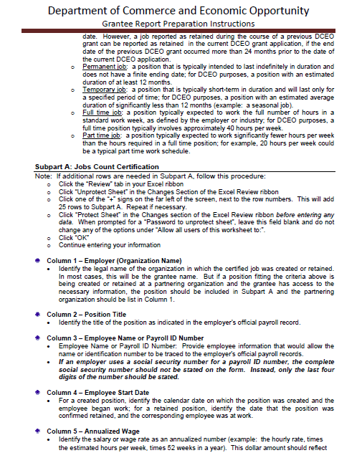

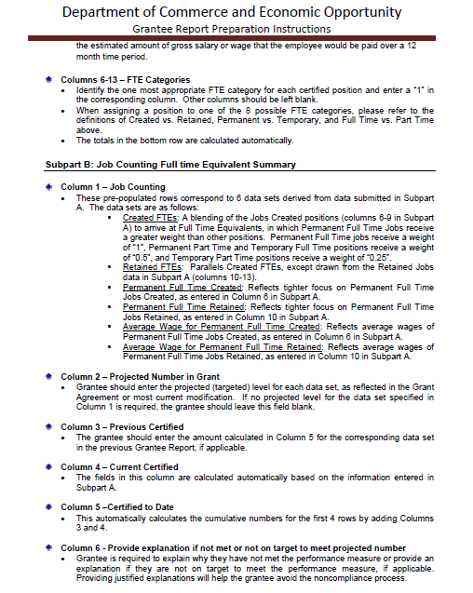

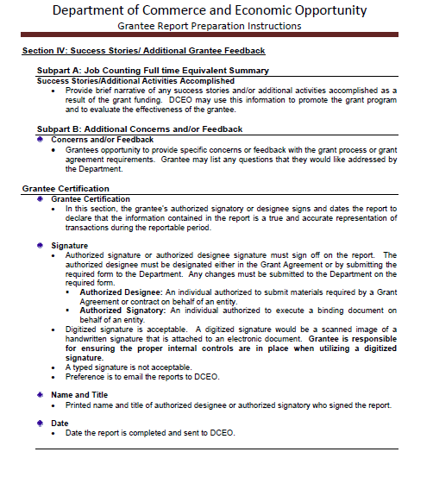

ATTACHMENT G

- Release Forms
- Entity
- Individual

RELEASE FORM - ENTITY
Authorization for Release of Photograph, Voice,
Use of Likeness or Printed Quotes or Statements

I hereby release to the Illinois Department of Commerce and Economic Opportunity “the Department”) its officers, agents, employees and/or affiliates the rights of ________________________ (entity) photograph, image, likeness, representative’s voice as recorded on videotape or film and any oral or written statement(s) regardless of format (whether they are direct quotes or paraphrased by the Department) for the purpose of promotion videos, publications and marketing material including Internet publications related to the EPIC Pilot Program. I hereby release any and all claims against the Department its officers, agents, employees and/or affiliates arising out of or in connection with the usage of _________________________ (entity) photo, likeness, representative's voice and/or oral or written statement(s) regardless of format (whether they are direct quotes or paraphrased by the Department) for the purpose of promotion videos, publications and marketing material including Internet publications related to the EPIC Pilot Program. I acknowledge that this release is legally binding and understand that this is the entity’s final notice regarding this matter and that the Department its officers, agents, and/or affiliates may proceed in reliance thereon. The undersigned in this release desires to assist in the work of the Department, its officers, agents, employees and/or affiliates by making the entity’s image, likeness, representative’s voice and/or oral or written statement(s) available for the Department’s program marketing publication(s) related to the EPIC Pilot Program. By signing below, I acknowledge that for good and valuable consideration, the receipt and sufficiency of which are hereby acknowledged, I, on behalf of ________________________________(entity) hereby release, indemnify and hold harmless, the Department, its officers, agents, employees and/or affiliates from and against any and all claims, losses, suits, damages, or costs (including reasonable attorney’s fees) arising out of, resulting from or relating to the entity’s participation in the Department’s marketing publication(s) related to the EPIC Pilot Program. I further acknowledge that (1) I am a person of legal age and the person identified below who is authorized to execute this release; (2) I have read this release in its entirety; (3) I fully understand and accept its terms; and (4) I have executed this release voluntarily.

Names of entity: _____________________________________________________________

Entity’s representative furnishing oral or written statement(s): ___________________________________________________________________________
Date picture taken and/or oral or written statement was made: ________________________

Authorized Representative Signature and Title Date

RELEASE FORM - INDIVIDUAL
Authorization for Release of Photograph, Voice,
Use of Likeness or Printed Quotes or Statements

I hereby release to the Illinois Department of Commerce and Economic Opportunity (“the Department”) its officers, agents, and/or affiliates the rights of my and/or my child/ward’s photograph, image, likeness, voice as recorded on videotape or film and any oral or written statement(s) regardless of format (whether they are direct quotes or paraphrased by the Department) for the purpose of promotion videos, publications and marketing material including Internet publications related to the EPIC Pilot Program. I hereby release any and all claims against the Department its officers, agents, and/or affiliates arising out of or in connection with the usage of my and/or my minor child/ward’s photo, likeness, voice or oral or written statement(s) regardless of format (whether they are direct quotes or paraphrased by the Department) for the purpose of promotion videos, publications and marketing material including Internet publications related to the EPIC Pilot Program. I acknowledge that this release is legally binding and understand that this is my final notice regarding this matter and that the Department its officers, agents, and/or affiliates may proceed in reliance thereon. The undersigned in this release desires to assist in the work of the Department its officers, agents, and/or affiliates by making their and/or their minor child/ward’s image, likeness or voice and/or oral or written statement(s) available for program marketing publication(s) related to the EPIC Pilot Program. By signing below, I acknowledge that for good and valuable consideration, the receipt and sufficiency of which are hereby acknowledged, I, on behalf of myself and/or my minor child/ward, ___________________ hereby release, indemnify and hold harmless the Department its officers, agents, and/or affiliates from and against any and all claims, losses, suits, damages, or costs (including reasonable attorney’s fees) arising out of, resulting from or relating to my and/or my minor child/ward’s participation in the Department’s marketing publication(s). I further acknowledge that (1) I am a person of legal age and the person (or the parent/guardian of the minor child/ward) identified below who is authorized to execute this release; (2) I have read this release in its entirety; (3) I fully understand and accept its terms; and (4) I have executed this release voluntarily.

Individual’s name appearing in photograph and/or furnishing oral or written statement(s):
___________________________________________________________________________________
Minor: Yes _____ No _______ (If individual is a minor, a parent or legal guardian must execute this authorization on behalf of the minor child on the appropriate line below)
Date picture was taken and/or oral or written statement(s) made: _______________________________
Parent or Legal Guardian’s signature and printed name if on behalf of minor child
Date: __________________

Signature of adult individual appearing in photograph and/or furnishing oral or written statement(s)

