Audience
This document is designed for designated testers, program staff, referral coordinators, and system stakeholders responsible for validating referral creation, referral transmission, and referral status update workflows within the SIU UAT environment. Participants should have experience with customer referral processes and inter-agency communication to evaluate these new enhancements effectively.

Purpose
The purpose of this guide is to validate the enhanced referral workflow that allows users to record status updates in response to the referral. Although the SIU UAT environment has no security constraints, testers must ensure that no personal identifiable information (PII) is entered during testing.


Responding to Referrals

Log into service finder: [LINK]

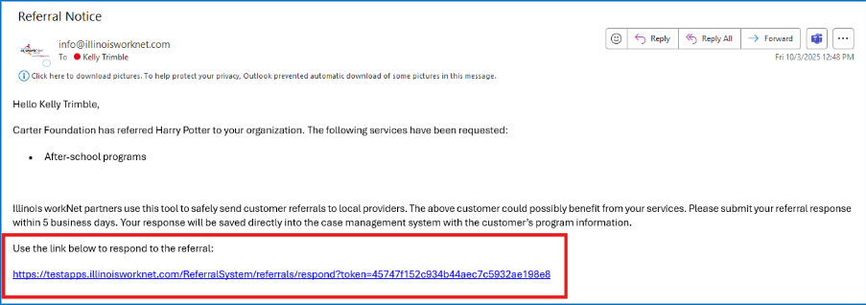
Receiving an email. The user’s name will be displayed under the “Primary Contact” section if it is appropriately tied to the organization added in Referral Guide 1.

Click the link from the email; a Referral Response page will open.

This page displays:

Customer Contact Information – this will be used to contact the customer

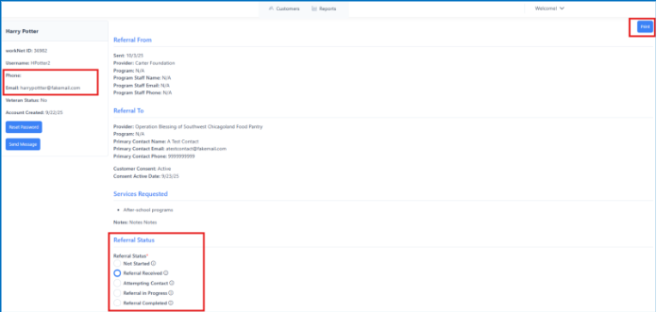
“Referral From” and “Referral To.”

Services Requested

Referral Status (Required) – Referral Responder will update referral status after taking action.

Note – Status will show “Referral Received” after being sent to the primary contact.

Print using the “Print” button.

Updating Referral Status
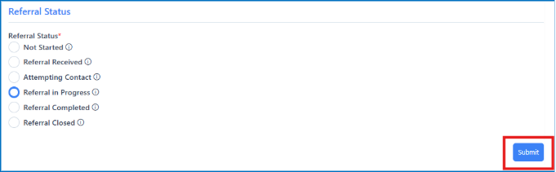
- Under the “Referral Status” section, indicate the status of the referral by selecting the appropriate button and then selecting “Submit.”
- After submitting, select “Customers” or close the tab to return to the customer’s list.


Viewing and Filtering Customer Referrals

Return to customer’s list.

Select customer’s name from the list.

Under the “Referred To” tab, look for “Status.”

View a customer’s referral, various statuses, and apply filters here.

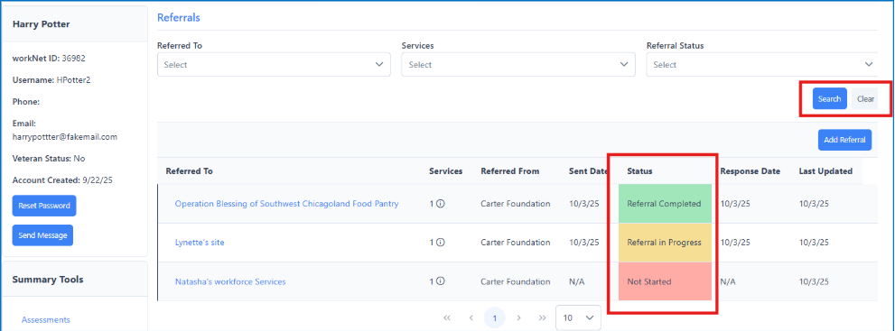
Note - For ease of viewing, filter and color-coding have been added to indicate referral status.

The Illinois workNet Center System, an American Job Center, is an equal opportunity employer/program. Auxiliary aids and services are available upon request to individuals with disabilities. All voice telephone numbers may be reached by persons using TTY/TDD equipment by calling TTY (800) 526-0844 or 711. This workforce product was funded by a grant awarded by the U.S. Department of Labor’s Employment and Training Administration.

