Step 1: Access the Service Finder
- Visit the Illinois workNet homepage.
- Log in or create an account:
- Click Login to sign in.
- Click Sign Up to register.
📌 Important: For new accounts, you must click the link in your confirmation email to activate your account.

Step 2: Navigate to the Service Finder
- Once logged in, go to Menu > Network & Connect > Illinois workNet Service Finder.
- Click Add or Edit Locations to open the Service Finder Administration dashboard.
- Click Add a New Site.

Step 3: Search for Your Location
- Enter the Location Name and City, then click Search.
- If your site is not listed, click I don’t see my site here.
- Review and agree to the Terms of Service, then click Next.
Terms of Service
All items that are added to the locator need to be:
- Free or charged only a nominal fee for cost recovery.
- Available to the general public and displayed on web and mobile sites.
- Designed to help adults, youth, dislocated workers, students, educators and employers achieve their education and employment goals.
- Meet requirements set by the Illinois workNet website Terms of Use and Privacy Policies.
Items and people will be reviewed before they are added to the locator. We will not approve items or people that:
- Are not appropriate for the locator's audience;
- Lead to the selling of a product or service (including training);
- Do not follow the Illinois workNet website Terms of Use and Privacy Policies; or
- Cannot be confirmed to be real.

Step 4: Enter Site Information
Entering Your Location Information
When you start adding your site’s information, you’ll see tabs at the top of the page. These tabs help you know where you are and let you move between different parts of the form.
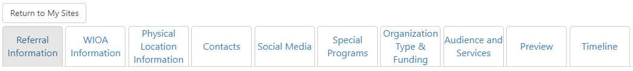

Referral Type
- Select either:
  - Illinois workNet Partner: These are locations that offer in-person assistance to help individuals and employers achieve their training and employment goals. When entering an Illinois workNet Partner site, you must enter a complete street address.
  - Work Support Referral: These locations help people in need of specialized assistance and support. When entering a work support referral site, you must enter either a complete street address OR state, county, and website
- Click Save and Continue.

WIOA Information
- Indicate if your site is WIOA Title I funded.
- If Yes, you must provide your IWDS Office Number on the Physical Location tab.

Physical Location
Complete all required fields (marked with a red asterisk *). Use info bubbles for guidance.
Field | Notes
Is this site active? * | Yes / No
Services available to * | General Public / Enrolled Customers / Admin Only
Eligibility Criteria | Optional
Organization Name * | Name of organization
Address * | Street, City, State, ZIP+4
Phone * | Format: ###-###-####
Email | Use a general office email if available
Hours of Operation * | Select days and times or use 24-hour/text options
Website | Include full URL
Logo Upload | Optional, adds visual appeal

Step 5: Contact Information
Each site must have a point of contact that will be used to maintain/verify the Service Finder location. This information will NOT be displayed to the public. Contact accounts should use work email and not personal email accounts.

Primary Contact
- Enter the email linked to your workNet account and click Search.
- Select the correct result to autofill fields. Required fields include name, birth date, Zip Code, and phone number.
- Click Save and Continue.

Additional Contacts
- Must include at least one Service Finder Primary Contact.
- Search by email or add a new contact.
- Assign as Service Finder Primary/Secondary, or Referral Primary/Secondary.
- Click Save Contact or Save and Add Another Contact.

On this tab, you will see all contacts who are associated with your location. (NOTE: All contacts will have their Illinois workNet accounts elevated to Partner level. Read this article to learn more about the benefit of being a workNet partner.)

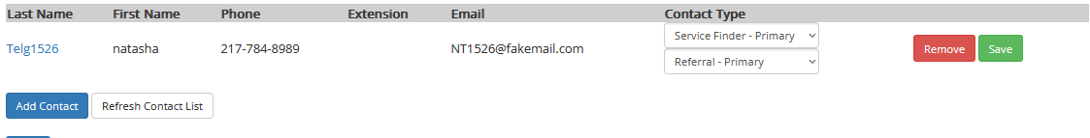

Step 6: Social Media
- Add full URLs (including http:// or https://) for any social media accounts.
- Click Next.

Step 7: Programs
- Select Add Program to identify the programs available at this location. When you select a program, the system will automatically populate the following information:
  - Program Description - A summary of the services provided.
  - Who is Served - Basic eligibility information about the population served.
  - Eligibility Criteria - Specific requirements for participation.
- After selecting a program, complete the remaining fields, including:
  - Referral acceptance details
  - Program Availability Status
  - Program Contact Information
- Click Next.

Step 8: Organization Type & Funding
- Select your Organization Type and Funding Source.
- Click Next

Step 9: Audience & Services
- Select target audience categories (e.g., Youth, Adults).
- Click Add Services:
  - Choose services for Individuals and/or Businesses.
  - Assign services to specific counties or statewide.
  - Click Save or Save and Add More.

Step 10: Preview & Submit
- Review all sections.
- Edit any section with errors.
- Click Submit to finalize your site creation or update.

Step 11: Request Partner Access
After you have completed the creation of your Illinois workNet Partner Site, request to become a partner. We will review your request, confirm your information is accurate, and provide you with a partner account.
Email info@illinoisworknet.com with:
- Subject: Request Illinois workNet Partner Account
- Your full name (as in your account)
- Organization name (as listed in Service Finder)
- Organization address and work phone number

Additional Notes

Timeline
The Timeline Tab provides a log of all entries/updates to a Service Finder location. Use the dropdown to see the log for a specific type of update.

The Illinois workNet® Center System, an American Job Center, is an equal opportunity employer/program. Auxiliary aids and services are available upon request to individuals with disabilities. All voice telephone numbers may be reached by persons using TTY/TDD equipment by calling TTY (800) 526-0844 or 711. This workforce product was funded by a grant awarded by the U.S. Department of Labor’s Employment and Training Administration. For more information please refer to the footer at the bottom of any webpage at illinoisworknet.com. January 2026 v12

