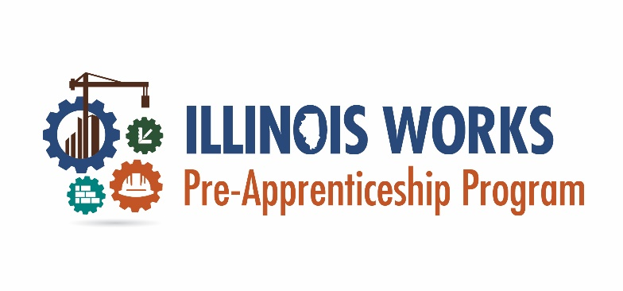
Participant Enrollment Checklist
After completing the initial outreach, recruitment, and application steps it is time to enroll your participants. This welcome checklist helps to ensure that each participant has all the Illinois Works required documents/assessments completed. Maintaining one of these checklists per participant will shorten data entry time long-term and ensure all participants are properly counted toward outcome metrics.
Participant Name: _______________________________________________________
Completed directly in IWRS
Completed on paper/alternate system then entered/uploaded in IWRS
Provide to participant – upload to IWRS not required
Save in participant paper file – upload to IWRS not required
 | Document/Assessment | Date Completed
□ | Pre-screen assessment
□ | Application or
□ | Standardized Interview (minimum of two (2) interview sheets uploaded to IWRS)
□ | Add names of interviewers and the average of their score
□ | Enrollment decision letter
□ | Commitment Agreement
□ | Wrap-around service assessment
□ | Orientation – Career Assessment
□ | Performance-based Stipend Policy
□ | Discrimination, Harassment, Bullying Policy
□ | Extenuating Circumstances Policy for Make-Up Post-assessments and Sessions
□ | Make-Up Sessions and Post-assessment Policy
□ | Eligibility documents (i.e. birth certificate, state ID/driver’s license, social security card, high school transcripts/diploma, GED/HiSet etc.)
□ | Participant Referral Form (if applicable)

