Add & Edit Additional Contacts – UAT Guide
Contents
Figures 1
Overview 1
UAT Release 4 – Cycle 2 Expectations & Homework 2
Add & Edit Additional Contacts 4
Navigating to the Customer Profile 4
Additional Contacts List on Customer Profile 5
Add an Additional Contact 5
View an Existing Additional Contact 7
Edit an Existing Additional Contact 7
Delete an Existing Additional Contact 8

Figures
Figure 1 - Customer List Page 4
Figure 2 - Additional Contacts Section on Customer Profile 5
Figure 3 - Add Additional Contact Screen 6
Figure 4 - Additional Contact on Customer Profile 7
Figure 5 - Additional Contact View Only Page 7
Figure 6 - Edit Additional Contact Screen 8
Figure 7 - Delete Additional Contact Modal 9

Overview
User Acceptance Test (UAT) Release 4 has already been deployed to the SIU UAT environment. There are no security constraints for this environment. It is important not to enter any personal identifiable information (PII). The purpose of Release 4 is to review and edit certain customer information on the Customer Profile.

UAT Release 4 – Cycle 2 Expectations & Homework
Homework Areas – For this week, your UAT tasks will focus on the following key areas listed below. More information on these areas can be found in the next section of this document.
  - Additional Contacts
    - Navigating to the Customer Profile
    - Add Additional Contact
    - View Existing Additional Contacts
    - Edit Additional Contact
    - Delete Additional Contacts
Due Date - Please complete your testing in these areas and submit your feedback by Tuesday, June 10th.
Access to UAT Environment – To access the UAT environment in your browser, follow the link provided here. https://testapps.illinoisworknet.com/iwdst-Preview
Reporting Issues – Please document any issues, bugs, or enhancement requests you identify in our shared notebook – UAT Notebook 2025. The main purpose of using a shared notebook is for collaboration between members of the UAT team and the business analysts. This will cut down on duplicate issues being reported.
- When logging your entries:
  - You should document this information as you are completing your UAT work.
  - The first page of the notebook is labeled Example Issue Reporting. Please refer to that page to get an idea of how you can report an issue.
  - In the notebook, you will find a section labeled Release 4 Cycle 2. The section is divided into several pages, each of which is specific to a feature set. Ensure each item is tracked under the correct category for the cycle and feature set you are providing feedback on.
  - Be concise but detailed.
  - If multiple issues arise in one area, address each separately for clarity.
- If you have issues accessing the OneNote notebook, please contact one of the business analysts (BA) on the team. The business analysts are:
    - Taylor Littig – taylor.littig@siu.edu
    - Olivia Miller – olivia.miller@siu.edu
    - Lynette Tritz – lynette.tritz@siu.edu
    - Al Menke – al.menke@siu.edu

Expectations for UAT – As you test these areas, please keep in mind the following best practices:
- Test Thoroughly: Ensure that you navigate through all functions and features within these areas. Pay attention to any discrepancies between expected and actual results.
- Detail-Oriented: When reporting issues, provide as much context as possible, including:
  - Steps to reproduce the issue
  - Screenshots or recordings, if possible
  - Browser or device used during testing
  - Expected vs. actual outcomes
- Feedback Categories:
  - Bugs – When the system does not perform as expected, and the system is not performing according to the requirements, then a bug will be reported, tracked, fixed, and retested.
  - Issues – If the system is performing according to the requirements, but the user feels that the requirement was not captured correctly or now the user feels like the requirement is just not working as expected, then this is recorded as an issue. Issues are tracked and prioritized for change.
  - Enhancements – Once we are in UAT and the users recognize an area that could be improved, then this will also be logged as an issue and tagged as an enhancement.

Best Practices for Effective UAT
- Think like the end user: Approach your testing from the perspective of someone unfamiliar with the system. This will help you identify usability issues and areas for improvement.
- Be specific and thorough: The more specific your feedback, the easier it will be to address. Include specific steps, expected outcomes, and actual results.
- Provide context: Always give context for your feedback. For instance, explain why an enhancement would improve the user experience or system performance.

By following these guidelines and providing detailed feedback, you’re helping to ensure the final product meets user expectations and performs as intended.

Add & Edit Additional Contacts

Navigating to the Customer Profile
To access the Customer Profile to view and edit a customer’s information, you must first select the customer you wish to work with.
Figure 1 - Customer List Page
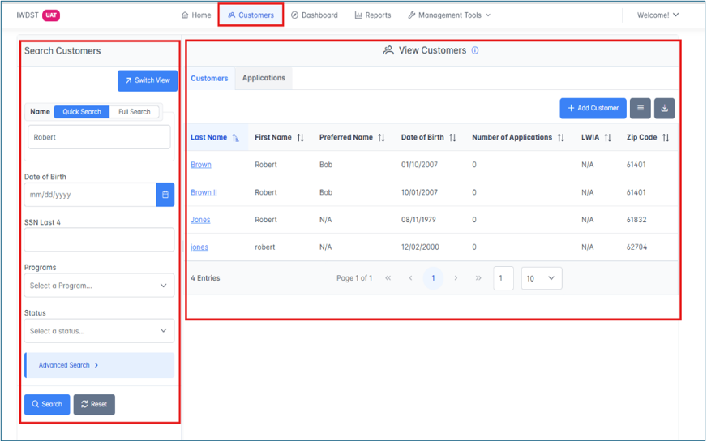
- Navigate to the Customer page within IWDS 2.0
- The View Customers Page is displayed
- The View Customers page is a two-panel page with the Search Filter on the left and the List View on the right.
- Use either the Search Filter or the List to find the customer that you wish to work with.
- Click on their hyperlinked last name to navigate to the Customer Profile.

Additional Contacts List on Customer Profile
Once on the Customer Profile, scroll to the bottom of the screen to find the Additional Contacts section (see Figure 2 below).
Figure 2 - Additional Contacts Section on Customer Profile
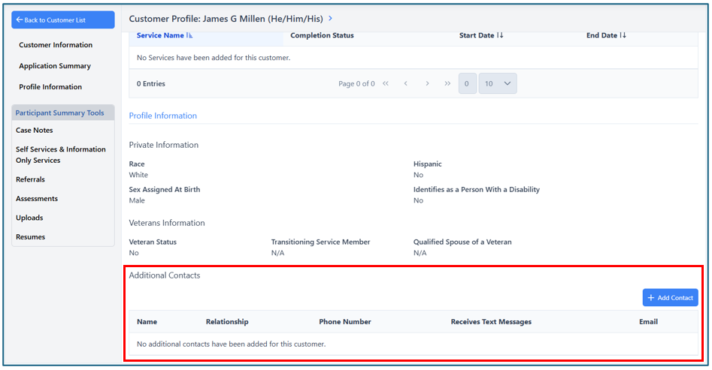
The Additional Contacts section will have a table that will display the following information:
- Name
- Relationship
- Phone Number
- Receives Text Messages
- Email
If no additional contacts have been added for a customer, the table will display a message stating this information.

Add an Additional Contact
To add a new Additional Contact for a customer, click the Add Contact button. This will navigate you to the Add Additional Contact screen (see Figure 3 below).

Figure 3 - Add Additional Contact Screen
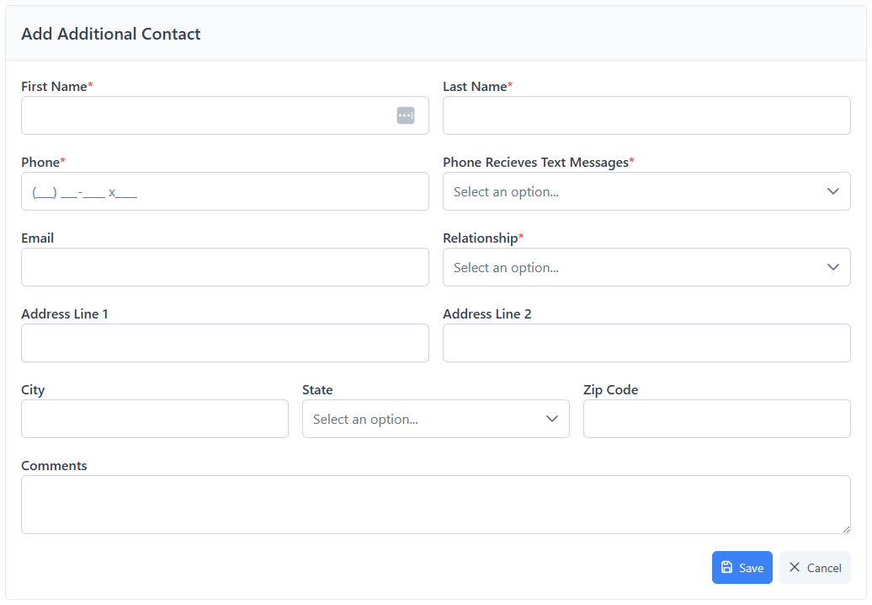
The Additional Contact screen will have the following fields:
- First Name – Required
- Last Name – Required
- Phone – Required
- Phone Receives Text Messages – Required
- Email
- Relationship – Required
- Other – Please Specify
  - This only displays if Other is selected for the Relationship field
- Address Line 1
- Address Line 2
- City
- State
- Zip Code
- Comments
Once the necessary fields have been completed, click the Save button to save the Additional Contact and be navigated back to the Customer Profile.
To exit the screen without saving any information, click the Cancel button to close the screen.

View an Existing Additional Contact
To view an existing Additional Contact, click on their hyperlinked name within the Additional Contacts table within the Customer Profile (see Figure 4 below).
Figure 4 - Additional Contact on Customer Profile
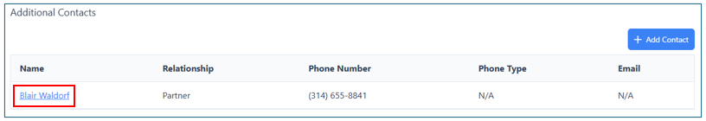
Once the hyperlinked name is clicked, you will be redirected to the View page for that specific contact. From this page, you can view all the contact's details (see Figure 5 below).
To return to the Customer Profile after viewing the Additional Contact, click the Back to Customer Profile button at the top left of the View page.
To edit an existing Additional Contact, click the Edit button at the top right of the View page.
Figure 5 - Additional Contact View Only Page
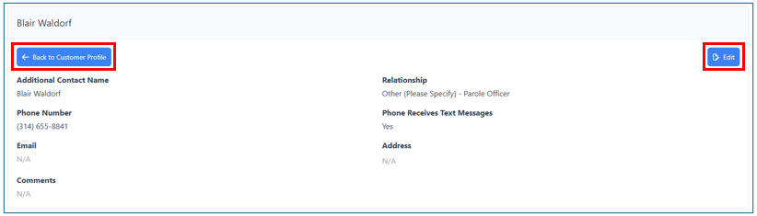

Edit an Existing Additional Contact
Once the Edit button is clicked, the Edit Additional Contact page opens (see Figure 6 below).
Figure 6 - Edit Additional Contact Screen
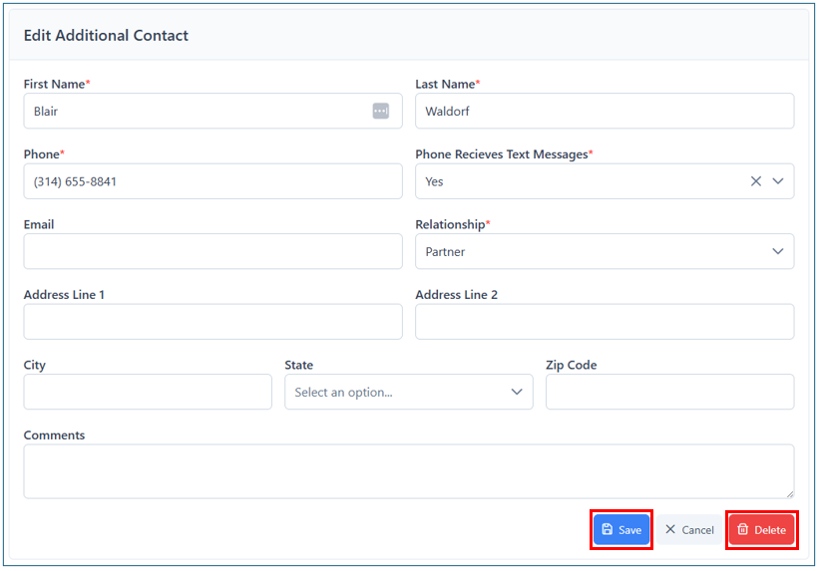
From this page, you can make any changes necessary for that Additional Contact.
Click the Save button to save your changes and navigate back to the View page.
If you do not want to save any changes, click the Cancel button to navigate back to the View page without making any changes.

Delete an Existing Additional Contact
To delete an existing Additional Contact, click the Delete button at the bottom of the page. This will open the Delete Additional Contact modal (see Figure 7 below).
Figure 7 - Delete Additional Contact Modal
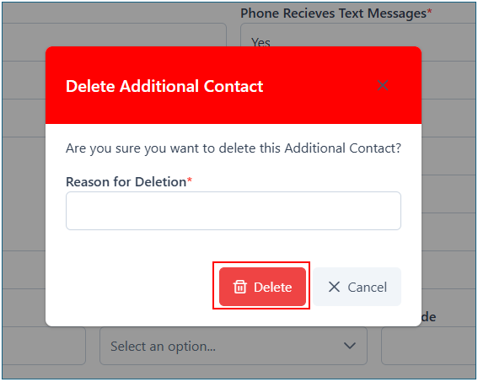
A reason for deletion is required to delete an Additional Contact.
Once the reason is entered, click the Delete button to delete the Additional Contact.
To cancel the deletion, click the Cancel button on the modal to close the modal and return to the Edit Additional Contact screen.

