Edit Customer Information – UAT Guide
Contents
Figures 1
Overview 1
UAT Release 4 – Cycle 1 Expectations & Homework 2
Edit Customer Information 4
Navigating to the Customer Profile 4
Customer Profile – View Customer Information 5
Customer Title Bar 6
Edit Customer Information 8

Figures
Figure 1 - Customer List Page 4
Figure 2 - Customer Information Section on Customer Profile 5
Figure 3 - Customer Title Bar: Closed View 6
Figure 4 - Customer Title Bar: Open View 7
Figure 5 - Edit Customer Information Page 8

Overview
User Acceptance Test (UAT) Release 4 has already been deployed to the SIU UAT environment. There are no security constraints for this environment. It is important not to enter any personal identifiable information (PII). The purpose of Release 4 is to review and edit customer information.

UAT Release 4 – Cycle 1 Expectations & Homework
Homework Areas – For this week, your UAT tasks will focus on the following key areas listed below. More information on these areas can be found in the next section of this document.
  - Editing Basic Customer Information
    - Navigating to the Customer Profile
    - View Customer Information
    - Edit Customer Information
    - Customer Title Bar
Due Date - Please complete your testing in these areas and submit your feedback by Tuesday, June 3rd.
Access to UAT Environment – To access the UAT environment in your browser, follow the link provided here. https://testapps.illinoisworknet.com/iwdst-Preview
Reporting Issues – Please document any issues, bugs, or enhancement requests you identify in our shared notebook – UAT Notebook 2025. The main purpose of using a shared notebook is for collaboration between members of the UAT team and the business analysts. This will cut down on duplicate issues being reported.
- When logging your entries:
  - You should document this information as you are completing your UAT work.
  - The first page of the notebook is labeled Example Issue Reporting. Please refer to that page to get an idea of how you can report an issue.
  - In the notebook, you will find a section labeled Release 4 Cycle 1. The section is divided into several pages, each of which is specific to a feature set. Ensure each item is tracked under the correct category for the cycle and feature set you are providing feedback on.
  - Be concise but detailed.
  - If multiple issues arise in one area, address each separately for clarity.
- If you have issues accessing the OneNote notebook, please contact one of the business analysts (BA) on the team. The business analysts are:
    - Taylor Littig – taylor.littig@siu.edu
    - Olivia Miller – olivia.miller@siu.edu
    - Lynette Tritz – lynette.tritz@siu.edu
    - Al Menke – al.menke@siu.edu

Expectations for UAT – As you test these areas, please keep in mind the following best practices:
- Test Thoroughly: Ensure that you navigate through all functions and features within these areas. Pay attention to any discrepancies between expected and actual results.
- Detail-Oriented: When reporting issues, provide as much context as possible, including:
  - Steps to reproduce the issue
  - Screenshots or recordings, if possible
  - Browser or device used during testing
  - Expected vs. actual outcomes
- Feedback Categories:
  - Bugs – When the system does not perform as expected, and the system is not performing according to the requirements, then a bug will be reported, tracked, fixed, and retested.
  - Issues – If the system is performing according to the requirements, but the user feels that the requirement was not captured correctly or now the user feels like the requirement is just not working as expected, then this is recorded as an issue. Issues are tracked and prioritized for change.
  - Enhancements – Once we are in UAT and the users recognize an area that could be improved, then this will be also logged as an issue and tagged as an enhancement.

Best Practices for Effective UAT
- Think like the end user: Approach your testing from the perspective of someone unfamiliar with the system. This will help you identify usability issues and areas for improvement.
- Be specific and thorough: The more specific your feedback, the easier it will be to address. Include specific steps, expected outcomes, and actual results.
- Provide context: Always give context for your feedback. For instance, explain why an enhancement would improve the user experience or system performance.

By following these guidelines and providing detailed feedback, you’re helping to ensure the final product meets user expectations and performs as intended.

Edit Customer Information

Navigating to the Customer Profile
To access the Customer Profile to view and edit a customer’s information, you must first select the customer that you wish to work with.
Figure 1 - Customer List Page
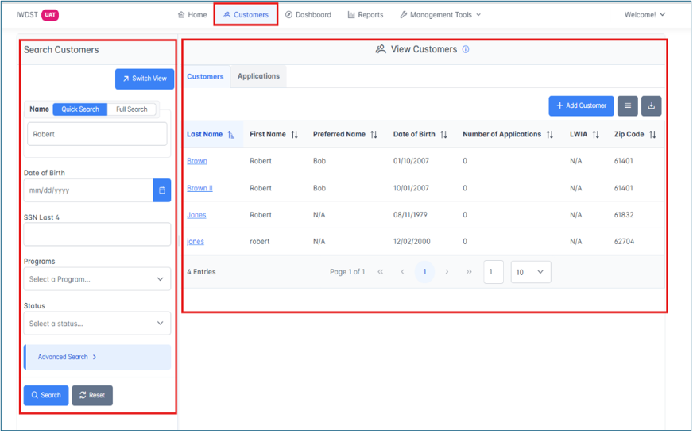
- Navigate to the Customer page within IWDS 2.0
- The View Customers Page is displayed
- The View Customers page is a two-panel page with the Search Filter on the left and the List View on the right.
- Use either the Search Filter or the List to find the customer that you wish to work with.
- Click on their hyperlinked last name to navigate to the Customer Profile.

Customer Profile – View Customer Information
The Customer Profile page will appear. From the Customer Profile, users will be able to view the following sections:
- Customer Information (Covered in Release 4 Cycle 1 UAT)
- Application Summary
  - Applications (Still under development and NOT part of UAT)
  - Program Services (Still under development and NOT part of UAT)
- Profile Information
  - Private Information (Still under development and NOT part of UAT)
  - Veterans Information (Still under development and NOT part of UAT)
  - Additional Contacts (Will be covered in Release 4 Cycle 2 UAT)
Figure 2 - Customer Information Section on Customer Profile
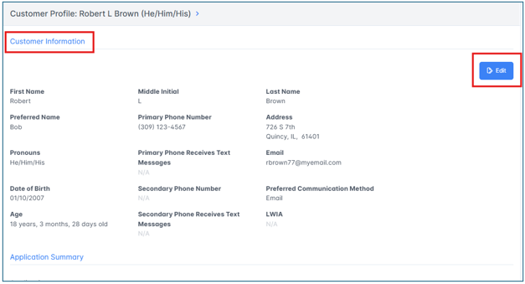
The Customer Information section lists all the basic information for a customer. This information is pulled over from the Create Customer Profile screen and includes additional information. This information can be updated at any time within the customer’s lifecycle.
The following fields are displayed:
- First Name
- Middle Initial
- Last Name
- Preferred Name
- Pronouns
- Date of Birth
- Age
- Primary Phone Number
- Primary Phone Receives Text Messages
- Secondary Phone Number
- Secondary Phone Receives Text Messages
- Address
- Email
- Preferred Communication Method
- LWIA
The following fields are not currently in the Customer Information section but will be added in the future:
- IwN Username
- IwN ID Number

Customer Title Bar
The Customer Profile also has a Title bar at the top of the screen. The Title Bar can be opened and closed to view more information. When the Title Bar is closed, the following information will display:
- Full Customer Name
- Pronouns (If any have been entered)
Figure 3 - Customer Title Bar: Closed View
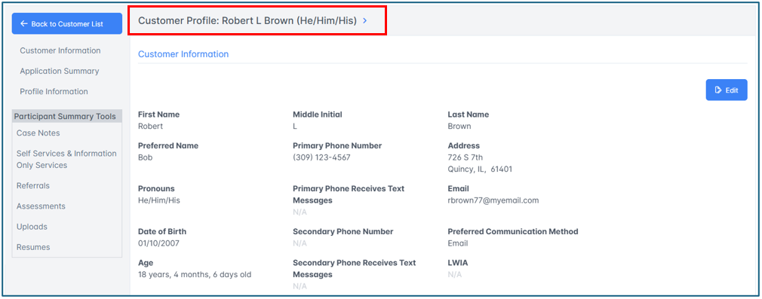
When the Title Bar is open, the following information will now display:
- Preferred Name
- Preferred Communication Method
- Primary Phone Number
- Email
Figure 4 - Customer Title Bar: Open View
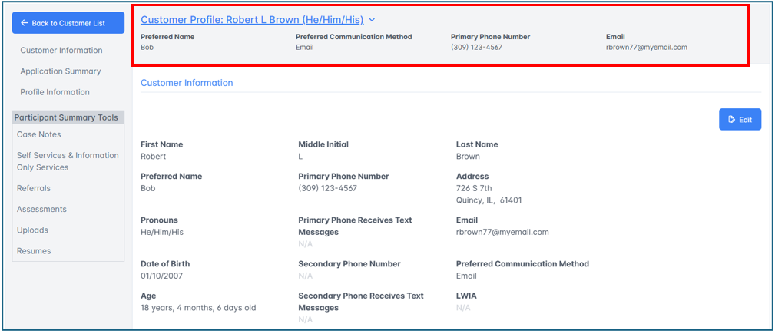
The Title Bar will be used across the system when working within a specific customer. This makes it easy for a user to view basic information when they are in different areas of the system (such as assessments or career plan).

Edit Customer Information
When a user needs to edit any of the information in the Edit Customer Information section, they will be able to do so by clicking on the Edit button that is within the Customer Information section of the Customer Profile.
Figure 5 - Edit Customer Information Page
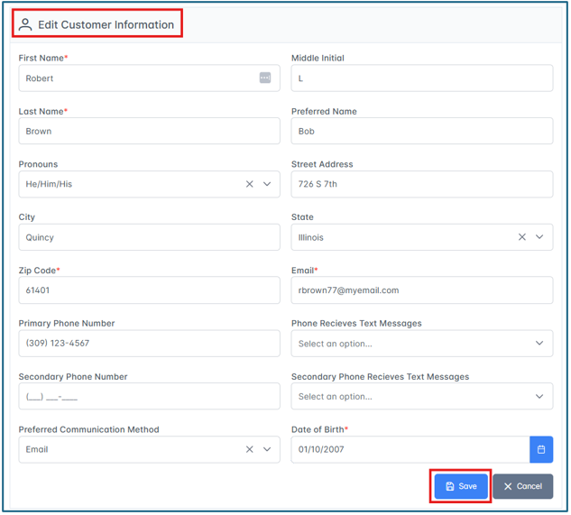
- Click the Edit button on the right-hand side of the section.
- After clicking the Edit button, the user will be navigated to the Edit Customer Information page.
- On this page, users can edit the following information:
  - First Name – Required
  - Middle Initial
  - Last Name – Required
  - Preferred Name
  - Pronouns
  - Street Address
  - City
  - State
  - Zip Code – Required
  - Email – Required
  - Primary Phone Number
  - Phone Receives Text Messages
  - Secondary Phone Number
  - Secondary Phone Receives Text Messages
  - Preferred Communication Method
  - Date of Birth – Required
- Once the user is finished editing the customer information, the user can click Save at the bottom of the page.
- If the user wants to exit the screen without making any changes, they can click on the Cancel button.

