Training Provider Performance Reporting:

Downloading/Uploading All-Student Data Spreadsheet

The following process will assist and guide an Eligible Training Provider to download the All-Student Data performance spreadsheet template specific to their entity and training programs. Training on the general process to submit all-student data was provided in the IWDS ETPL Training Series, Module 5. For further guidance outlining the requirements for eligible training providers to report on performance, please reference WIOA Notice 25-NOT-05 Required Eligible Training Provider Program of Study Performance Reporting which is available on ePolicy under WIOA Policy 7.2.2.9 Performance Measures for Eligible Training Providers.
IWDS 2.0 allows for a download specific to each Training Provider that includes all related Training Program ID and Location ID numbers. By providing this information, it will provide a guide to the programs that need reported on in any WIOA Program Year that a provider had a program on Illinois’ Eligible Training Provider List (ETPL). Local and State ETPL Coordinators can assist the training provider, as necessary.
Community Colleges do NOT have to manage this process as the Illinois Community College Board (ICCB) is compiling and submitting all-student data performance reports on behalf of every community college and all their eligible training programs on Illinois’ ETPL.
Before You Begin
Before completing these steps, ensure:
- You are a known contact for the training provider and have access to IWDS 2.0 on its behalf.
- If you do not have IWDS 2.0 access, you will need to request that from your Local Area or State Entity Management contact.
  - Further information on getting access to IWDS 2.0 can be found by clicking here.
- Ensure the training provider creates an ILogin account if they have already requested IWDS 2.0 access.
  - For access instructions please reference XXXXXX and review the IWDS ETPL Training Series, Modules 1 and 2.
- You have the Entity Provider (special) as your IWDS 2.0 User Role.

Once you have the Entity Provider Special role and access to the system, you can complete training program performance reporting of All Student Data.

Note: Only users with the appropriate permissions can download the spreadsheet template and upload the final list of all students in all training programs as a Training Provider User.

Training providers may choose to include ALL eligible training program data in one spreadsheet or submit separate spreadsheets for each training program; either way is acceptable.

The following steps provide an at-a-glance summary of the process for downloading and uploading the All-Student Data Spreadsheet in IWDS 2.0:

- Acting as an Entity Provider Special User, access the Provider Details page. This should be your Home Page when you login.

- At the top of the page, click on the Training Programs and review those names and IDs.

- Click on the Training Program Performance Tab. You will see 3 buttons labeled
- [Download Template],
- [Download Instructions & Examples], and
- [Upload Performance]

- Click on the second button, [Download Instructions & Examples]. That spreadsheet has a wealth of information on how to build out the student data.

- Download the template first by clicking the [Download Template] button. This will send a spreadsheet to your downloads folder.
- The first Tab on the spreadsheet is primarily blank but is in the format the system is expecting, and it has the Entity ID in the first cell.
- The second Tab on the spreadsheet is a reference that provides the IDs of all the locations and all your programs.

- Once the first Tab on the spreadsheet is filled out, you can click on the [Upload Performance] button and browse for the spreadsheet filled with your student data.
If you would like further information, the following pages provide detailed instructions with examples of screenshots for each step to complete All-Student Data Reporting in IWDS 2.0.

Detailed Steps to Complete All-Student Data Reporting in IWDS 2.0
- Training Provider contact would Download Template from their Training Program Performance tab. This is specific to each provider.
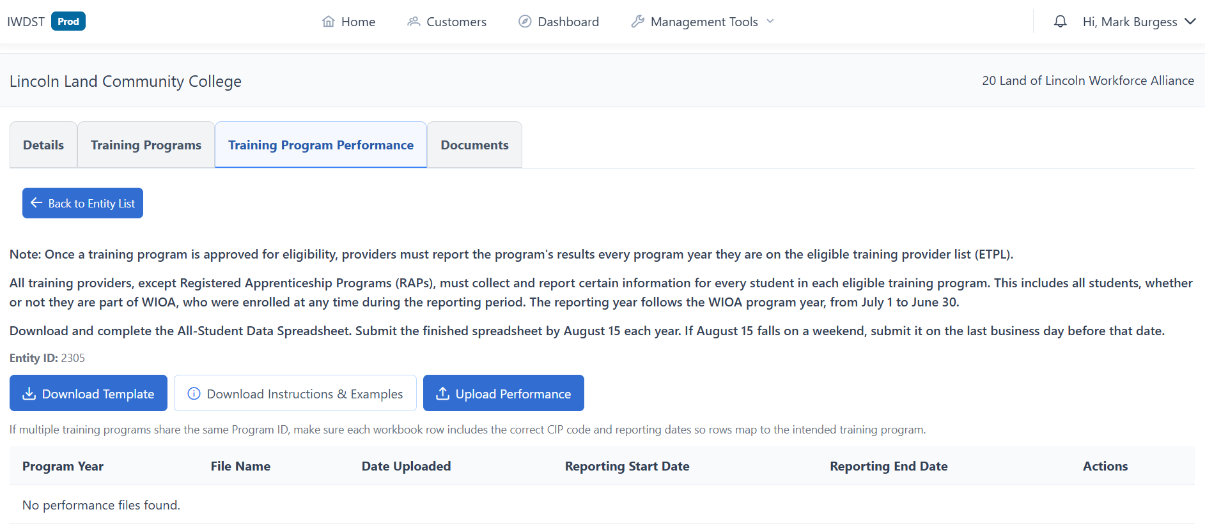
- Select Download Template from the Training Provider
- The spreadsheet will be downloaded and should be saved where it is easily accessible such as in the contact’s hard drive Download folder. (Note, the file name is generic as downloaded, so if the individual, such as an ETPL Coordinator, is downloading the template for multiple providers, they should add a defining name to the file name to differentiate it from other downloads.)
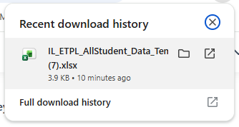
- The spreadsheet template is an Excel document.
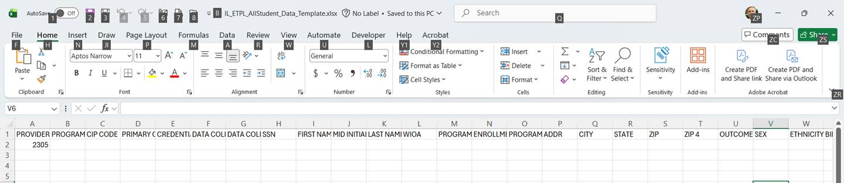
- They will then see the Spreadsheet with 2 Tabs. 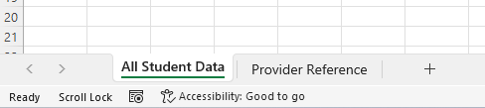
- The first is where entry of every student in every program being reported on would be entered.

- The second tab includes ALL Training Program IDs and ALL Training Program Locations IDs that need reported on. 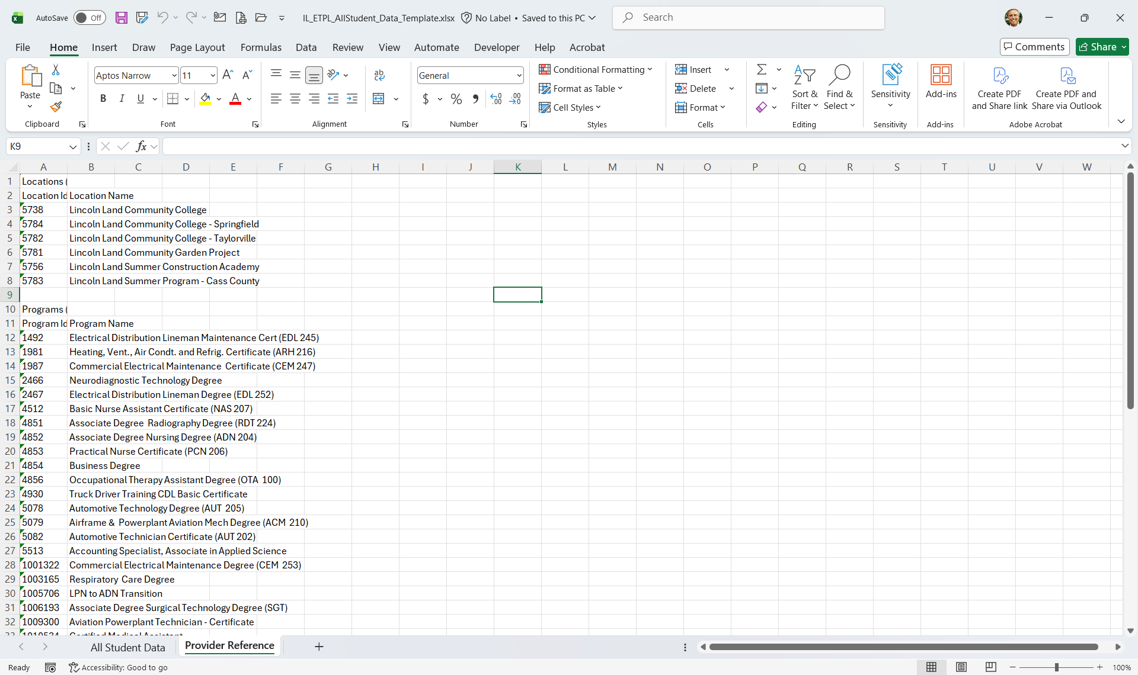

- The Location and Program information would be included in the first Tab information for each student to reference the training program they were enrolled in.
  - Program ID is entered in Column B.
  - Location ID are entered in Column C
  - The Program Location and Program Name do not need to be entered in the all-student data Tab but is here as reference to ensure selection of the appropriate program ID can be made.
  - 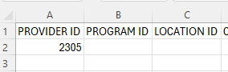
- Once the training providers have completed the spreadsheet, they will return to the Training Program Performance tab in IWDS 2.0 to Upload Performance.
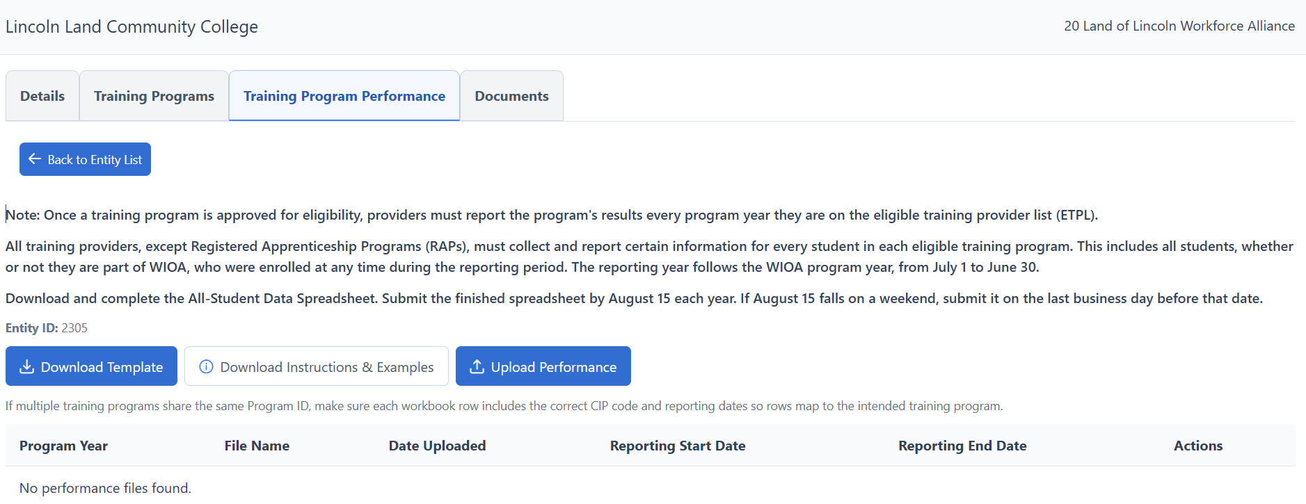

- Select the Upload Performance Tab
- The Open from folder dialogue will open so you can select the appropriate file to upload.
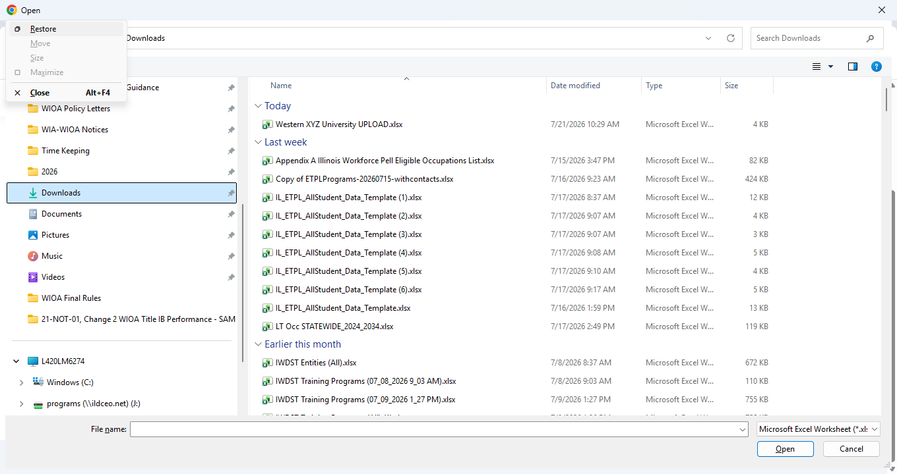
- Select the appropriate file and then “Open” to begin the upload process.
- If there are errors within the spreadsheet, error messages will be produced, and the Upload will not be accepted until they are corrected. An example is shown below.

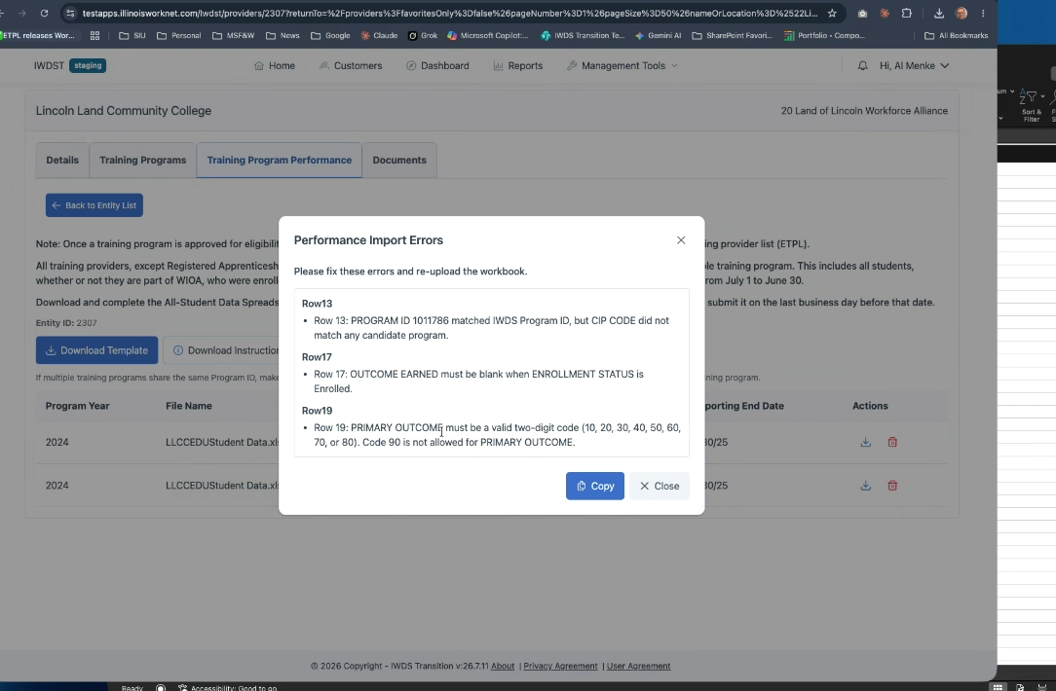
- If there are errors, please reference the error message, return to the excel spreadsheet and correct all errors and attempt to upload again.
- If there are no errors that need corrected, the document will be accepted.
- An ETPL Coordinator can assist the Training Provider in completing the spreadsheet and uploading the spreadsheet if they have the appropriate User Role.

