Purpose: Maintaining accurate, current, and complete Training Provider Contact information is essential for meeting WIOA ETPL objectives.

This document provides instructions for ETPL Coordinators to ensure that Training Provider Contacts (Users) can access IWDS 2.0. Note that this process is different than for other contacts seeking User Access such as for service providers, employers, or customers. Please do not guide these other contacts to the ETPL process for User Access and ensure all training provider contacts are using only this process for this level of Access.

The following process will assist and guide a Local ETPL Coordinator through the process of adding a Contact to a Training Provider or allowing them appropriate User Access by updating vital information.

Before You Begin
Before completing these steps, confirm that you have the Provider Management role in IWDS. This role is required to:
- Add or update Training Provider Contacts.
- Designate a Contact as an ITA Training Provider User.

To verify your role:
- Log into IWDS 2.0. (Link)
- Navigate to Management Tools > Security Management > Users.
- Search for your user account.
- Select your name and review the Roles assigned to your account.
- Confirm that Provider Management is listed.

If you do not have the Provider Management role, you will not be able to complete the steps in this guide. Contact your LWIA Account Manager to request appropriate access.

Verifying Training Provider Contacts
Complete the following steps for each Training Provider requiring access to IWDS 2.0.
- Identify the Training Provider (Entity) and the individual who requires access.
- Navigate to Management Tools > Entity Management.
- Search for and select the appropriate Entity.
- Scroll to the Contacts section on the Entity Detail page.
- Verify that the individual is listed as a Contact and is associated with the correct Location.

Note: If the individual is not listed as a Contact, complete the steps in Add a New Contact before continuing.

Verify the Contact

  - Navigate to Management Tools > Entity Management
  - Search for and select the appropriate Entity X
  - Scroll to Contacts (bottom of page) to see the summary listing of all contacts and you can also see which Location the contact is assigned.
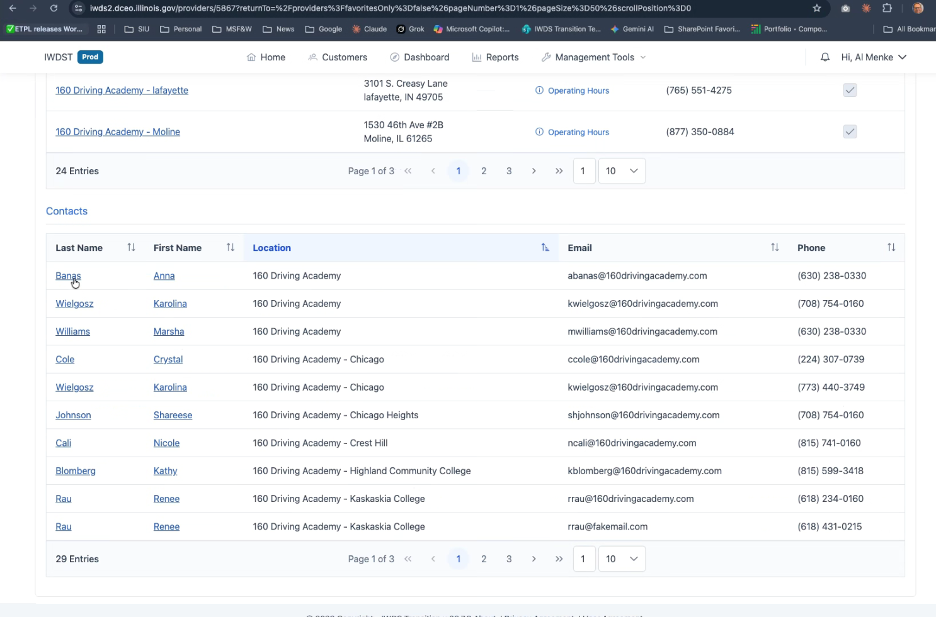
- If the training provider user does NOT appear on this list, then they will need to be set up as a contact for one or more locations under this entity.
  - If they are not found in the summary list, it means either they do not have a user account, or they have not been assigned to a location under this entity. Contacts are added to locations, not to the entity itself.
  - There is no user search available under an entity or location, so you will have to manually search the lists under the entity or the individual locations.
  - If searching in the general Entity Contact list of all contacts, be sure to expand search to view entire list, up to 50 entries per page. This will ensure an existing contact is not missed.

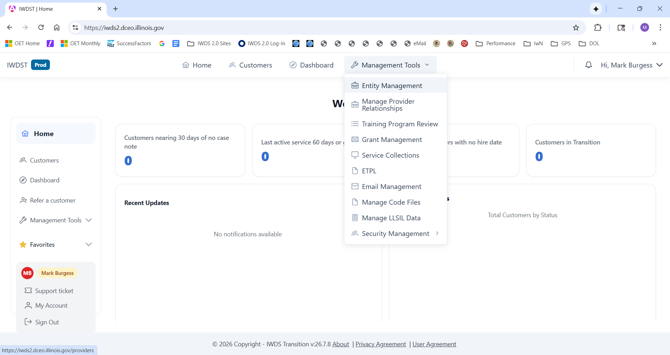
- Search for the Entity by Name or Location (We will use 160 Driving Academy as an example)
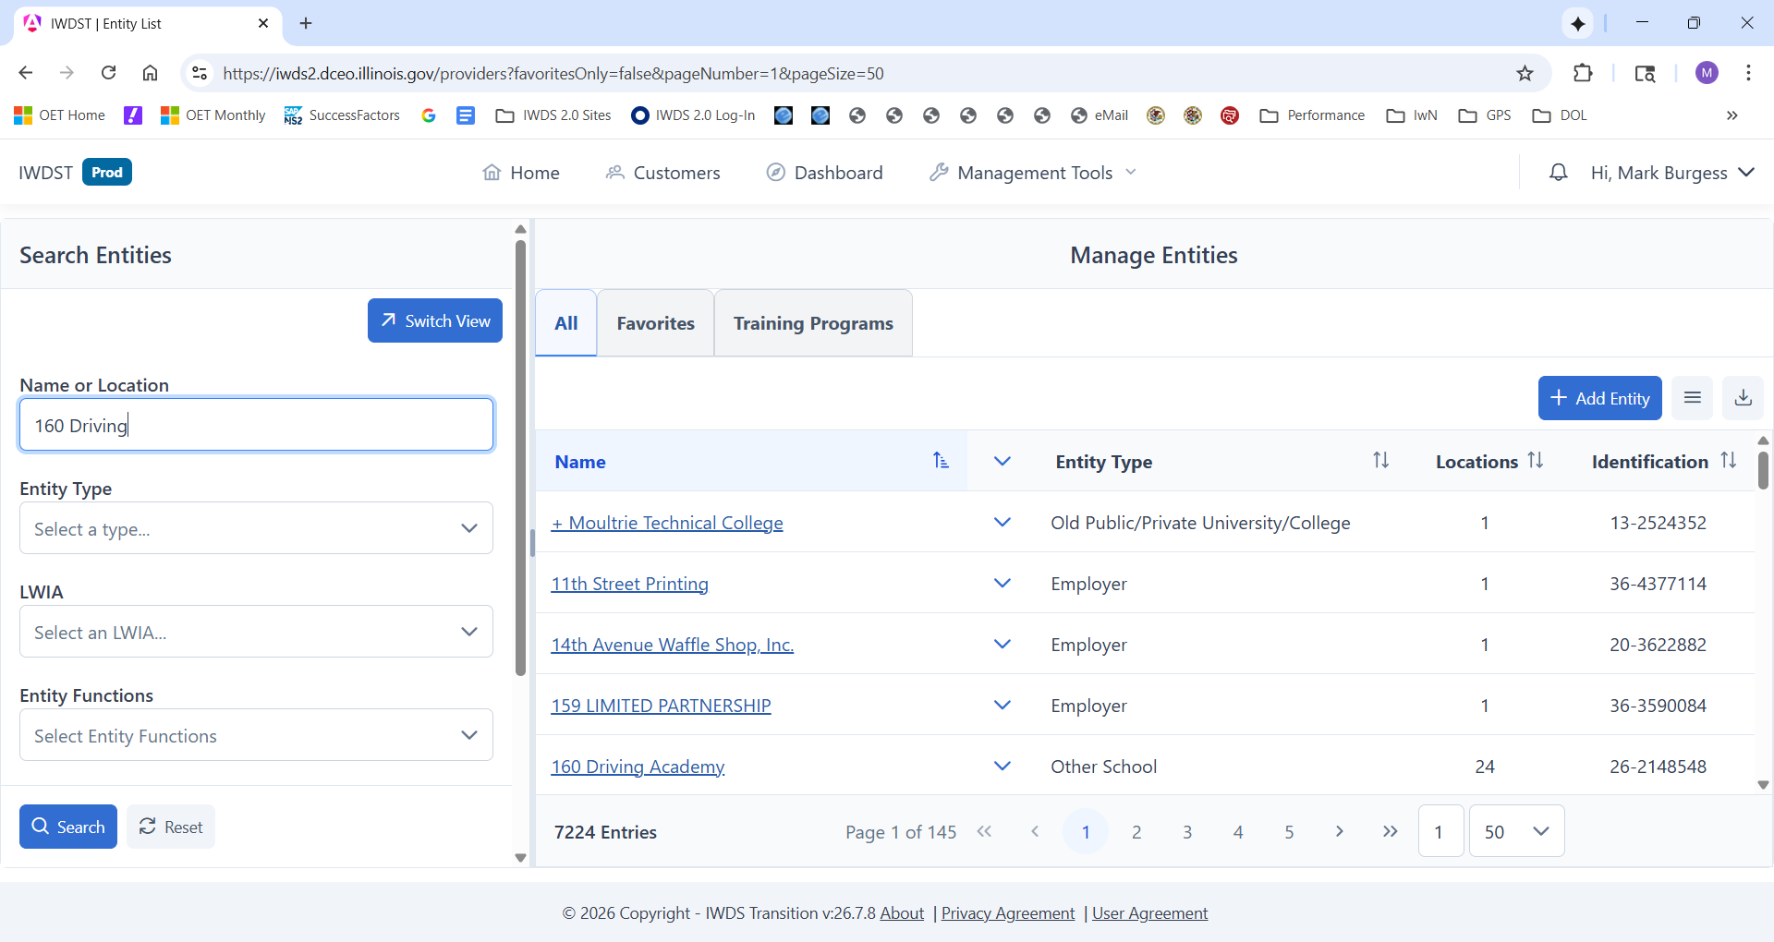

- Find the appropriate Entity and select it. You want to be on the “Details” tab.
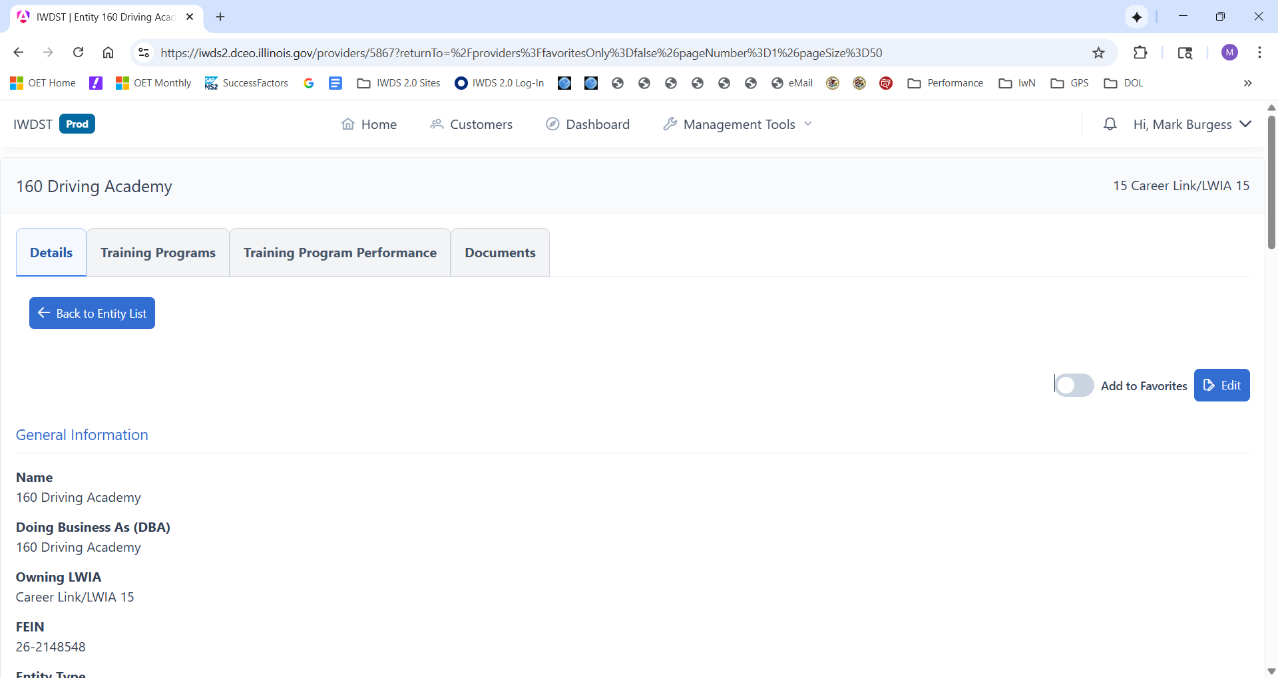
- Scroll down to Contacts and search for the individual seeking Access. You can change the number of results displayed to 10, 20, 30, 40 or 50 per page.
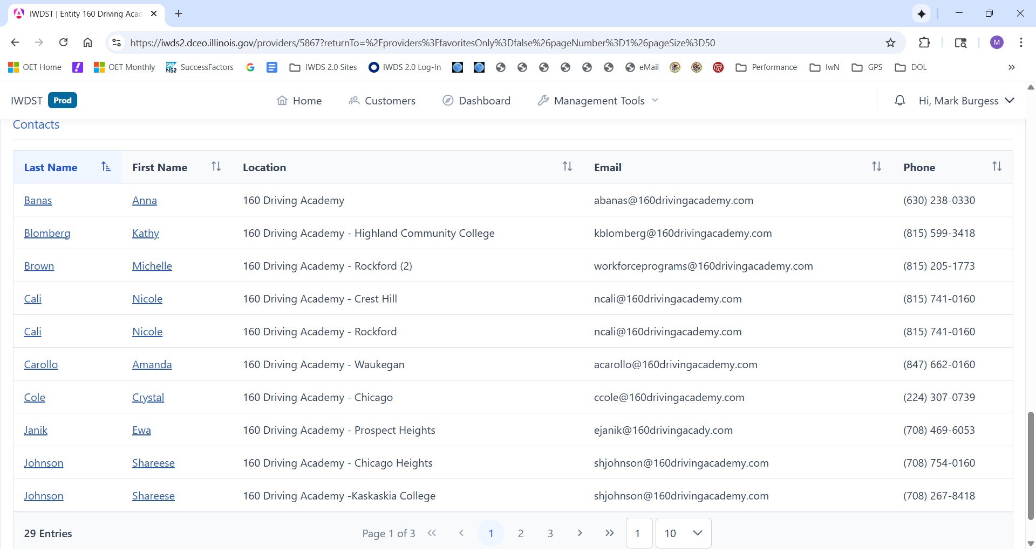
- If the User has User Access, jump to Step 12 for the next steps. If they do NOT have User Access, follow the next steps 8 - 11 to Add a Contact and set up User Access.

- To Add a Contact, you will need to Select one of the Locations for the Entity where the contact needs to be associated.
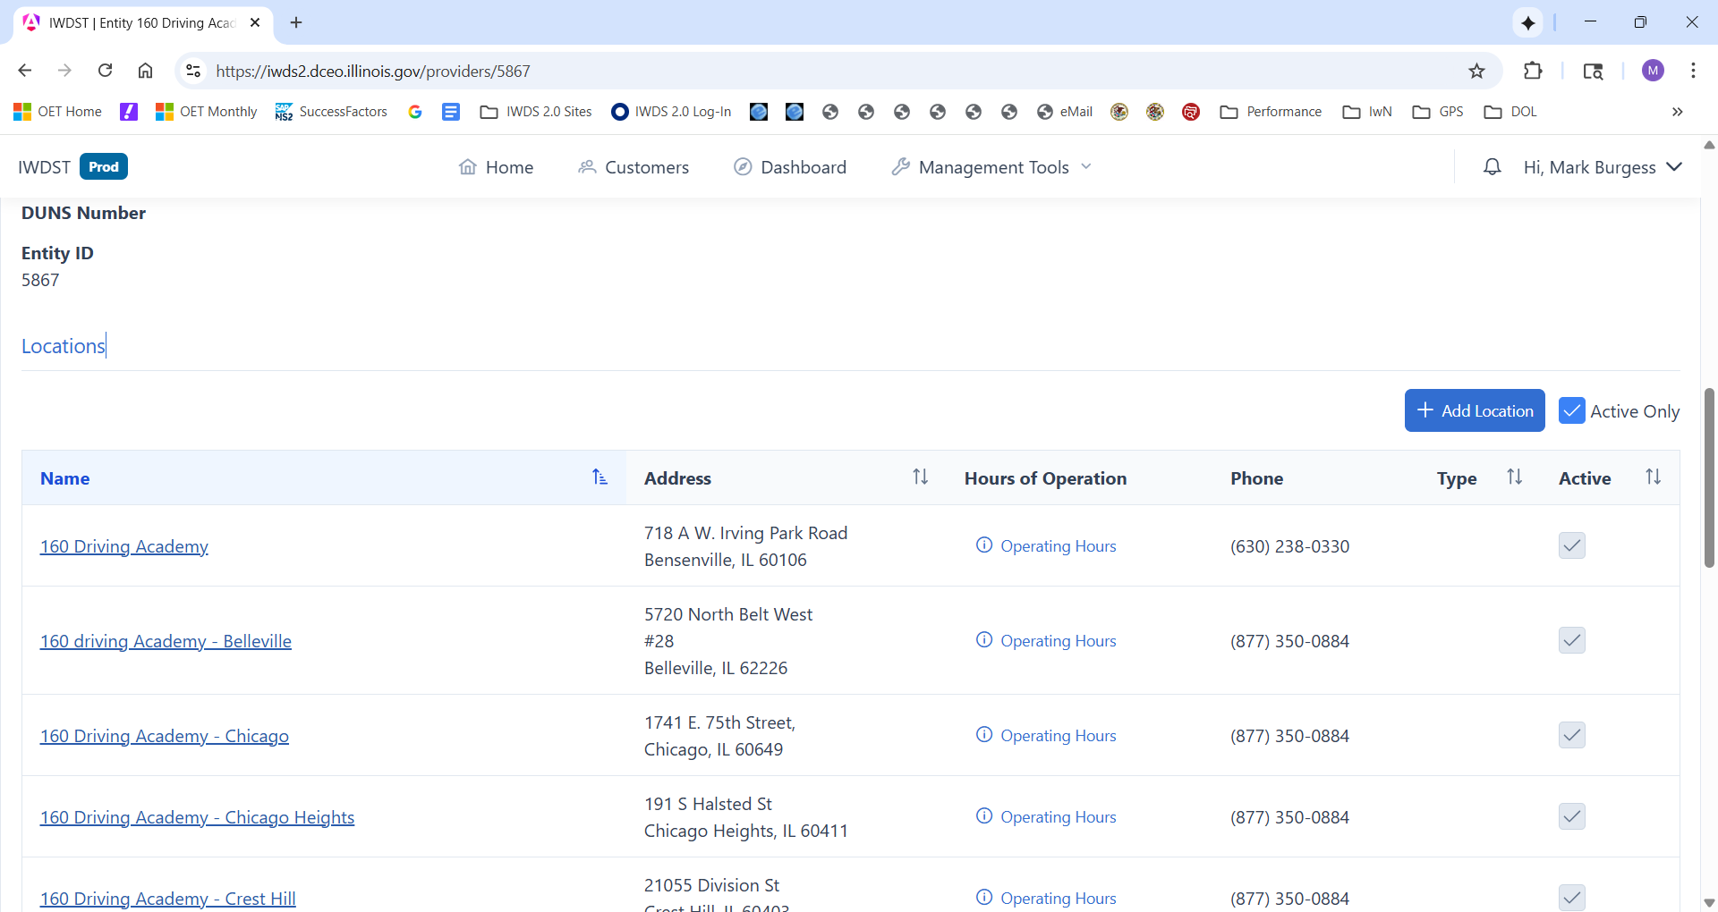

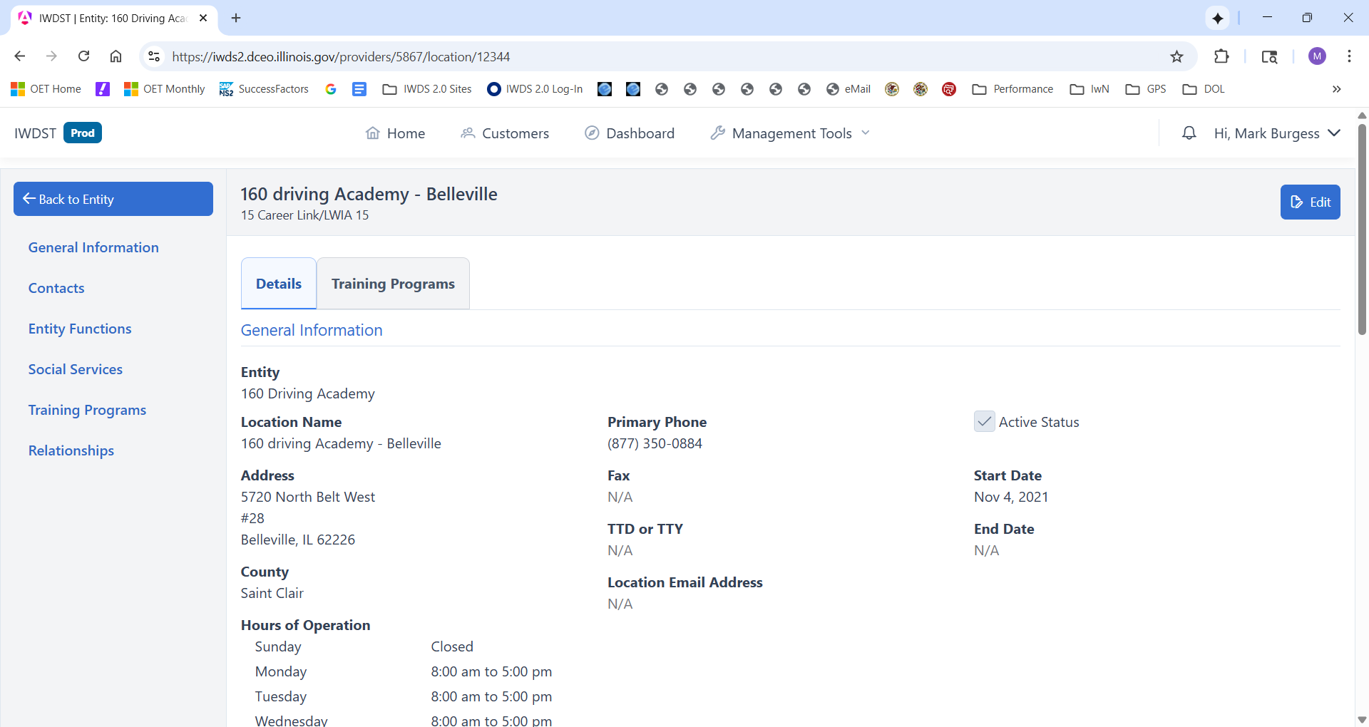

- You are now at an Entity Location screen. Scroll down to Contacts that are specific to this Location, verify the contact is not there, and select + Add Contact.
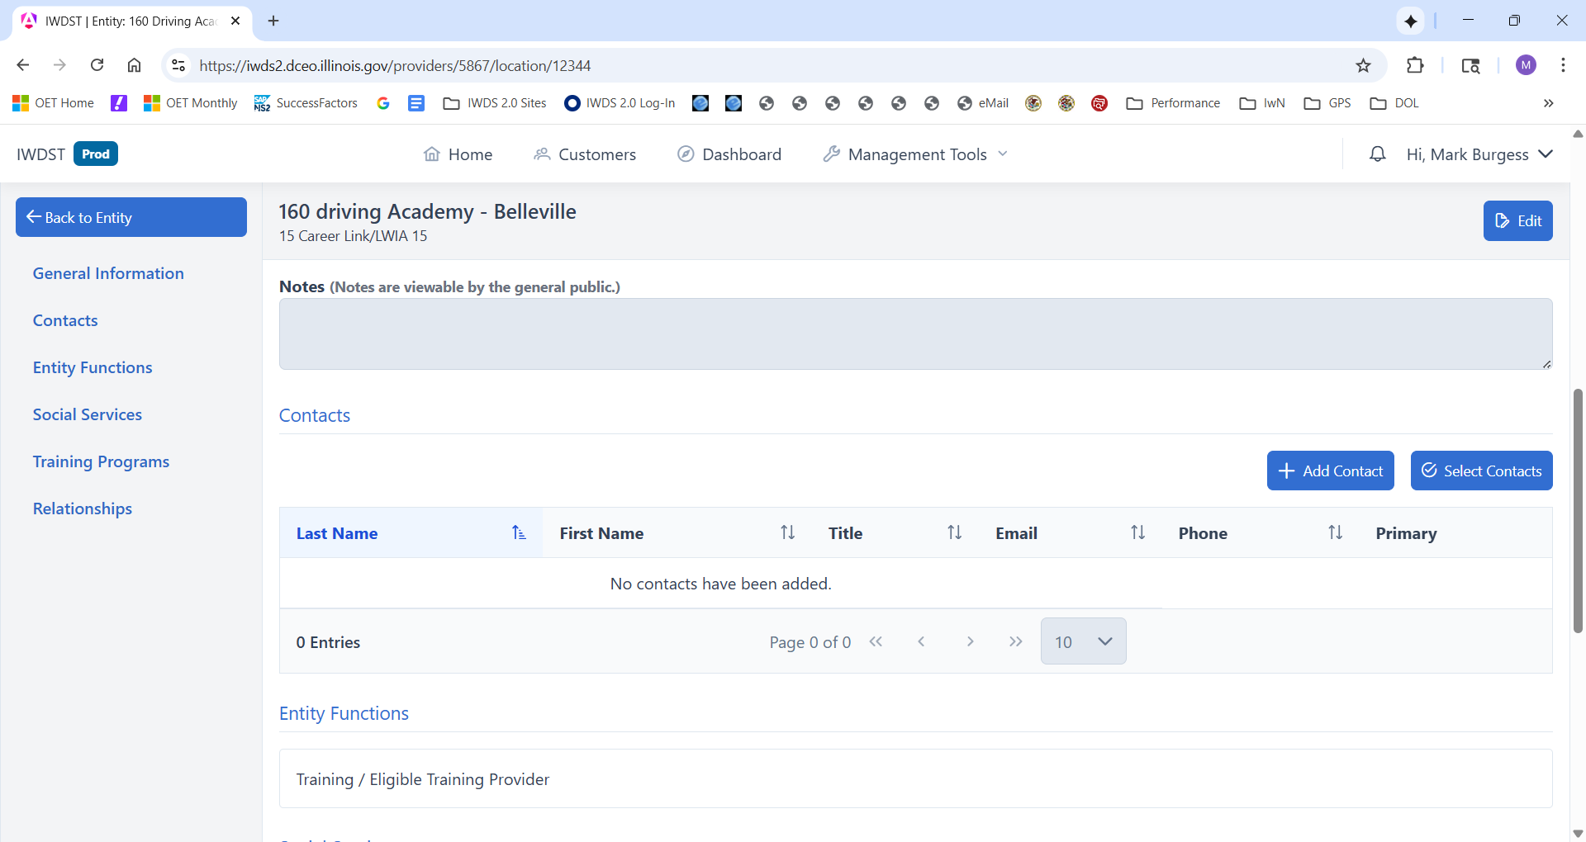
- Add the Contact information, and then check the boxes for Active, Primary Contact, ITA Training Provider User and Receive Notifications in Email, as appropriate. Then select +Add Contact.
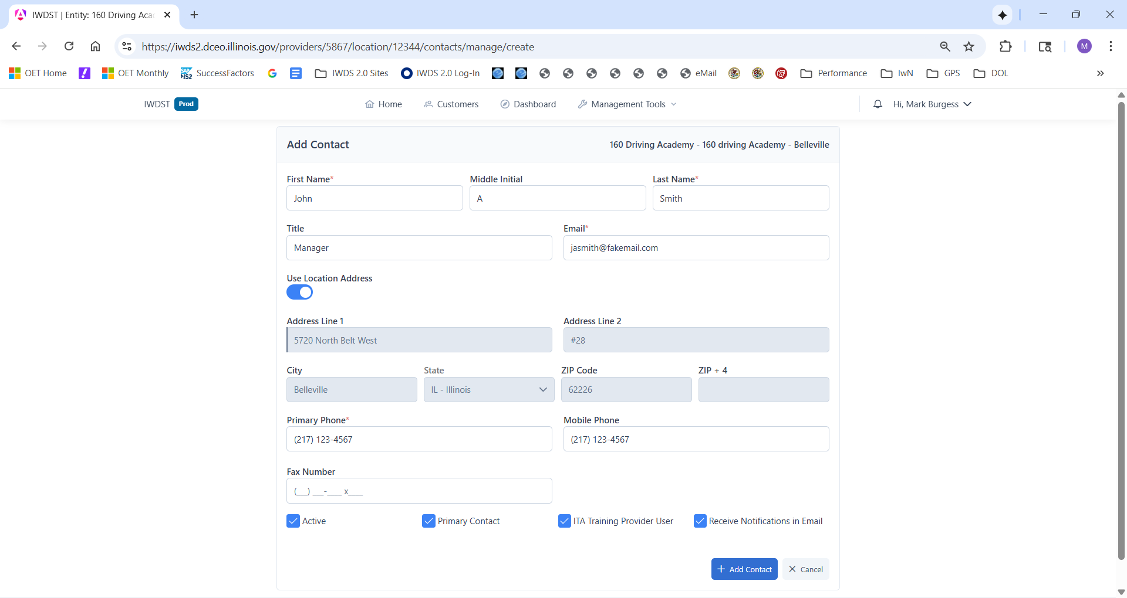
- Finally, the user will receive an email informing them that they are now a Contact, and they will need to select the Link in the email to set up User Access.

- If the User has a User Account, confirm whether the ITA Training Provider User access box is switched on for that contact.
- Click on Contact Name > Make sure box ITA Training Provider User is checked
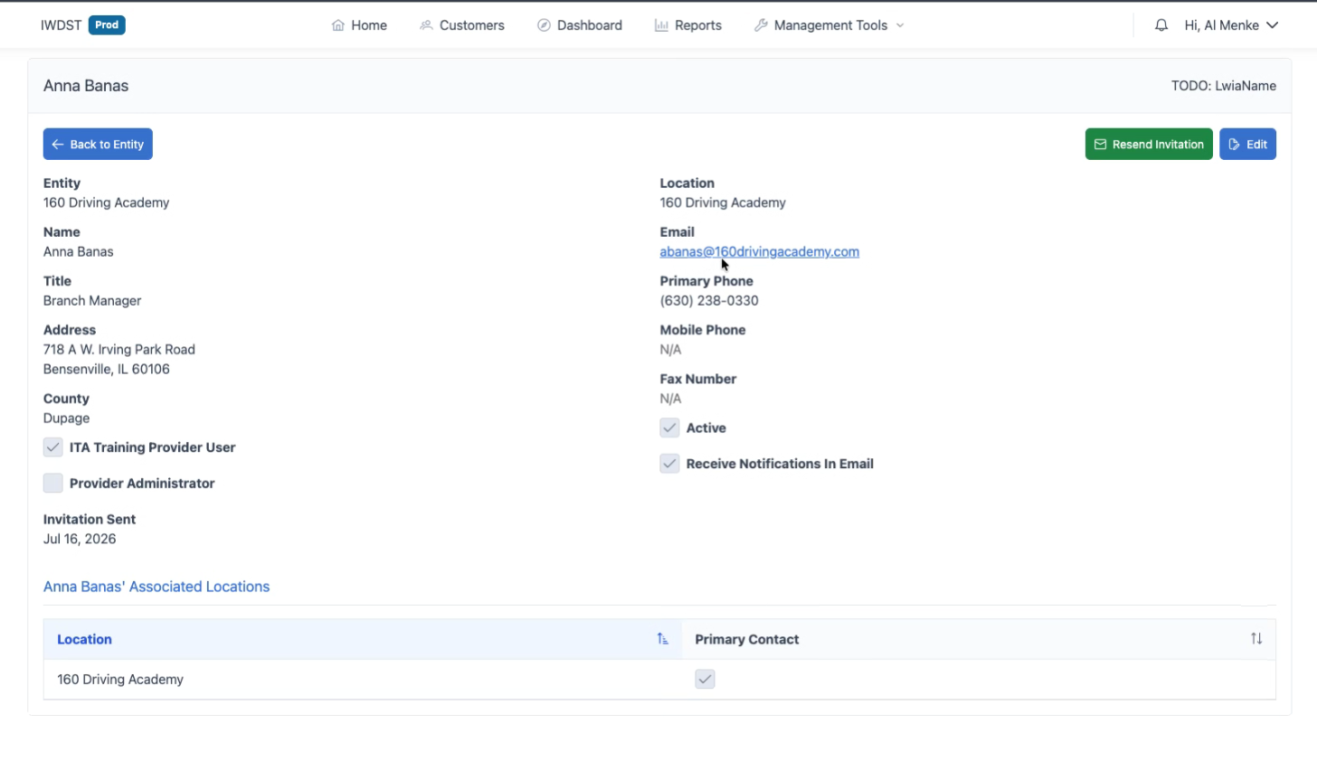
- If the box is not checked, then select the Edit button, check it, and then save the page. 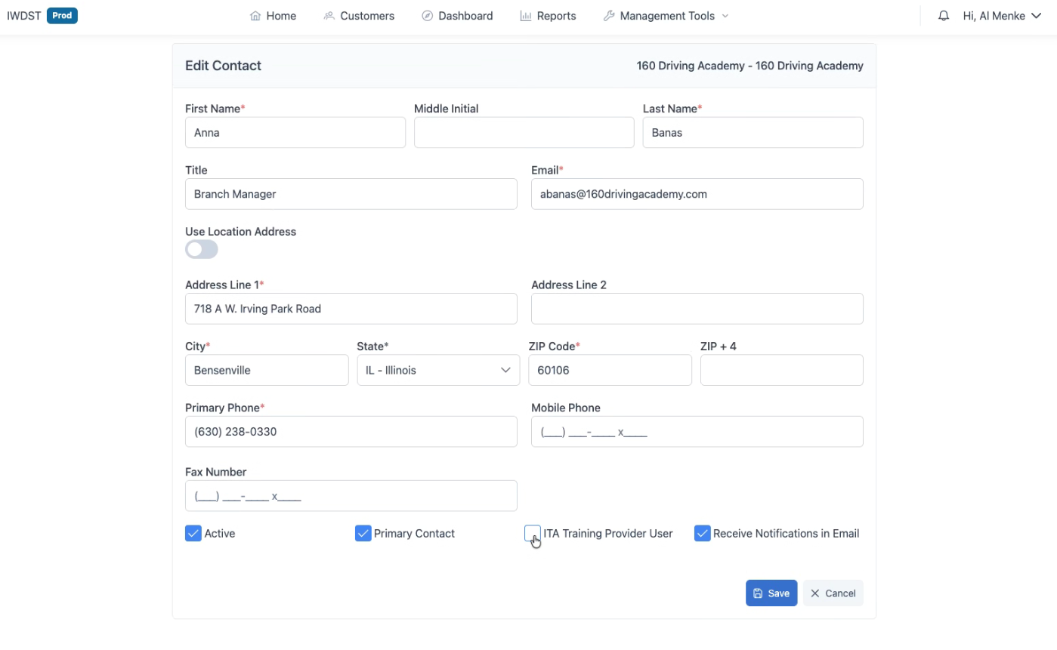
- On the Contact screen, check to ensure they have the right email address that matches the correct email address of the user's account.
- Go to the User’s Page and find the individual. Management Tools > Security Management> Users
- Type a portion of their name or email in the Keyword search to find the user.
- Identify the appropriate User by First Name and Last Name
- Make sure the email associated with the user matches the email used on the contact screen.
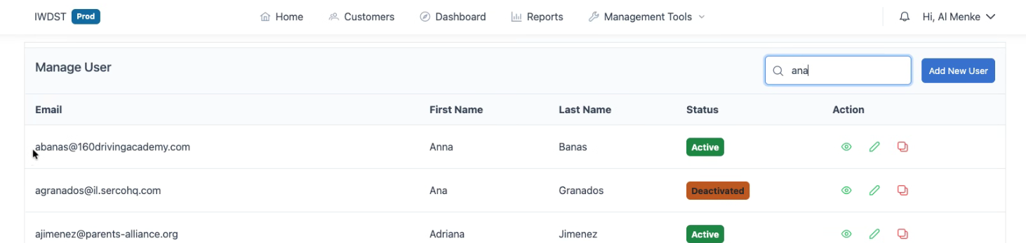
- If they do not match, update the record with the incorrect email to align it.
- Select the edit “pen”
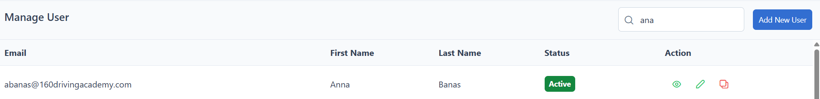

- Correct the email address and select ✓Update at the bottom of the page.
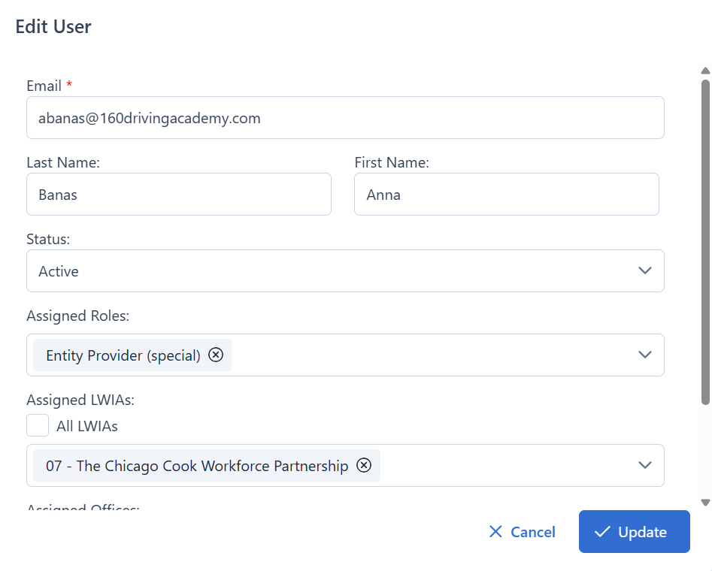

- Verify that the email address was updated.

- Inform the provider's contact that their User Access should now be established, and they should attempt to log into IWDS 2.0.
- If the contact is not on the user list, they could:
- Be pending access in the Pending Users List. They will need to be assigned the appropriate role and granted access.
- Not have yet requested access. They will need to complete the steps for creating an ILogin account and requesting access. If the contact has not yet requested access, they will need to complete the steps for creating an ILogin account and requesting access. Please refer to the Quick Start Guide to request access in IWDS 2.0.
- Upon completion of Adding a Contact or Updating information related to a Contact, Log Out of your account, log back to your account, and ensure the Contact record now exists with appropriate information.
- If the description process still does not lead to Access, please elevate this to the SIU help team at iwdst.info@illinoisworknet.com.

