Contents
Overview 1
UAT Release 9 – Cycle 2 Expectations & Homework 1
Goals and Objectives 3
Accessing Goals and Objectives 3
Completing Goals and Objectives 5

Overview
User Acceptance Test (UAT) Release 2 is deployed to the SIU UAT environment. There are no security constraints for this environment. It is important not to enter any personal identifiable information (PII). The purpose of release 2 is two-fold. First, we want to move into a regular repeating process of user acceptance testing and general validation of the system early and often in our project lifecycle. This will allow us to catch any issues with the releases compared to the requirements. Second, we want to put our UAT process into practice. We would like to introduce everyone to the system and agree upon expectations.

UAT Release 9 – Cycle 2 Expectations & Homework
Homework Areas - For this week, your UAT tasks will focus on the following key areas listed below. More information on these areas can be found in the next section of this document.
  - Goals and Objectives
    - Add a Goal and Objective
    - View Goal and Objective Table
    - Edit a Goal and or Objective

Due Date - Please complete your testing in these areas and submit your feedback by December 23rd at noon.
Access to UAT Environment – To access the UAT environment in your browser, follow the link provided here. https://testapps.illinoisworknet.com/Iwdst-Preview/testing
Reporting Issues- Please document any issues, bugs, or enhancement requests you identify in our shared notebook - UAT Notebook IWDS2 Release 9. The main purpose of using a shared notebook is for collaboration between members of the UAT team and the business analysts. This will cut down on duplicate issues being reported.
- When logging your entries:
  - You should document this information as you are completing your UAT work.
  - The second section in the notebook is labeled Example Issue Reporting. Please refer to that page to get an idea of how you can report an issue.
  - In the notebook you will find a section labeled Prescreening. The section is divided into several pages, each page is specific to a specific page of the prescreening. Ensure that each item is tracked under the correct page you are providing feedback on.
  - Be concise but detailed.
  - If multiple issues arise in one area, log each one separately for clarity.
  - Please provide the name of the customer you are using when you log an issue so we can easily go in and take a look at what is going on to troubleshoot.
- If you have issues accessing the OneNote notebook - Please contact one of the business analysts (BA) on the team. The business analysts are:
    - Kelly Trimble – Kelly.trimble@siu.edu
    - Olivia Miller - olivia.miller@siu.edu
    - Lynette Tritz - lynette.tritz@siu.edu
    - Al Menke – al.menke@siu.edu

Expectations for UAT - As you test these areas, please keep in mind the following best practices:
- Test Thoroughly: Ensure that you navigate through all functions and features within these areas. Pay attention to any discrepancies between expected and actual results.
- Detail-Oriented: When reporting issues, provide as much context as possible, including:
  - Steps to reproduce the issue
  - Screenshots or recordings, if possible
  - Browser or device used during testing
  - Expected vs. actual outcomes
- Feedback Categories:
- Bugs - When the system does not perform as expected, and the system is not performing according to the requirements, then a bug will be reported, tracked, fixed, and retested.
- Issues - If the system is performing according to the requirements, but the user feels that the requirement was not captured correctly or now the user feels like the requirement is just not working as expected, then this is recorded as an issue. Issues are tracked and prioritized for change.
- Enhancements- Once we are in UAT and the users recognize an area that could be improved, then this will be also logged as an issue and tagged as an enhancement.

Best Practices for Effective UAT
- Think like the end user: Approach your testing from the perspective of someone unfamiliar with the system. This will help you identify usability issues and areas for improvement.
- Be specific and thorough: The more specific your feedback, the easier it will be to address. Include specific steps, expected outcomes, and actual results.
- Provide context: Always give context for your feedback. For instance, explain why an enhancement would improve the user experience or system performance.

By following these guidelines and providing detailed feedback, you’re helping to ensure the final product meets user expectations and performs as intended.

Goals and Objectives
Goals and Objectives are one part of the customer’s Universal Career Plan. Objectives are a series of steps for the customer to take to complete their overall goal(s), to obtain a job/career, complete a degree/licensing programing, or obtain additional training.
Goals and Objectives adapts based on customer information:
- Objectives adjust dynamically based on the type of goal selected.
- For example, only objectives that would be relevant to completing and education goal will display in the if that is the type of goal selected.
The universal career plan will be built with goals and objectives by a career coach.

Accessing Goals and Objectives
UAT Link Access:
URL: https://testapps.illinoisworknet.com/Iwdst-Preview/testing
Navigating to Goals and Objectives:
- Log into IWDS 2.0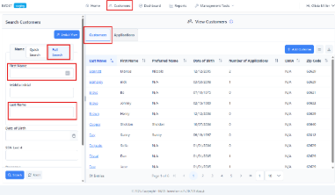
- Navigate to the Customer Page
Use the top banner bar to locate the Customer page.
- Search for Your Customer
From the Customer tab, use the Full Name Search to find your customer. Select the customer’s hyperlinked last name to access their IWDS 2.0 profile. Refer to your assigned persona for the correct name.
- Navigate to Application Summary
Once you’ve opened the customer’s profile, scroll down to the Applications section. Then click the Eyeball icon in the Actions field.
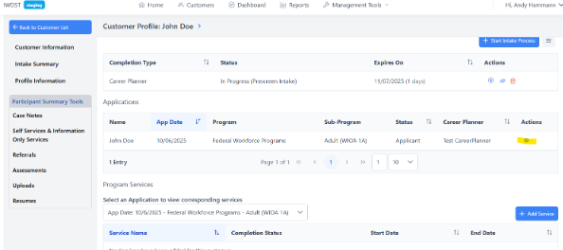
- Navigate to Goals and Objectives
Change the What Area Do You Want to Work In dropdown field to Career Plan, then click the Goals and Objectives tab. Next, click the blue Add Goals and Objectives button to open the Add Goals page.
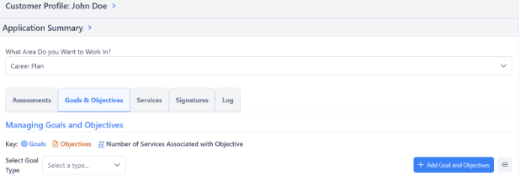

Completing Goals and Objectives

Personas
To help staff and stakeholders test the prescreening process, we’ve created customized personas that represent different customer scenarios and eligibility types across WIOA programs (Adult, Youth, and Dislocated Worker). Please note that you may need to change the name for these customers as there will be several testers who may be using these personas.
Each persona includes:
- General Customer Information: Age, employment status, education level, and other relevant details.
- Eligibility Alignment: Personas are designed to reflect various program eligibility pathways.
- Comprehensive Data: While not all information may apply to the prescreening, each persona contains everything needed to complete it successfully.

Using these personas ensures consistent testing and helps validate that the prescreening adapts dynamically to different customer situations.
Link to Persona List: https://www.illinoisworknet.com/partners/Documents/IWDS%20and%20Monitoring/Prescreening%20Personas_2025%20AH.docx

General Navigation and Information
- Add Goal
  - Based on your customer’s persona, select the type of goal that will be needed. NOTE: All the following fields will have different types of choices depending on the original type of goal you choose. Also, additional fields may be displayed to fill in, depending on the response provided. (Example: if Other is selected, a new field will display for you to describe the response.) Once all the dropdowns are completed, you will need to enter a Planned End Date for the goal. (All other date fields will be automatically populated.)

- Add Objective(s)
  - Based on your customer’s persona, select the type of objective and status to go along with the goal selected, then you can add any comments you’d like. Once you’ve done that, you may either be done by clicking Save Goal/Objectives, or you may add more objectives by clicking Add Another Objective.

