Training Plan UAT Guide
Contents
Figures 2
Overview 2
UAT Release 6 – Cycle 1 Expectations & Homework 2
Creating a Training Program for Submission 6
Starting a new program 6
Program of Study 6
Program of Study – Other Fields 7
Registered Apprenticeship 8
Registered Apprenticeship fields 8
Pre-apprenticeship Program Page 9
Pre-apprenticeship Fields 10
Program Outcomes 12
Program Outcomes Fields 12
Program Costs 14
Program Costs Fields 16
Instructional Hours 17
Instructional Hours fields 17
Entry Level Requirements 18
Entry Level Requirements Fields 18
Program Offerings 20
Program Offerings Fields 20
O*NET Codes 22
O*NET Codes page fields 22
Program Performance 23
Program Performance fields 24
Assurances and Certifications 25
Assurances & Certifications fields 26
Review and Submit 27
What happens on submit 27

Figures
Figure 1 - Training program grid 6
Figure 2 - Program of Study 7
Figure 3 - Registered Apprenticeship 9
Figure 4 - Pre-apprenticeship program 10
Figure 5 - Program Outcomes 12
Figure 6 - Program Costs 15
Figure 7 - Instructional Hours 17
Figure 8 - Entry Level Requirements 18
Figure 9 - Program Offerings 20
Figure 10 - O*NET codes 22
Figure 11 - Program Performance 23
Figure 12 - Assurances & Certifications 25
Figure 13 - Review and Submit 27

Overview
User Acceptance Test (UAT) Release #6 cycle 1, will be deployed to the SIU UAT environment Thursday afternoon, 9/4/2025. There are no security constraints for this environment. It is important to not enter any personal identifiable information (PII). The purpose of release #6 is to review the ETPL training program add, edit, and view feature sets.

UAT Release 6 – Cycle 1 Expectations & Homework
Homework Areas - For this week, your UAT tasks will focus on the following key areas listed below. More information on these areas can be found in the next section of this document.
  - New Training Program
    - Program of Study
    - Registered Apprenticeship
    - Pre-Apprenticeship
    - Program Outcomes
    - Program Costs
    - Instructional Hours
    - Entry Level Requirements
    - Program Offerings
    - O*NET codes
    - Program Performance
    - Assurances & Certifications
    - Review & Submit

Due Date - Please complete your testing in these areas and submit your feedback by Friday, Sept 19th.
Access to UAT Environment – To access the UAT environment in your browser, follow the link provided here. https://testapps.illinoisworknet.com/iwdst-Preview
Reporting Issues- Please document any issues, bugs, or enhancement requests you identify in our shared notebook -  UAT Notebook_2025. The main purpose of using a shared notebook is for collaboration between members of the UAT team and the business analysts. This will cut down on duplicate issues being reported.
- When logging your entries:
  - You should document this information as you are completing your UAT work.
  - The first page of the notebook is labeled Example Issue Reporting. Please refer to that page to get an idea of how you can report an issue.
  - In the notebook you will find a section labeled Release 6 – Cycle 1. The section is divided into several pages, each page is specific to pages of the training plan. Ensure that each item is tracked under the correct category for the cycle and feature set you are providing feedback on.
  - Be concise but detailed.
  - If multiple issues arise in one area, log each one separately for clarity.
  - Please add your name/initials with your entry.
- If you have issues accessing the OneNote notebook - Please contact one of the business analysts (BA) on the team. The business analysts are:
    - Olivia Miller - olivia.miller@siu.edu
    - Lynette Tritz - lynette.tritz@siu.edu
    - Al Menke – al.menke@siu.edu

Expectations for UAT - As you test these areas, please keep in mind the following best practices:
- Test Thoroughly: Ensure that you navigate through all functions and features within these areas. Pay attention to any discrepancies between expected and actual results.
- Detail-Oriented: When reporting issues, provide as much context as possible, including:
  - Steps to reproduce the issue
  - Screenshots or recordings, if possible
  - Browser or device used during testing
  - Actual outcome vs. Expected outcome
- Feedback Categories – The SIU team will categorize your findings into three (3) possible classifications.
  - Bugs - When the system does not perform as expected, and the system is not performing according to the requirements, then a bug will be reported, tracked, fixed, and retested.
  - Issues - If the system is performing according to the requirements, but the user feels that the requirement was not captured correctly or now the user feels like the requirement is just not working as expected, then this is recorded as an issue. Issues are tracked and prioritized for change.
  - Enhancements- Once we are in UAT and the users recognize an area that could be improved, then this will be also logged as an issue and tagged as an enhancement.

Best Practices for Effective UAT
- Think like the end user: Approach your testing from the perspective of someone unfamiliar with the system. This will help you identify usability issues and areas for improvement. Your persona in cycle 6 is as a Provider User first, then as an LWIA ETPL Coordinator user.
- Be specific and thorough: The more specific your feedback, the easier it will be to address. Include specific steps, expected outcomes, and actual results.
- Provide context: Always give context for your feedback. For instance, explain why an enhancement would improve the user experience or system performance.

By following these guidelines and providing detailed feedback, you’re helping to ensure the final product meets user expectations and performs as intended.

- Training Plan Add / Edit
  - Program of Study
  - Registered Apprenticeship (optional)
  - Pre-Apprenticeship (optional)
  - Program Costs
  - Program Outcomes
  - Instructional Hours
  - Entry Level Requirements
  - Program Offerings
  - O*NET codes
  - Program Performance
  - Assurances & Certifications
  - Review & Submit

Accessing Training Plans on Entities(providers)
To access the training plan tab for an entity, go to the Management Tools on the top menu, select Entity Management, and you will be at the entity management landing page. From there you can select an entity to work with that exists in the list or you could create a new entity. When you access the entity, you will see the training plan tab as shown below.

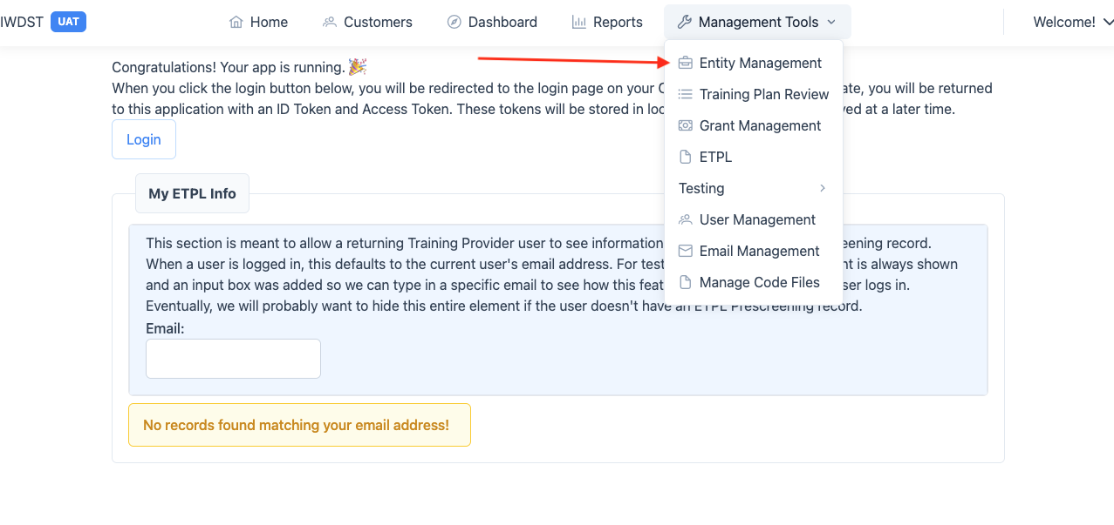

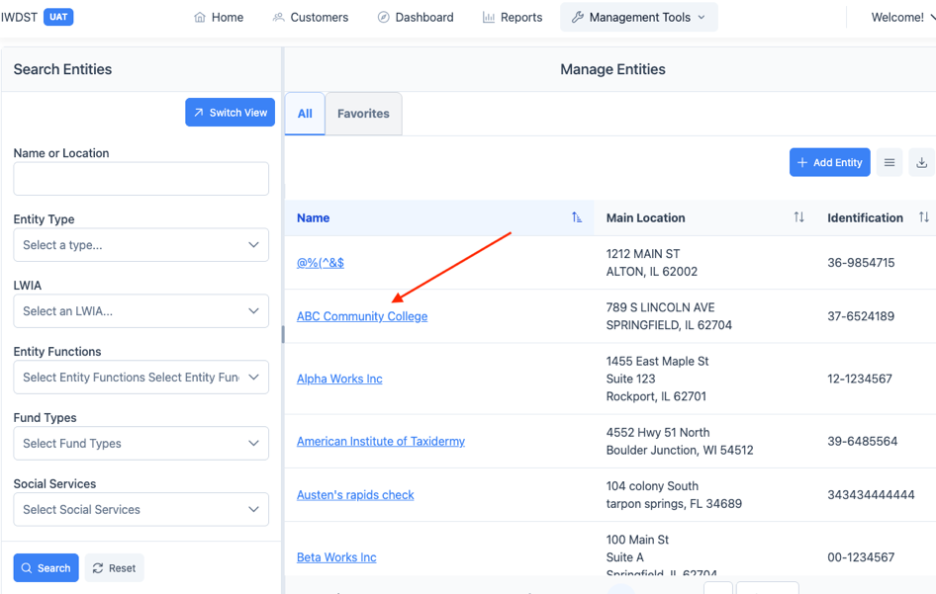

Creating a Training Program for Submission

Starting a new program
After the entity and first location has been established in IWDS-2.0, the system will route the user to the entity view page. The initial creation of the entity (provider) record and the subsequent main location record will be covered in another UAT release. This release will cover adding a new training program to an existing entity. This process starts at the selection of the Add Training Program button above the training programs grid.
See #1 on Figure 1 - Training program grid.
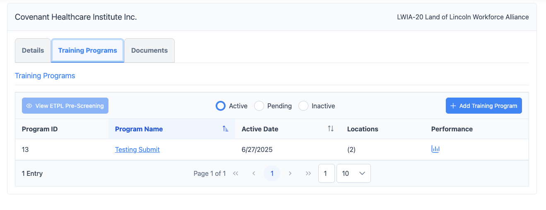
Figure 1 - Training program grid

By selecting the [+ Add Training Program] button, the first page of the training program definition will be displayed. See Figure 2 - Program of Study for the first page of the training program. You will notice that the Program of Study link, in the navigator at the left side of the page, is the only link available. This is because there are three (3) inputs on this page that need to take place before the program can be saved and before the navigator is available.

Program of Study
- Program Name text field – This is a required field that names the program and shows up in the provider’s training program grid as shown in Figure 1 - Training program grid.
- Program Description choice list – In the center of the page, there are three (3) choices for this program description. The program is an apprenticeship program, a pre-apprenticeship program or neither (all other programs).
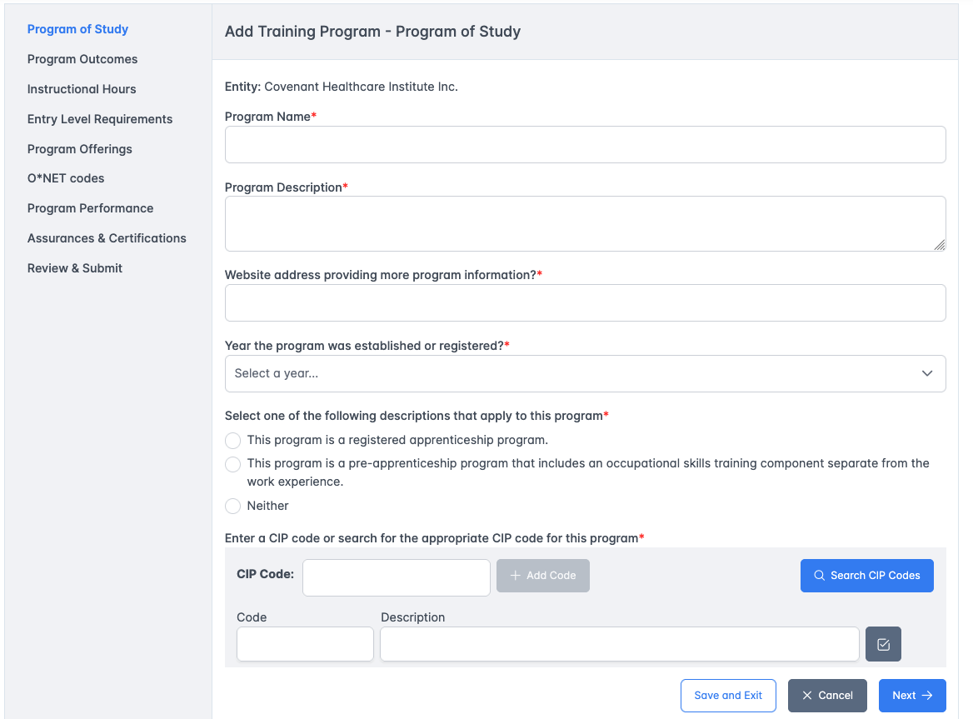
Figure 2 - Program of Study

Program of Study – Other Fields
- Program Description text area – Multi-line text area field to provide a description of the program
- Website Address text field – The website of the provider that can provide information for the program.
- Year the program was established or registered selection
- CIP code lookup – The CIP code search widget will take a direct CIP code entry or provide a search window to find the appropriate CIP code. Multiple CIP codes can be entered, at least one CIP code is required.
- Location Selection checkbox in grid – There is a location grid that shows all the current locations for the provider. In each location row there is a selection checkbox. At least one location must be selected for the program.

- [Cancel] button – Stops entry, dismisses the data entered, closes the page and routes back to the entity details page.
- [Next] button – Validates all entries on the page, saves the data, and moves to the next page. The next page is either the Registered Apprenticeship page, Pre-apprenticeship page, or Program Outcomes page according to the description selection on this page.
- [Save and Exit] button – Validates all entries on the page, saves the data, and moves back to the entity details page.
Once the page has been successfully saved and the user selected the [Next] button, the navigation links will all be available. The user does not have to proceed through all pages in order.

Registered Apprenticeship
If the user selects the Registered Apprenticeship in the program description choice on the program of study page, the registered apprenticeship page will be next. See XXXXXX below. This page has 8 fields.

Registered Apprenticeship fields
- RAPIDS ID text field
- Number of Active Apprenticeships in the United States text field
- Number of Active Apprenticeships in Illinois text field
- Registered Apprenticeship Type selection – There are three (3) choices available, Time, Competency, Hybrid.
- Upload Standards Document upload button – Any standards documentation can be uploaded using this upload button which allows the user to browse their machine and upload the documentation for later review.
- Worksites grid – At least one worksite should be added to the grid. Using the [+ Add Worksite] button provides a window to enter worksite locations.
- Related Technical Instruction toggle – If this toggle is set to yes, then a RTI grid will appear with a [+ Add RTI Site] button available which will provide a window to enter RTI site locations.
- Program Cost text field – The program cost will appear on the Registered Apprenticeship page and a detail costs page will not be required.
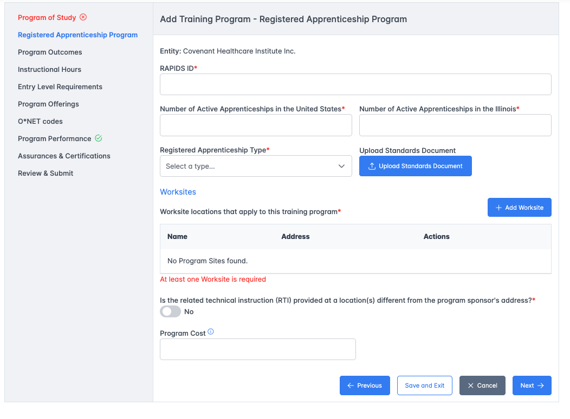
Figure 3 - Registered Apprenticeship
- [Previous] button - Validates all entries on the page, saves the data, and moves to the previous page.
- [Cancel] button – Stops entry, dismisses the data entered, closes the page and routes back to the entity details page.
- [Next] button – Validates all entries on the page, saves the data, and moves to the next page. The next page is the Program Outcomes page.
- [Save and Exit] button – Validates all entries on the page, saves the data, and moves back to the entity details page.

Pre-apprenticeship Program Page
If the user selected the pre-apprenticeship program on the program of study page description question, then the second page will be the pre-apprenticeship program page.
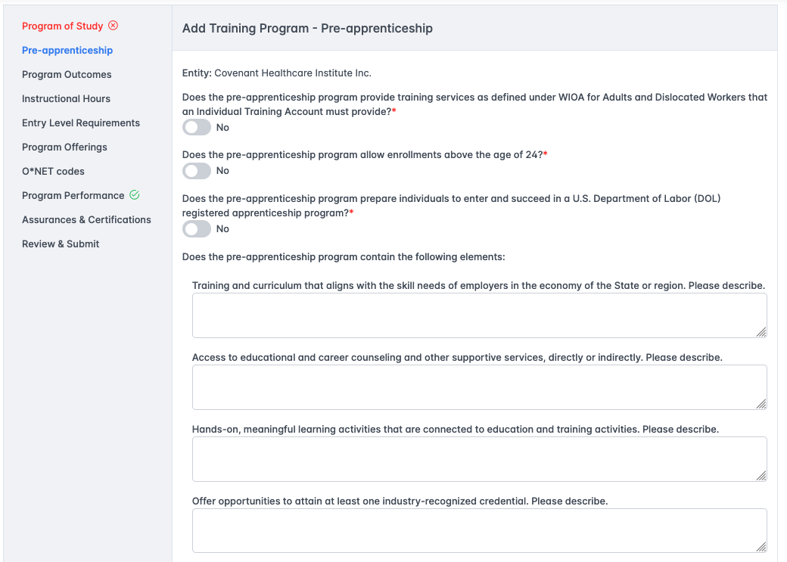
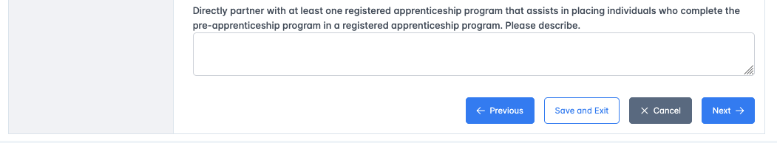
Figure 4 - Pre-apprenticeship program

Pre-apprenticeship Fields
- Does the pre-apprenticeship program provide training services as defined under WIOA for Adults and Dislocated Workers that an Individual Training Account must provide toggle.
- Does the pre-apprenticeship program allow enrollments above the age of 24 toggle.
- Does the pre-apprenticeship program prepare individuals to enter and succeed in a U.S. Department of Labor (DOL) registered apprenticeship program toggle.
- Training and curriculum that aligns with the skill needs of employers in the economy of the State or region. Please describe text area
- Access to educational and career counseling and other supportive services, directly or indirectly. Please describe text area
- Hands-on, meaningful learning activities that are connected to education and training activities. Please describe text area
- Offer opportunities to attain at least one industry-recognized credential. Please describe text area
- Directly partner with at least one registered apprenticeship program that assists in placing individuals who complete the pre-apprenticeship program in a registered apprenticeship program. Please describe text area.
- [Previous] button - Validates all entries on the page, saves the data, and moves to the previous page.
- [Cancel] button – Stops entry, dismisses the data entered, closes the page and routes back to the entity details page.
- [Next] button – Validates all entries on the page, saves the data, and moves to the next page. The next page is the Program Outcomes page.
- [Save and Exit] button – Validates all entries on the page, saves the data, and moves back to the entity details page.

Program Outcomes
The program outcomes page describes what the outcome will be when the program is completed.
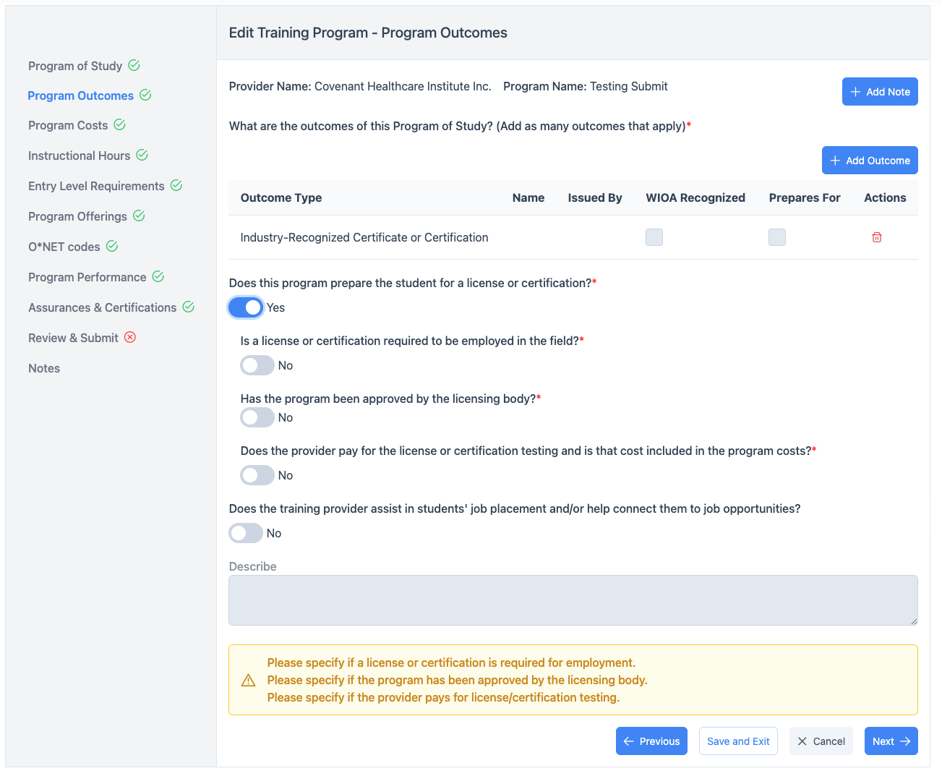
Figure 5 - Program Outcomes

Program Outcomes Fields
There are four (3) questions describing the outcomes for the program.
- What is the primary outcome of this Program of Study.(Add Outcomes that apply). This question has a grid to add multiple outcomes for the program.
- Does the training provider assist in students’ job placement and/or help connect them to job opportunities toggle – If yes then this question is followed by a description text area.
- [Previous] button - Validates all entries on the page, saves the data, and moves to the previous page.
- [Cancel] button – Stops entry, dismisses the data entered, closes the page and routes back to the entity details page.
- [Next] button – Validates all entries on the page, saves the data, and moves to the next page.
- [Save and Exit] button – Validates all entries on the page, saves the data, and moves back to the entity details page.

Program Costs
When the user does not select Apprenticeship or Pre-Apprenticeship as the program description, then the program costs page is provided. There are three (3) question areas of this page. The first area is to capture the costs of the program for an individual registrant. The second section is to describe the procedures for those costs that are listed. The third section is to provide types of financial assistance that is available.
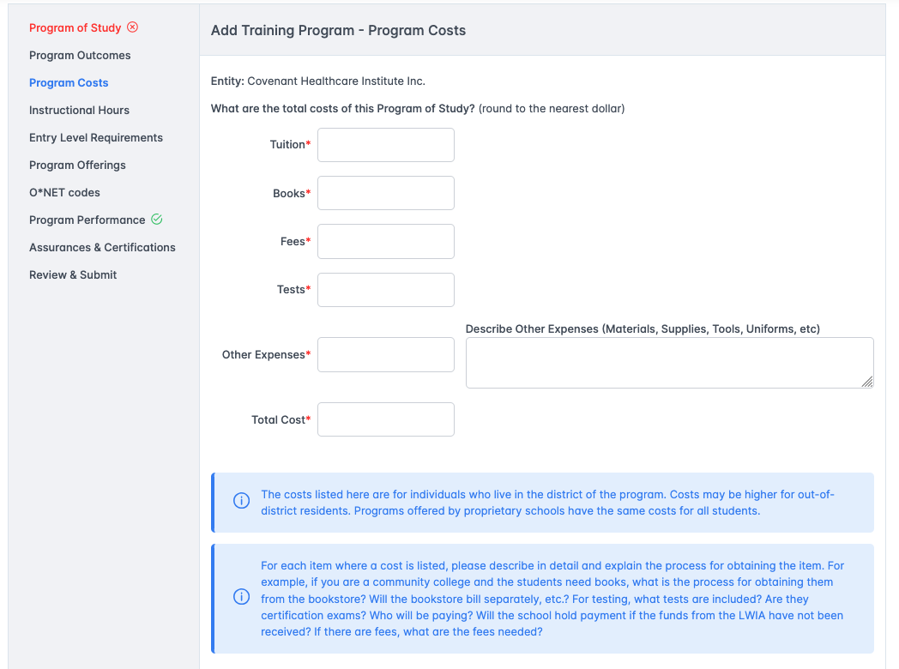

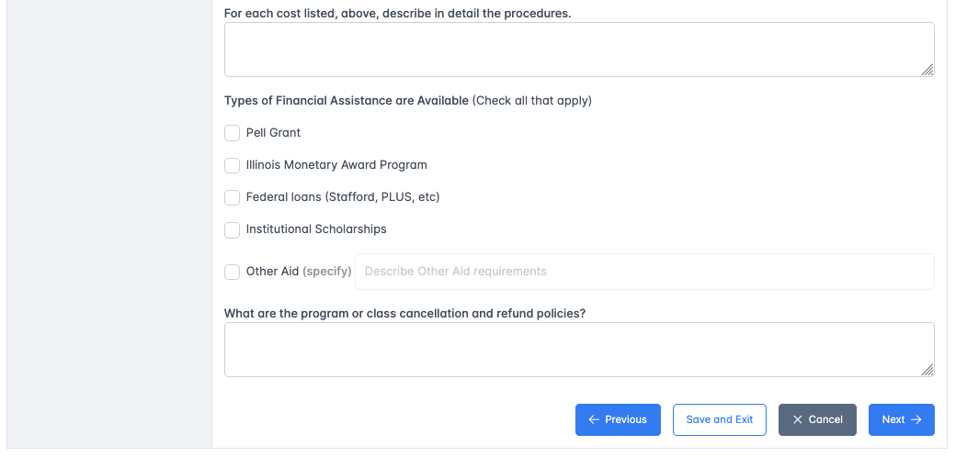
Figure 6 - Program Costs

Program Costs Fields
- Tuition text field – this field captures the amount of tuition for the program, this could be for multiple courses that a registrant will enroll in over the course of the entire program. The tuition field automatically adds to the total cost. If there is no tuition cost, then a zero must be entered.
- Books text field – this field captures the program cost for books. The books field automatically adds to the total costs. If there is no books cost, then a zero must be entered.
- Fees text field – this field captures any fees. Fees could include lab fees, transportation fees, etc. The fees field automatically adds to the total costs. If there are no fees costs, then a zero must be entered.
- Tests text field – this field captures the testing fees. This test fees field automatically adds to the total costs. If there are no testing fees, then a zero must be entered.
- Other Expenses text field – this field captures any other costs that are not recognized in the first four fields. If there is an amount other than zero in this field, then the description of the other costs must be entered. The other expenses are automatically added to the total cost field.
- Cost procedures text area – this field will provide a way to describe the method that costs are expended. Examples include where to get books or other costs. When the test fees or other fees will be assessed.
- Types of Financial Assistance multi-select field – There are five (5) choices for financial assistance that can be selected.
- Program or class cancellation and refund policies text area – this field provides a way to describe when a program or class can be cancelled along with any refund policies for cancellation.
- [Previous] button - Validates all entries on the page, saves the data, and moves to the previous page.
- [Cancel] button – Stops entry, dismisses the data entered, closes the page and routes back to the entity details page.
- [Next] button – Validates all entries on the page, saves the data, and moves to the next page.
- [Save and Exit] button – Validates all entries on the page, saves the data, and moves back to the entity details page.

Instructional Hours
The instructional hours page provides information about credit hours and total instructional hours.
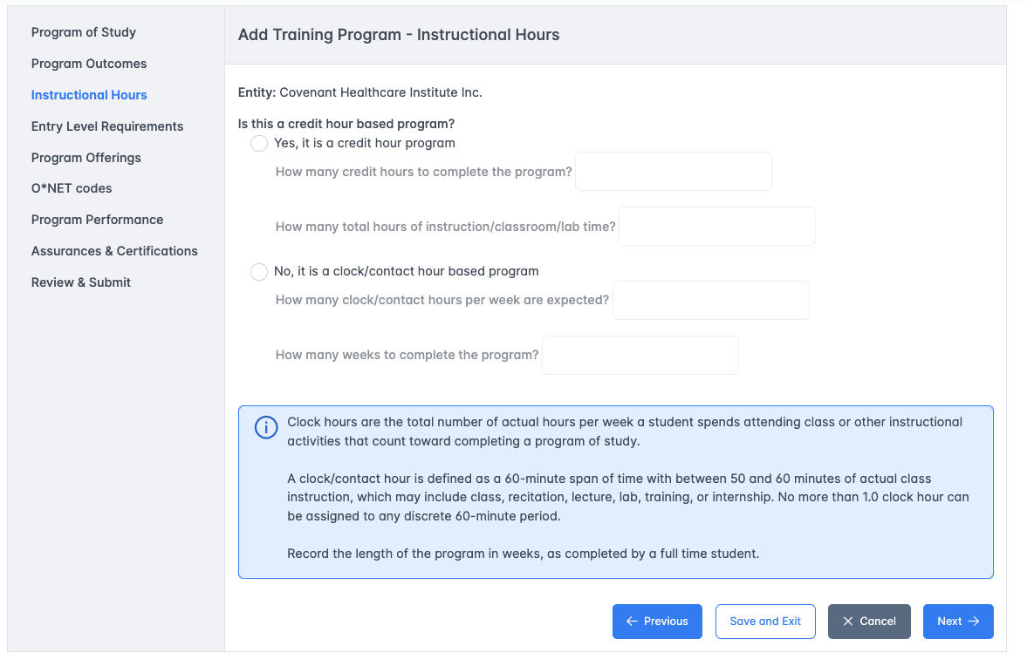
Figure 7 - Instructional Hours

Instructional Hours fields
- Is this a credit hour program toggle field. If yes, the number of credit hours for program completion can be entered into the text field.
- What are the total hours of instruction/classroom/lab time text field.
- Is this a competency-based program toggle. If no, then how many weeks doe it typically take to compete this program text field.
- [Previous] button - Validates all entries on the page, saves the data, and moves to the previous page.
- [Cancel] button – Stops entry, dismisses the data entered, closes the page and routes back to the entity details page.
- [Next] button – Validates all entries on the page, saves the data, and moves to the next page.
- [Save and Exit] button – Validates all entries on the page, saves the data, and moves back to the entity details page.

Entry Level Requirements
The entry level requirements describe the expectations of the level of the registrant upon entry to the program.
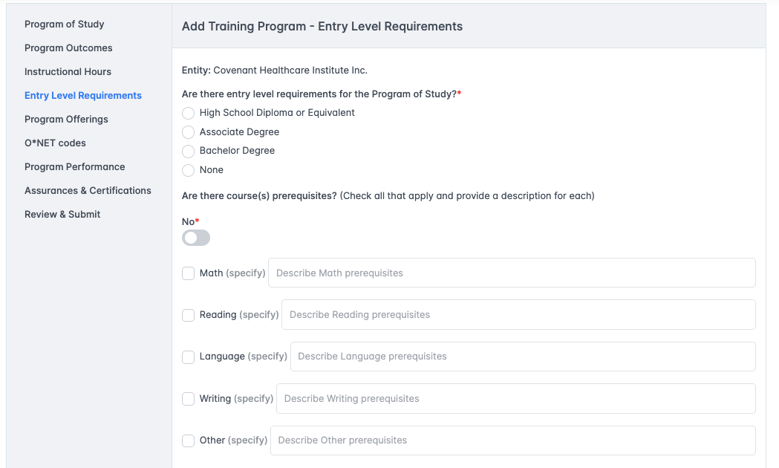
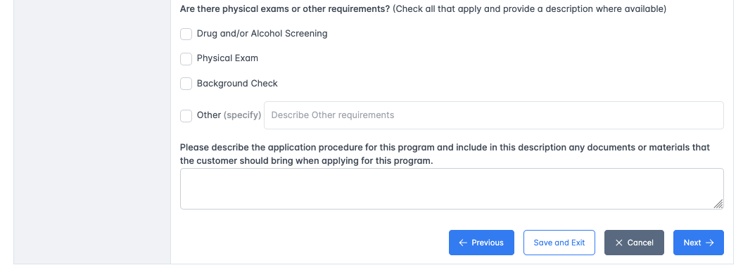
Figure 8 - Entry Level Requirements

Entry Level Requirements Fields
- What are the entry level requirements for the program of study question with four mutually exclusive answers.
  - High School Diploma or Equivalent
  - Associate degree
  - Bachelor’s degree
  - None
- Are there course(s) prerequisites multi-select checkbox list. Each of these when checked require a description to be added in the field that follows.
  - Math
  - Reading
  - Language
  - Writing
  - Other
- Are there physical exams or other requirements multi-select checkbox list.
  - Drug and/or Alcohol Screening
  - Physical Exam
  - Background Check
  - Other with a text field to enter the other requirement.
- Please describe the application procedure text area.
- [Previous] button - Validates all entries on the page, saves the data, and moves to the previous page.
- [Cancel] button – Stops entry, dismisses the data entered, closes the page and routes back to the entity details page.
- [Next] button – Validates all entries on the page, saves the data, and moves to the next page.
- [Save and Exit] button – Validates all entries on the page, saves the data, and moves back to the entity details page.

Program Offerings
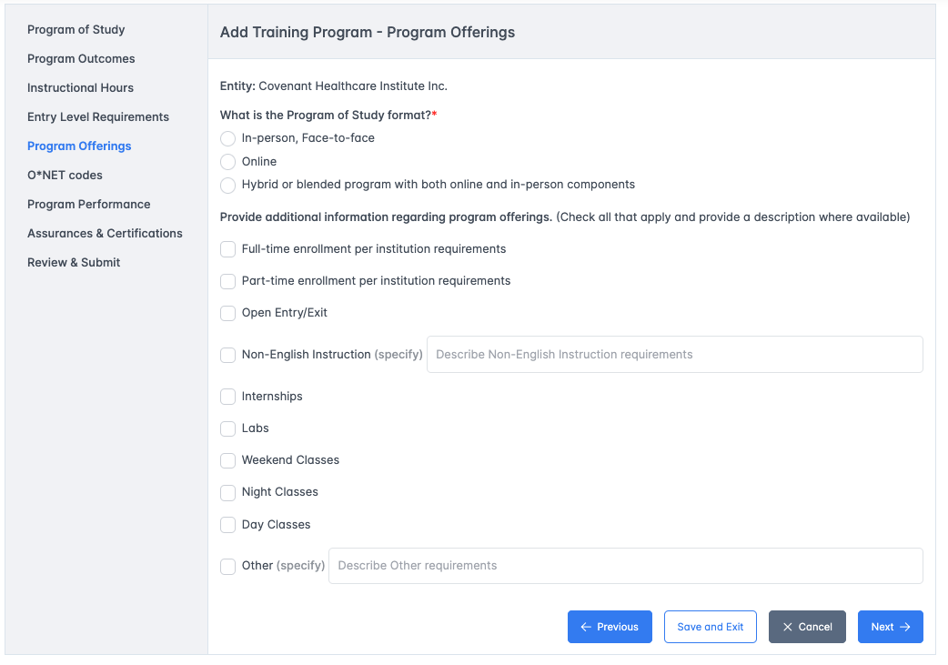
Figure 9 - Program Offerings
The program offerings page describes how a registrant can participate in the training as well as what to expect as how the program is structured.

Program Offerings Fields
- What is the program of study format single-selection – This question is followed by the following three (3) options:
  - In-person, face-to-face
  - Online
  - Hybrid or blended program with both online and in-person components
- Provide additional information regarding program offerings – this is a multiple selection set of checkboxes that included:
  - Full-time enrollment per institution requirements
  - Part-time enrollment per institution requirements
  - Open Entry/Exit
  - Non-English Instruction with a text field to specify
  - Internships
  - Labs
  - Weekend Classes
  - Night Classes
  - Day Classes
  - Other with a text field to specify
- [Previous] button - Validates all entries on the page, saves the data, and moves to the previous page.
- [Cancel] button – Stops entry, dismisses the data entered, closes the page and routes back to the entity details page.
- [Next] button – Validates all entries on the page, saves the data, and moves to the next page.
- [Save and Exit] button – Validates all entries on the page, saves the data, and moves back to the entity details page.

O*NET Codes
The O*NET codes page will collect the exact O*NET codes that are applicable to the program. Multiple codes can be entered. Only three (3) codes are used to report to the USDOL. At least one code is required.

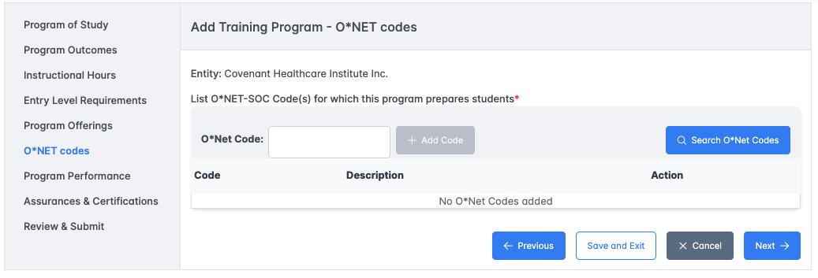
Figure 10 - O*NET codes

O*NET Codes page fields
- The page has a single grid to display the O*NET codes selected. These codes can be entered using the text field and the add code button or using the search O*Net Codes button.
- [Previous] button - Validates all entries on the page, saves the data, and moves to the previous page.
- [Cancel] button – Stops entry, dismisses the data entered, closes the page and routes back to the entity details page.
- [Next] button – Validates all entries on the page, saves the data, and moves to the next page.
- [Save and Exit] button – Validates all entries on the page, saves the data, and moves back to the entity details page.

Program Performance
When adding and submitting a program for review, the department requests that past program performance is added. This page will collect multiple years of performance numbers if these numbers exist.

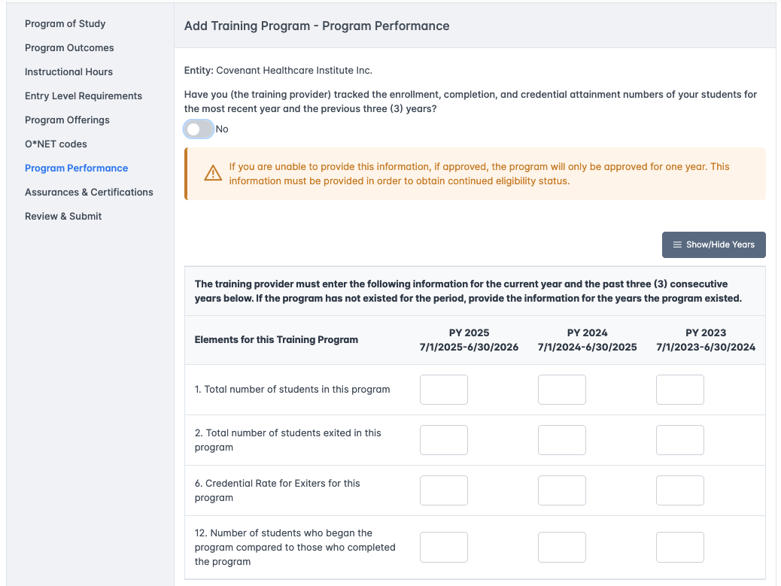
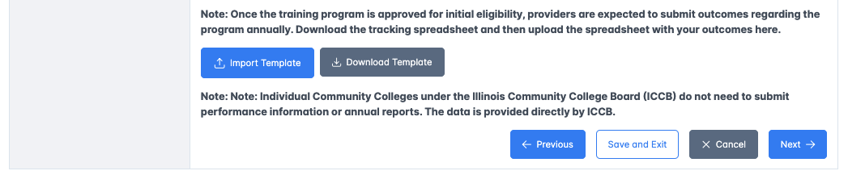
Figure 11 - Program Performance

Program Performance fields
- The first question asks if the training provider has tracked performance for the current year and the past three (3) years. If this answer is no then the user can go to the next page. If this answer is yes, then the program performance for 1 – 4 years is entered in the grid below.
- There are four (4) rows to enter multiple years of program performance. Each row has a different element.
  - 1. Total number of students in this program.
  - 2. Total number of students exited in this program.
  - Credential Rate for Exiters for this program.
  - Number of students who began the program compared to those who completed the program.
- [Import File] button. The import file button is used to browse and upload a spreadsheet that has the numbers for each year.
- [Download Template] button. This button provides a file that is in the format of the upload file for performance. This file must be completed and used for the import.
- [Previous] button - Validates all entries on the page, saves the data, and moves to the previous page.
- [Cancel] button – Stops entry, dismisses the data entered, closes the page and routes back to the entity details page.
- [Next] button – Validates all entries on the page, saves the data, and moves to the next page.
- [Save and Exit] button – Validates all entries on the page, saves the data, and moves back to the entity details page.

Assurances and Certifications
There are just three (3) questions on this page with a set of checkboxes that auto-check when the questions are answered affirmatively.

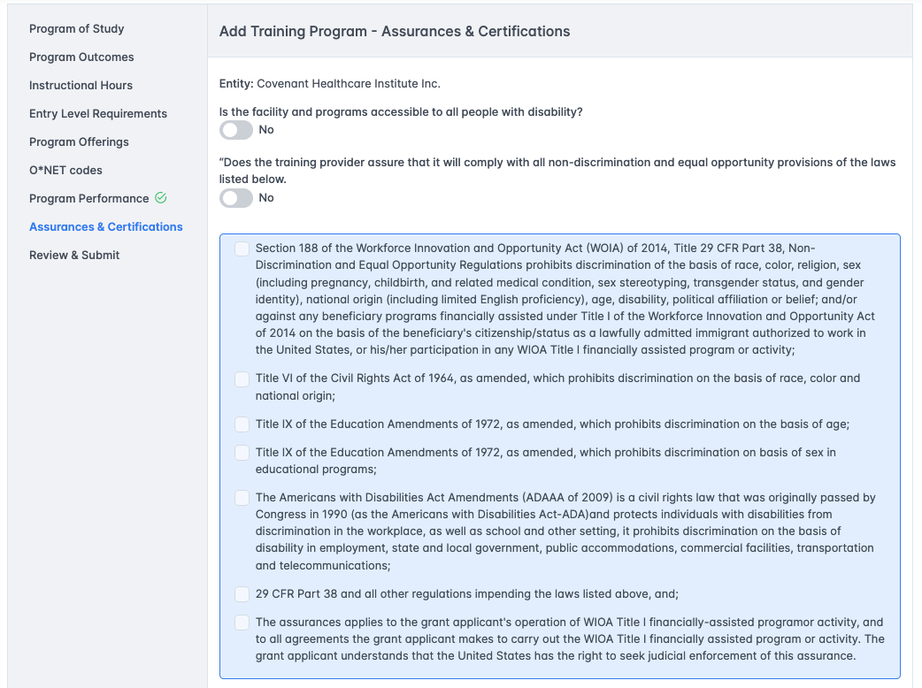
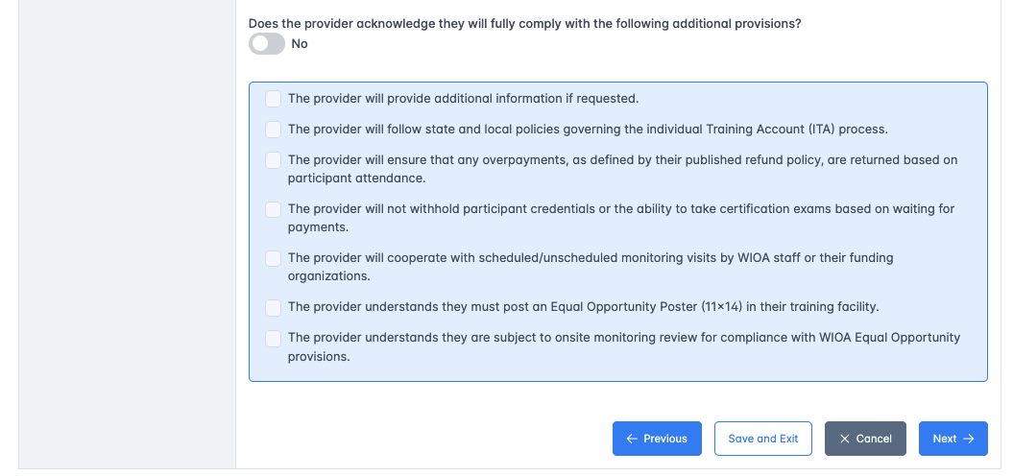
Figure 12 - Assurances & Certifications

Assurances & Certifications fields
- Is the facility and programs accessible to all people with disability toggle.
- Does the training provider assure that it will comply with all non-discrimination and equal opportunity provisions of the laws listed toggle. When this toggle is selected and set to yes then the laws listed will all be checked automatically.
- Does the provider acknowledge they will fully comply with the following additionally provisions toggle. When this toggle is selected and set to yes then the provisions listed below the toggle will automatically check.
- [Previous] button - Validates all entries on the page, saves the data, and moves to the previous page.
- [Cancel] button – Stops entry, dismisses the data entered, closes the page and routes back to the entity details page.
- [Next] button – Validates all entries on the page, saves the data, and moves to the next page.
- [Save and Exit] button – Validates all entries on the page, saves the data, and moves back to the entity details page.

Review and Submit
This page has an application declaration, a text field to enter the name which must match the current user, and a button that will allow the program to be submitted if all pages have been successfully validated.

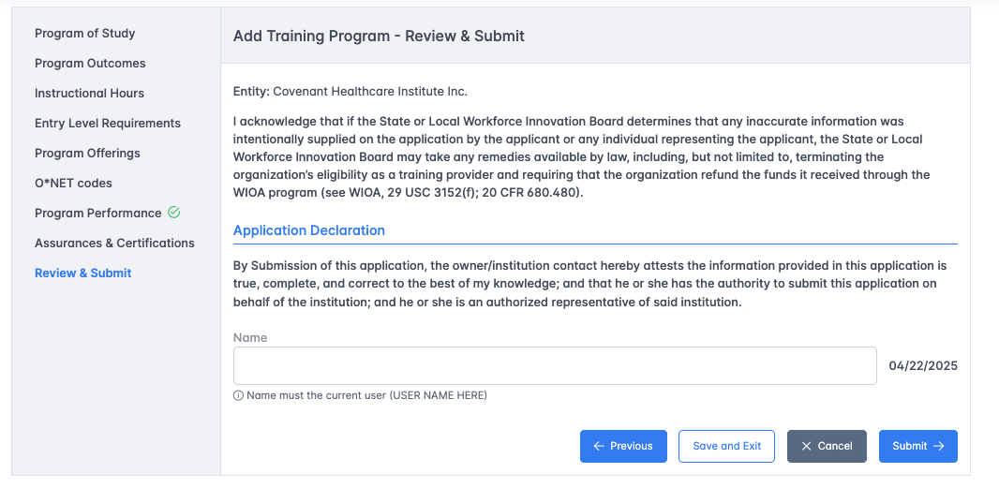
Figure 13 - Review and Submit

What happens on submit
When the program is successfully entered and submitted, then the program status will change to either Pending Initial or Pending Continued. Pending initial is the status of a pending new program. Pending Continued is the status of a program that is active and is being re-submitted for review.

If the program is in-state, then it will be routed to the LWIB ETPL Coordinator for first review. If the program is out-of-state or only provided on-line, then the program will be routed directly to the State ETPL Coordinator.

