ETPL Pre-screening UAT Guide
Contents
Figures 2
Overview 2
UAT Release 5 – Cycle 1 Expectations & Homework 2
ETPL Pre-screening 5
Collect Provider Identification and Email 6
Step 1- Collect Provider Name, Identification and Email 6
Email Example 7
Provider Description 8
Step 2 – Description of the provider 8
Step 2 – Description of Provider – Questions to the first answer 9
Step 2 – Description of Provider – Sub-Question for the second answer 9
Step 2 – Description of Provider – Sub-questions for the third answer 10
Step 2 – Description of Provider – fourth answer 11
Provider Location – In-State or Out-of-State, Virtual Learning 12
Step 3 – Provider Location Question 12
Step 3 – Provider Location – Answer two sub-questions 12
In-state, Public Higher Education 14
Step 4 – Public Higher Education 15
Private Higher Education 16
Step 4 – Private Higher Education 16
Registered Apprenticeship Program Public Organization 17
Step 4 – Registered Apprenticeship Public Program 17
Registered Apprenticeship Program Private Organization 19
Step 4 – Registered Apprenticeship Public Program 19
Community-Based or Labor Management Organization 21
Step 4 – Community Based or Labor Management Organization questions 21
Sign-up page after successful completion of pre-screening 23

Figures
Figure 1 - Access the ETPL Pre-screening 5
Figure 2 - Identify Provider and User 6
Figure 3 - Pre-screening verification email. 7
Figure 4 - Provider Description 8
Figure 5 – Additional questions in response to answering provider description first answer. 9
Figure 6 - Registered Apprenticeship sub-question 10
Figure 7 - Sub-questions for Other public or private providers 10
Figure 8 - Error Page 11
Figure 9 - Provider Location 12
Figure 10 - Sub-questions for out of state providers 13
Figure 11 - State ETPL selection 13
Figure 12 - OOS documentation 13
Figure 13 - Public Higher Education 14
Figure 14 - Private Higher Education 16
Figure 15 - Registered Apprenticeship Page 17
Figure 16 - RAP Private Organization 19
Figure 17 - Community Based or Labor Management top half of page 21
Figure 18 - Successful completion sign-up page 23

Overview
User Acceptance Test (UAT) Release 5 will be deployed to the SIU UAT environment Wednesday, 6/25/25. There are no security constraints for this environment. It is important to not enter any personal identifiable information (PII). The purpose of release #5 is to review the ETPL pre-screening pages. This was introduced in UAT Release 3 where we gathered feedback and upgraded.

UAT Release 5 – Cycle 1 Expectations & Homework
Homework Areas - For this week, your UAT tasks will focus on the following key areas listed below. More information on these areas can be found in the next section of this document.
  - New Provider ETPL Pre-Screening
    - Email Verification
    - Completion of all pre-screening pages
    - Cleared to submit training plan
Due Date - Please complete your testing in these areas and submit your feedback by April Thu, July 3rd.
Access to UAT Environment – To access the UAT environment in your browser, follow the link provided here. https://testapps.illinoisworknet.com/iwdst-Preview
Reporting Issues- Please document any issues, bugs, or enhancement requests you identify in our shared notebook - UAT Issues Reporting Notebook . The main purpose of using a shared notebook is for collaboration between members of the UAT team and the business analysts. This will cut down on duplicate issues being reported.
- When logging your entries:
  - You should document this information as you are completing your UAT work.
  - The first page of the notebook is labeled Example Issue Reporting. Please refer to that page to get an idea of how you can report an issue.
  - In the notebook you will find a section labeled Release 2. The section is divided into several pages, each page is specific to a feature set. Ensure that each item is tracked under the correct category for the cycle and feature set you are providing feedback on.
  - Be concise but detailed.
  - If multiple issues arise in one area, log each one separately for clarity.
- If you have issues accessing the OneNote notebook - Please contact one of the business analysts (BA) on the team. The business analysts are:
    - Taylor Littig - taylor.littig@siu.edu
    - Olivia Miller - olivia.miller@siu.edu
    - Lynette Tritz - lynette.tritz@siu.edu
    - Al Menke – al.menke@siu.edu

Expectations for UAT - As you test these areas, please keep in mind the following best practices:
- Test Thoroughly: Ensure that you navigate through all functions and features within these areas. Pay attention to any discrepancies between expected and actual results.
- Detail-Oriented: When reporting issues, provide as much context as possible, including:
  - Steps to reproduce the issue
  - Screenshots or recordings, if possible
  - Browser or device used during testing
  - Expected vs. actual outcomes
- Feedback Categories:
  - Bugs - When the system does not perform as expected, and the system is not performing according to the requirements, then a bug will be reported, tracked, fixed, and retested.
  - Issues - If the system is performing according to the requirements, but the user feels that the requirement was not captured correctly or now the user feels like the requirement is just not working as expected, then this is recorded as an issue. Issues are tracked and prioritized for change.
  - Enhancements- Once we are in UAT and the users recognize an area that could be improved, then this will be also logged as an issue and tagged as an enhancement.

Best Practices for Effective UAT
- Think like the end user: Approach your testing from the perspective of someone unfamiliar with the system. This will help you identify usability issues and areas for improvement.
- Be specific and thorough: The more specific your feedback, the easier it will be to address. Include specific steps, expected outcomes, and actual results. Don’t forget to add screen shots please.
- Provide context: Always give context for your feedback. For instance, explain why an enhancement would improve the user experience or system performance.

By following these guidelines and providing detailed feedback, you’re helping to ensure the final product meets user expectations and performs as intended.

ETPL Pre-screening
Accessing pre-screening in the UAT environment. Please go to the link provided which will land you at the “current test” homepage. Then select the Management Tools drop down menu from the top row and select ETPL from that menu. See image.
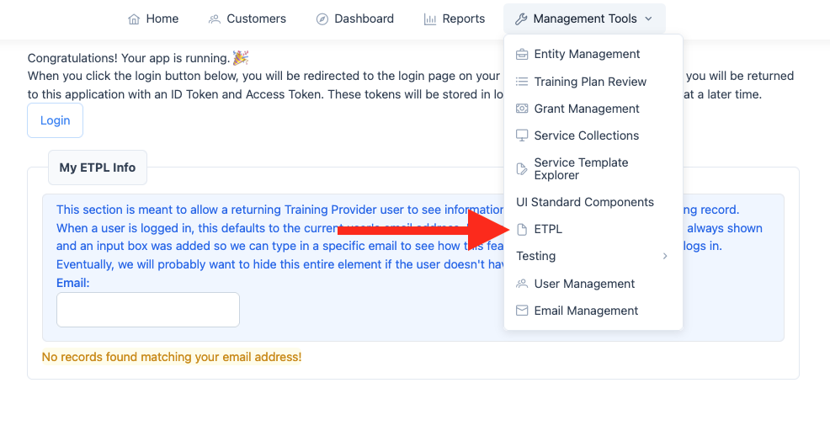
Figure 1 - Access the ETPL Pre-screening

Collect Provider Identification and Email
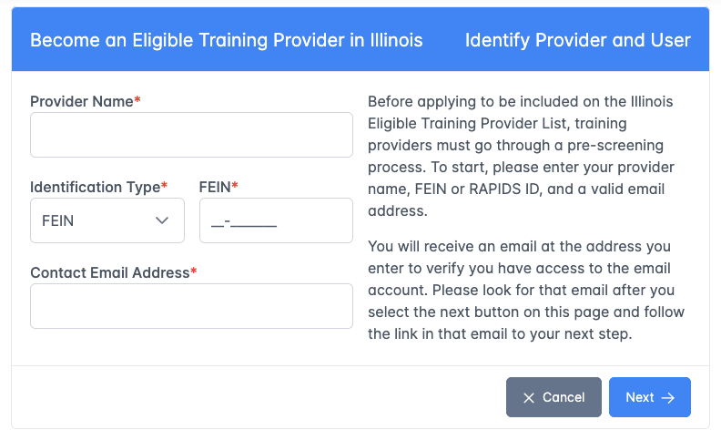
Figure 2 - Identify Provider and User

Step 1- Collect Provider Name, Identification and Email
There are four (4) required fields on this page. Once all fields are entered and the next button is selected, the system will determine if the provider identification is already in the system. If the provider identification is a duplicate, then the user will get a message with the contact information of the provider found. If the provider is not a duplicate, then an email will be sent to the email address with a link back into the pre-screening process page 2.
NOTE: You can enter any email with the domain as @fakemail.com you will not have to route through your email account. This was provided for testing purposes only.
- Provider Name – Text field to collect the provider’s name.
- Identification Type – Selection field for either FEIN or RAPIDS ID. This field sets the format and label on the following field.
- FEIN / RAPIDS ID – Text field with a mask to enter either a FEIN or a RAPIDS ID.
- Contact Email Address – Text field to collect the email address.

Email Example
When the user successfully enters a unique provider and a valid email address, the system will send an email with a secure link back into the pre-screening process. The email is shown in Figure 2 - Pre-screening verification email..
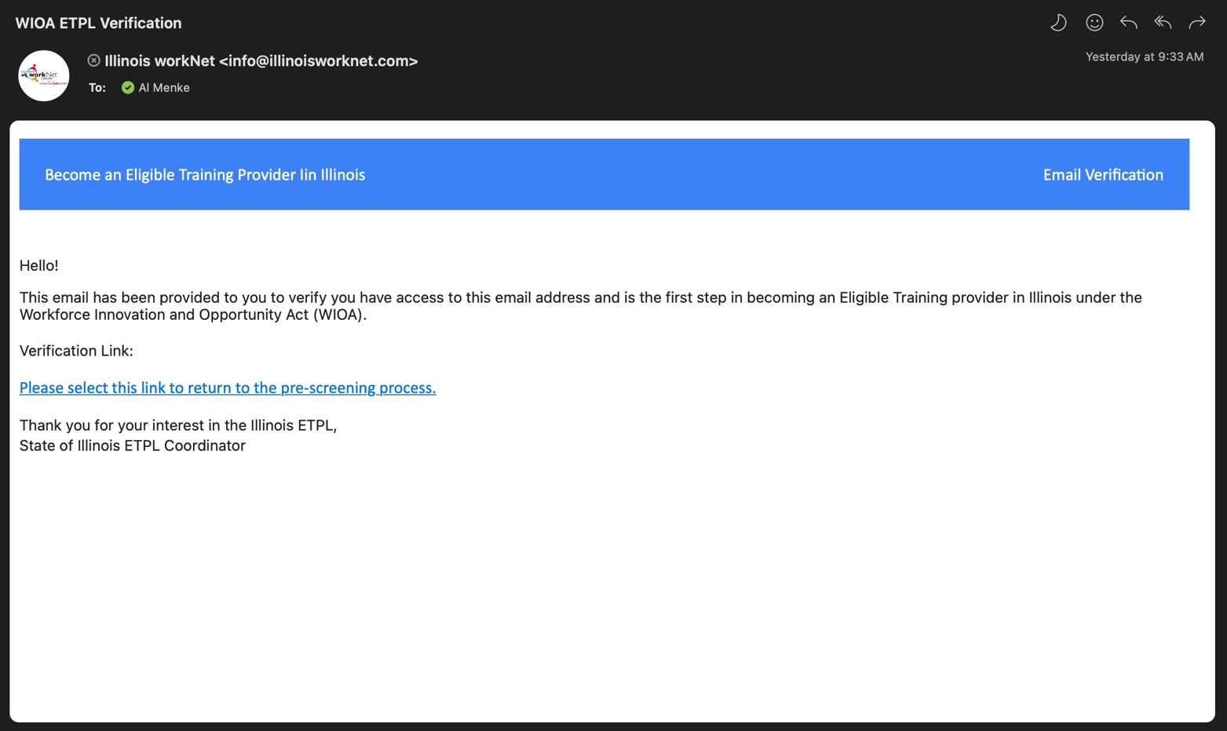
Figure 3 - Pre-screening verification email.

Provider Description
The second page of the pre-screening process is the provider description page. This page has a provider description text area followed by a description question with four (4) choices.
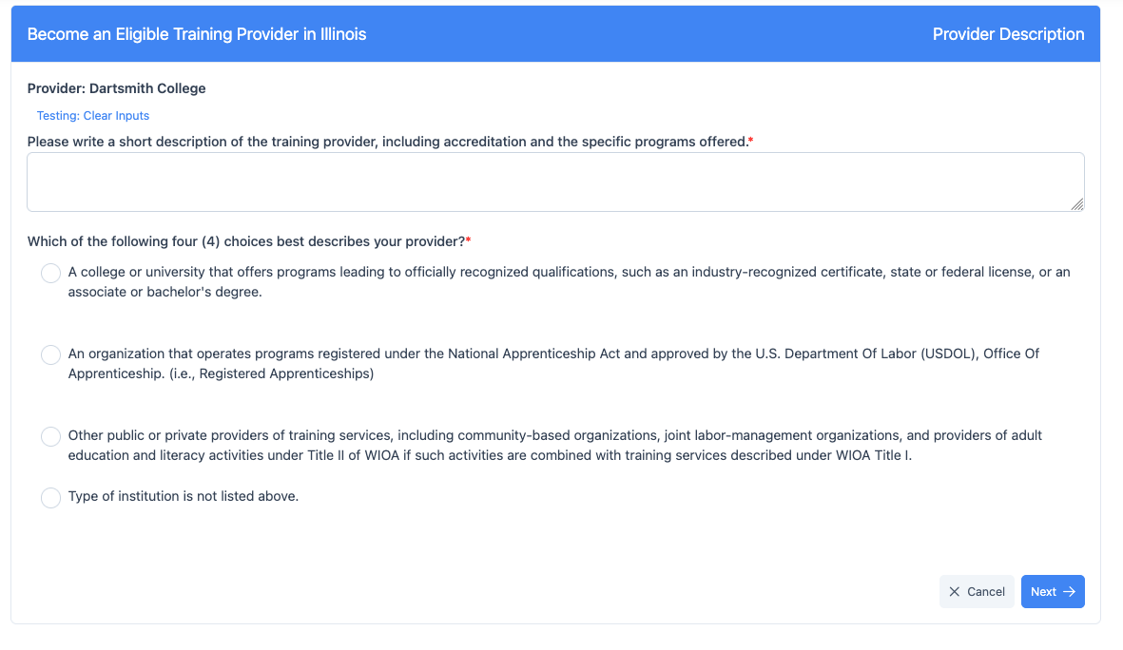
Figure 4 - Provider Description

Step 2 – Description of the provider
- Provider Description – Text Area to collect a description of the training provider including accreditation and the specific program or programs offered.
- Description selector – Single answer selection with greater detail defining the provider. The question is, “Which of the following four (4) choices best describes your provider?”
- Answer 1 - A college or university that offers programs leading to officially recognized qualifications, such as an industry-recognized certificate, state or federal license, or an associate or bachelor’s degree.
- Answer 2 - An organization that operates programs registered under the National Apprenticeship Act and approved by the U.S. Department of Labor (USDOL), Office of Apprenticeship. (i.e., Registered Apprenticeships)
- Answer 3 - Other public or private providers of training services, including community-based organizations, joint labor-management organizations, and providers of adult education and literacy activities under Title II of WIOA if such activities are combined with training services described under WIOA Title I.
- Answer 4 – Type of Institution is Not listed Above.

Step 2 – Description of Provider – Questions to the first answer
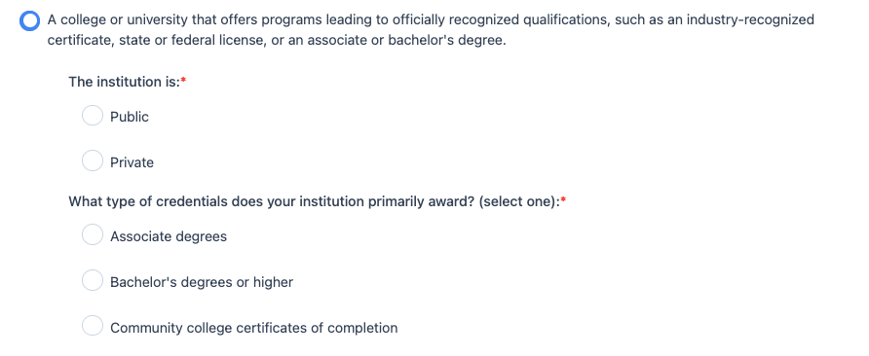
Figure 5 – Additional questions in response to answering provider description first answer.
When the first answer is selected, of the top four (4) provider descriptions, the answer will expand into two additional questions.
- The institution is: Public or Private
- What type of credentials does your institution primarily award? (select one):
  - Associate’s degrees
  - Bachelor’s degrees or higher
  - Community college certificates of completion

Step 2 – Description of Provider – Sub-Question for the second answer
When the second high-level answer on the provider description page is selected, “An organization that operates programs registered under the National Apprenticeship Act and approved by the U.S. Department Of Labor (USDOL), Office of Apprenticeship.”, then the page will expand to provide one additional sub-question.
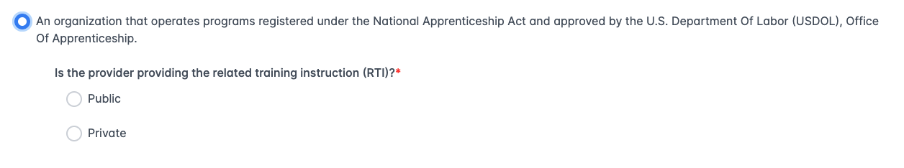
Figure 6 - Registered Apprenticeship sub-question
- Is the provider providing the related training instruction (RTI) Public or Private

Step 2 – Description of Provider – Sub-questions for the third answer
When the third high-level answer on the provider description page is selected, “Other public or private providers of training services, including community-based organizations, joint labor-management organizations, and providers of adult education and literacy activities under Title II of WIOA if such activities are combined with training services described under WIOA Title I.”, two additional questions will be asked.
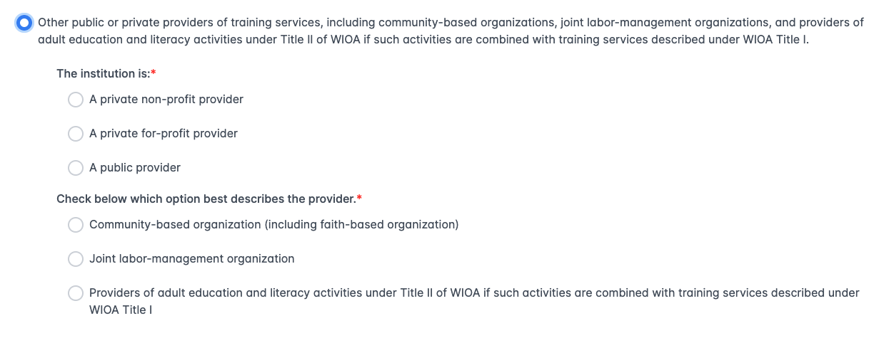
Figure 7 - Sub-questions for Other public or private providers
- The institution is:
- A private non-profit provider
- A private for-profit provider
- A public provider. Check below which option best describes the provider
- Community-based organization (including faith-based organization)
- Joint labor-management organization
- Providers of adult education and literacy activities under Title II of WIOA if such activities are combined with training services described under WIOA Title I. When answer C is selected then two additional questions are required
- Is the provider an adult education provider funded through the Illinois Community College Board (ICCB)? Yes/No
- Does the provider have a program or programs that are part of the Integrated Career & Academic Preparation System (ICAPS)? Yes/No

Step 2 – Description of Provider – fourth answer
If the fourth answer is selected from the high-level question, “Type of Institution is Not Listed Above.” The area under the question expands with a statement as follows:
Contact the State ETPL Coordinator for more information on becoming an eligible training provider in Illinois under the Workforce Innovation and Opportunity Act (WIOA).
If the next button is selected when the fourth answer is selected, the following error page will appear.
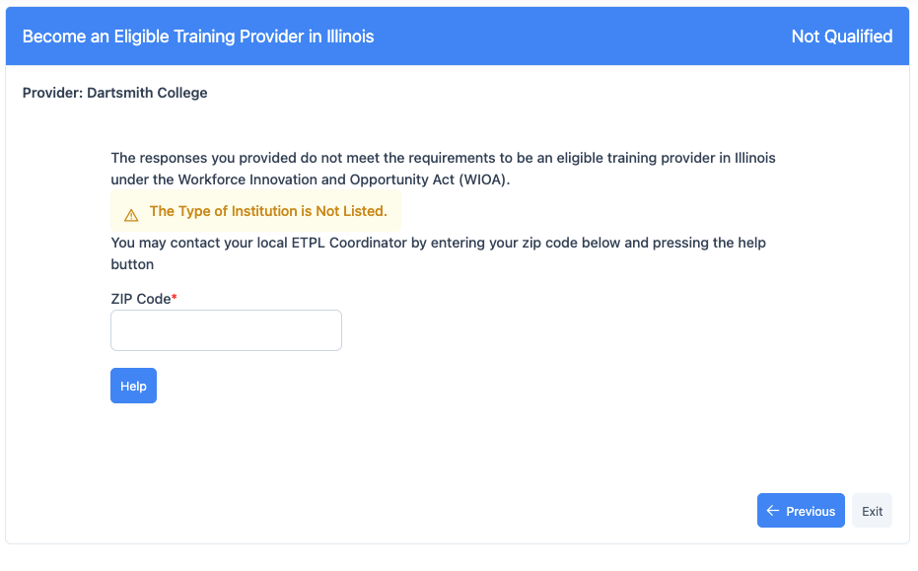
Figure 8 - Error Page

Provider Location – In-State or Out-of-State, Virtual Learning
The third page of the pre-screening process is the determination if the provider is in-state, out-of-state, or only virtual learning.
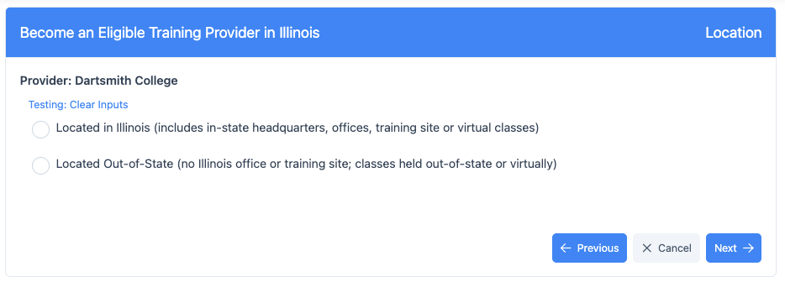
Figure 9 - Provider Location

Step 3 – Provider Location Question
There are two top-level choices for the provider location.
- Located in Illinois (includes in-state headquarters, office, training site or virtual classes)
- Located Out-of-State (no Illinois office or training site; classes held out-of-state or virtually)

Step 3 – Provider Location – Answer two sub-questions
When the first answer is selected, the provider is in-state, no additional questions are asked. When the second answer is selected, the provider is out of state or virtual, then the area below the answer will expand as shown in figure below and two (2) additional questions will be asked.
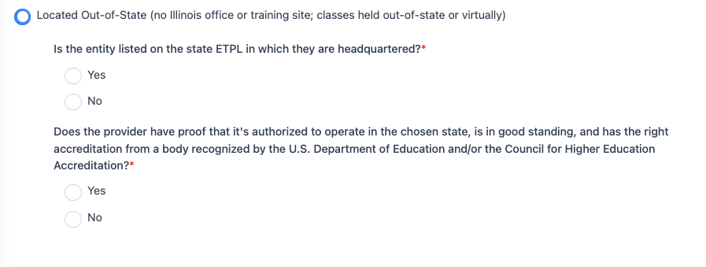
Figure 10 - Sub-questions for out of state providers
The Out-of-State or Virtual only answer has three (2) sub-questions
- Is the entity listed on the state ETPL in which they are headquartered? Yes or No. If yes is selected then the area will expand to allow the user to select the state.
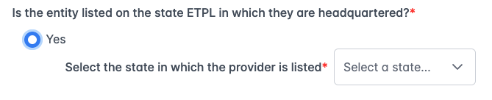
Figure 11 - State ETPL selection
- Does the provider have proof that it's authorized to operate in the chosen state, is in good standing, and has the right accreditation from a body recognized by the U.S. Department of Education and/or the Council for Higher Education Accreditation? Yes or No. If yes is selected then the area will expand to allow the user to upload a file.

Figure 12 - OOS documentation

In-state, Public Higher Education
After collecting the answers in step 2 and step 3, the system will route the user to step 4 according to the answers on page 2. The first page type is when the provider is a public higher education provider.
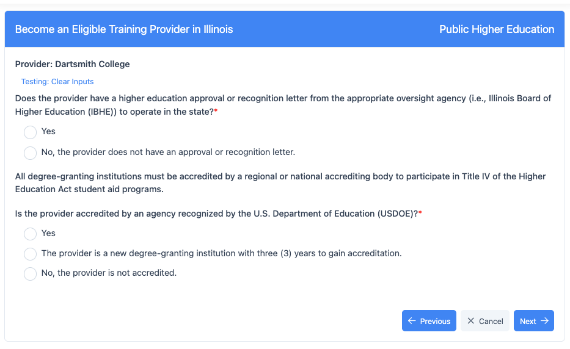
Figure 13 - Public Higher Education

Step 4 – Public Higher Education
The public higher education page has two (2) questions.
- Does the provider have a higher education approval or recognition letter from the appropriate oversight agency (i.e., Illinois Board of Higher Education (IBHE)) to operate in the state?*
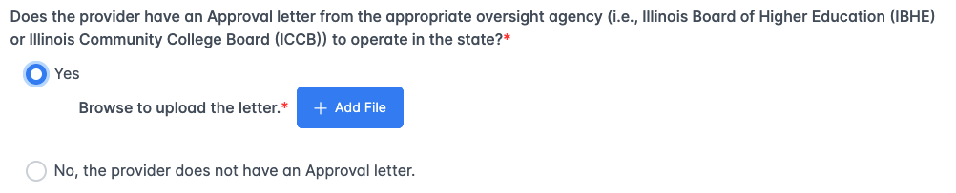
- All degree-granting institutions must be accredited by a regional or national accrediting body to participate in Title IV of the Higher Education Act student aid programs.
  - Yes – with a selection field to select the Accrediting Agency
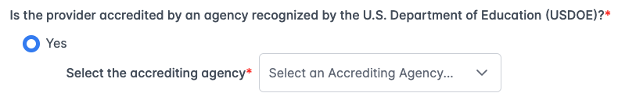
  - The provider is a new degree-granting institution with three (3) years to gain accreditation.
  - No, the provider is not accredited.
.

Private Higher Education
When the user selects private higher education on step 2, then private higher education step 4 is displayed.
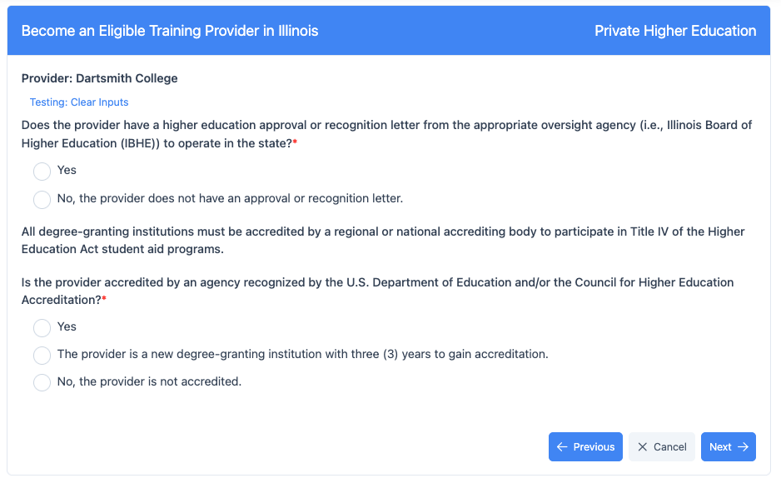
Figure 14 - Private Higher Education

Step 4 – Private Higher Education
This step has two (2) questions to answer affirmatively.
- Does the provider have a higher education approval or recognition letter from the appropriate oversight agency (i.e., Illinos board of Higer Education (IBHE)) to operate in the state .
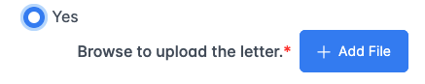
- All degree-granting institutions must be accredited by a regional or national accrediting body to participate in Title IV of the Higher Education Act student aid programs.
  - Yes
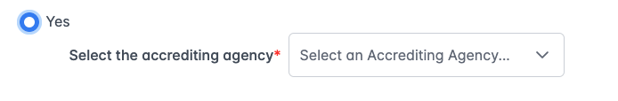
  - The provider is a new degree-granting institution with three (3) years to gain accreditation.
  - No, the provider is not accredited.

Registered Apprenticeship Program Public Organization
When the user selects the registered apprenticeship answer on step 2 and Public, the system will route the user to the registered apprenticeship questions on step 4.
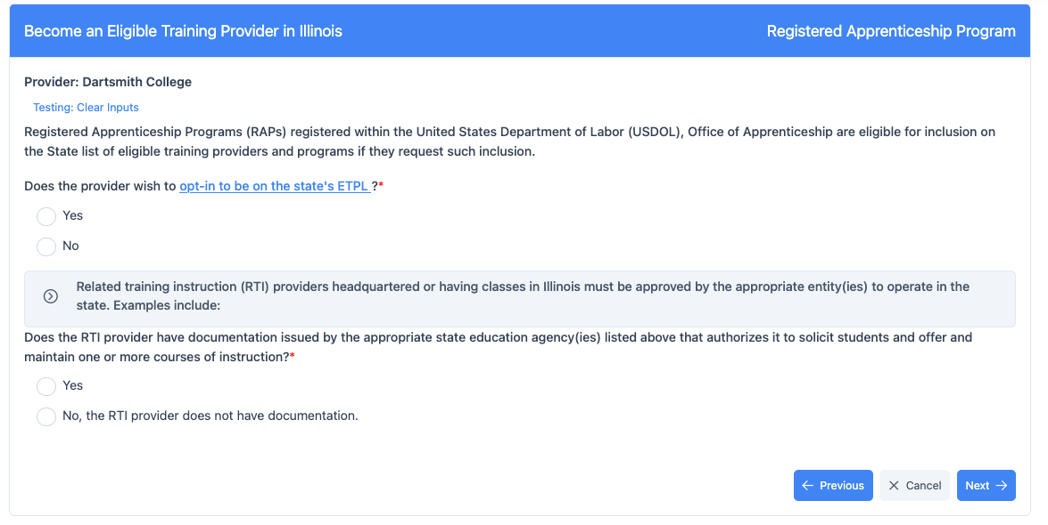
Figure 15 - Registered Apprenticeship Page

Step 4 – Registered Apprenticeship Public Program
There are two (2) questions on the Registered Apprenticeship Program with an expandable information block in the center of the page.
- The first question is “Registered Apprenticeship Programs (RAPs) registered within the United States Department of Labor (USDOL), Office of Apprenticeship are eligible for inclusion on the State list of eligible training providers and programs if they request such inclusion. This question has a link to the opt-in form that can be completed and uploaded.
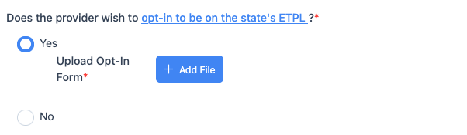
- The second question is “Does the RTI provider have documentation issued by the appropriate state education agency(ies) listed above that authorizes it to solicit students and offer and maintain one or more courses of instruction?”. Yes or No. If yes, then the authorization document can be uploaded.
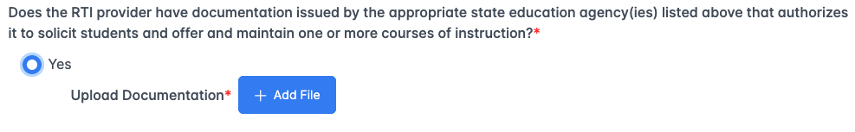

Registered Apprenticeship Program Private Organization
When the user selects the registered apprenticeship answer on step 2 and Private, the system will route the user to the registered apprenticeship questions on step 4.
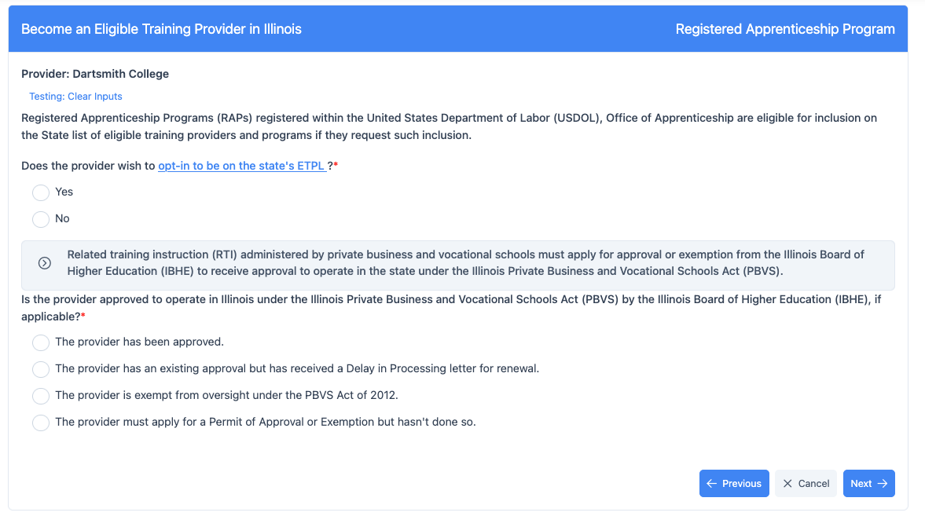
Figure 16 - RAP Private Organization

Step 4 – Registered Apprenticeship Public Program
There are two (2) questions on the Registered Apprenticeship Program with an expandable information block in the center of the page.
- The first question is “Registered Apprenticeship Programs (RAPs) registered within the United States Department of Labor (USDOL), Office of Apprenticeship are eligible for inclusion on the State list of eligible training providers and programs if they request such inclusion.
- The second question is “Is the provider approved to operate in Illinois under the Illinois Private Business and Vocational Schools Act (PBVS) by the Illinois Board of Higher Education (IBHE), if applicable?”. This question has four (4) answers:
  - The provider has been approved.

  - The provider has an existing approval but has received a Delay in Processing letter for renewal.
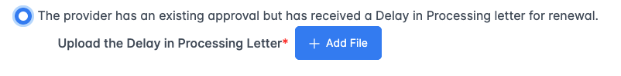
  - The provider is exempt from oversight under the PBVS Act of 2012.

  - The provider must apply for a Permit of Approval or Exemption but hasn't done so.

Community-Based or Labor Management Organization
When the user selects a community-based or labor management organization on step 2, then the fourth step will collect information on the organization.
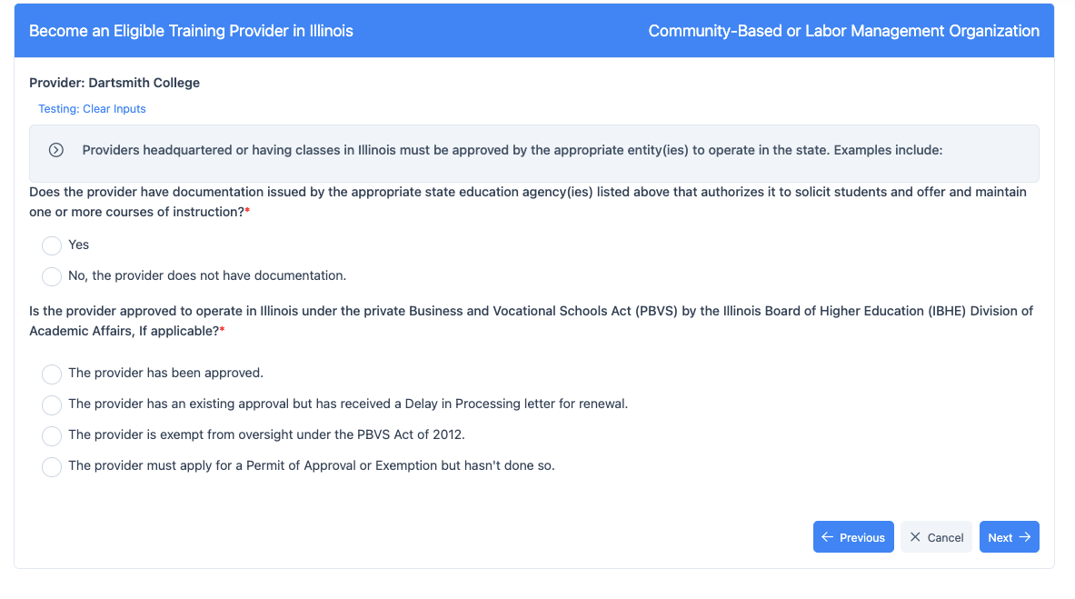
Figure 17 - Community Based or Labor Management top half of page

Step 4 – Community Based or Labor Management Organization questions
There are two (2) questions on this page with an expandable information section at the top of the page.
- The first question is “Does the provider have documentation issued by the appropriate state education agency(ies) listed above that authorizes it to solicit students and offer and maintain one or more courses of instruction?”. If yes, then the user can upload the authorization document.
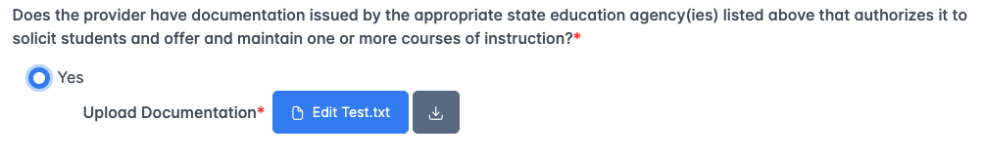
- The second question is, “Is the provider approved to operate in Illinois under the private Business and Vocational Schools Act (PBVS)?”. This question has four (4) possible answers.
  - The provider has been approved.

  - The provider has an existing approval but has received a delay in processing letter.
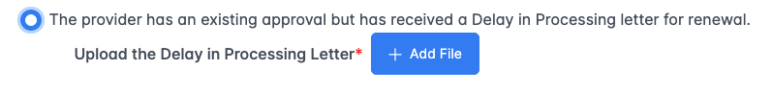
  - The provider is exempt.

  - The provider must apply.

Sign-up page after successful completion of pre-screening
After the appropriate four (4) pages have been answered affirmatively, the system will present the sign-up page. This page will allow the user to get their account to sign-in to IWDS-2.0. Once they have successfully setup their account through the DoIT Okta sign-up process, and they have successfully signed-in using that account, the system will take the user to the Add Entity page to complete the steps of adding their provider information and at least one location. Once that is complete, they can proceed to enter their training program and submit it for review.
Note: This page will likely change according to the parameters of getting an account through the DoIT Okta system. Most likely this will only be an explanation and a link to obtain the account.
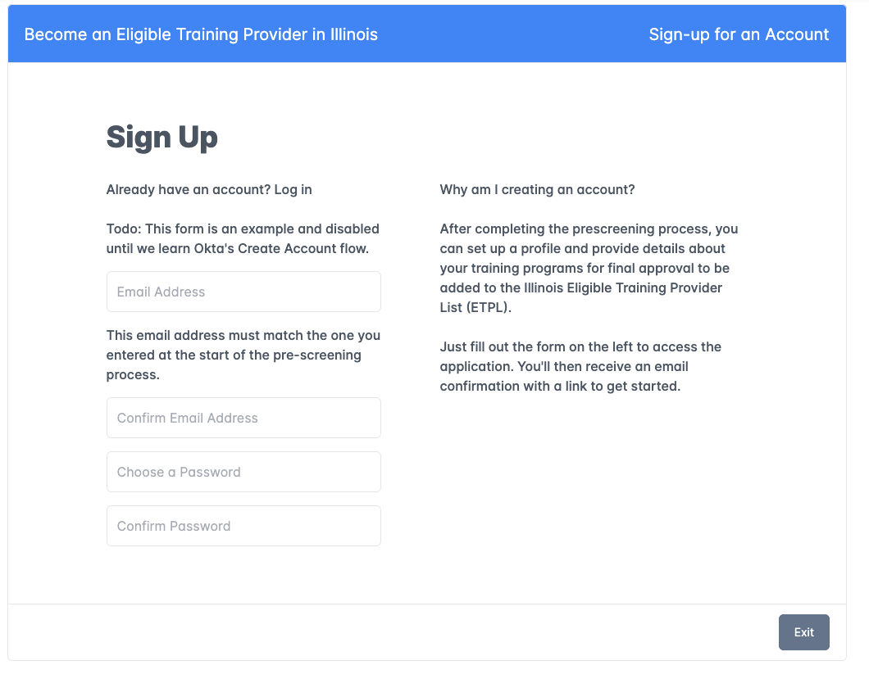
Figure 18 - Successful completion sign-up page

