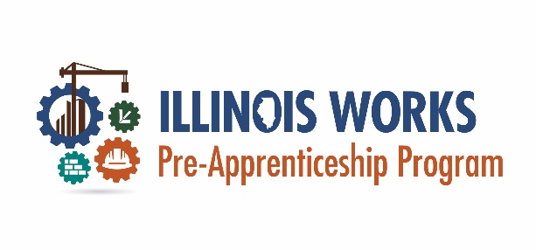
Exhibit 7 – Participant File Checklist
Participant File Checklist
Participant’s Name: _________________________________________________
Application Date: __________________ Enrollment Date: (if applicable) ___________________

Cohort # / Year: (if applicable) ___________________

Required Documentation for Each Stage of the Participant LifeCycle | Documentation Received (Please Initial |  |  |  | Document Source/Comments
 | Yes | No | N/A | Date & Initial
Outreach and Recruitment
Pre-screen Assessment (if completed hard copy)
Application
Pre-apprenticeship Program Application
Pre-apprenticeship Program Interview Questionnaire (with scores)
Enrollment decision letter (acceptance, conditional acceptance, denial)
Intake and Wrap-Around Services
Proof of address/Illinois residency
Age verification
Proof of Driver’s License
Proof of GED/HiSET or H.S. Diploma
Pre-Apprenticeship Training Program Commitment Agreement
Wrap-Around Service Assessment and relevant Wrap-around service documents
Career Assessment - Orientation
Policy documents provided to participants
 | Participant Name:
Training
Relevant documentation of Student Support, Wrap-Around, and Transition Services
Proof of stipend payment
Program Completion
Certificate of Completion and/or other document indicating successful completion (NCCER Core/MC3/ICCB, OSHA 10, First Aid/CPR, etc.)
Other credentials/certificates/certifications earned
Transition Services
Documentation of application and/or placement in DOL Registered Apprenticeship
Documentation of placement on DOL Registered Apprenticeship Waiting List (if applicable)
Documentation of placement in a secondary transition
Follow Up Services
Other documents relevant to follow-up
Exit Interview (if participant did not complete the program)

This document was developed by the Office of Illinois Works for the use by Illinois Works Pre-apprenticeship Program grantees.

