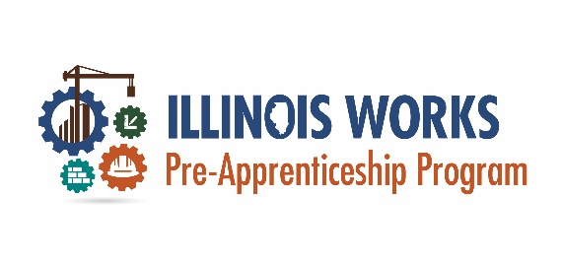
Tips for Running an Open House
Hosting an Open House can be an ideal and low-pressure way to meet prospective participants and give them a chance to learn about the program, meet program staff, and begin the application process. Below are some tips to keep in mind as your plan your open house and a sample agenda to help you plan your first event:
- Date and Time
When you are planning your open house, think about your target population. What is the best day and time for them to attend? Consider your target population’s other potential obligations such as school, work, and caring for children. Many open houses will span several hours to accommodate differing schedules, perhaps 5:00 PM – 9:00 PM on a weekday, or an all-day open house on a weekend day.
- Encourage Your Team and Partners to Attend
Open houses help introduce prospective participants to instructors, staff, and partner agencies that will provide support and help them succeed in the program. Fostering this connection and allowing prospective participants to gather information directly from program staff can increase their confidence and interest in the program.

Additionally, make sure to have staff positioned throughout the event so that potential participants feel welcome, and they know where to go for certain activities including where to complete pre-screening questions, and even fill out an application on-site.

- Offer an Activity or Learning Opportunity
These events are ideal times to show off the unique aspects of your program and provide participants with a more meaningful experience. Some activities might include providing tours of the classroom space/construction lab, having alumni mini sessions where prospective students can hear from/ask questions of recent graduates, or host a scavenger hunt that teaches potential participants about your program along the way.
- Offer Refreshments
Depending on the time of day that is chosen, make sure to offer refreshments in your open house event.
- Collect Information and Follow Up
The goal of the open house is to recruit new participants into the program. As a result, a key objective during the event is to gather contact information from potential participants. Collect this information as part of the registration process or as attendees arrive (use a sign-in sheet they need to fill out when they arrive). Prior to the event, set a standard for how quickly you want to follow up with attendees, and who will be assigned to do the follow-up.
Some attendees may want to complete pre-screening questions or the full application the night of the open house. Make sure to have staff available to help.
This document was developed by the Office of Illinois Works for the use by Illinois Works Pre-apprenticeship Program grantees.

