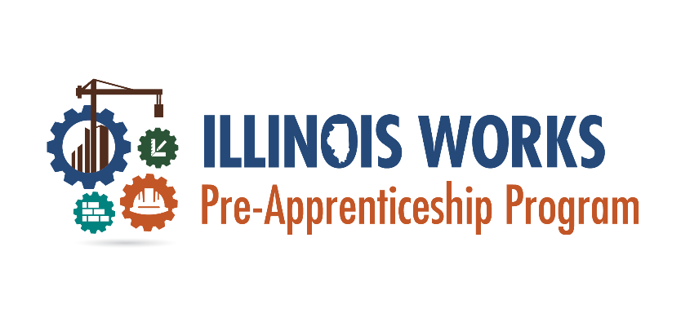
DOL Registered Apprenticeship Program Verification Form
In compliance with Illinois Works Pre-apprenticeship Program guidance, all grantees are required to offer participants information regarding any Department of Labor Registered Apprenticeship Program (DOL RAP) that the participant has expressed interest in. This includes but is not limited to assisting with apprenticeship applications, introductions to alumni or partners in that trade, DOL RAP site visits/tours. Please complete this form outlining which trade(s) were introduced to you during this program and provide information on any additional trades you may be interested in pursuing.
Participant name:
Program site:
Trades of interest:

Trades introduced during the program:

Are there any additional trades you’re interested in that you have not been introduced to/provided with information on? □ Yes □ No
If yes, what trades?

I acknowledge that the Illinois Works Pre-apprenticeship Program at _______________ [Program Site] provided me with information or introductions to multiple trades/DOL RAPs including those I have stated I have an interest in.

Signature:
Print Name:
Date:

