**Exhibit 15: Wrap-around Services Plan**

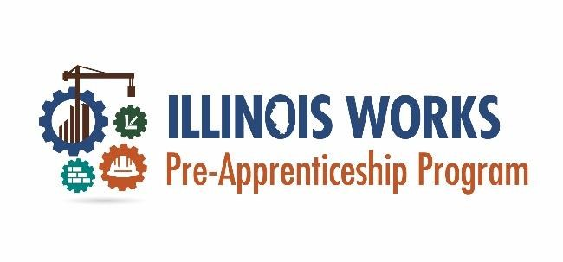

**Wrap-around Services Plan**

|  |
| --- |
| Illinois Works Grantee Manual Section 6 provides guidance on planning for Wraparound as outlined, these can include an array of items, but some common services are childcare, union application support, apprenticeship fees, and transportation. Participants must opt into wrap-around services. This model of services leads to greater self-sufficiency as it challenges participants to think through long-term planning for services. The Wrap-Around Services Plan document is a resource to support planning for services, Partnerships, to ensure participants have an equitable opportunity to complete pre-apprenticeship training. |
| **Organization Name:** |
| **Wrap-around Services Coordinator:** |

Illinois Works Grantee Manual Section 6: **Tables 10 and 11** can assist with identifying the specific program and/or service offered by your organization. The purpose of the Template below is to help you identify potential gaps in wrap-around services, so you can determine how the gaps can be filled. Use the Template to document Wraparound Service Partners, along with specifying if the services will be provided by internal staff or provided by an external Partner/Provider.

|  |  |  |  |  |
| --- | --- | --- | --- | --- |
| **Wrap-around Service** | **Service Partner/Provider**  **\*(Please specify if the service will be provided by internal staff, or an**  **external Partner/Provider)** | **Person responsible for**  **allocation to participant** | **Outreach Date** | **Confirmation Date** |
| **Childcare** |  |  |  |  |
| **Transportation (Public)** |  |  |  |  |
| **Transportation (Gas)** |  |  |  |  |
| **Transportation**  **(Car Repair)** |  |  |  |  |
| **Plate Renewal** |  |  |  |  |
| **Vehicle Registration** |  |  |  |  |
| **Vehicle Sticker** |  |  |  |  |
| **Plate Renewal** |  |  |  |  |
| **Vehicle Registration** |  |  |  |  |
| **Vehicle Sticker** |  |  |  |  |
| **Tech Support (Broadband)** |  |  |  |  |
| **Tech Support** |  |  |  |  |
| **(Hot Spot)** |  |  |  |  |
| **Tech Support**  **(Loaner Laptop)** |  |  |  |  |
| **Driver Education (Licensing)** |  |  |  |  |
| **Financial Literacy** |  |  |  |  |
| **Other (please specify)** |  |  |  |  |
| **Other (please specify)** |  |  |  |  |
| **Other (please specify)** |  |  |  |  |

**Guidance on Other Wraparound Supportive Services (Complex Needs)**

In addition to the identified wraparound services, Illinois Works provides guidance on populations that may experience specific challenges that require support beyond ILWs’ scope of services. Please see **Table 12** for additional support for planning for these barriers. The ILWPP Grantee Manual also provides other strategies for developing supportive services for participants with **complex needs** include planning and coordination of activities including but not limited to:

* Explore areas of support that are available to populations most in need.
* Convene regional topical interest groups to gather input on target populations, workforce development, career pathway, and transition issues.
* Explore, identify, and share options for providing high-quality counseling and advising to assist all participants in designing an appropriate social, academic and/or career pathway and enabling them to persist in the continuum of programs making successful transitions along the way.
* Develop closer partnerships with social service agencies to assist immigrants and refugees with multiple native languages who may have difficulty understanding initial guidance and career counseling.
* Provide support services that empower all learners to take responsibility for self - advocacy.