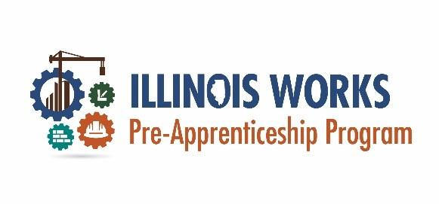
Program Coaching versus Technical Assistance
Exhibit 13: Program Coaching versus Technical Assistance
To help ensure program success, Illinois Works (ILW) provides a robust catalog of professional development, and technical assistance support including webinar sessions, the coaching program, technical assistance (compliance), Toolbox Tuesdays, regional meetings, and the ILW annual conference. Each offers benefits associated with activities that support grantee compliance with program expectations.
Program Coaching
The goal of Program Coaching is to provide grantees with customized support in the following domains: Instructional Certifications, Pre-apprentice LifeCycle, and Business Development. According to the Illinois Works Grantee Manual, “Program Coaching is tailored to provide proactive, and preventive one-on-one support, driven by the needs analysis and coaching planning,” (2022, p. X). Approximately 75 percent of coaching support is proactive, and 25 percent is reactive.
The Illinois Works Program Coach partners with individual grantee organizations to provide tailored support to help ensure program success and alignment with their ILW grant expectations.
Illinois Works conducts a needs analysis of each Grantee, using the following to help identify possible barriers to program success;
- Internal Controls Questionnaire (ICQ)
- Programmatic Risk Assessment Questionnaire (PRAQ)
- NOFO Reviewers’ Application Evaluation Scoring Sheets and Notes
- Illinois Works Coaching Needs Assessment Questionnaire
- Per the Direction of the Illinois Works Deputy Director (contract negotiations)

The results of the needs analysis will inform the creation of a tailored Program Coaching Plan (Track II / Track III) or Technical Assistance using an internal Professional Development Plan (Track I). The grantee Program Coaching Plan will be leveraged to prevent or mitigate program challenges and to support continuous program improvement.

Program Coaching
Program Coaching is approached with optimism, possibility, and compassion with the goal of overcoming obstacles that may impose on performance outcomes. Track II Grantees will receive feedback on the results of the needs analysis, with details regarding the outcomes for Program Coaching.
*Please note, ILW Program Coaches are not programmatic staff and cannot assist grantees with program delivery but exist to provide beneficial guidance for program and organizational improvement.
Technical Assistance
The goal of Technical Assistance is to help ensure compliance with ILW performance expectations, reporting requirements, and grant outcomes. Grantees will receive feedback and targeted assistance guided by their monthly compliance report. This one-on-one intervention involves troubleshooting, problem solving, and corrective action to help ensure grantees meet their programmatic milestones and outcomes.
Please note, Technical Assistance is responsive and reactive support driven by program reports and deployed on an as-needed basis. Grantees will be alerted when technical assistance is necessary. Unlike Program Coaching, which is delivered by Consultants, Technical Assistance is delivered by ILW Grant Managers, or other ILW staff.
Benefit of Technical Assistance: Technical Assistance uses the data entered into IWRS to identify performance opportunities, and addresses those directly associated with grantees.
Program Coaching vs. Technical Assistance
- Program Coaching is prevention and mitigation, while Technical Assistance aids with course correction.
- Program Coaching is scheduled regularly, while grantees will be alerted when Technical Assistance is necessary.
- Program Coaching is primarily proactive, while Technical Assistance is reactive.
- Program Coaching is delivered by independent consultants and Technical Assistance is delivered by ILW Grant Managers, or other ILW staff.
Both Technical Assistance and Program Coaching provide “targeted assistance to grantees, with the goal of program performance improvement through program development” (ILW Grantee Manual.)
More information related to Technical Assistance/Professional Development can be found in Section 9: Technical Assistance/Professional Development of the ILW Grantee Manual.

This document was developed by the Office of Illinois Works for the use by Illinois Works Pre-apprenticeship Program grantees.

