APPENDIX F: State and Regional Workforce Plans
Illinois’ Unified State Workforce Plan includes labor market information to help workforce, education and economic development partner design and deliver programs and services. The plan includes an in-depth analysis of Illinois’ targeted industries and occupations. Applicants are encouraged to review the Economic and Workforce Analysis of the state and regional plans at https://www.illinoisworknet.com/WIOA/Resources/Pages/StateUnifiedPlan.aspx

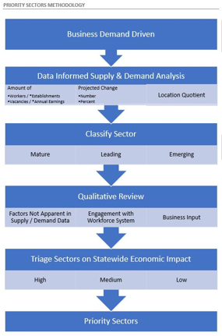
Regional Economic Analysis of Existing and Emerging Sectors
The regional planning process utilizes the same analytic steps to assist regional teams to identify leading, emerging, and maturing industry clusters and occupations within each region. This includes the development of crosswalks between the detailed (3-digit) industry clusters and the occupational pathways for each region. Results of the crosswalk pinpoint occupations related to the detailed industry clusters identified statewide as leading, emerging, and maturing. These are considered starting points for conversations with employers regarding critical occupations within their industries during the complete regional planning process. See page 34 of the Unified Plan for a summary of the Leading Emerging and Maturing Industry by Economic Development Region. To download the regional plans please go to:
https://www.illinoisworknet.com/WIOA/RegPlanning/Pages/Plans_MOUs_Dashboard.aspx

