**APPENDIX E: Diversity, Equity, and Inclusion Action Plan**

Applicants will be required to develop a Diversity, Equity and Inclusion (DEI) plan that includes a commitment to adopt, expand, and promote the proposed diversity, equity, and inclusion activities. The following table outlines strategies for applicant to consider in developing a diversity, equity, and inclusion plan.

**Table 1 – Additional Strategies for DEI RAP Expansion**

|  |
| --- |
| Using RAP pathways, such as youth and pre-apprenticeships and qualifying customized employer-based training, to diversify Registered Apprenticeships. |
| Identifying opportunities to braid and blend funding from other education and workforce partners to increase supportive services for participants with multiple barriers. This includes greater alignment and integration with state agencies and industry partners such as the Department on Aging, Department of Human Services, and H1B expansion grant programs for Manufacturing and Human Resources. |
| Reaching out to partners organizations with a track record in moving women into non-traditional jobs |
| Rethinking State workforce policy to incentivize employers and service providers to expand access to apprenticeships by low-income and underrepresented populations. |
| Training State front-line and AJC staff in effective strategies to increase RAP participation |
| Reaching out to existing apprenticeship staff to identify technical assistance needs and resources relevant to inclusion and diversification strategies. |
| Structuring the RFP process for regional expansion grant activities to prioritize DEI projects |
| Provide Business Coaching services to support apprentices as they onboard into their respective RAPs. Business Coaches will serve two primary functions: 1) providing essential skills development through real-time coaching, advising, and mentoring, and 2) providing DEI training for employers who may not have a dedicated DEI HR system |

*Illinois’ Diversity, Equity, and Inclusion Plan*

Illinois has wholeheartedly embraced that Diversity, Equity, and Inclusion (DEI) efforts are the pillars on which a just outcome must rest for all its programs and residents. On January 16, 2019, Governor J.B. Pritzker issued Executive Order #3 (E.O. #3), directing state agencies to review current practices and recommend alignment of resources that serve disenfranchised populations, setting forth the State’s unequivocal commitment to adopting, promoting, and expanding statewide its DEI efforts. This Executive Order forms the basis for individual state agency plans, which are under refinement at: (1) DCEO [Equity Action Agenda adopted April 2019; Equity Task Force formed in 2020 and actively meeting] and (2) IL Board of Higher Education [equity strategic plan under development]. The Illinois Community College Board completed the Closing the Achieving Gap Report in November 2020. The Illinois State Board of Education (K-12 districts) adopted an equity plan in its 2020 strategic plan. The Partnership for College Completion (public and private colleges in 7 county region) adopted its Illinois Equity Plan framework in 2018, with updates in 2020. The Illinois Innovation Network (state public universities and colleges) launched in 2017 includes DEI as a priority in its charge. These statewide efforts, encompassing the public and private sector reflect the State of Illinois’ intentional decision to transform its foundation from one of DEI awareness to one of data-documented strategic DEI outcomes.

DCEO was selected to participate in a [Maher & Maher Innovation Cohort](http://maherdemo.com/InnovationCohort/Innovation_Cohort/index.html#/) (Cohort) focused on increasing diversity in apprenticeships. A four-person team representing Illinois brought together leadership experience and perspectives from higher education, human services and rehabilitation services, and state and local workforce, spanning the WIOA titles. Both the Cohort groups and Illinois specifically quickly acknowledged that addressing DEI goes far beyond simply recruiting apprentices in target populations or under-represented groups. They recognized that the focus is not solely on potential apprentices, but also the system itself, how inclusive the marketing and outreach are, the culture of the employers and workplaces, and the supports available to boost chances of success at every stage.

Following on the Cohort participation, Illinois is undertaking the following steps to institutionalize DEI principles statewide: (1) confirm alignment of strategies and action steps with the IWIB Equity Taskforce established in 2020; (2) coordinate and align between IWIB Committees; (3) request that a joint Apprenticeship Illinois Committee member and Equity Taskforce member serve ambassador for DEI in apprenticeship on the IWIB Equity Taskforce and provide quarterly reports on DEI efforts to the Apprenticeship Illinois Committee; (5) implement a process to collect and analyze demographic apprenticeship data; (6) continue using Cohort tools, such as the action planning framework and a draft apprenticeship partner map in various applications, such as the training for new apprenticeship staff started in March 2021.

In pursuing an equity-based approach to system design and program delivery, Illinois recognizes that diversity and inclusion alone will not improve opportunities for the most marginalized and least supported workers. It is equity, the assessment of the distribution of assets and resources, coupled with active enforcement of clearly defined outcome measures that will drive the pursuit a more “wholistic” approach to workforce education and training to prepare Illinois’ workers for 21st century opportunities, regardless of zip code at birth, first grade, or residence. That “wholistic” approach recognizes that the “whole” needs of the “whole” person needs to be addressed in the “whole” of their community for a truly holistic, leveraged approach to work effectively for the employee, employer, community, and State.

**Creating apprenticeships in Illinois that achieve gender and racial equity**

According to [*Closing the Divide: Making Illinois a Leader in Equitable Apprenticeships*, a report by Young Invincibles](https://www.illinoisworknet.com/DownloadPrint/YI_ClosingTheDivide.pdf), only 4 percent of Illinois apprentices are women and only 27 percent are people of color. Women and people of color are less likely to complete apprenticeships and are often employed in positions with lower-than-average pay.

Strategies to address equity include changes in recruitment practices, intentional marketing (including using images of women and people of color), addressing discrimination within programs and at workplaces, and offering supports that boost retention and completion, such as child care, transportation, and career counseling.

More resources for competitive proposals

* *[Growing Equity and Diversity Through Apprenticeship: Business Perspectives](https://www.jff.org/resources/growing-equity-and-diversity-through-apprenticeship-business-perspectives/)*[, JFF Center for Apprenticeship and Work-based Learning](https://www.jff.org/resources/growing-equity-and-diversity-through-apprenticeship-business-perspectives/)
* *[Principles for Equity in Apprenticeship](https://www.jff.org/resources/growing-equity-and-diversity-through-apprenticeship-business-perspectives/)*[, Center on Wisconsin Strategy](https://www.jff.org/resources/growing-equity-and-diversity-through-apprenticeship-business-perspectives/)
* [*Flowchart of Equitable Apprenticeship Models*, Young Invincibles and Chicago Jobs Council](https://www.illinoisworknet.com/DownloadPrint/Flowchart%20of%20Equitable%20Apprenticeship%20Models.pdf)

The IWIB Equity Taskforce is charged with identifying specific steps that the IWIB and its local workforce boards, stakeholders and partners could utilize to: (1) adopt the IWIB’s framework for equity; (2) implement specific measurable activities to ensure that its workforce was professionally trained in this area; and (3) align programs and best practices with its equity focus and outcome metrics. By December 2020, the Taskforce identified anchors and drivers for its equity work and, in January 2021, established an equity framework and began applying an equity lens to its work.

Through E.O. #3 and DCEO’s adoption of a Plan, the focus on DEI is not only on the apprentice but on the trainer, navigator, intermediary, and all other personnel supporting an apprenticeship program. The Equity Task Force is reviewing professional development training and standards to require of its stakeholders to ensure that they are equipped, trained, and experienced in delivering services through an equity framework, in designing programs and curricula that reflect an understanding of the dimensions of diversity, and in developing policies that integrate equity outcomes into the analysis and metrics. Additionally, the Equity Task Force is setting equity goals for programs to measure performance, ensuring that outcomes are the focus of the programs and using a data-driven approach to measuring sustainable progress.

The chart below demonstrates how Illinois is building its equity foundation to elevate target populations to achieve wealth, building its programs on an equity framework and aspirational goal of achieving equity in the future. Illinois has adopted the “rung bell” approach: once exposed to inequity and trained in strategies to overcome individual and collective contributions to disinvestment, marginalization, and segregation, one must change how one works in their field of specialty.

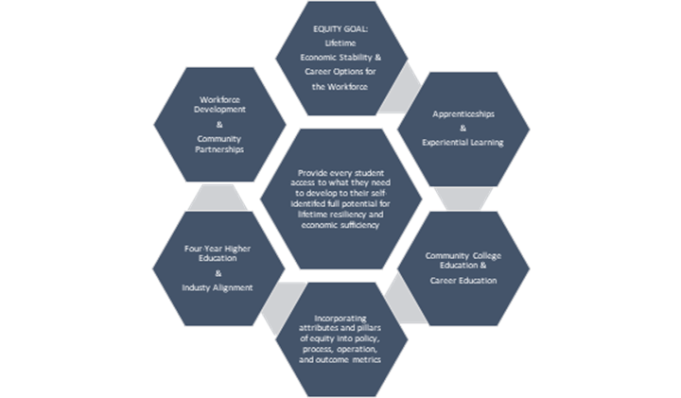

This paradigm is particularly important to achieving equity – immersing frameworks of equity, dimensions of diversity, and principles of inclusion into every action. While some populations’ lived experience is that shown on the student-focused chart below, many members in the target populations approach education and apprenticeship experience as a luxury.

*Investing in Supportive Services to Reduce Barriers*

Illinois’ equity initiative starts with the understanding that Safety Net Security must be provided for all as part of making education and family supporting living wage work experience a reachable reality and not only an aspirational dream. Illinois’ application is supported by the Illinois Department of Human Services, Division of Rehabilitative Services and Division of Youth Services that are also committing to an equity approach in their work and in partnership with DCEO to ensure that the “whole” person is supported in their apprenticeship journey

Illinois’ equity initiative starts with the understanding that Safety Net Security must be provided for all as part of making education and family supporting living wage work experience a reachable reality and not only an aspirational dream. Illinois’ Apprenticeship Illinois Framework is supported by the Illinois Department of Human Services, Division of Rehabilitative Services and Division of Youth Services that are also committing to an equity approach in their work and in partnership with DCEO to ensure that the “whole” person is supported in their apprenticeship journey.

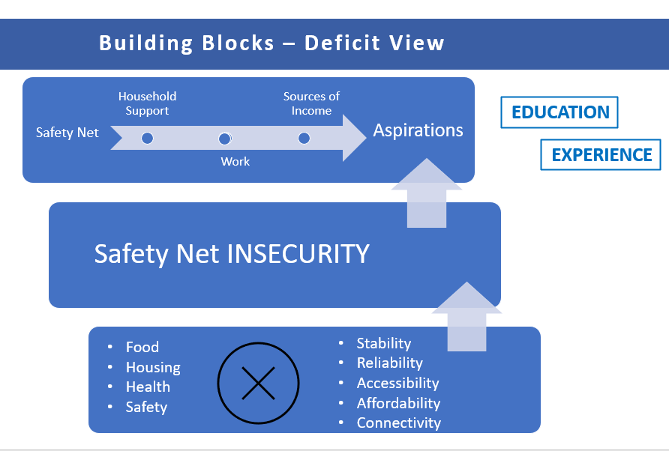

With the adoption of an Executive Order, development of an Equity Action Agenda, formation of an Equity Task Force, engagement of diverse and inclusive strategic partners, and enhancement of its partnerships with equity-focused stakeholders, Illinois is demonstrating that it is not only adopting, expanding and promoting DEI as a key state-wide initiative, it is demonstrating that Illinois is building its future talent pipeline on a data-driven equity framework that increases diversity, promotes inclusion, and leverages fair and just opportunity for all.