APPENDIX C. U.S. Chamber of Commerce Foundation Talent Pipeline Management Initiative
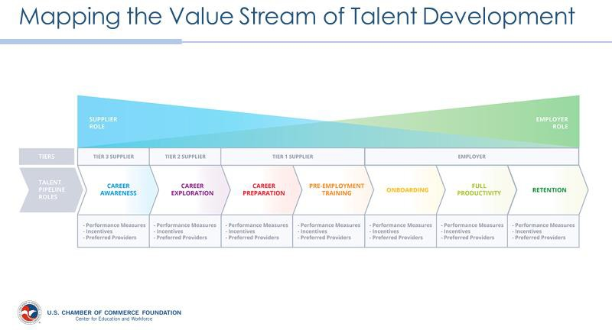
https://www.uschamberfoundation.org/talent-pipeline-management

