APPENDIX A: Apprenticeship Illinois Framework

The Department has recognized that apprenticeships are a promising work-based learning strategy connecting individuals to a career pathway as well as being a solution for businesses to find and tap into undiscovered talent. The Department and the IWIB Apprenticeship Committee have determined support for Apprenticeship Intermediaries and Regional Navigators are the best investment to build the foundation for apprenticeship expansion in Illinois. Regional Apprenticeship Navigators and Apprenticeship Intermediaries represent two important sides of a statewide apprenticeship system: Navigators represent the demand side, e.g., businesses who want to host apprenticeships, and Intermediaries represent the supply side, e.g., the institutions and/or partnerships that coordinate and/or implement apprenticeship programs, including recruiting potential apprentices and preparing them to enter apprenticeships.

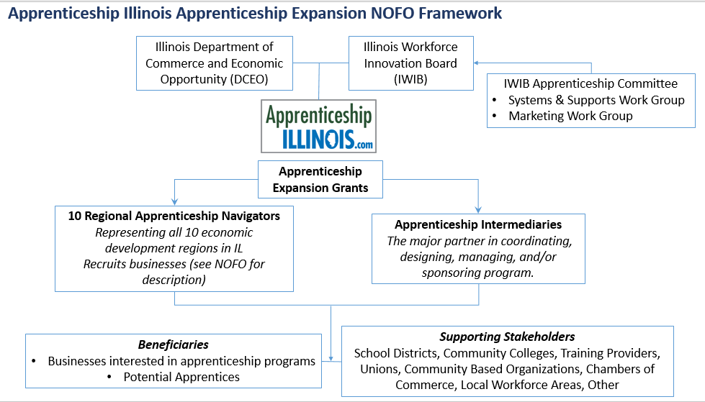

Seeing the value of apprenticeships, multiple organizations are either providing, promoting, advocating,
or supporting pre-apprenticeship, youth apprenticeship, non-registered apprenticeship, and registered
apprenticeship programs within Illinois. Besides state agencies (DCEO, ICCB, IDES, IDHS-VR, ILDOL), other
stakeholders include the Illinois Workforce Innovation Board (IWIB) Apprenticeship Committee, the local
workforce areas, universities, community colleges, secondary school districts, chambers of commerce,
industry associations, unions, non-profits, community-based organizations, apprenticeship navigators,
intermediaries, and more.

Utilizing apprenticeship as a workforce strategy for businesses and a career pathway for individuals aligns the Governor's vision as well as the plans required for state education and workforce entities. These include the following: Governor Pritzker's Executive Order 2019-03; the Illinois Economic Plan, the
Illinois Unified State Plan, including the Illinois Workforce Innovation Board, WIOA, and Perkins V. The Illinois Workforce Innovation Board (IWIB) established the Apprenticeship Committee in 2016. The Committee integrates their work into the larger framework of career pathways, establishing apprenticeship as a work-based learning model. The Committee recognized that apprenticeships are a promising work-based learning strategy connecting individuals to a career pathway as well as being a solution for businesses to find and tap into undiscovered talent, all branded under the name of Apprenticeship Illinois. This volunteer committee includes leaders representing all key apprenticeship stakeholders: business and industry, training providers, local workforce innovation boards, community-based organizations, unions, secondary and post-secondary entities, the core WIOA partners, and the State Workforce Board. The Committee’s charge is to advise the IWIB on apprenticeship and to oversee the implementation of a comprehensive statewide plan with the following goals:
- Fully integrate apprenticeship into state workforce development, education, and economic development strategies and programs
- Support the rapid development of new apprenticeship programs and/or the significant expansion of existing programs
- Support the development and recruitment of a diverse pipeline of apprentices, and
- Build state capacity to make it easier for businesses to start apprenticeship programs and for apprentices to access opportunities

Some states, such as Illinois, do not have state apprenticeship offices, where apprenticeship development and programming can be centralized and expanded. Currently apprenticeship programs cut across three state entities: Department of Commerce and Economic Opportunity, Department of Employment Security, Department of Human Services Division of Rehabilitation Services, and the Illinois Community College Board. The Department of Commerce has a long-term vision for growing apprenticeships that revolves around supporting apprenticeship navigators to promote apprenticeships regionally and apprenticeship intermediaries that support the apprenticeship experience start to finish. Since Illinois has a decentralized apprenticeship structure as a state, expanding apprenticeships statewide will need an infrastructure to support apprenticeship development and implementation.

Illinois has made significant progress with the service integration policies lead by the State Workforce Board through the Service Integration Taskforce. It is anticipated that this important work will expand to the next phase as the core and required workforce partners strengthen the current level of integration, identify opportunities for improvement, and launch innovative approaches to expansion of RAP opportunities and the recruitment of a diverse apprenticeship candidate base.

The projects that are supported by this NOFO should leverages past successes and seek to better align projects with an increased focus on pre-apprenticeship and registered apprenticeship programs, as well as supporting unregistered apprenticeship programs in transitioning to RAPs. For example, an Apprenticeship Illinois mapping project is underway to formalize coordination efforts and to continue to build knowledge about the funding landscape and effectiveness of specific apprenticeship programs and supports, which follows the key opportunities identified in a 2020 Apprenticeship and Work-Based Learning in Illinois report studying potential expansion of apprenticeship programs, the Apprenticeship Illinois committee work plan, and working groups. The following table highlights some of the active federal, state, and private initiatives.

Partner | Opportunities for Leveraged Funding and Programming
IL Community College Board | Information Technology Grant Program - , Expanded Navigator integration
IL State Board of Education | Secondary Ed apprenticeships, pre-apprenticeship expansion
IL Board of Higher Education | Degree apprenticeship expansion, University partnerships
IL Dept. of Commerce and Economic Opportunity | IL Apprenticeship Tax Credit (Business Development), IL Film Tax Credit (Film Department), WIOA (Local Workforce, Office of Employment & Training), Trade Act
IL Dept. of Employ. Security | Federal Work Opportunity Tax Credit; Federal Bonding Program for second chance hiring of workers reentering the workforce
IL Dept. of Human Service | Youth Program; Div. of Vocational Rehabilitation Services
IL Dept. on Aging | Senior Community Service Employment Program
IL Innovation Network | Linking apprenticeship with 4-year degrees: University partnerships, including Minority Serving Institutions (MSIs)
Labor and Trade Unions including AFL-CIO | Recruitment and retention of underserved populations with an emphasis on female and minority candidates
Chambers of Commerce and Industry Organizations | Talent Pipeline Management (TPM) training expansion, leveraging sector-specific work-based learning strategies
Society for HR Management | H1B grants for human resource occupation apprenticeships
Community-Based and Advocacy Organizations | Supportive services for pre-apprenticeship and RAP candidates, DEI recruitment and retention strategies

