Illinois workNet Virtual Job Fair (VJF) Instructions for Workforce Partners
Contents
Illinois workNet Virtual Job Fair (VJF) Instructions for Workforce Partners 1
Overview of Virtual Job Fair Portal 1
Overview of Resources 2
Employer 2
Job Seeker 3
Virtual Job Fair 3
Training & Services 3
Instructions for Employers on Adding a Booth and Additional Resources 3
Preparing for a Virtual Job Fair in Your LWIA 3
VJF Partner and Planning Guides for LWIA Staff 4
Samples of Outreach to Employers and Job Seekers in Your LWIA 5
Managing Employer Booths in Illinois workNet 6
Overview of Dashboard Area 7
Actions within Dashboard 7
Illinois workNet Virtual Job Fair Platform - Staffing Agency Participation Guidelines 12
VJF Events Dashboard 12
Managing Single Employer Events 13
Managing Multi-Employer Events 20
FAQs 28

Overview of Virtual Job Fair Portal
The Virtual Job Fair tools are an opportunity for employers in Illinois who are hiring to easily advertise their organization and connect with qualified job applicants at no cost.
- Employers are able to set up and manage their virtual job booths and post information about their organization and available job openings.
- Employers are able to enter virtual job events. They can host their own event or request webinar assistance when hosting their Virtual Job Fair events.
- Job Seekers can learn about and apply for job openings by exploring these employer booths.
- Job seekers will be able to attend Virtual Job Fair events to explore what opportunities are available to them and communicate with representatives from employers that are hiring in Illinois for free.

Employers and job seekers are welcome to visit the site and start setting up and visiting the Virtual Job Booths.
Virtual Job Fair events continue to be scheduled as requested.

Overview of Resources
The Illinois workNet homepage now has a few different sections for Illinois residents seeking employment opportunities.
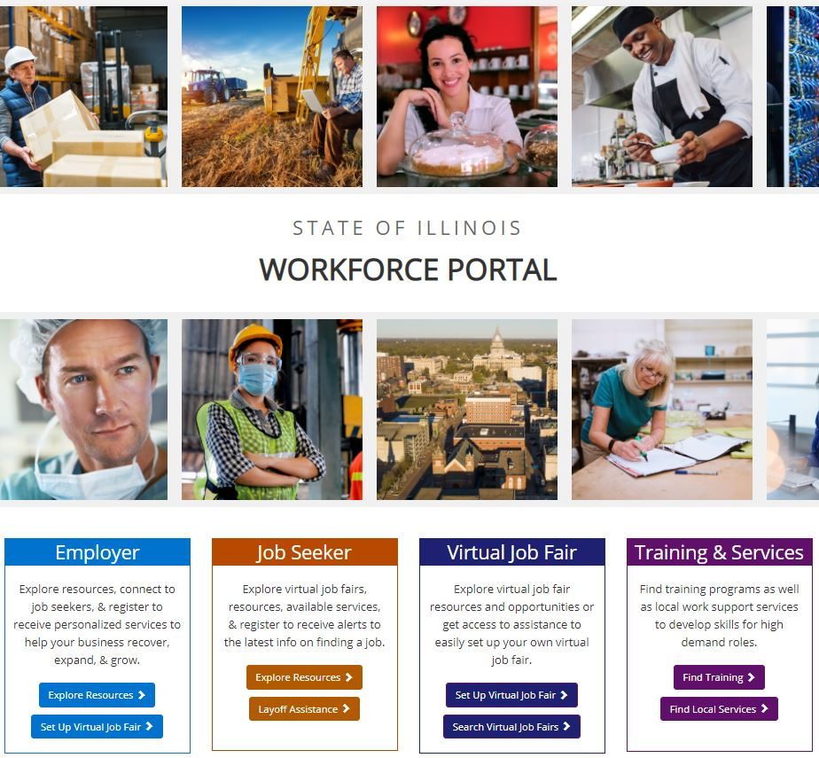
The information below lists the links and has a brief description of where each button directs you:

Employer
Explore Resources – Quick Start Guide for Employers of available resources on Illinois workNet.

Set Up Virtual Job Fair – Step by step instructions for employers to create an Employer Booth with the Virtual Job Fair portal.

Job Seeker
Explore Resources – Quick Start Guide for Job Seekers of available resources on Illinois workNet.

Layoff Resources – Layoff Assistance Guide that job seekers can use to find relief due to loss of employment.

Virtual Job Fair
Set Up Virtual Job Fair – Step by step instructions for employers to create an Employer Booth with the Virtual Job Fair portal. This includes brief videos for each step in this process.
Search Virtual Job Fair – Directs users to the Virtual Job Fair (VJF) landing page that lists Employer Booths of organizations that are currently hiring in Illinois and the number of available job openings. There is also a calendar view where you can view upcoming Virtual Job Fair Events.

Training & Services
Find Training – This is a quick start guide for training opportunities and resources available on Illinois workNet and the Illinois Community College Board (ICCB) website.
Find Local Services – This leads to the Illinois workNet Service Finder page where job seekers and employers can contact local organizations to assist them with their employment and hiring needs.

Instructions for Employers on Adding a Booth and Additional Resources
Instructions are available for employers to add their booth to the Virtual Job Fair portal. This page provides a step by step overview of how employers can go through the process of submitting their employer booth and requesting assistance in holding a virtual event.

There are also a few articles for job seekers and employers regarding Virtual Job Fair events. These articles provide tips for both audiences to prepare for and attend these live events:

Job Seekers:
- Prepare for a Virtual Job Fair: Job Seeker Tips for Success
- Attending Virtual Job Fair Events – Job Seekers

Employers:
- Preparing for Virtual Job Fairs – Employers
- Attending Virtual Job Fairs – Employers

Preparing for a Virtual Job Fair in Your LWIA
While there have been press releases and other announcements about the Virtual Job Fair portal, we strongly encourage you to reach out to employers within your region so that they may submit their employer booth page(s) for job seekers to see.
There’s the option to hold VJFs for one employer or multiple employers.
In targeting outreach to employers in your region, feel free to focus on a specific industry or group of employers.
If you find a date that works for all parties, you can try to hold four or five VJF events in one afternoon, whether or not the target audience or group of employers is the same.
For the Virtual Job Fair events you will hold, our staff will assist with technical issues on Zoom while your team facilitates the webinar. You can find recordings of previous events on the Illinois workNet YouTube channel to get a sense of how these are structured (search “Virtual Job Fair” within Illinois workNet’s YouTube page to find past events)
Additionally, you can drive job seekers and employers to Virtual Job Fair events in your LWIA by:
- Sharing posts on your social media channels
- Creating and posting flyers regarding upcoming events
- Adding to your website’s calendar of upcoming events
If employers or job seekers would like to read more about the VJF on Illinois workNet, you can refer them to this announcement: https://www.illinoisworknet.com/UpdatesHelp/Pages/News.aspx?PostID=610

Also, you may provide this instructional handout on how employers can submit their booth: https://www.illinoisworknet.com/DownloadPrint/Creating%20a%20Virtual%20Job%20Fair%20Booth%2 0Final.pdf

Job seekers may refer to this Virtual Job Fair Quick Start Guide.

There is also an FAQ page for job seekers and employers regarding the VJF system.

VJF Partner and Planning Guides for LWIA Staff
The VJF Partner Guide page includes an abundance of resources and information for partner staff to access such as:
- Articles for Guidance
- Partner Training Materials & Videos
- Full List of Resources
- Updates to the VJF System
- Upcoming and Past Events

Additionally, there are different types of VJFs that you can hold. Illinois workNet has put together guides for these types of events that include information on getting started:
- VJF Planning Landing Page
  - VJFs for LWIAs - Quick Start Guide
  - Single Employer Event
  - Multi-Employer Event
  - Legislative Event

Samples of Outreach to Employers and Job Seekers in Your LWIA
Below are links to the Virtual Job Fair Flyers that are available as well as some samples you can use as talking points in sharing information about upcoming Virtual Job Fairs:
Virtual Job Fair Flyers:
- Job Seekers
- Employers
- Custom VJF Flyer

Sample 1 – Overview of VJF Tool:
#ILworkNet new tools are here for employers and job seekers!

Employers submit an Employer Booth and set up a Virtual Job Fair for job seekers to learn about your company and job openings.
Job seekers explore employer booths, access services available to you, and build a resume using the Resume Builder to prepare for upcoming virtual job fairs.
Head over to Illinois workNet to check out the new homepage designed for employers, job seekers, and #IllinoisVJF information.

Sample 2 – Announcement of upcoming VJF Event:

Illinois workNet is hosting a Virtual Job Fair for Name of Company Hiring on date at time! They will be providing information about their company and how to apply for one of their # of available job openings job openings in City, Illinois. Register here (include link to registration page included on the Employer Booth page)
Sample 3 – Reminder of upcoming VJF Event:

Don't forget to join #ILworkNet and Name of Company Hiring today at 2:00pm for the Virtual Job Fair! Registration is still open, hurry to reserve your spot: (include link to registration page included on the Employer Booth page)
Sample 4 – Reminder of VJF tool and upcoming event:
Your job search just got easier with #ILworkNet. We're bringing you Virtual Job Fairs, so there is no need to attend an in-person event when it's all done in the comfort of your home. Are you registered for an upcoming Virtual Job Fair event with Name of Hiring Company? Don't miss out on this hiring employer, they have # of job openings to fill! Register here: (include link to registration page included on the Employer Booth page)

Managing Employer Booths in Illinois workNet
You will be added to a group in the Illinois workNet Customer Support Center that will allow you access to manage employer booth entries in the Virtual Job Fair Portal. If there are others from your team that should be granted this access, please send an email to info@illinoisworknet.com, and be sure to include the LWIA you are in. Someone from the Illinois workNet team will follow up with you.
Access Employer Booths VJF Dashboard:
- Login to your Illinois workNet account.
  - Note: You may have to create an account or update your workNet account information.
- Click the My Dashboard dropdown.
- Select the icon “Virtual Job Fair” under the Personal Tools section.
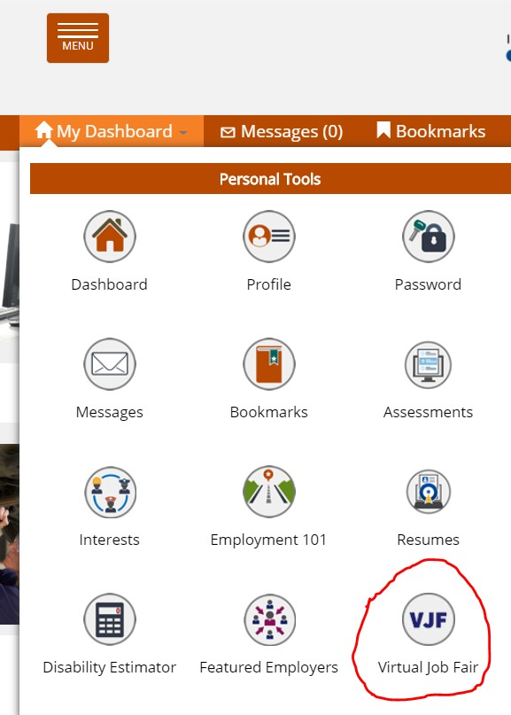

Overview of Dashboard Area
This will take you to the Dashboard area where you can manage Employer Booths that have been submitted.
Entries in this Dashboard area will be from organizations that have a physical address within your LWIA.
You may use filters at the top to narrow results by Approval Status (Approved and Not Approved) and By Booth Status (Active, Expired, Archived).
You may also use the search bar on the right side of the page to search for the name of an Employer.

High-Level Information available on the Dashboard area includes:
- Name and address of the employer that submitted a booth
- Booth ID#
- Status (Approved, Expired, or Archived)
- Employer Booth Submission Date
- Start and End Dates of when the Employer Booth will be listed publicly on the VJF landing page.

Actions within Dashboard
On the Dashboard page, there is a column titled “Actions” on the right. You will notice three different
icons that look like this:
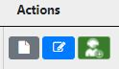

- Booth Details - Grey square with a white page in the middle.
- Edit Booth Employer Information – Blue square with a pencil in the center.
- Manage Job Fairs – Green square with a figure wearing a headset.

Booth Details
The Booth Details page provides an overview of the information that has been entered for the Employer Booth page.
Before approving the Employer Booth, it is important to verify the information is correct based on the links provided by the individual who submitted the booth.

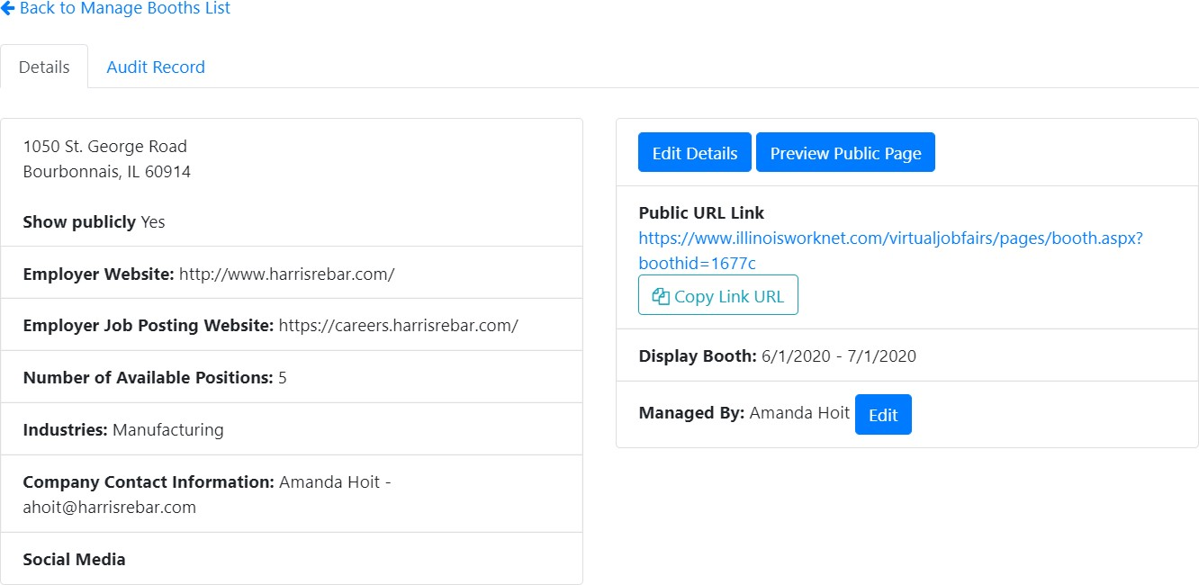

The information on the left side is a high-level overview of the employer’s:
- Main Website
- Job Posting Website
- Number of Available Positions
- Industry Type
- Employer Contact Information
- Social Media Links
The information on the right allows you to edit and share the Employer Booth:
- Edit Details – This takes you to the Employer Entry form. Here you can edit and change details that are public on the Employer Booth page.
- Preview Public Page – Provides a preview of what the Employer Booth page will look like.
- Copy Link URL – Provides a URL of the Employer Booth page that you can share accordingly.
- Display Booth Date Range – This date range indicates when the Employer Booth will be publicly visible on the VJF landing page.
- Managed By – This indicates the primary user who has access to edit the Employer Booth page.

Edit Booth Employer Information
Information for the Employer Booth can be edited after it has been submitted and approved. When you click the Edit Booth Employer Information icon, you are taken to the
Employer Booth entry form that is covered in the Step by Step Instructions on submitting an Employer Booth.
After making any changes to the entry form, click the “Save and Submit Employer Booth.” This will make
any changes to the information covered in this form public on the booth page.

After a booth has been approved, you may add documents and links to that booth via the entry form in the Dashboard:
- To Add Documents
  - These documents will appear on the Employer Booth page under the Documents section. These documents can be supplemental information for job seekers such as applications or other documents for the employer’s hiring process.
  - To add a document, click the blue “Add Document” button.
    - The Attach File(s) window will open.
    - Enter a title for the document you are uploading.
    - Then upload the file. Note: the maximum size of a file that can upload is 50MB. Documents that can be uploaded are:
      - PDFs, Word, and Excel.
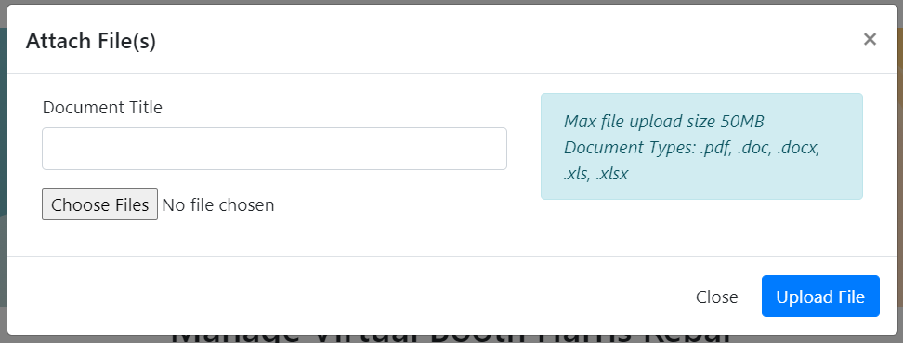
    - Then click the blue “Upload File” button.

- To Add Links
  - These links will appear on the Employer Booth page under the Links section. These links can be supplemental information for job seekers such as links to the About or Mission Statement of the employer.
  - To add a link, click the blue “Add Link” button.
    - A window will pop up. Here you enter the title of the page that the link directs you to.
    - In the Link URL field, include the URL.
    - Then click the blue “Add” button.

Manage Job Fairs
Employers can create and host their own VJF or request assistance through this page:

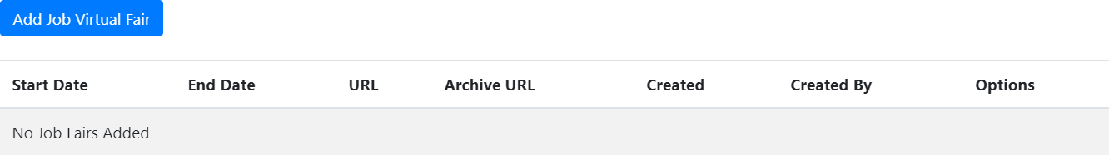

- To Add Virtual Job Fairs
  - Click the “Add Virtual Job Fair” button.
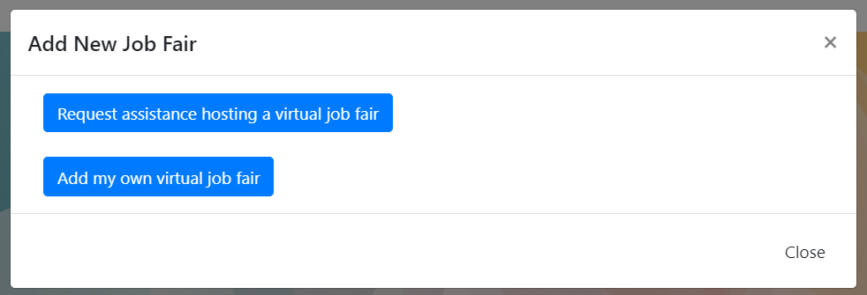
  - You can either request assistance or enter a previously recorded Virtual Job Fair.

- – If you choose to request assistance hosting a Virtual Job Fair, a new tab will open and you will be required to complete a registration form. Some of the information in the form will be pre-filled. The information you will be required to enter includes:
  - Employer Contact Phone Number
  - If the employer needs training on how to use Zoom
  - If there is a preferred date or date range for the employer’s live event
  - Time(s) that the employer is available for a Virtual Job Fair session on the selected/preferred date(s)
  - If the employer would like to participate in a live event that only includes their organization OR if they would be open to participating in a live event with multiple, similar employers in one live session
  - The target population for their live event
  - If the employer accepts non-English speaking employees, and if so, will they provide their own translator?
- Once the information in the form has been completed, click the blue “Submit” button.
- Illinois workNet staff will then coordinate with the employer:
  - Date and time of the live Virtual Job Fair event
  - Registration page
  - Webinar Meeting Information such as Zoom URL, call-in #, and Meeting ID

- – If you would like to add a previously recorded Virtual Job Fair event, click the blue “Add My Own Virtual Job Fair” button.
- Clicking this button will open an “Add New Job Fair” window. Here you will enter:
  - The start and end dates of the Virtual Job Fair you will be holding.
  - The Job Fair URL field will link to a page you have created where job seekers can register and learn more about your live event. This information will appear on the Employer Booth page under the “Upcoming VJF” section.
  - The Archived Job Fair URL is a field where you can include a recording of the Virtual Job Fair event that was held. When posted, this will appear on the Employer Booth page under the “Archived VJF Videos” section.
  - Once the fields have been completed, click the blue “Add” button.
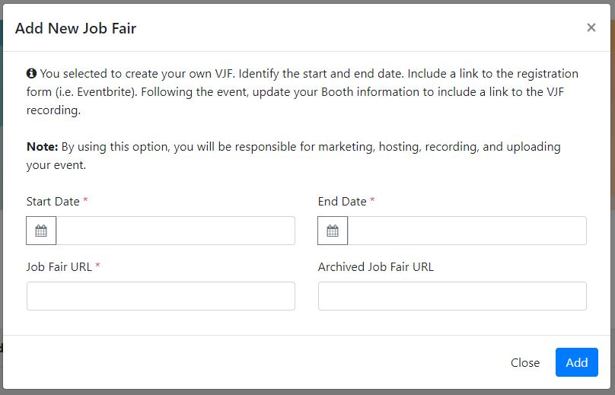
/

Illinois workNet Virtual Job Fair Platform - Staffing Agency Participation Guidelines:
The Illinois workNet Virtual Job Fair platform will allow staffing agencies to participate unless job seekers are charged by the agency for the services they receive. Staffing agencies that charge businesses for their services or require job seekers to create a free account to receive services will be permitted to participate in the Virtual Job Fair platform. Any agencies that are reported for charging job seekers for services or requiring a paid account to access services will result in an investigation. If the reports determine that a “pay for services” relationship exists, the organization will be removed from the Illinois workNet Virtual Job Fair platform.

Every Employer Booth submitted through the Illinois workNet Virtual Job Fair platform is reviewed for accuracy before being approved. During the approval process of staffing agency booths, the assigned staff will review the staffing agency website to verify there is not a cost associated to job seekers for receiving employment-related services. Any discrepancies will be discussed with the primary contact listed in the Employer Booth.

VJF Events Dashboard
Whether you are hosting a single or multi-employer event, the VJF system has a dashboard feature that allows you to track events, export registration information by event, create notes, and plan your event so that it goes off without a hitch.

There are two different dashboards referenced below: The Single-Employer Event Dashboard (in which one employer requests assistance in holding an event) and the Multi-Employer Event Dashboard (in which you or a member of your team may plan, coordinate, and hold a VJF event with or without assistance from Illinois workNet staff).

Managing Single-Employer Events
In order to reach the single-employer requests dashboard, you will:
- Login to your Illinois workNet account
- Select the My Dashboard dropdown
- Select the VJF Event Administration dropdown and click “Single-Employer VJFs”

You will then be directed to a dashboard that will look like the image below:
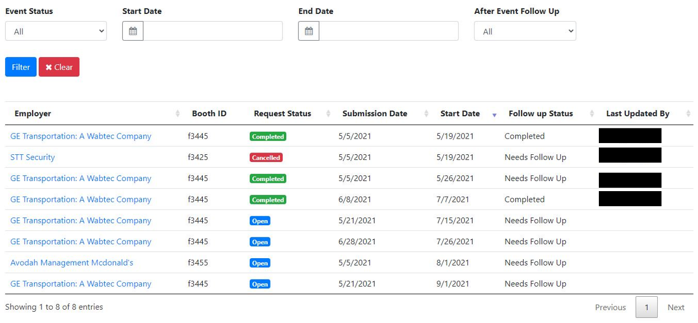
In the single-employer VJF event Dashboard, you will see the entries of employers in your LWIA that have requested assistance in hosting a VJF event. You can filter the results in your Dashboard by:
- Event Status:
  - All
  - Open
  - In Progress
  - Completed
  - Canceled
- Start and End Date of the event requested
- After Event Follow Up:
  - All
  - Needs Follow Up
  - Followed Up with Employer
  - Completed

After making the filter selections above, you will simply click the blue “Filter” button to refine your results.

You may clear the results selected by clicking the red “Clear” button.

Additionally, you can sort through the results in the table by:
- Employer Name (alphabetically)
- Request Status
- Event Status
- Submission Date of when the event was requested
- Start Date of the event requested
- Follow Up Status
- Last Updated By (i.e. which member of your organization last updated the event request)

In selecting an employer entry under the “Employer” column, you will see more information about the event that has been requested:
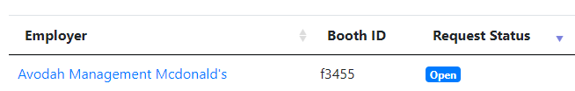

Selecting the hyperlinked text will take you to the record for this event and will display the following page:

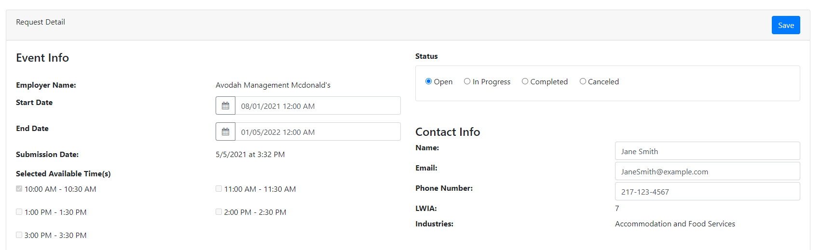
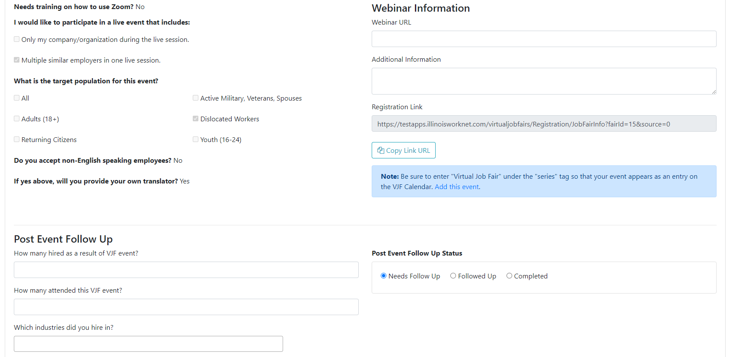
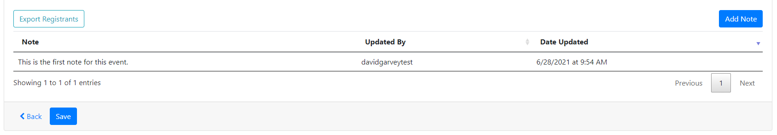

The following sections are included on this page:
- Event Info
- Status
- Contact Info
- Webinar Information
- Post Event Follow Up
- Notes

Here’s more information about each section listed above:

Event Info
The Event Info section includes:
- The name of the employer submitting the request
- Start date and end date of the event requested
  - Note: This can be updated using the calendar and time picker (this will automatically be updated on the registration page for this event)
- Selected Available Time(s) (these are the times that the employer has selected for their availability)
- Whether or not the employer requesting the event needs assistance with Zoom
- Whether or not the employer is open to participating in an event that includes other employers hiring
- The target population of the event
- If the employer accepts non-English speaking employees
  - And if so, will they be providing a translator

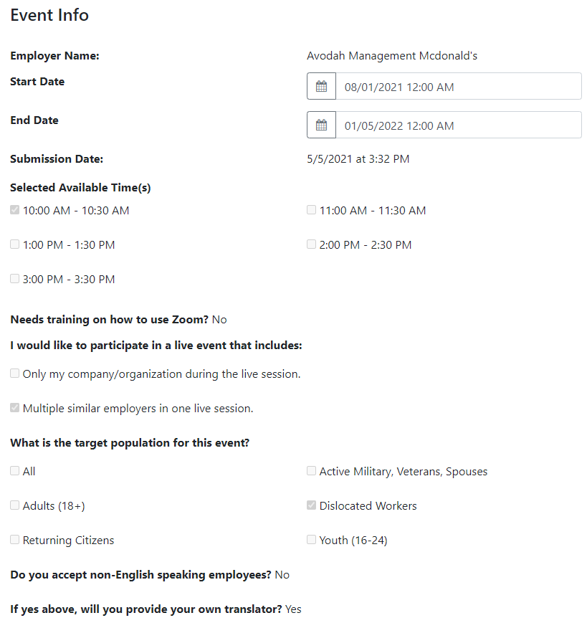

Status
The Status section determines the status of the event:
- Open: The request has been opened, but a follow-up with the employer to coordinate details about the event has not occurred.
- In Progress: Your staff is working with the employer in coordinating and planning their event.
- Completed: The event has been completed.
- Canceled: The event has been canceled.

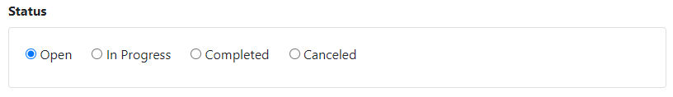

Contact Info
The Contact Info section includes:
- Point of Contact for the event
- Point of Contact’s email address
- Point of Contact’s phone number
- LWIA
- Industries hiring for the employer who requested assistance with their event
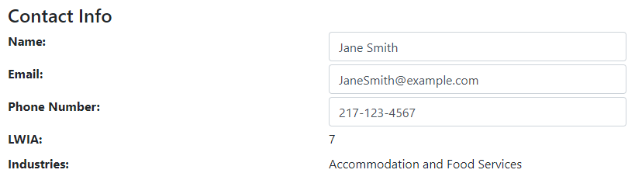

Webinar Information
The Webinar Information section includes the webinar information, registration link, and the ability to add the event to the Illinois workNet VJF calendar:
- Whether you are using Zoom or another VJF platform, you can add the URL, call-in #, and any other meeting information into the “Webinar URL” and “Additional Information” sections.
  - Note: If you are working with Illinois workNet staff, the Zoom information will be added to this section for your event.
- Registration Link: A Registration Link is automatically created when the employer requests assistance with an event. You can copy this URL and distribute it accordingly through your social media and other channels.
  - Note: Information that is changed for the event, such as date and time, is automatically updated on the registration page.
- There is also a section where you can add your event so that it shows up in the Virtual Job Fair calendar on Illinois workNet. Click the “Add this event” text to add the event to the calendar.
  - Note: Be sure to enter “Virtual Job Fair” under the series tag so that the event appears as an entry on the VJF calendar page.

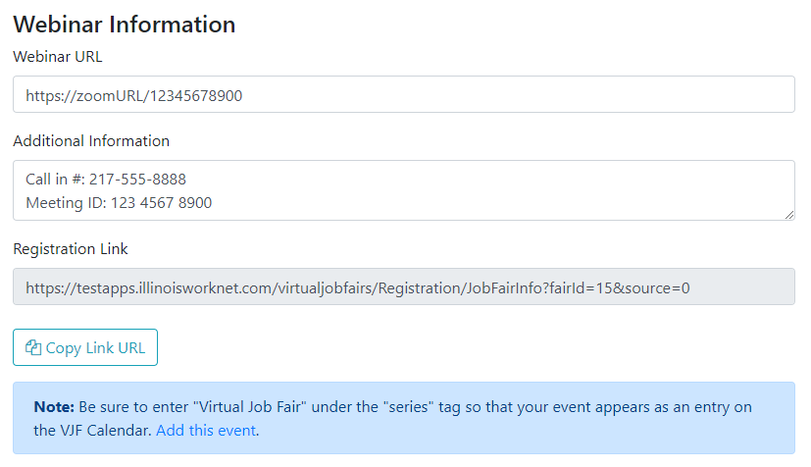

Post Event Follow Up
After the VJF event has taken place, you may follow up with the participating employer in a timely manner to determine and enter the following information:
- How many job seekers were hired because of this event?
- How many attended this VJF event?
- Which industries were hiring in this event?
- Post Event Follow Up Status:
  - This radio button selection signifies if someone from your team has followed up with the employer or if this information has been collected and entered.
- Export Registrants:
  - Selecting this button will generate an Excel document that collects the registration information of individuals registered for the VJF. The information collected includes the following:
    - Name
    - Email address
    - Phone number
    - Ethnicity
    - Gender
    - Employment Status
    - Veteran Status
    - Name of Employer Laid-off from (if applicable)
    - Experience in this industry
    - If they would like their resume to be forwarded to the employer
    - URL of their resume (this may be housed in the Illinois workNet Resume Builder)
    - If they have accessibility needs for the VJF
      - If so, what those accessibility needs are
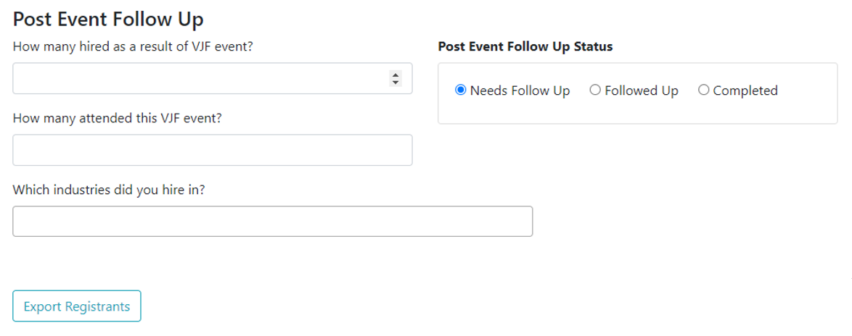

Notes

The Notes section documents the status and updates that are made for the event. As you and your team make updates to the event and coordinate details, it is important to add notes so that all team members who have access to VJF events in your region are on the same page and do not duplicate any efforts.

To add a note simply click the blue “Add Note” button. A window will open, and you can add your note via text and click the Save button. Note: You cannot edit or delete previously entered notes.

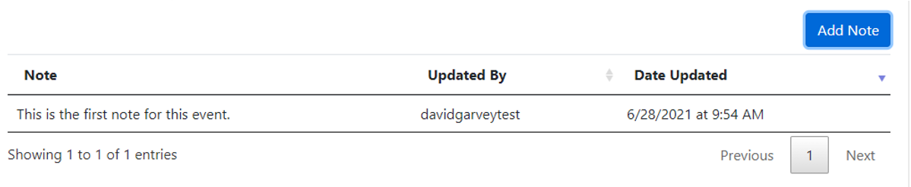

Most important of all is the “Save” button at the bottom of the page. If you do not click the blue “Save” button, changes will not be saved to the request record.

You may also select the “Back” button to return to the single employer VJF request dashboard page.
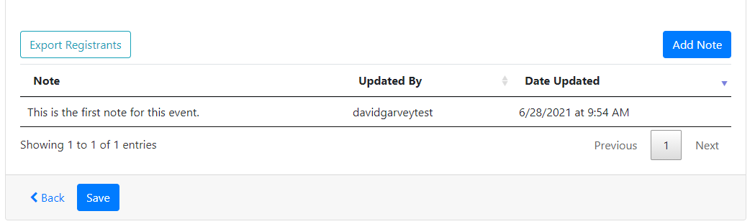

Managing Multi-Employer Events
To reach the multi-employer requests dashboard, you will:
- Login to your Illinois workNet account
- Select the “My Dashboard” dropdown
- Select the VJF Event Administration Dropdown and select “Multi-Employer VJF”

You will then be directed to a dashboard that will look like the image below:
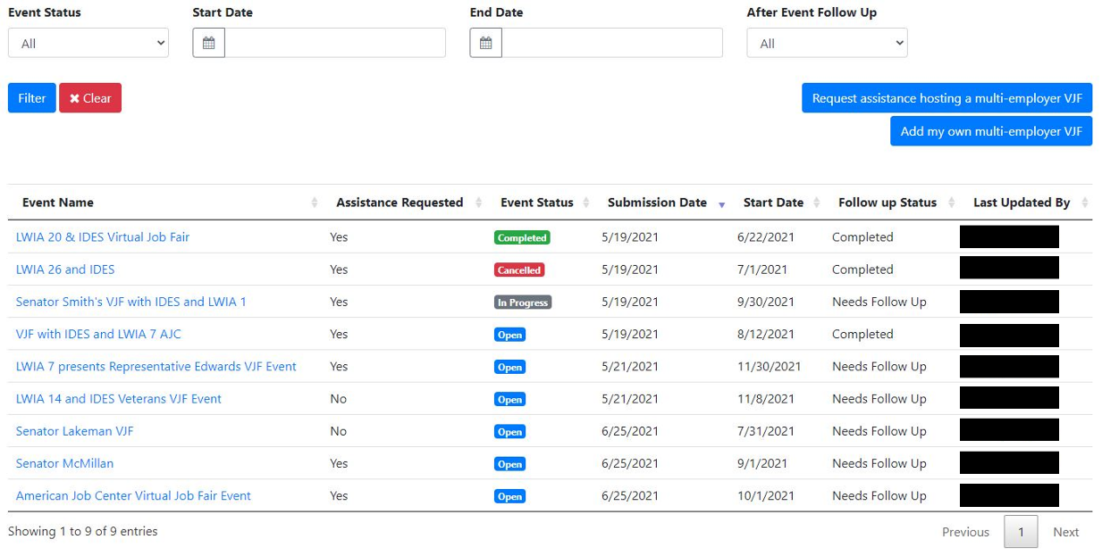

While this looks similar to the single-employer VJF event dashboard, there are some differences:
- Instead of the employer’s name, there is the name of the multi-employer event. Selecting this will lead to the record page where you can update event information, export registration information, and add notes about the progress/status of the event.
- Assistance Requested: This indicates to Illinois workNet staff whether the partners who have added this event need assistance in providing a webinar platform for the Virtual Job Fair event.
- From this dashboard, there are also two buttons for partners to:
  - Request assistance in hosting a multi-employer VJF OR
  - Add their own multi-employer VJF

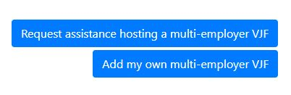

Request Assistance with Your Multi-Employer VJF
If you request assistance in hosting a multi-employer VJF a new window will open, and you will be required to fill out a registration form that includes:
- Name of event
- Your LWIA
- Point of Contact for event
- Point of Contact’s Phone Number
- Point of Contact’s Email Address
- Industries that are participating in the event
- Date and Time range for when you would like your event to be held
- The Target Population
- Additional Notes about your event, i.e. Event Description

Once you have completed the registration form, a member of the Illinois workNet team will reach out to you to discuss coordinating your VJF event.

A record of this event will then be created on the Dashboard page. You may have to refresh the Dashboard page in order to see the record in the table.

Adding Your Own Multi-Employer VJF

If you choose to select “Add my own multi-employer VJF”, a window will appear that will acknowledge that by creating this event, the Illinois workNet team will not be responsible for planning, coordinating, marketing hosting, providing technical assistance for, or uploading your event. There is also a link for you to add your event to the Illinois workNet VJF calendar. Be sure to enter “Virtual Job Fair” under the series tag when adding your event.
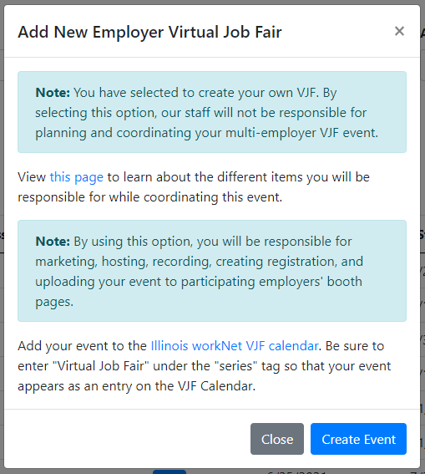

Once you select the “Create Event” button, you will be directed to a form where you will enter:
- Name of the event
- LWIA the event is located in
- Point of Contact for event
- Point of Contact’s Phone Number
- Point of Contact’s Email Address
- Industries that are participating in the event
- Date and time range for when you would like your event to be held
- Target Population
- Additional Notes about your event, i.e. Event Description

A record of this event will then be created in the dashboard page. You may have to refresh the dashboard page in order to see the record in the table.

Multi-Employer VJF Dashboard (continued)

Below the buttons for creating an event, you will see the entries of multi-employer events in your LWIA that have requested assistance in hosting a VJF event or have been added by a member of your organization. You can filter the results in your dashboard by:
- Event Status
  - All
  - Open
  - In Progress
  - Completed
  - Canceled
- Start and End Date of the multi-employer events
- After Event Follow Up
  - All
  - Needs Follow Up
  - Followed Up with Employers
  - Completed

After making the filter selections above, you will simply click the blue “Filter” button to refine your results.

You may clear the results selected by clicking the red “Clear” button.

Additionally, you can filter the results in the table by:
- Event name (alphabetically)
- Assistance Requested (primarily for Illinois workNet staff)
- Event Status
- Submission Date of when the event was requested
- Start Date of the event requested
- Follow up Status
- Last Updated By (i.e. which member of your organization last updated the event request)

In selecting an event entry under the “Event Name” column, you will see more information about that multi-employer event that has been added or requests assistance:

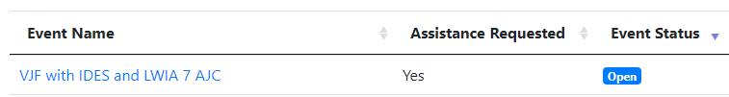

Selecting the hyperlinked text will take you to the record for this event and will display the following page:

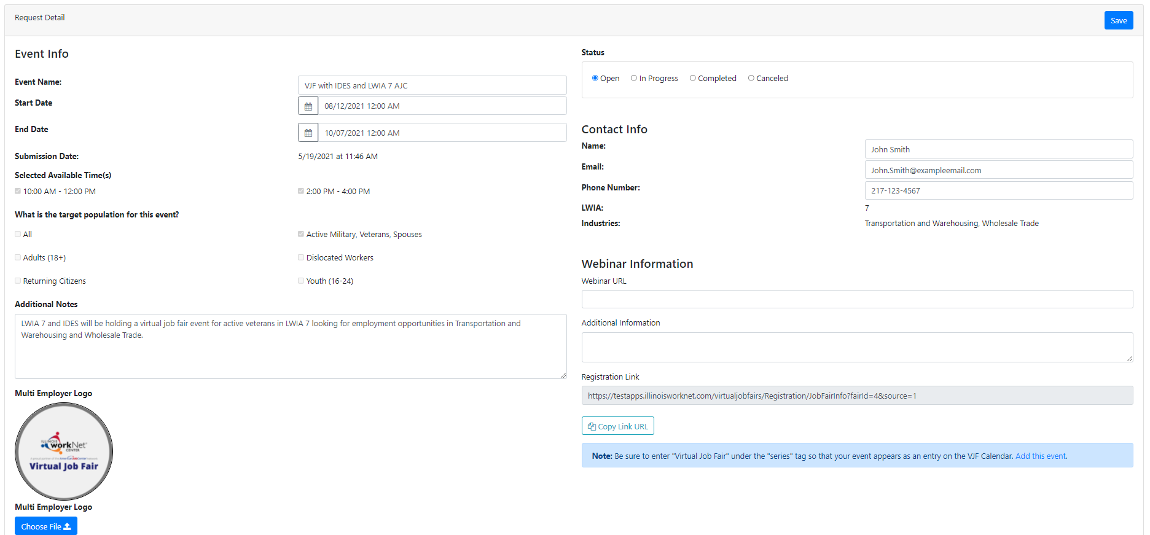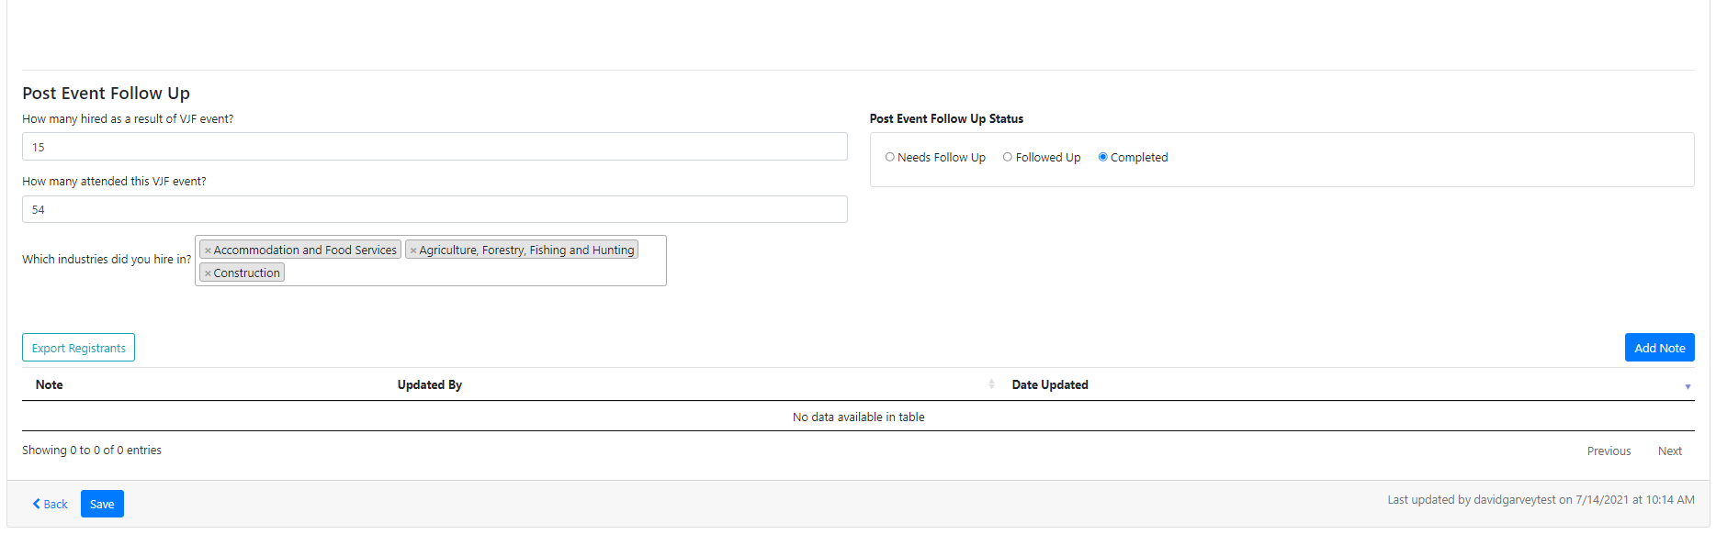

The following sections are included on this page:
- Event Info
- Status
- Contact Info
- Webinar Information
- Post Event Follow Up
- Notes

Here’s more information about each section listed above:

Event Info
The Event Info section includes:
- The name of the multi-employer event added
- State Date and End Date of the event requested
  - Note: This can be updated using the calendar and time picker (this will automatically be updated on the registration page for this event)
- Selected Available Time(s) (these are the times that the employer has selected for their availability)
- The target population of the event
- Additional notes, i.e. Event Description
- Logo for the event
  - Note: the Illinois workNet logo is a default image but can be replaced

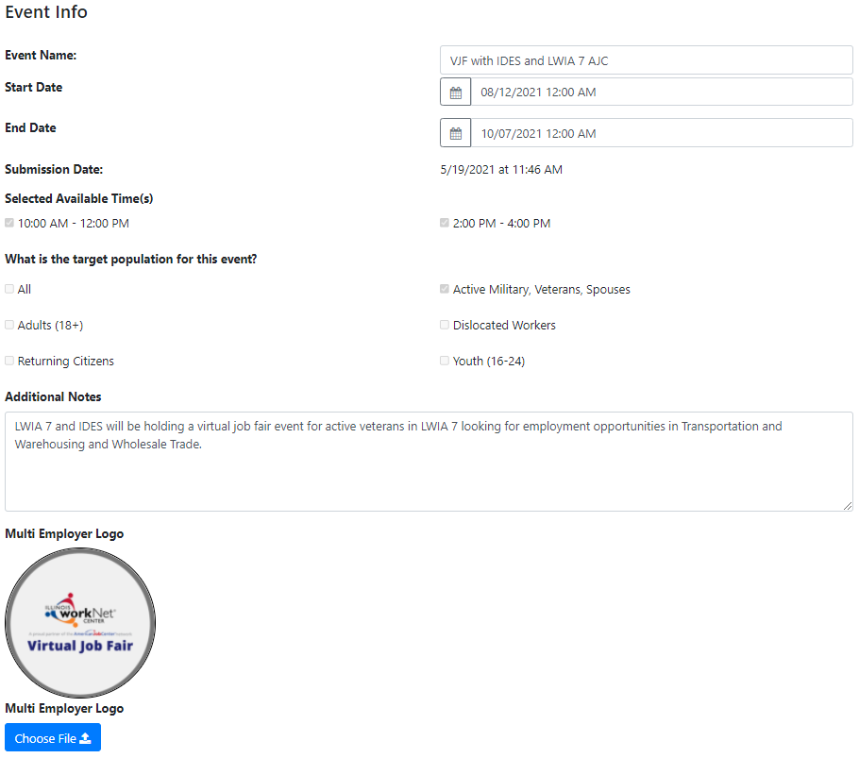

Status
The status section determines the status of the event:
- Open: The request has been opened, but a follow-up with the employer to coordinate details about the event has not occurred.
- In Progress: Your staff is working with the employer in coordinating and planning their event.
- Completed: The event has been completed.
- Canceled: The event has been canceled.

Contact Info
The information included in the Contact Info section is the name, email address, phone number, LWIA, and industries hiring for the employer who requested assistance with their event.

Webinar Information
The webinar information section includes the webinar information, registration link, and the ability to add the event to the Illinois workNet VJF calendar:
- Whether you are using Zoom or another VJF platform, you can add the URL, call in number, and any other meeting information into the “Webinar URL” and “Additional Information” section
  - Note: If you are working with Illinois workNet staff, the Zoom information will be added to this section for your event.
- Registration Link: A registration link is automatically created when the employer requests assistance with an event. You can copy this URL and distribute it accordingly through your social media and other channels.
  - Note: Information that is changed for the event, such as date and time, is automatically updated on the registration page.
- There is also a section where you can add your event so that it shows up in the Virtual Job Fair calendar on Illinois workNet. Click the “Add this event” text to add the event to the calendar.
  - Note: Be sure to enter “Virtual Job Fair” under the series tag so that the event appears as an entry on the VJF calendar page.

Post Event Follow Up
After the VJF event has taken place, you may follow up with the participating employers in a timely manner to determine and enter the following information:
- How many job seekers were hired because of this event?
- How many attended this VJF event?
- Which industries did the event hire in?
- Post Event Follow Up Status:
  - This radio button selection signifies if someone from your team has followed up with the employer or if this information has been collected and entered
- Export Registrants:
  - Selecting this button will generate an Excel document that collects the registration information of individuals who have registered for the VJF. The information collected includes the following:
    - Name
    - Email address
    - Phone number
    - Ethnicity
    - Gender
    - Employment Status
    - Veteran Status
    - Name of Employer Laid off from (if applicable)
    - Experience in this industry
    - If they would like their resume to be forwarded to the employer
    - URL of their resume (this may be housed in the Illinois workNet Resume Builder)
    - If they have accessibility needs for the VJF
      - If so, what those accessibility needs are

Notes

The Notes section documents the status and updates that are made for the event. As you and your team make updates to the event and coordinate details, it is important to add notes so that all team members who have access to VJF events in your region are on the same page and do not duplicate any efforts.

To add a note simply click the blue “Add Note” button. A window will open, and you can add your note via text and click the “Save” button. Note: You cannot edit or delete previously entered notes.

Perhaps most important of all is the “Save” button at the bottom of the page. If you do not click the blue “Save” button, changes will not be saved to the request record.

You may also select the “Back” button to return to the single-employer VJF request dashboard page.

FAQs
For more information about Virtual Job Fairs, refer to our VJF FAQ page.

