# Illinois workNet Virtual Job Fair (VJF) Instructions for Employers

Contents

Illinois workNet Virtual Job Fair (VJF) Instructions for Employers 1

Overview of Virtual Job Fair Portal 1

Overview of Resources 2

Employer 2

Job Seeker 2

Virtual Job Fair 2

Instructions for Employers on Adding a Virtual Job Fair Booth 3

Managing Your Employer Booth Page in Illinois workNet 3

Overview of Dashboard 4

Actions within Dashboard 4

Illinois workNet Virtual Job Fair Platform - Staffing Agency Participation Guidelines: 9

FAQs 9

### Overview of Virtual Job Fair Portal

The new Virtual Job Fair tools are an opportunity for employers in Illinois who are hiring to easily advertise their organization and connect with qualified job applicants at no cost.

Virtual Job Fair tools allow employers to:

* Set up and manage their Virtual Job Fair Booths and post information about their organization and available job openings.
* **Enter virtual job events**, host their own Virtual Job Fair event, or request webinar assistance when hosting their Virtual Job Fair events.

Virtual Job Fair tools allow job seekers to:

* **Learn about and apply for job openings** by exploring these employer booths.
* **Job seekers will be able to attend Virtual Job Fair events** to explore what opportunities are available to them as well as communicate with representatives from employers that are hiring in Illinois for free.

Employers and Job Seekers are welcome to visit the site and start setting up and visiting the Virtual Job Booths.

### Overview of Resources

The [Illinois workNet homepage](http://illinoisworknet.com/) has a few different sections for Illinois residents seeking employment opportunities.

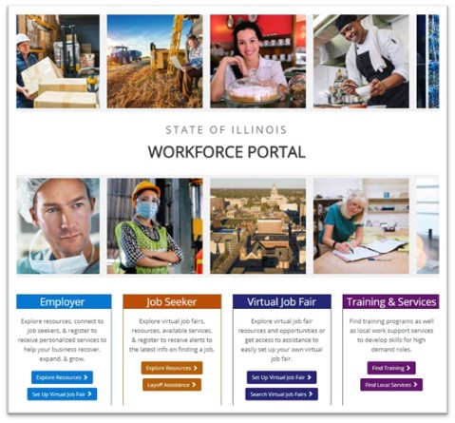

The information below lists the links and a brief description of where each button directs you:

### Employer

[Explore Resources](http://illinoisworknet.com/bizhub/Pages/QuickStart.aspx) – Quick Start Guide for Employers highlights available resources on Illinois workNet.

[Layoff Resources](https://www.illinoisworknet.com/LayoffRecovery/Pages/LayoffGuide.aspx) – Layoff Assistance Guide helps Job Seekers can use to find relief due to loss of employment.

### Job Seeker

[Explore Resources](https://www.illinoisworknet.com/Pages/IndividualResources.aspx) – Quick Start Guide for Job Seekers explains how to find available resources on Illinois workNet.

[Build Your Resume](https://www.illinoisworknet.com/Qualify/Pages/Resume.aspx) – Resume Writing Guide shows Job Seekers how to design, write, and share their resumes.

### Virtual Job Fair

[Set Up Virtual Job Fair](https://www.illinoisworknet.com/VirtualJobFairs/Pages/AddBooth.aspx) – Find easy to follow Step-by-Step instructions for Employers on how to create an Employer Booth with the Virtual Job Fair portal.

[Search Virtual Job Fair](https://www.illinoisworknet.com/virtualjobfairs) – Directs users to the Virtual Job Fair (VJF) landing page that lists Employer Booths of organizations that are currently hiring in Illinois and the number of available job openings. There is also a calendar view that shows upcoming Virtual Job Fair Events.

## Instructions for Employers on Adding a Virtual Job Fair Booth

[This page provides a step-by-step overview](https://www.illinoisworknet.com/VirtualJobFairs/Pages/AddBooth.aspx) for employers on Setting Up Your Employer Booth and how to add it to the Virtual Job Fair portal. Instructions are also provided for Employers on prepare prior to attending these live events:

#### Employers:

* [Preparing for Virtual Job Fairs – Employers](https://www.illinoisworknet.com/Pages/Article.aspx?ArticleId=371)
* [Attending Virtual Job Fairs – Employers](https://www.illinoisworknet.com/Pages/Article.aspx?ArticleId=372)

## Managing Your Employer Booth Page in Illinois workNet

Take the following steps to manage your Employer Booth entries in the Virtual Job Fair Portal.

To Access the VJF Dashboard:

* Login to your Illinois workNet account.
  + Note: You may have to create an account or update your workNet account information.
* Click the “My Dashboard” Dropdown.
* Select the icon “Virtual Job Fair” under the Personal Tools section.

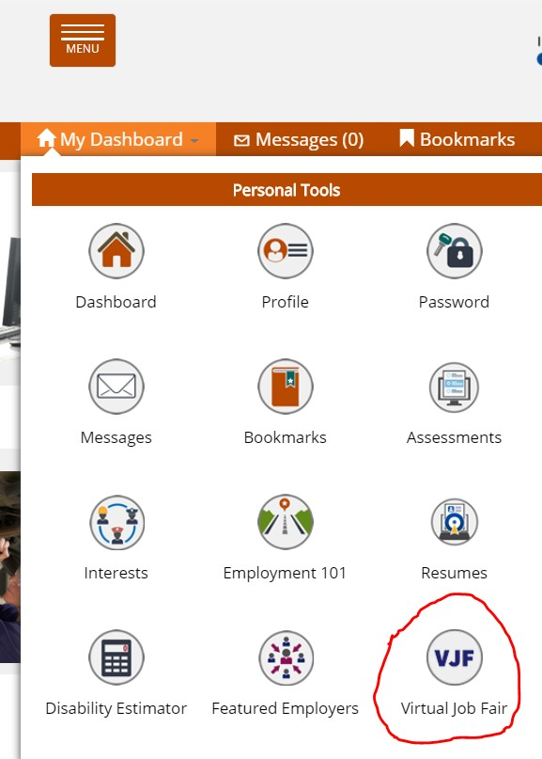

### Overview of Dashboard

The Dashboard allows you to manage Employer Booths that have been submitted to the Illinois workNet portal.

If needed, you may use filters at the top to narrow results by Status (All, Needs Reviewed, Upcoming, Active, Expired, Expired, or Archived).

You may also use the search bar on the right side of the page to search for the name of an Employer. High-Level Information available on the Dashboard includes:

* Name and Address of the Employer who submitted a booth
* Booth ID#
* Status (Approved, Expired, or Archived)
* Employer Booth Submission Date
* Start and End Dates of when the Employer Booth will be listed publicly on the [VJF landing page.](https://www.illinoisworknet.com/virtualjobfairs)

### Actions within Dashboard

On the Dashboard page, there is a column titled “Actions” on the right. You will notice three different

icons that look like this:

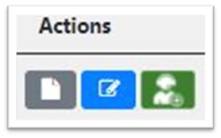

1. Booth Details - Grey square with a white page in the middle.
2. Edit Booth Employer Information – Blue square with a pencil in the center.
3. Manage Job Fairs – Green square with a figure wearing a headset.

Booth Details

The Booth Details page provides an overview of the information that has been entered for the Employer Booth page.

Prior to approving the Employer Booth, it is important to verify the information is correct based on the links provided by the individual who submitted the booth.

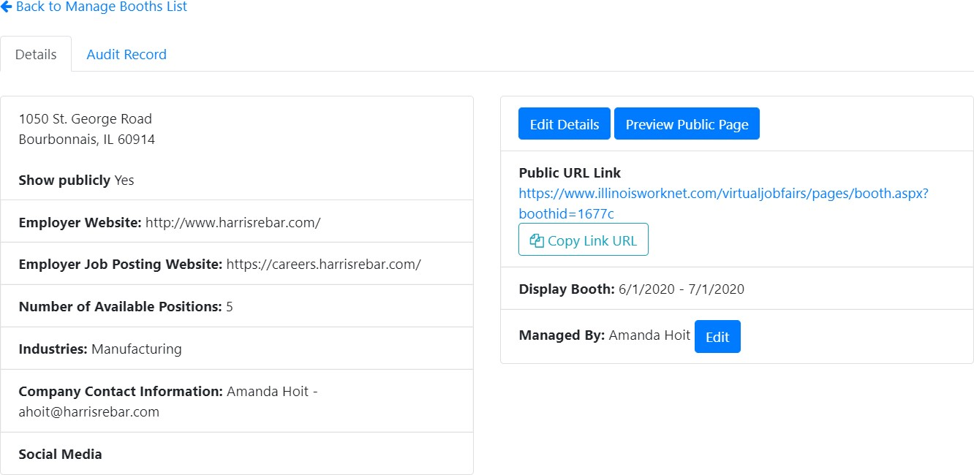

The information above and on the left is a high-level overview of the Employer’s information:

* Main Website
* Job Posting Website
* Number of Available Positions
* Industry Type
* Employer Contact Information
* Social Media Links

The information above and on the right allows you to edit and share the Employer Booth:

* Edit Details – This takes you to the Employer Entry form. Here you can edit and change details that are public on the Employer Booth page.
* Preview Public Page – Provides a preview of what the Employer Booth page will look like.
* Copy Link URL – Provides a URL of the Employer Booth page that you can share accordingly.
* Display Booth Date Range – This date range indicates when the Employer Booth will be publicly visible on the VJF landing page.
* Managed By – This indicates the primary user who has access to edit the Employer Booth page.

Edit Booth Employer Information

Information for the Employer Booth can be edited after it has been submitted and approved. When you click the “Edit Booth Employer Information” icon, you are taken to the completed Employer Booth entry form that is covered in the [Step-by-Step instructions](https://www.illinoisworknet.com/DownloadPrint/Creating%20a%20Virtual%20Job%20Fair%20Booth%20Final.pdf) on submitting an Employer Booth.

After making changes to the entry form, click “Save and Submit Employer Booth.” This will make

any changes to the information covered in this form public on the booth page.

After your booth has been approved, you may come back to this entry form and add documents and links.

* To Add Documents:
  + These documents will appear on the Employer Booth page under the “Documents” section. These documents can be supplemental information for Job Seekers, such as applications or other documents for the Employer’s hiring process.
  + To add a document, click the blue “Add Document” button.
    - The “Attach File(s)” window will open.
    - Enter a title for the document you are uploading.
    - Then upload the file. Note: the maximum size of a file that can upload is 50MB. Documents that can be uploaded are:
      * PDFs, Word, and Excel.
    - Then click the blue “Upload File” button.

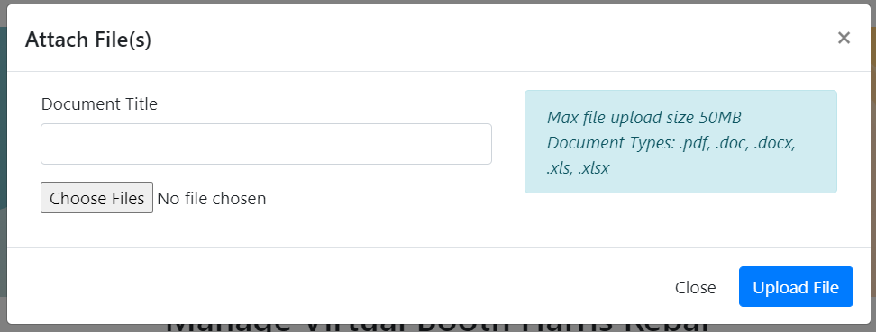

* To Add Links
  + These links will appear on the Employer Booth page under the “Links” section. These links can be supplemental information for job seekers, such as links to the About or Mission Statement of the Employer.
  + To add a link, click the blue “Add Link” button.
    - A window will pop up. Here you enter the title of the page that the link directs you to.
    - In the Link URL field, include the URL.
    - Then click the blue “Add” button.

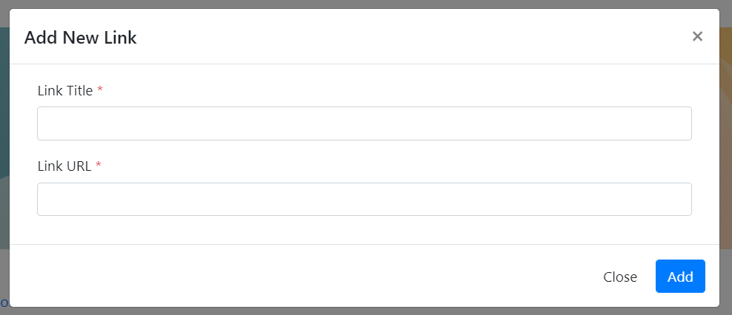

*Manage Job Fairs*

From this page, you may create or request assistance with, or add your VJF event:

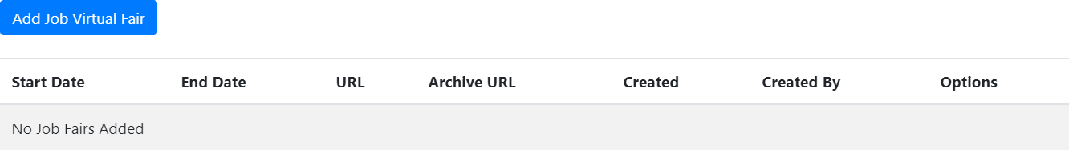

* To Add Virtual Job Fairs
  + Click the “Add Virtual Job Fair” button.
  + You can either request assistance or enter a previously recorded Virtual Job Fair.

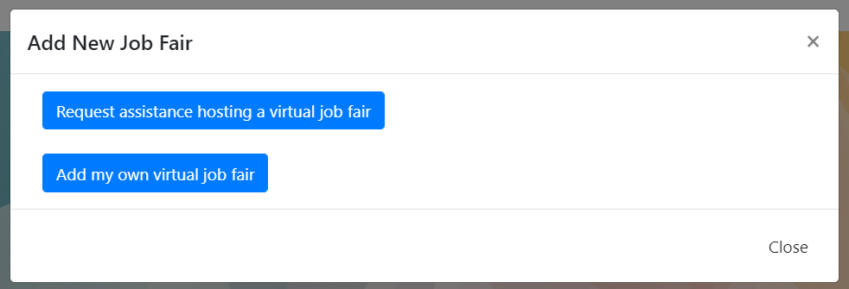

1. – If you choose to Request Assistance Hosting a Virtual Job Fair, a new tab will open, and you will be required to fill a form. Some of the information in the form will be pre-filled. The information you will be required to enter includes:
   * Employer Contact Phone Number
   * If the Employer needs training on how to use Zoom
   * If there is a preferred date or date range for the Employer’s live event
   * Time(s) that the Employer is available for a Virtual Job Fair session on the selected/preferred date(s)
   * If the Employer would like to participate in a live event that only includes their organization OR if they would be open to participating in a live event with multiple, similar Employers in one live session
   * If the Employer is interested in scheduling Virtual Job Fair Follow-up Interview Rooms
   * The target population for their live event
   * If the Employer accepts non-English speaking employees, and if so, will they provide their own translator.

* Once the information in the form has been completed, click the blue “Submit” button.
* Illinois workNet staff will then coordinate with the Employer:
  + Date and time of the live Virtual Job Fair Event
  + Registration page
  + Webinar Meeting Information such as Zoom URL, call-in #, and Meeting ID.

1. – If you would like to add a previously recorded Virtual Job Fair event, click the blue “Add My Own Virtual Job Fair” button.

* Clicking this button will open an “Add New Job Fair” window. Here you will enter:
  + The start and end dates of the Virtual Job Fair you will be holding.
  + The Job Fair URL field will link to a page you have created where job seekers can register and learn more about your live event. This information will appear on the Employer

Booth page under the “Upcoming VJF” section.

* + The “Archived Job Fair” URL is a field where you can include a recording of the Virtual Job Fair event that was held. When posted, this will appear on the Employer Booth page under the “Archived VJF Videos” section.
  + Once the fields have been completed, click the blue “Add” button.
  + **Note**: Be sure to add your event to the [workNet calendar](https://apps.illinoisworknet.com/Calendar/Admin/AddEvent?calendarId=1) so it shows up on the VJF Calendar. When adding your event be sure to select “Virtual Job Fair” under the “series” tag.

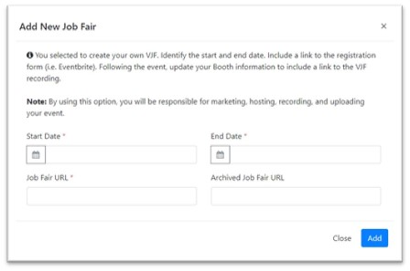

### Illinois workNet Virtual Job Fair Platform - Staffing Agency Participation Guidelines:

The Illinois workNet Virtual Job Fair Platform will allow staffing agencies to participate unless Job Seekers are charged by the agency for the services they receive. Staffing agencies that charge businesses for their services or require Job Seekers to create a free account to receive services will be permitted to participate in the Virtual Job Fair platform. Any agencies reported for charging Job Seekers for services or requiring Job Seekers to set up a paid account to access services, will result in an investigation. If the reports determine that a “pay for services” relationship exists, the organization will be removed from the Illinois workNet Virtual Job Fair platform.

Every Employer Booth submitted through the Illinois workNet Virtual Job Fair platform is reviewed for accuracy before being approved. During the approval process of staffing agency booths, the assigned staff will review the staffing agency website to verify there is not a cost associated to Job Seekers for receiving employment-related services. Any discrepancies will be discussed with the primary contact listed in the Employer Booth.

## FAQs

For more information about Virtual Job Fairs, refer to our [VJF FAQ page](https://www.illinoisworknet.com/virtualjobfairs/Pages/FAQs.aspx).