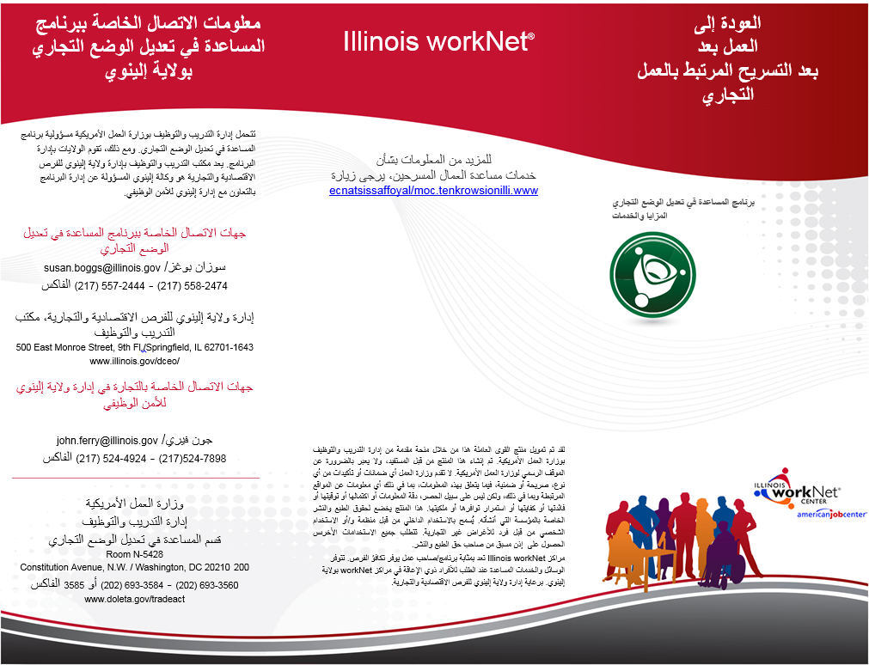
123 Main Street | Anytown, IL 60000 | 217-555-1234

www.illinoisworknet.com

Enter Your LWIA Contact/Locations Here:
Your LWIA Logo Here


