Getting Started

Logging Into Illinois workNet
- Go to www.illinoisworknet.com and click Login at the top right of the header.
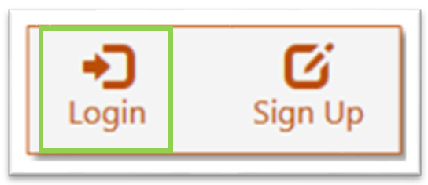

- Log in with your Username and Password.
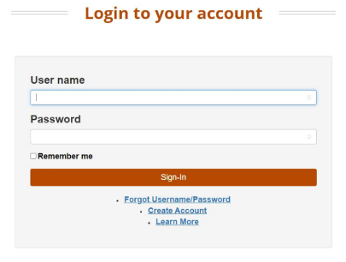

- Using the My Dashboard menu, Click Resumes.
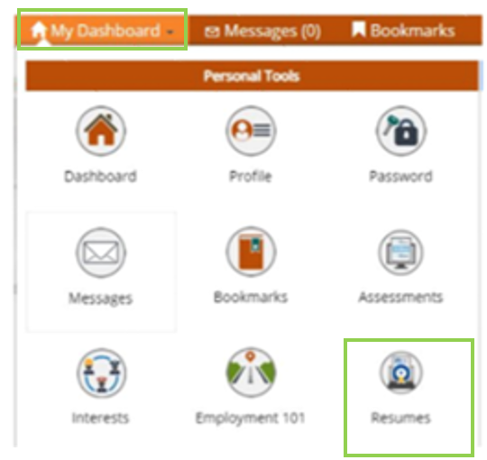
You can also click on My Dashboard and then select the “Resume Builder” option.
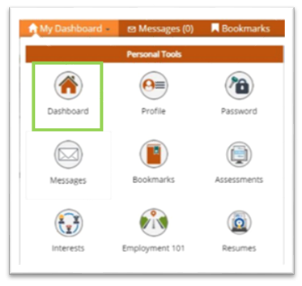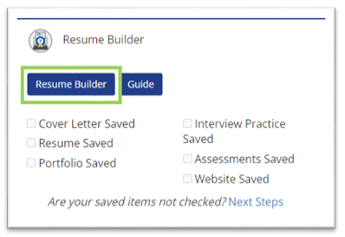

You will then be redirected to your SkillsFirst Gallery.
Note: If this is your first time accessing SkillsFirst, you will be asked to confirm your email address.

- Click Continue to confirm your email address.
- You will then see a message asking you to check your email. Go to your inbox and open the confirmation email (be sure to check your spam and junk folders if you do not see it) and click the confirmation link in the email.
  - Note: This link will expire in one hour, so be sure to confirm before the hour runs up, or you will have to repeat this confirmation process.
- Once you select the link, you will be redirected to SkillsFirst, where you can create your documents.

Creating a New Interview
Note: Before you create a new interview, please make sure that your webcam and microphone have been plugged in. In addition, please close any programs which may be using your webcam and microphone, especially video chat programs such as Skype or Zoom.

To begin a new Interview click the Take a practice interview button in your dashboard:

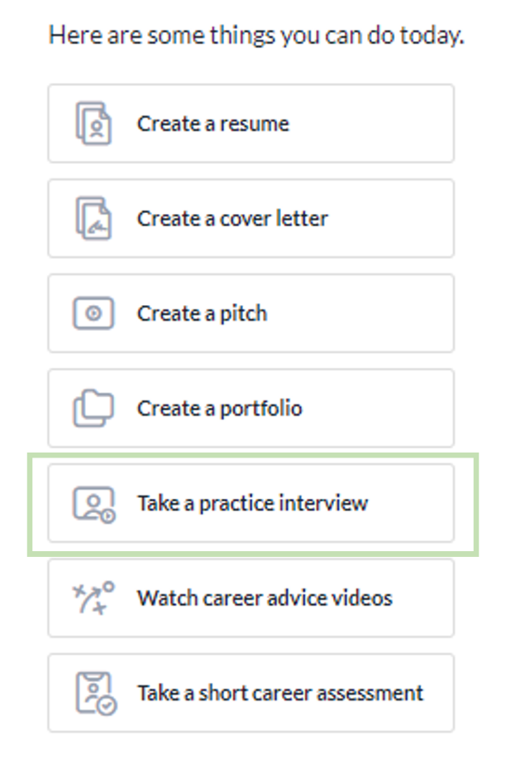

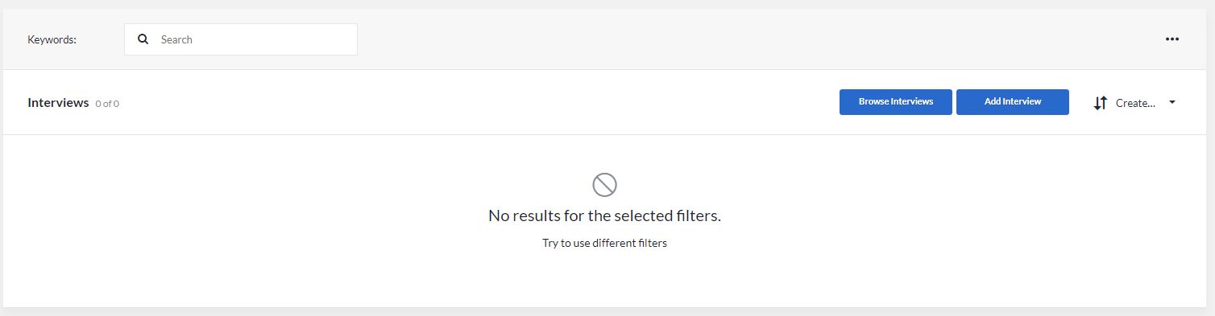

  - Click the Add Interview button in your Gallery.

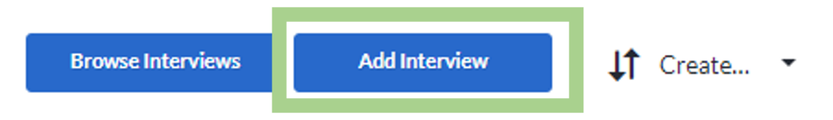

  - Enter a name for your interview. You can also add a description for your interview. Then click Save.

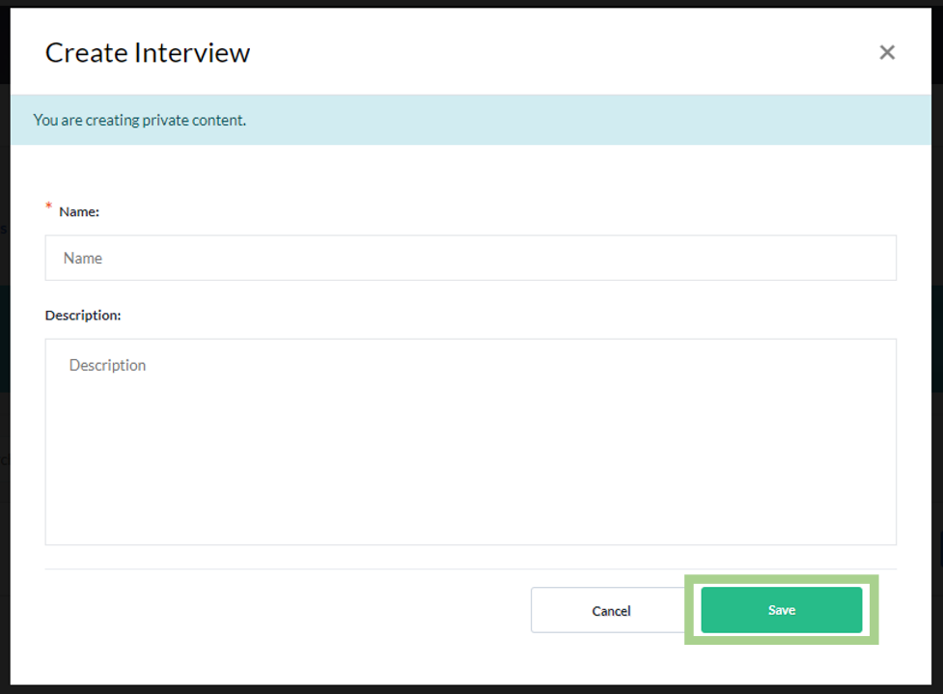

  - From this page, you can add questions, comments, share with others, reorder questions, delete questions, add notes, and more. Click Add Questions.

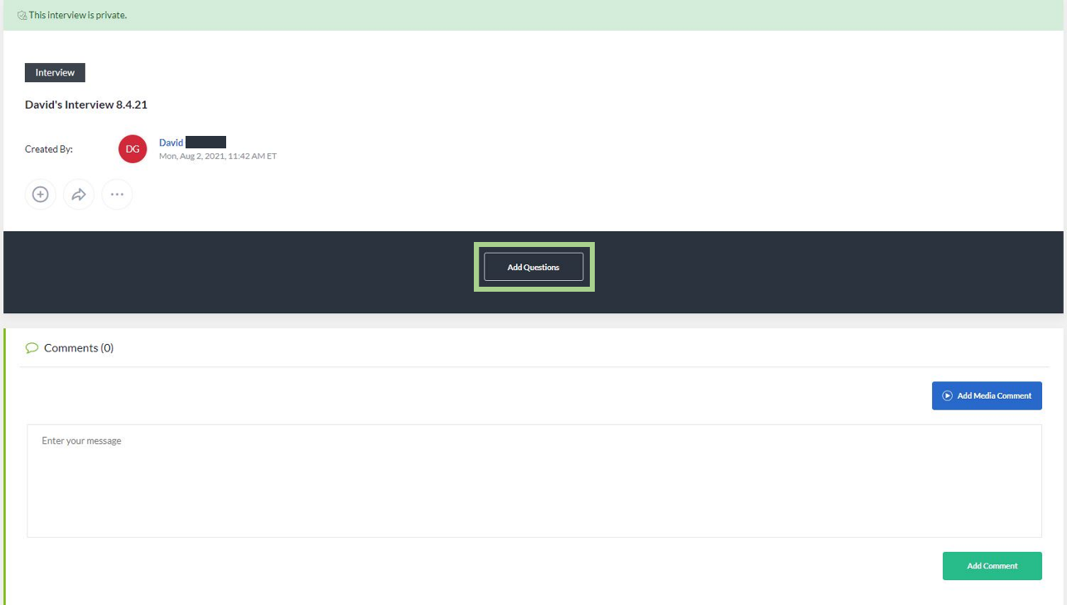

  - The window that opens will allow you to select multiple questions to add to the practice interview you have created.
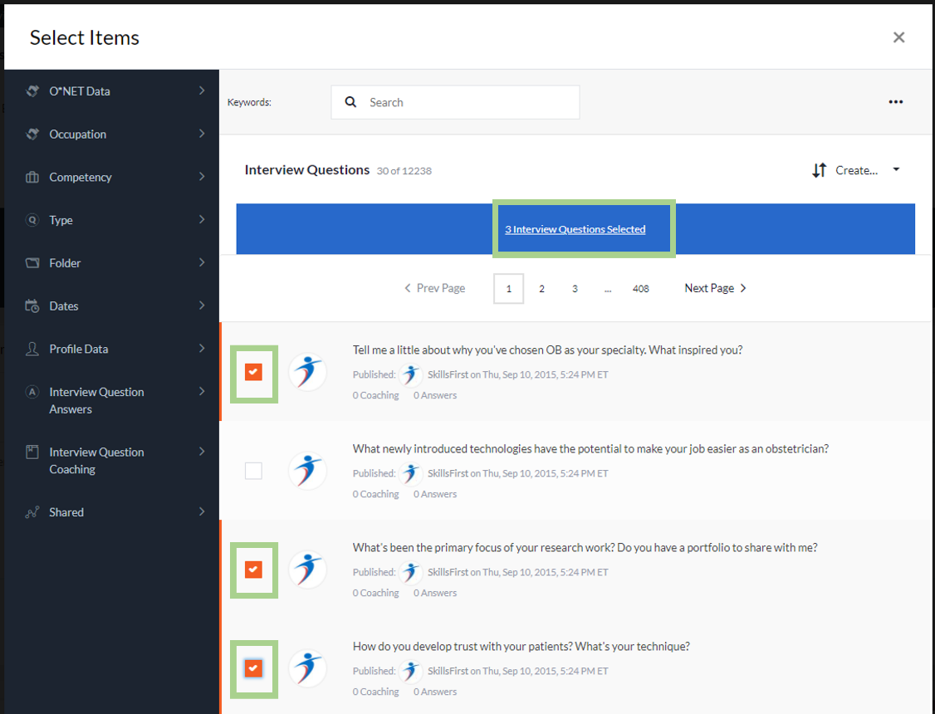

  - You may use the keyword search or the filters on the left-hand side to find the questions you would like to practice. Select the filter and its sub-filter to refine your results.
Note: You can select multiple filters for the over 12,000 practice interview questions.
These filters include:
    - O*NET Data
    - Occupation
    - Competency
    - Type
    - Folder (if created/applicable)
    - Dates (for when questions were created or updated)
    - Profile Data
    - Interview Question Answers (with or without answers)
    - Interview Question Coaching (with or without coaching)
    - Shared

  - When you have selected the questions you would like to add to your practice interview, click Interview Questions Selected.

  - You may then go back to select additional questions by clicking the Back to list or by closing out of the window to return to your gallery.
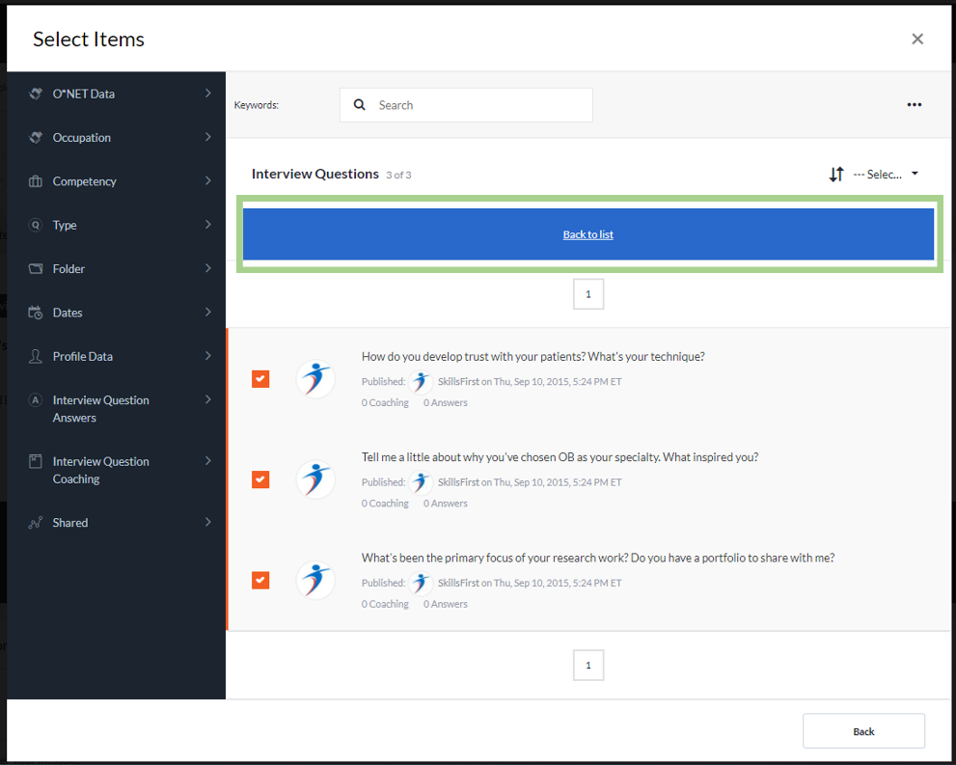

  - Back in the Gallery, you can:
    - Start your interview by clicking Start Interview
    - Navigate through the selected questions below the Start Interview button
    - Select the dropdown menu on the right-hand side of the page.
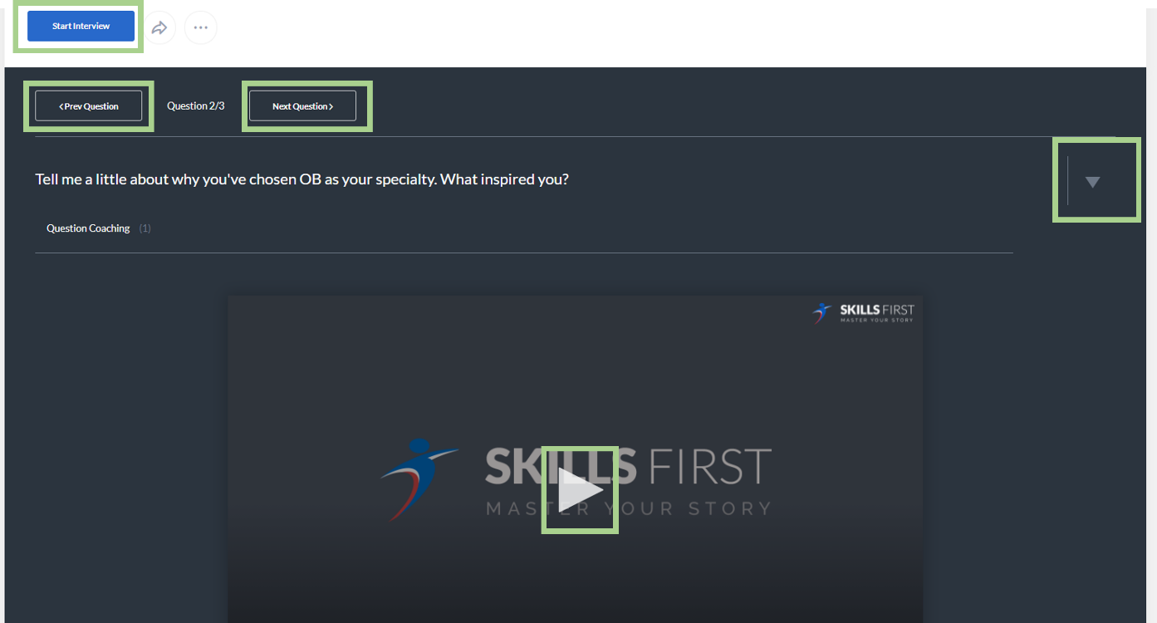

  - If Start Interview was selected, then you will be prompted to Add an Answer. You may view a video of an interviewer asking questions by selecting “Question Coaching.”

When you are ready to answer the question, click the green Add Answer button.
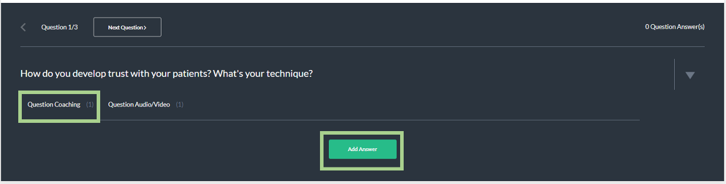

  - A new window will pop up asking you how you will answer the practice interview question. Select your option for Text, Record Audio/Video, Record Audio Only, Audio/Video Link, or Upload File.
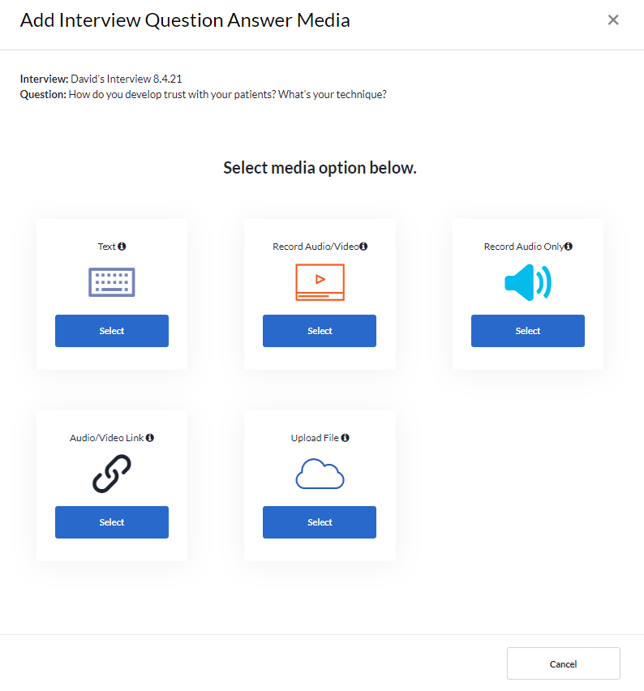

  - You will then be asked to record or enter your response to the question on the next screen. After you record or enter your response, you may go back and cancel or save the response. When you have answered the question, select the Save Media button.

Note: If you select the recording, you will have to select the red recording button to start AND stop the recording of your answer.

Click Done on the message that comes up after successfully saving your answer.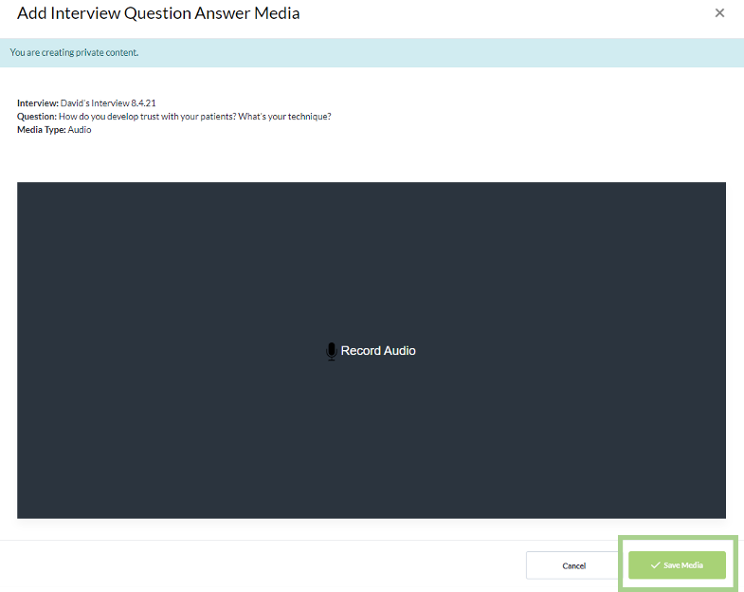

  - You will see your recording or entered answer below the question. If you select the three dots above the answer, you may download, replace, edit, or delete your answer.
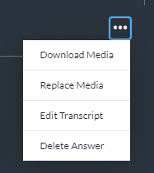

  - You can leave comments below your answer or recording by entering text into the box by clicking the blue Add Media Comment button or the green Add Comment button.

  - Complete the remaining questions selected by using the navigation menu located above the question. Feel free to continue to practice leading up to the interview so that you can ace it!

  - When you have finished with your interview questions and answers, you may share them with a workforce partner, by clicking the Share button above the questions.
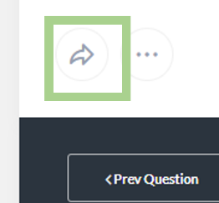

Sharing your document
When sharing your document with others, you can select the person(s) you are sharing with by using the following options:
- Editor allows the person(s) you are sharing with to make changes to your document.
- Reviewer allows the person(s) you are sharing with to make changes and/or leave comments.
- Viewer allows the person(s) you are sharing with to only view your document.

To make this selection click Viewer and make the appropriate changes.
You may preview what these permissions look like by clicking Preview Permissions.
You may also choose to share the document by clicking:
- Organization People Groups
You may share the document if you are part of any groups by entering the name of the group in the Select Group search. Options will appear based on your search criteria.
- Organization People
You may share the document with specific individuals by entering their name in the Select People search. Options will appear based on your search criteria.
- Anybody with Link
This will generate a link that you can share with others to access your document.

To make this selection click Organization People Groups and make the appropriate changes. Once these have been applied, click the Share button to share your document.
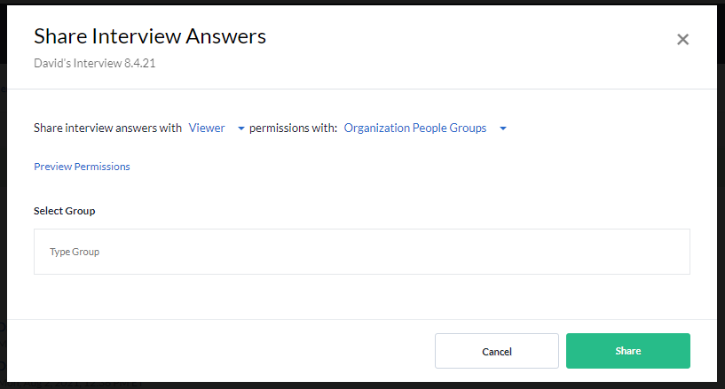

Additional Features and User Guides
For additional features and User Guides within the SkillsFirst platform:
- Log in to your Illinois Worknet Account.
- Select Resumes in the dashboard banner.
- When directed to SkillsFirst scroll to the bottom the page and click User Guide.
- On the next page, click Job Seekers.
Here, you can enter a keyword search for the assistance or feature you are interested in learning about.

These User Guides have the most up-to-date information about the SkillsFirst platform.

Technical Support

Support is available please contact the Illinois workNet team at info@illinoisworknet.com. Standard business hours are Monday-Friday, 8AM-4:30 PM (CST).
The Illinois workNet® Center System, an American Job Center, is an equal opportunity employer/program. Auxiliary aids and services are available upon request to individuals with disabilities. All voice telephone numbers may be reached by persons using TTY/TDD equipment by calling TTY (800) 526-0844 or 711. This workforce product was funded by a grant awarded by the U.S. Department of Laborʼs Employment and Training Administration. For more information please refer to the footer at the bottom of any webpage at illinoisworknet.com. – October 8, 2022 v8

