# Why Should I Have an Online Portfolio?

Online Portfolios or Efolios allow you to create an online gallery of your work that can be displayed as a page on your SkillsFirst website, shared as a link, or downloaded as a zipped folder.

Online portfolios can document your education, work samples, and skills. They are very useful for applying to jobs and training programs, demonstrating your transferable skills, and tracking your professional development.

Portfolios are composed of **projects** and these projects contain **files**. See figure 1.

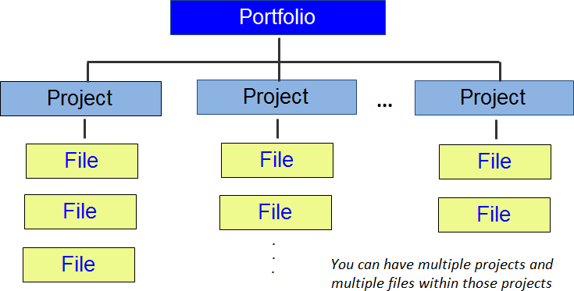

**Figure 1.** Portfolio Organization

## **What is a Project?**

Portfolios are organized in **projects** — groups of files that contain related or similar subject matter presented together in the portfolio. Projects can be based on anything you want, but here are some examples:

* A student might create projects based on individual assignments, and group files that are related to each assignment.
* Organize your portfolio *chronologically*, and have projects for every week, month, or year.
* Have a *theme* for every project, such as Writing Samples, Presentations, Letters of Recommendations, or Lesson Plans.

You must have at least one project in a portfolio, but you may add additional projects based on your needs.

# Getting Started

## Logging Into Illinois workNet

1. Go to [www.illinoisworknet.com](http://www.illinoisworknet.com/) and click **Login** in the top right of the header.

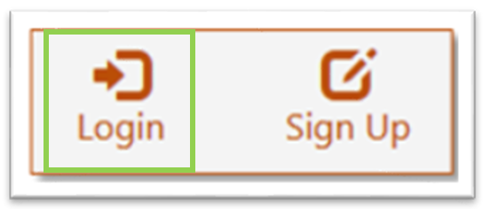

2. **Log in** with your username and password.

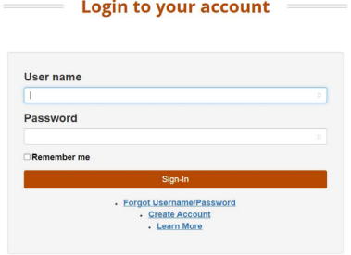

3. Using the My Dashboard menu, select **Resumes.**

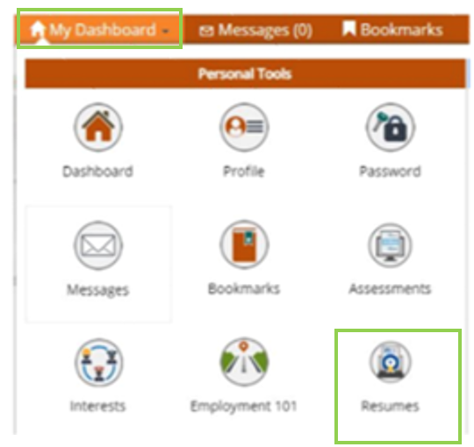

You can also click on **My Dashboard** and then select the “Resume Builder” option.

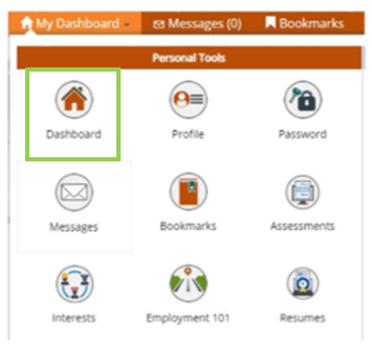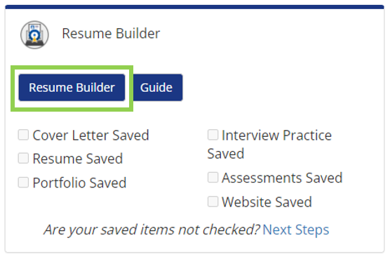

You will then be redirected to your SkillsFirst Gallery.

**Note**: If this is your first time accessing SkillsFirst, you will be asked to confirm your email address.

* Click Continue to confirm your email address.
* You will then see a message asking you to check your email. Go to your inbox and open the confirmation email (be sure to check your spam and junk folders if you do not see it) and click the confirmation link in the email.
  + **Note**: This link will expire in one hour, so be sure to confirm before the hour runs up, or you will have to repeat this confirmation process.
* Once you select the link, you will be redirected to SkillsFirst, where you can create your documents.

## Creating a New Portfolio

1. When you are redirected to SkillsFirst, scroll down and select the Portfolios icon in the stats section

2. You will be presented with a screen to:

* Browse Portfolios
* Add Portfolio

### Browse Portfolios

1. To browse portfolios click the blue Browse Portfolios button.

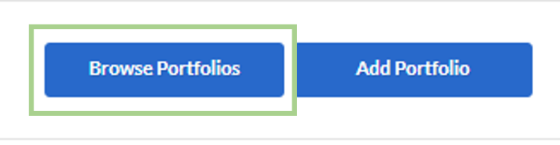

1. On the next screen, you can look through the available portfolio templates. Click on the name of the portfolio you are interested in.

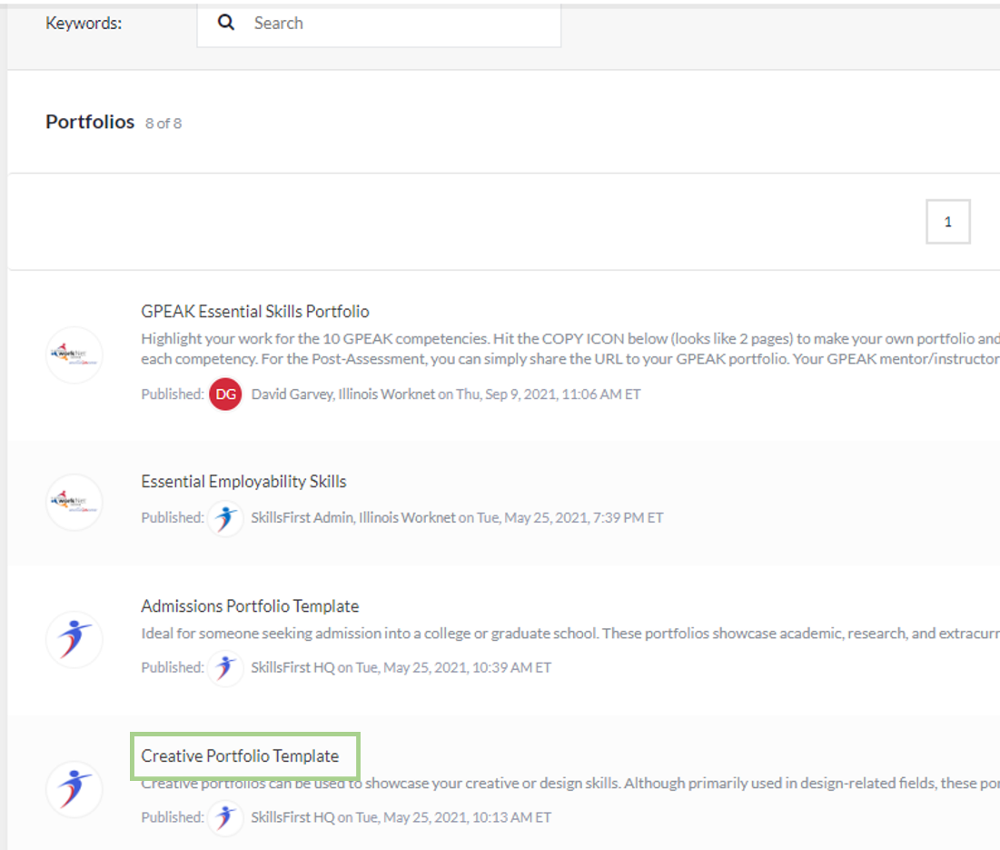

1. On the next page you will see the portfolio template. Click around and if you are interested in using this portfolio, select the Clone icon to make a copy of the portfolio that you can then customize.

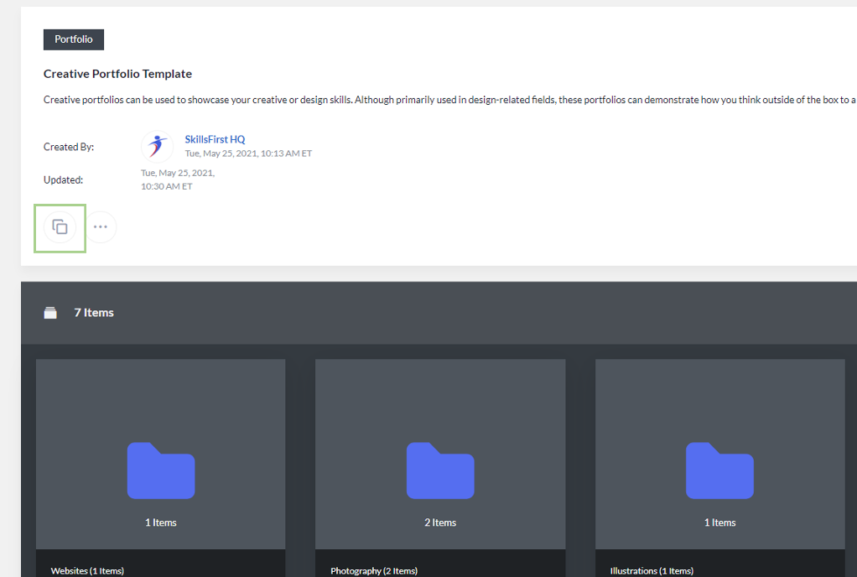

1. On the next page you will see a message that the portfolio has been copied and you are now ready to customize it.

**Note**: For further instructions on adding items to your portfolio and editing, please see the section below.

### Add Portfolio

1. Click **Add Portfolio**.

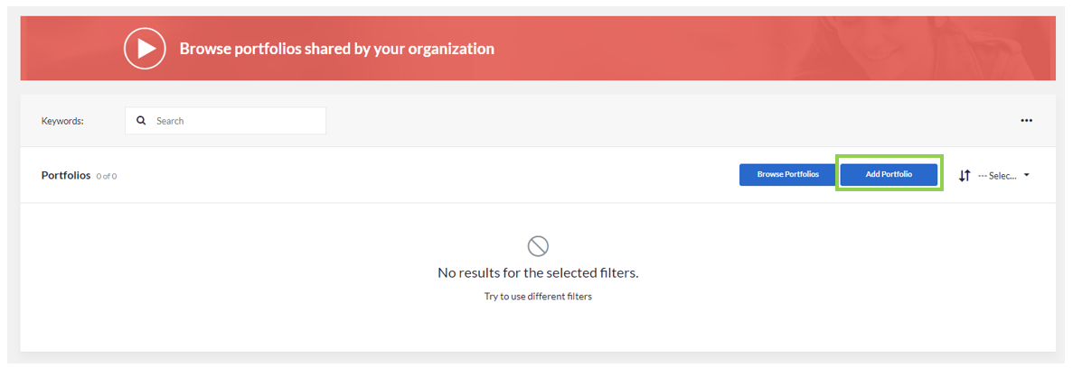

2. Enter a **name** and **description** for your portfolio. Then click **Save**.

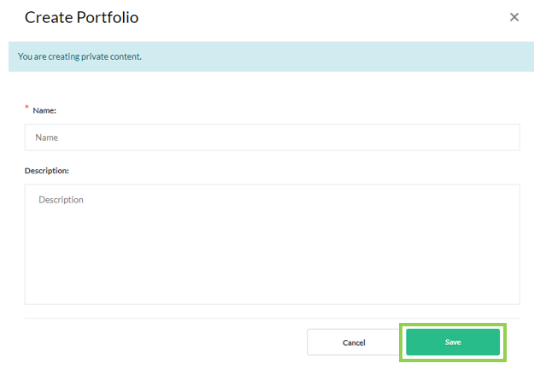

3. On this page you can Add Folders, Add Files, and Add Links to your portfolio. You can also share with others, add comments, delete parts of your portfolio, and more. To create a folder, select **Add Folder**.

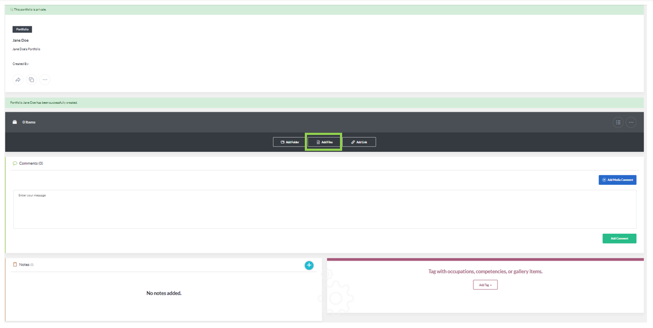

4. The window that opens allows you to name and provide a description of the folder you are creating. After the fields have been filled in, click **Save**.

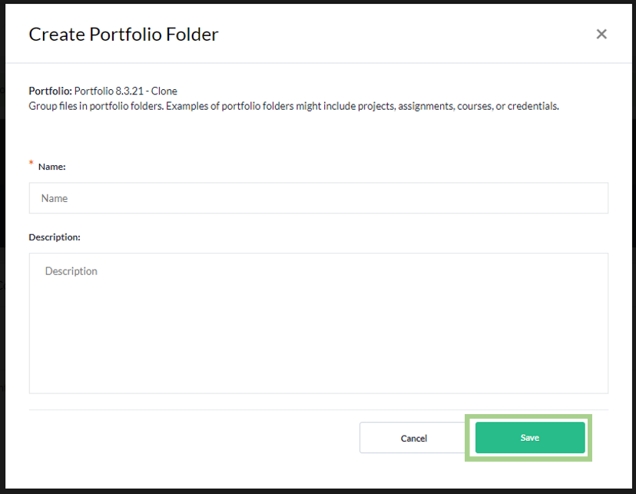

5. On this page, click **on the name** of the folder you created. (This page will show all the folders you have created.)

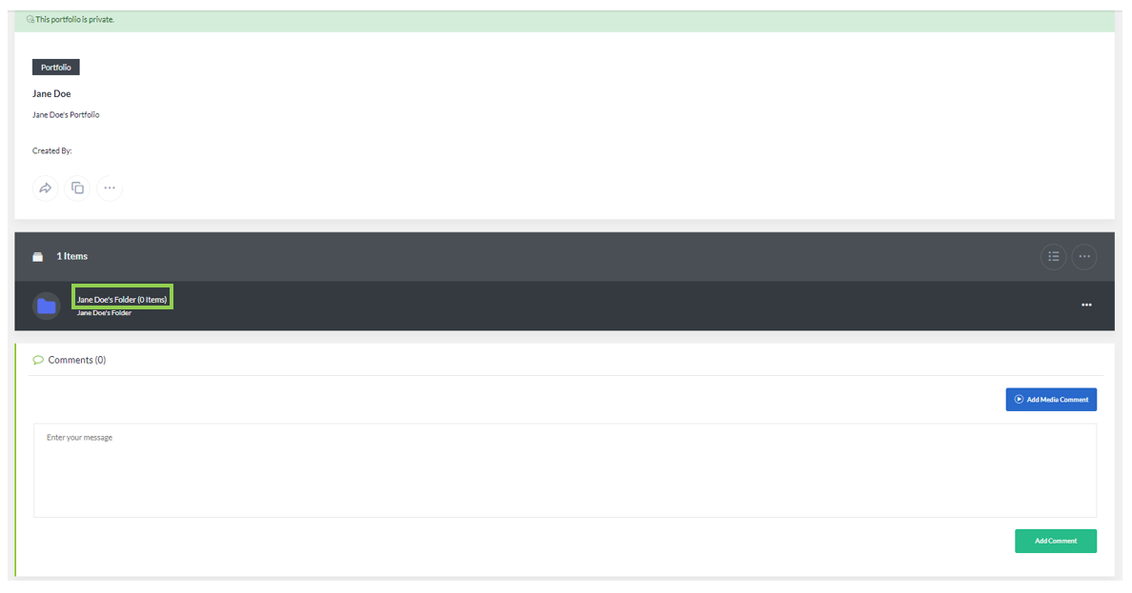

6. You can add files, links, or additional folders within the folder you have just created. Within a folder, you can return to the previous page by selecting the **Arrow and Title of the folder.**

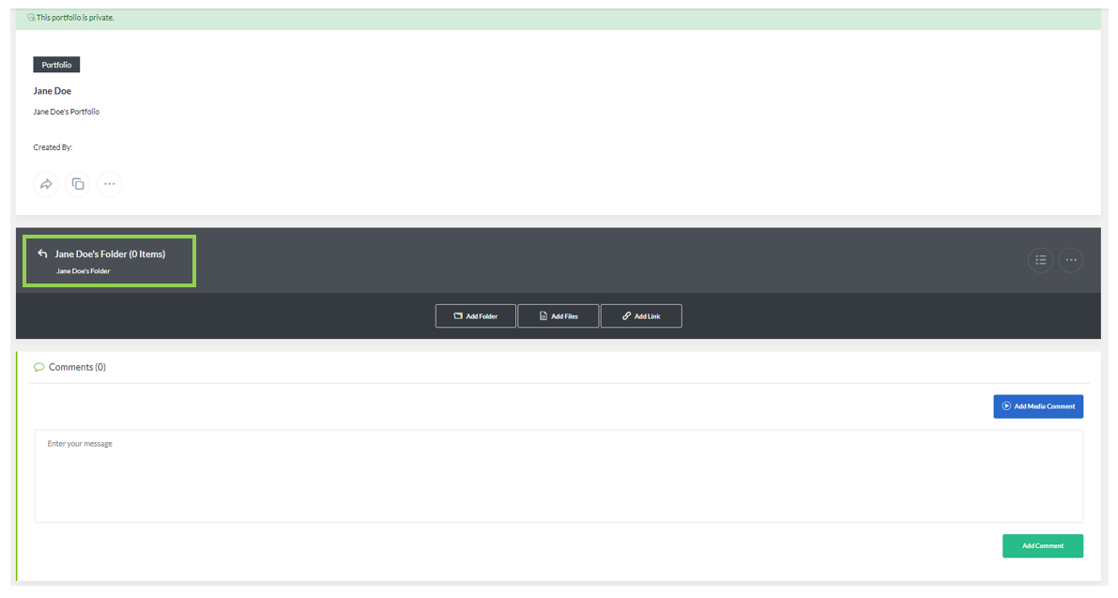

7. To Add Files to your portfolio or folders, select the **Add Files** button.

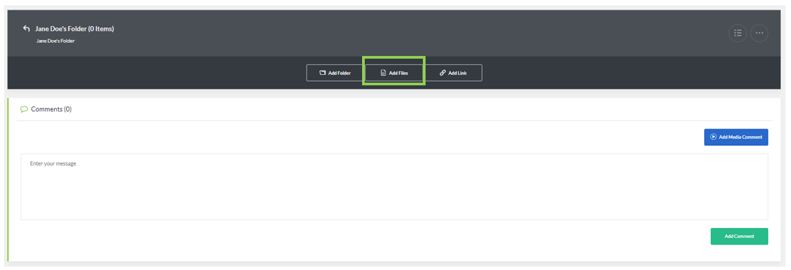

8. Here, you can either **drag and drop the files** or **Choose Files** from your computer that you want to include. **Note**: You are limited to 100MB per file.

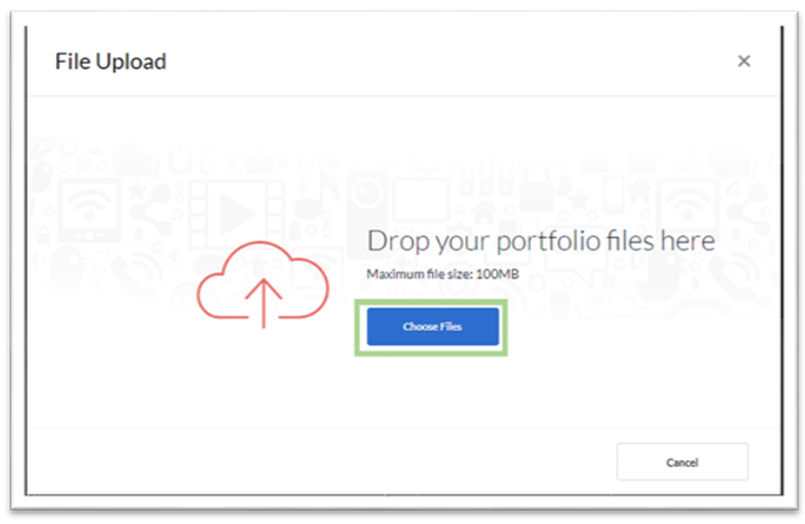

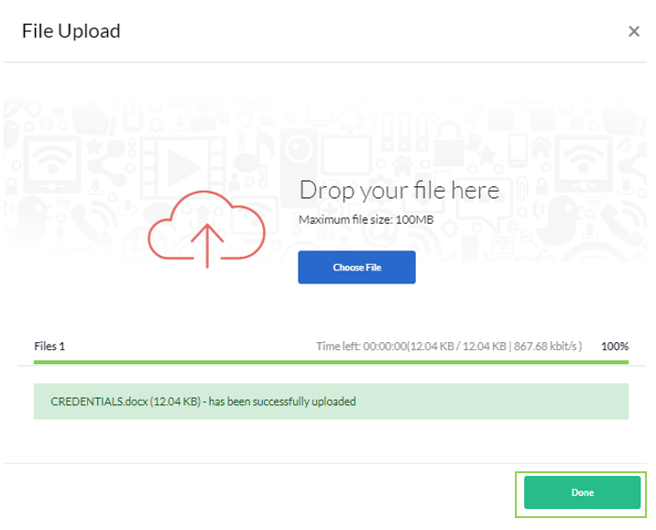

9. To add Links to your portfolio, click **Add Link.**

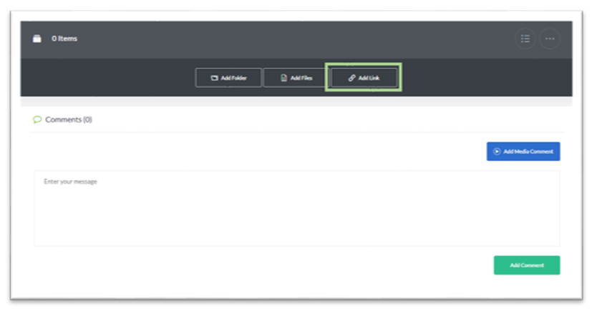

10. Here, you will need to provide the following details for the link:

* Name
* Link
* Description

Press **Save** when complete.

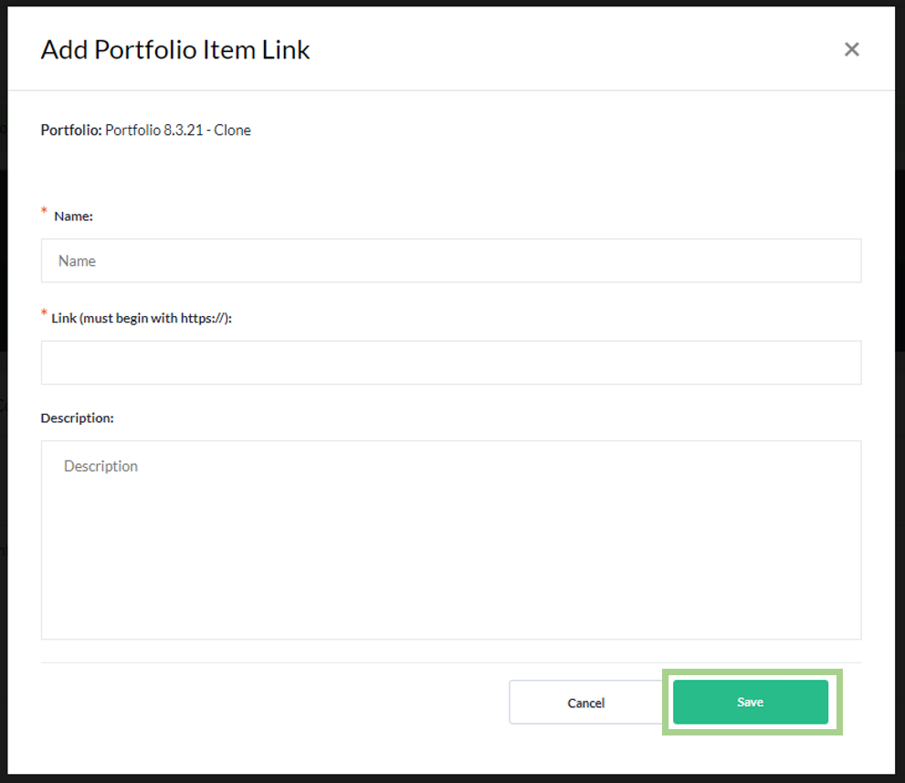

11. On the main folder and sub-folders of your portfolio, you may change the views by selecting the **bullet icon**. 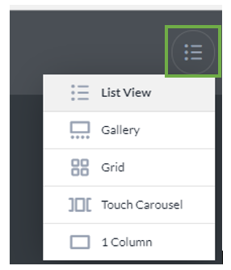

12. On the main folder and sub-folders, you may also select the **icon with the three dots** to add folders, files, links, and reorder the items in your portfolio.

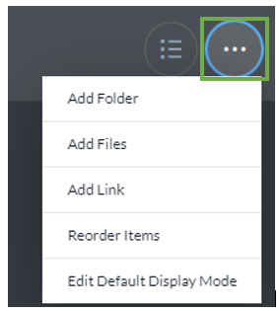

13. You can leave comments below your answer or recording by entering text into the box by clicking. The **Add Media Comment** buttonor **Add Comment** button.

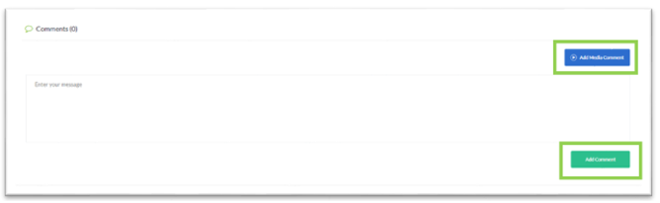

## Additional Features and User Guides

For additional features and User Guides within the SkillsFirst platform:

* Log in to your Illinois Worknet Account.
* Select Resumes in the dashboard banner.
* When directed to SkillsFirst scroll to the bottom the page and click **User Guide**.
* On the next page, click **Job Seekers**.

Here, you can enter a keyword search for the assistance or feature you are interested in learning about.

These User Guides have the most up-to-date information about the SkillsFirst platform.

## Technical Support

# Support is available please contact the Illinois workNet team at [info@illinoisworknet.com](mailto:info@illinoisworknet.com).

# Standard business hours are Monday-Friday, 8AM-4:30 PM (CST).

The Illinois workNet® Center System, an American Job Center, is an equal opportunity employer/program. Auxiliary aids and services are available upon request to individuals with disabilities. All voice telephone numbers may be reached by persons using TTY/TDD equipment by calling TTY (800) 526-0844 or 711. This workforce product was funded by a grant awarded by the U.S. Department of Laborʼs Employment and Training Administration. For more information please refer to the footer at the bottom of any webpage at [illinoisworknet.com](http://illinoisworknet.com/). – October 3, 2022 v8