Getting Started

Logging Into Illinois workNet
1. Go to www.illinoisworknet.com and click Login at the top right of the header.

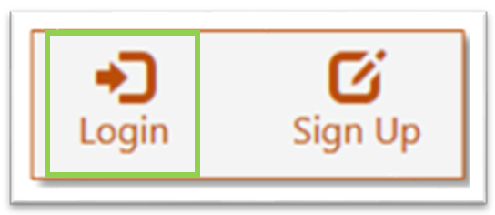
2. Log in with your Username and Password.

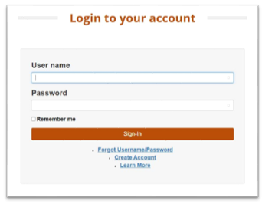

3. Using the My Dashboard menu, click Resumes.

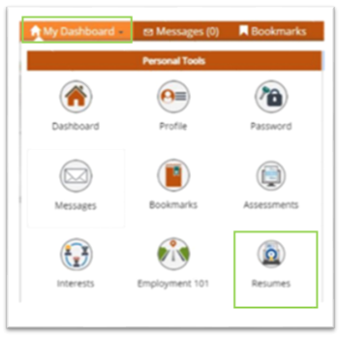

You can also click on My Dashboard and then click Resume Builder.

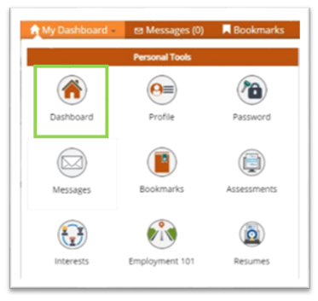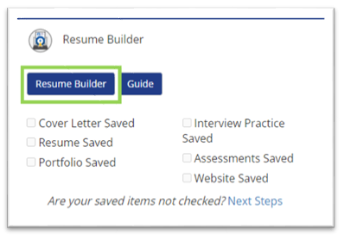

You will be redirected to your SkillsFirst Gallery, where you can add Cover Letters you create.
Note: If this is your first time accessing SkillsFirst, you will be asked to confirm your email address.

Click Continue to confirm your email address.
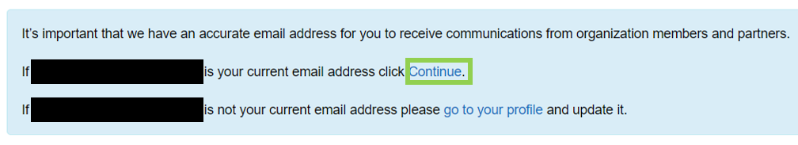
You will see a message asking you to check your email.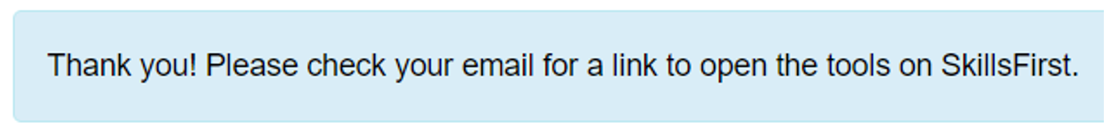
Go to your inbox and open the confirmation email (be sure to check your spam and junk folders if you do not see it) and click the confirmation link, Click here in the email.
Note: This link will expire in one hour so be sure to confirm before the hour expires.
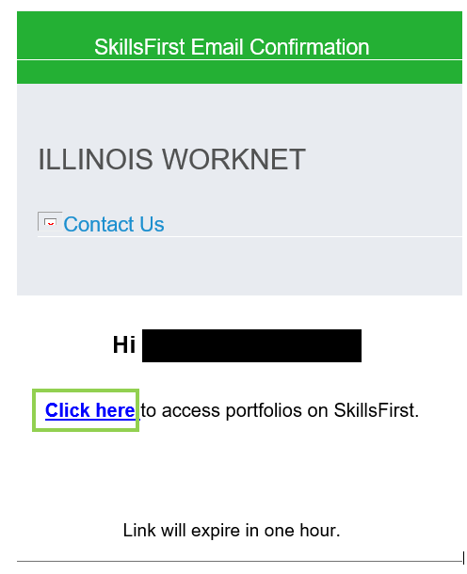
Once you select the link, you will be presented with a welcome message.
Click the X in the top right corner to continue to SkillsFirst.

Creating a New Cover Letter

Click the Create a Cover Letter button.

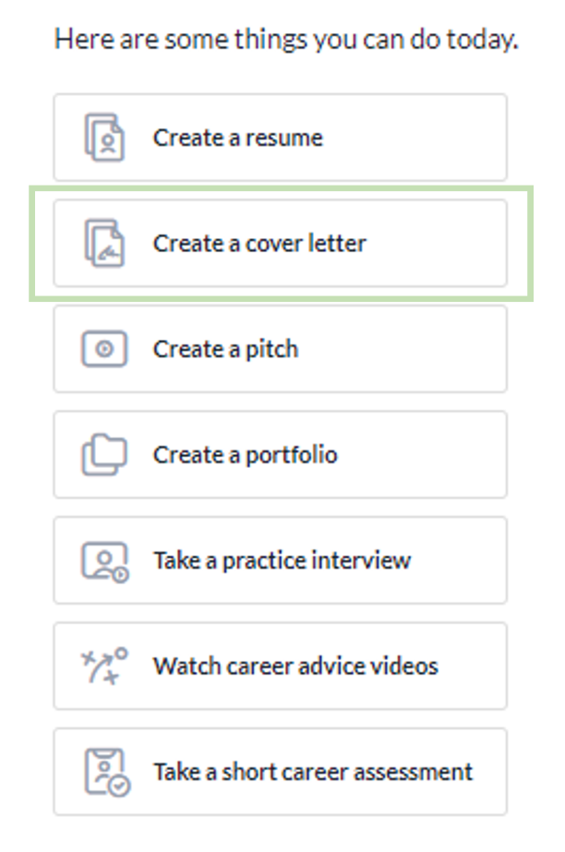
You will be presented with the following options:
- Upload a Cover Letter
- Edit a Sample
- Start from Scratch
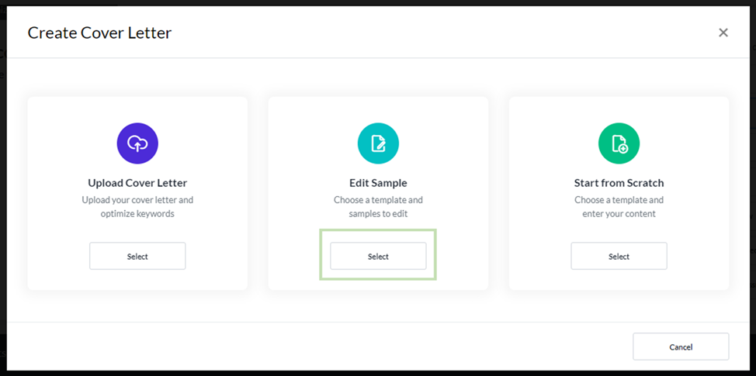

Uploading a Cover Letter Option
1. Click the Select button under Upload Cover Letter.
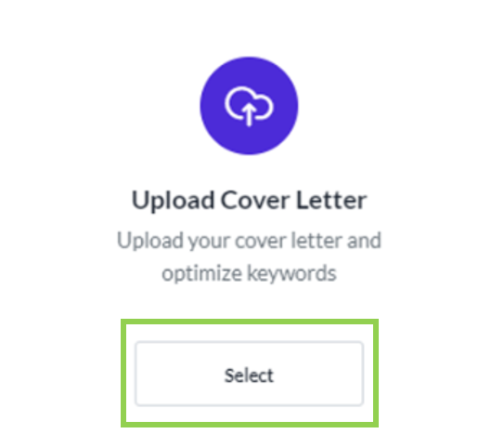

2. Create a Name and Description and click the Save button.
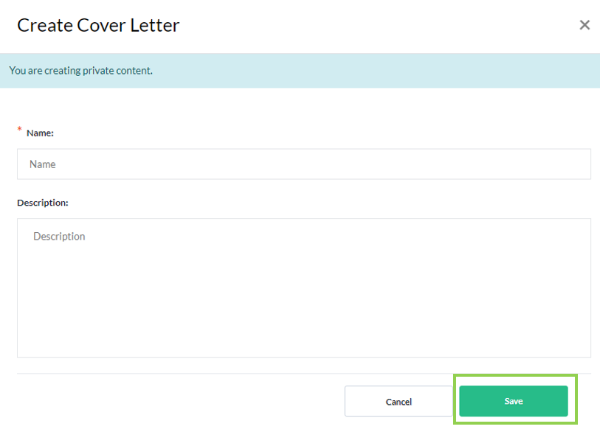
3. On the next screen, click the Upload Letter button and select your cover letter document from your computer or drag and drop the file into the file upload window.
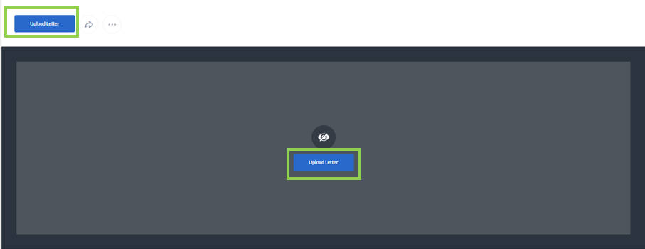
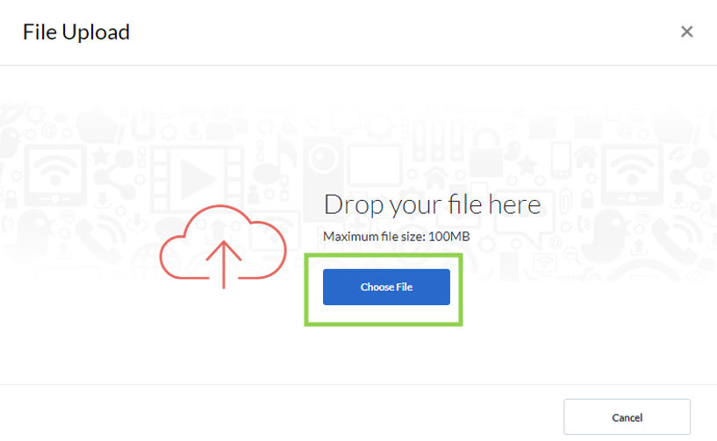
4. Once the file upload is complete, click Done.
5. With your cover letter uploaded you can:
  - Add Comments
  - Add Media Comments
  - Add Notes
  - Tag with Occupations
  - Add Competencies
  - Add Gallery Items.

These options are just below the cover letter you uploaded.
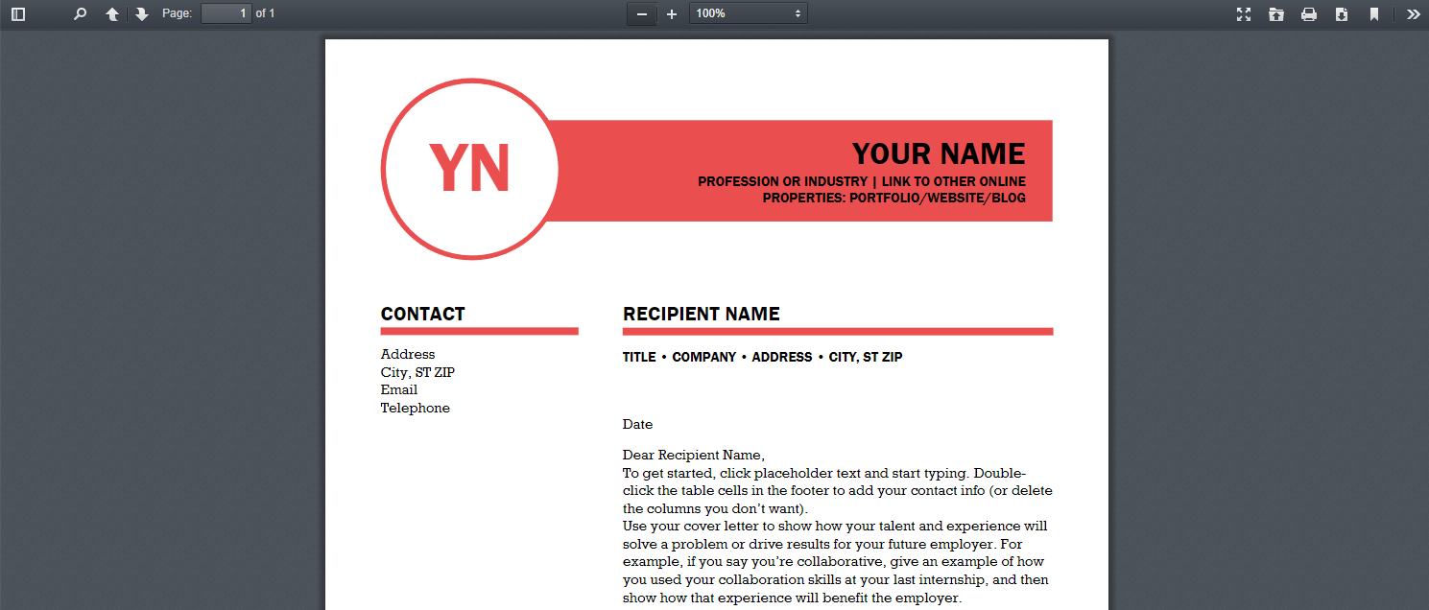
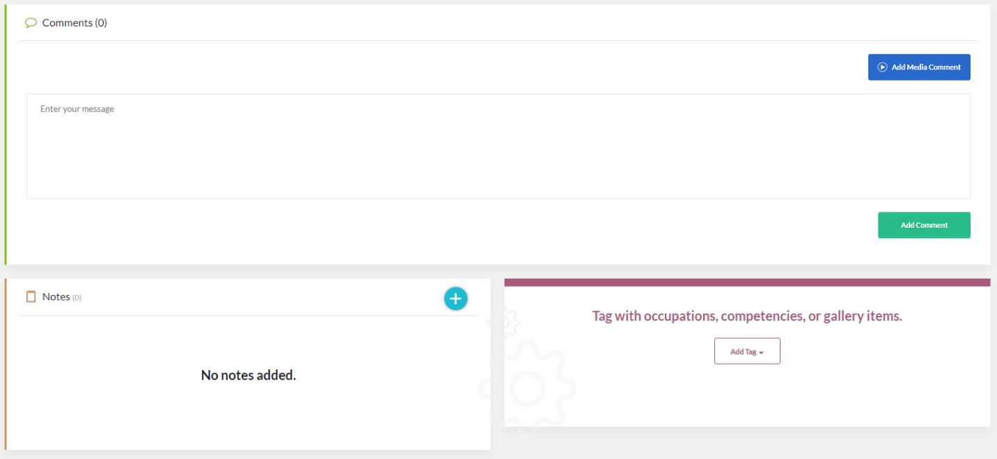

Editing a Sample Cover Letter
1. Click the Select button under Edit Sample.
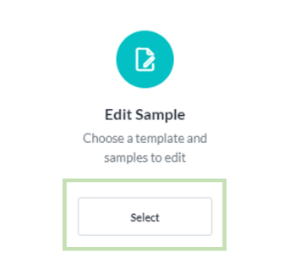
2. A new window will open with available cover letter templates. Note: You can change the template
later if need be.
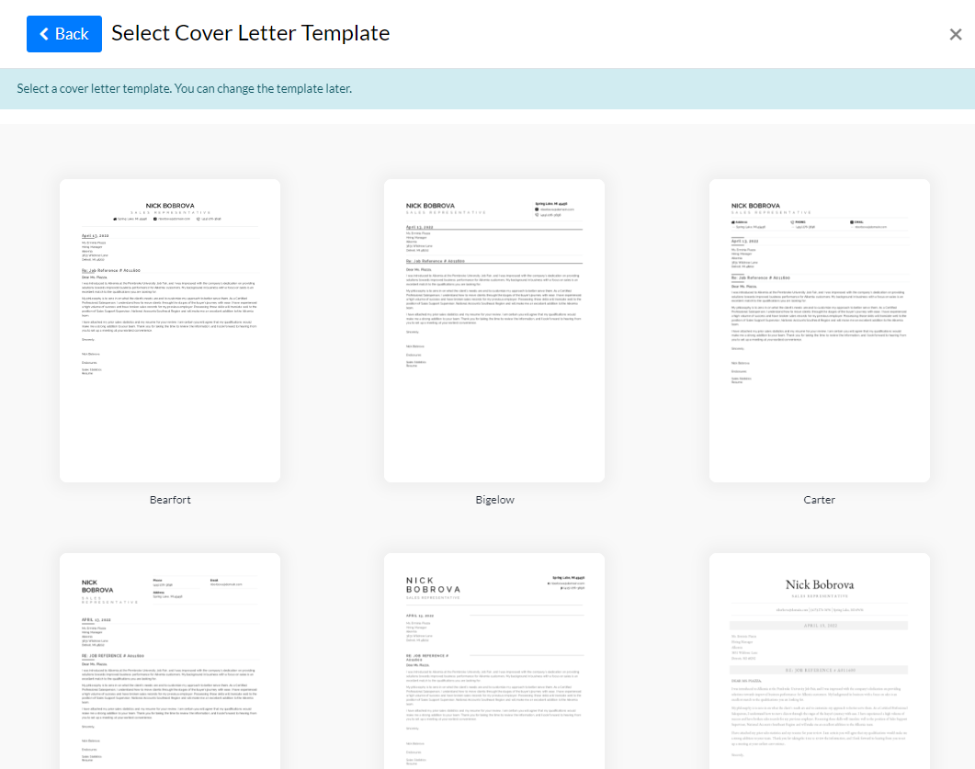

3. When you click on a template, a new window will open that will show different types of cover letters to choose from. Choose the option that most aligns with the cover letter you need.
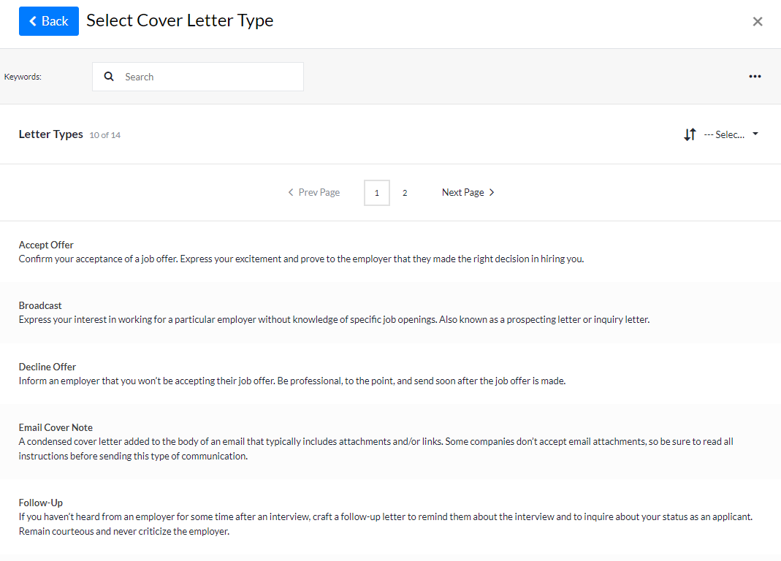

4. You can Preview the different options that are available based on your selection.
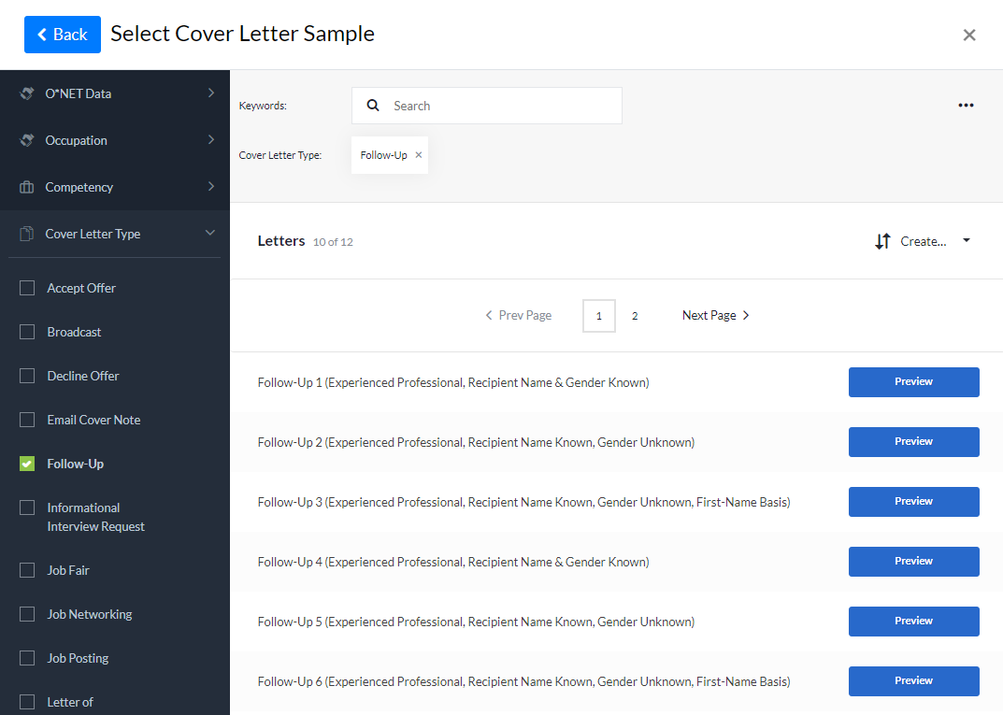
5. After clicking Preview, a new window will open that shows the template with the sample cover letter information. If you would like to use the sample, click Use This Sample.

Otherwise, click the Back button to select a different option.
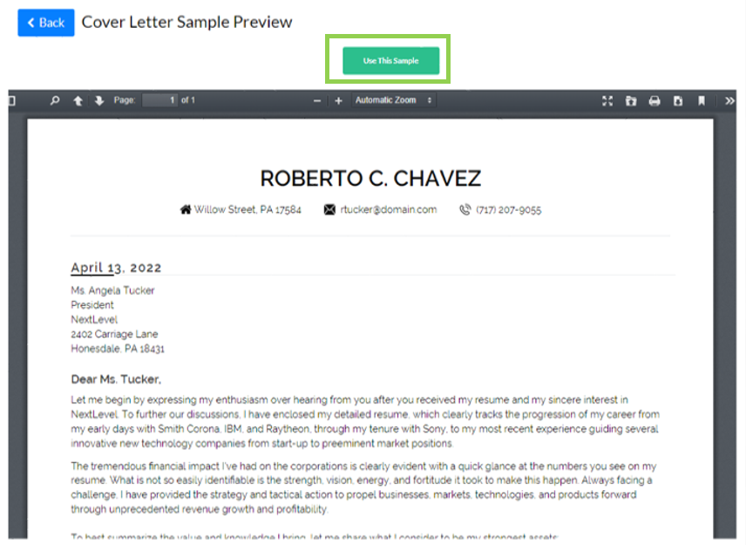

6. After clicking Use This Sample, you can Edit your cover letter.
You have the following options to edit your cover letter:
- Change Template
- Keyword Suggestions
- Updating the sample text provided with your information.
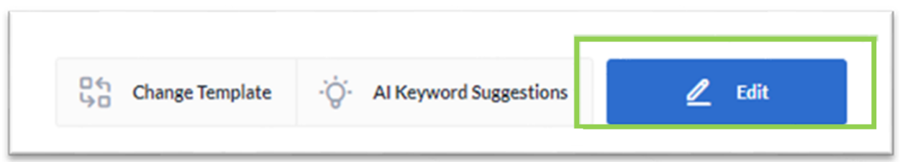
7. If you choose to Change Template, a new window with different cover letter templates will open. To change your template, click on a different template and your resume will be updated.
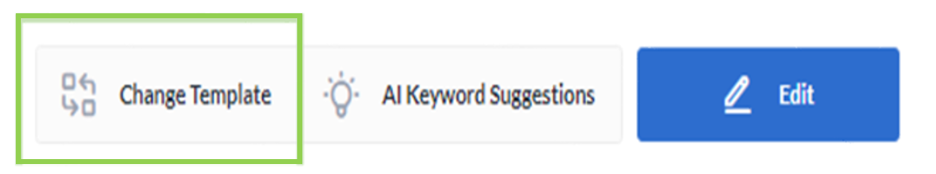
8. If you choose AI Keyword Suggestions, a new window will open next to your cover letter where you can paste a job description.
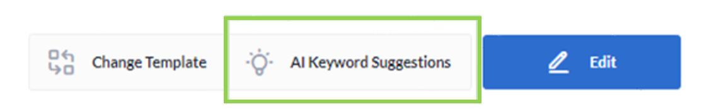
9. After you paste the description, click Get Suggestions.
Keywords will be provided to use to enhance your cover letter.
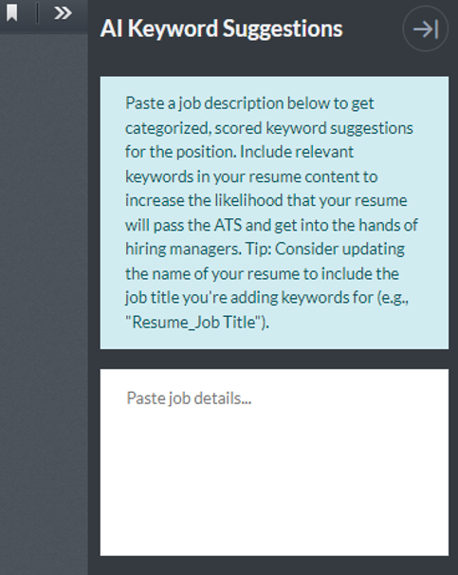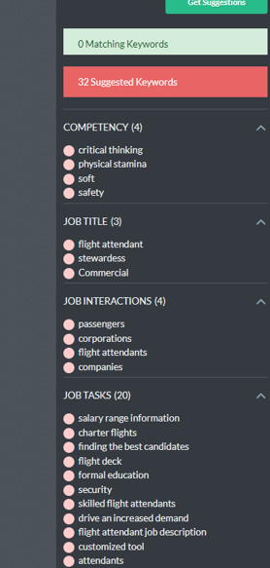
10. If you choose Edit, you can update the text in your cover letter. Once the information has been updated, click Save.
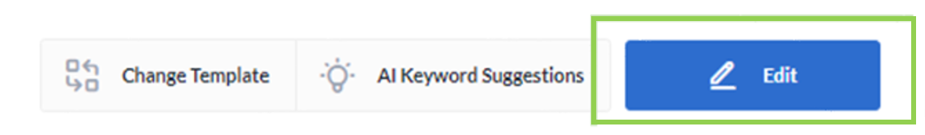
11. To navigate between tabs, click the tab and update the sample text with your information.
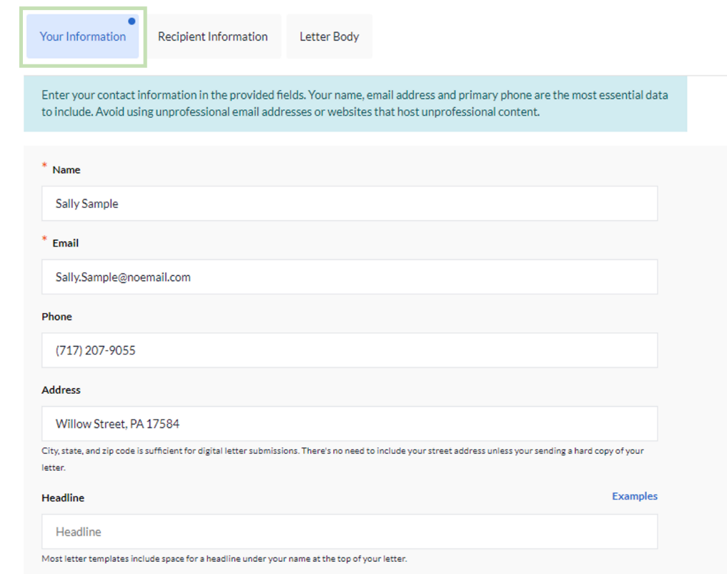
With your cover letter you can:
- Add Comments
- Add Media Comments
- Add Notes
- Tag occupations, competencies, or gallery items.

These options are just below the cover letter you saved.
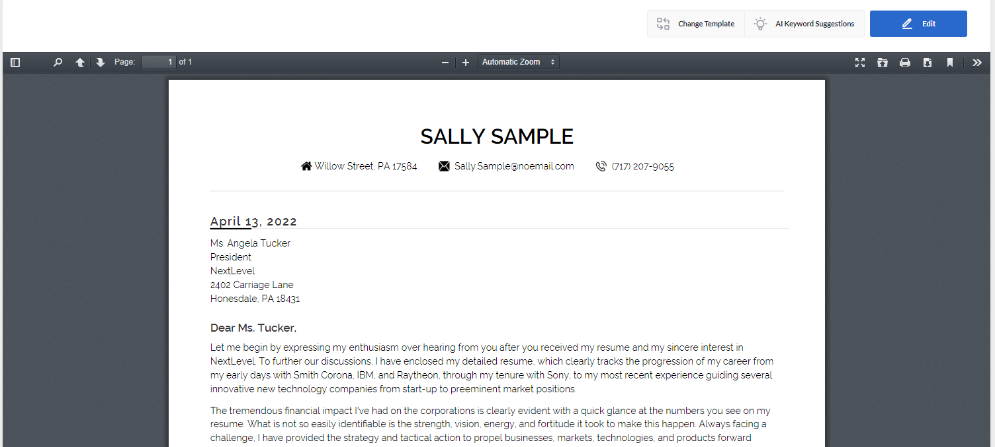
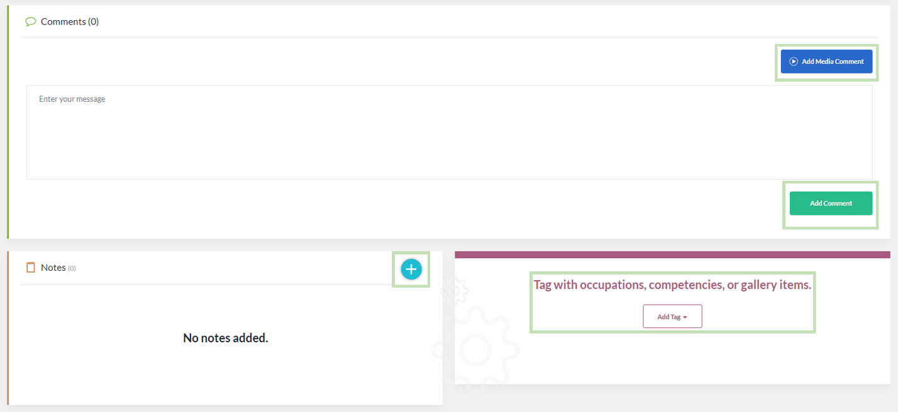

Start from Scratch
- If you choose to start a cover letter from scratch, click the Select button.
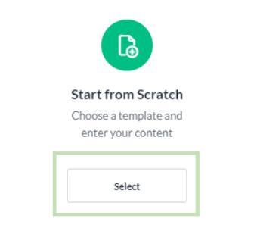
- You will be asked to Select a Cover Letter template.
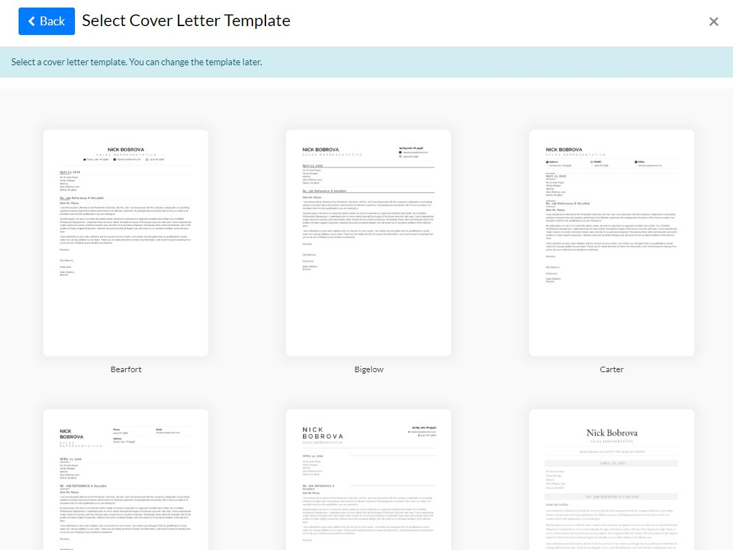

3. Once you have chosen a cover letter template, enter a Name and Description and click Save.
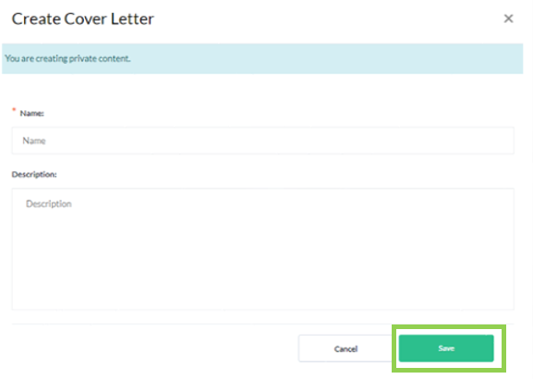
4. On the cover letter building screen, click the Edit button.
Update your cover letter by entering information in the following tabs:
- Your Information
- Recipient Information
- Letter Body
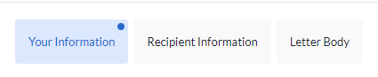
5. When you have finished adding comments, notes, and tagging with occupations, you may share it with a workforce partner who may be assisting you by selecting the Share button above the document.
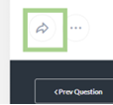

Sharing your document
When sharing your document with others, you can select the person(s) you are sharing with by using the following options:
- Editor allows the person(s) you are sharing with to make changes to your document.
- Reviewer allows the person(s) you are sharing with to make changes and/or leave comments.
- Viewer allows the person(s) you are sharing with to only view your document.

To make this selection click Viewer and make the appropriate changes.
You may preview what these permissions look like by clicking Preview Permissions.
You may also choose to share the document by clicking:
- Organization People Groups
You may share the document if you are part of any groups by entering the name of the group in the Select Group search. Options will appear based on your search criteria.
- Organization People
You may share the document with specific individuals by entering their name in the Select People search. Options will appear based on your search criteria.
- Anybody with Link
This will generate a link that you can share with others to access your document.

To make this selection click Organization People Groups and make the appropriate changes. Once these have been applied, click the Share button to share your document.
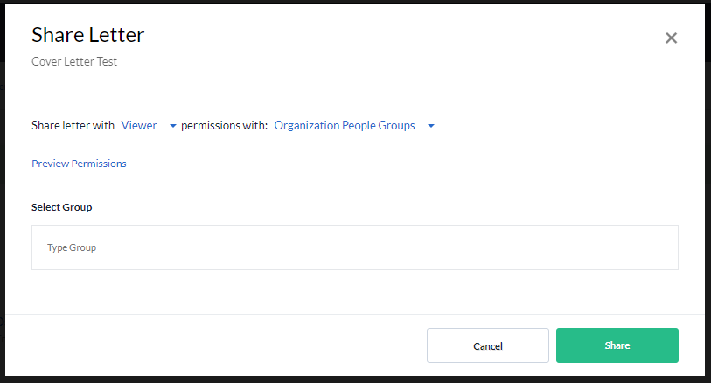

Additional Features and User Guides
For additional features and User Guides within the SkillsFirst platform:
- Log in to your Illinois Worknet Account.
- Select Resumes in the dashboard banner.
- When directed to SkillsFirst scroll to the bottom the page and click User Guide.
- On the next page, click Job Seekers.
Here, you can enter a keyword search for the assistance or feature you are interested in learning about.
These User Guides have the most up-to-date information about the SkillsFirst platform.

Technical Support

Support is available please contact the Illinois workNet team at info@illinoisworknet.com.

Standard business hours are Monday-Friday, 8AM-4:30 PM (CST).

The Illinois workNet® Center System, an American Job Center, is an equal opportunity employer/program. Auxiliary aids and services are available upon request to individuals with disabilities. All voice telephone numbers may be reached by persons using TTY/TDD equipment by calling TTY (800) 526-0844 or 711. This workforce product was funded by a grant awarded by the U.S. Department of Laborʼs Employment and Training Administration. For more information please refer to the footer at the bottom of any webpage at illinoisworknet.com.
October 3, 2022 v5

