Recruiting and Hiring New Employees Using Pinterest
Pinterest is a social media site that serves as a virtual bulletin board. Individuals and companies can “pin” items to titled boards and share them with anyone interested.
Get Started
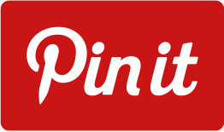
- Create a Business Account at https://business.pinterest.com/en/creating-your-account or convert your personal account to Business.
- Maintain brand consistency with your icon image.
- Connect to your Twitter account.
- Create career and product Boards.
Participate

UPDATES
- Pin images that represent your product AND company culture.
- Pin images in blog posts that you write.
- When searching for potential employees, look for boards that show off individuals’ skills and expertise or resume.
- Watch for individuals who share your company’s posts. They could be potential candidates.
- Post links to job postings. When possible, include an image on the posting to make it more visually interesting.
POST
Post stories about employee accomplishments and fun events at your workplace. This shows potential employees more about your company culture and work environment.
SEARCH
Search by keyword for potential employees. Be careful when including the word “resume,” as your search results will be full of “examples.”

LEARN
Use Pinterest to stay up-to-date with research and information in your industry. Follow your competitors to stay on top of any trends that you may have missed.
Resources

Learn about recruiting with other social media platforms by visiting this site:
http://www.illinoisworknet.com/socialmedia
Find more recruiting and hiring tips at:
http://www.illinoisworknet.com/recruitandhire

