Hello everyone,

The Illinois workNet website has released a brand new menu and header on our sitesyou will notice the new updated look and feel. Illinois workNet’s pages can now be accessed via a drop down menu located at the top left corner of any page. You can log in or sign up for an account by clicking next to the menu button.

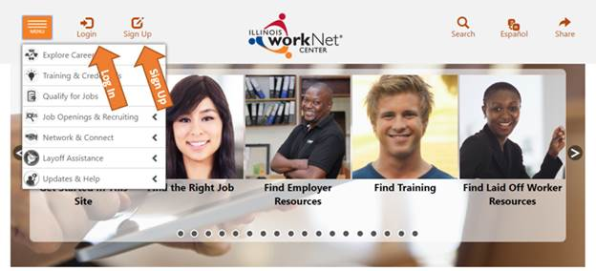

My Dasoard Once you log into your Illinois workNet account an orange bar will appear under the menu button from there you can access your dashboard, messages, bookmarks, and more.

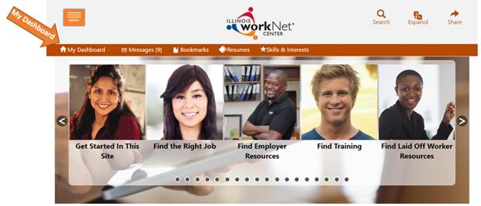

After you select **My Dashboard** you will have the option to access your dashboard, profile, resumes, and more!

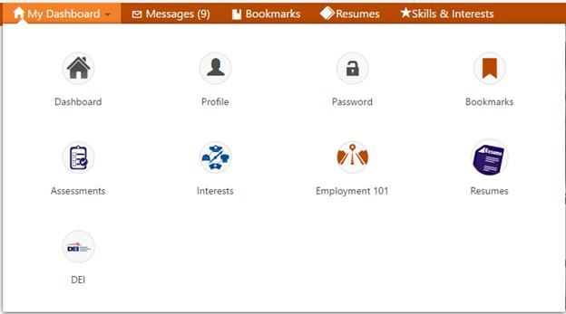

The ilepic.com and the EPIC Partners website have also undergone the same changes. The menu to access the different steps appears in a drop down menu located in the upper left hand corner. The Partners Page does not have a drop down menu, you will continue to access the links in the body of the website. You can log in or sign up for an account by clicking next to the menu button.



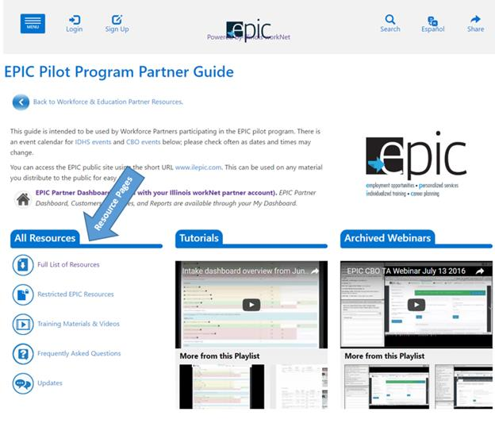

Once you are logged into your Illinois workNet account on ilepic.com you will be able to access your dashboard and more in the blue bar under the menu bottom.



After you select **My Dashboard** you will have the option to access your dashboard, profile, resumes, and more!

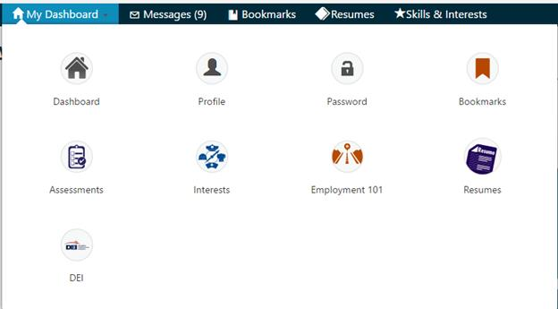

If you experience any issues please feel free to email us at [epic@illinoisworknet.com](mailto:epic@illinoisworknet.com)