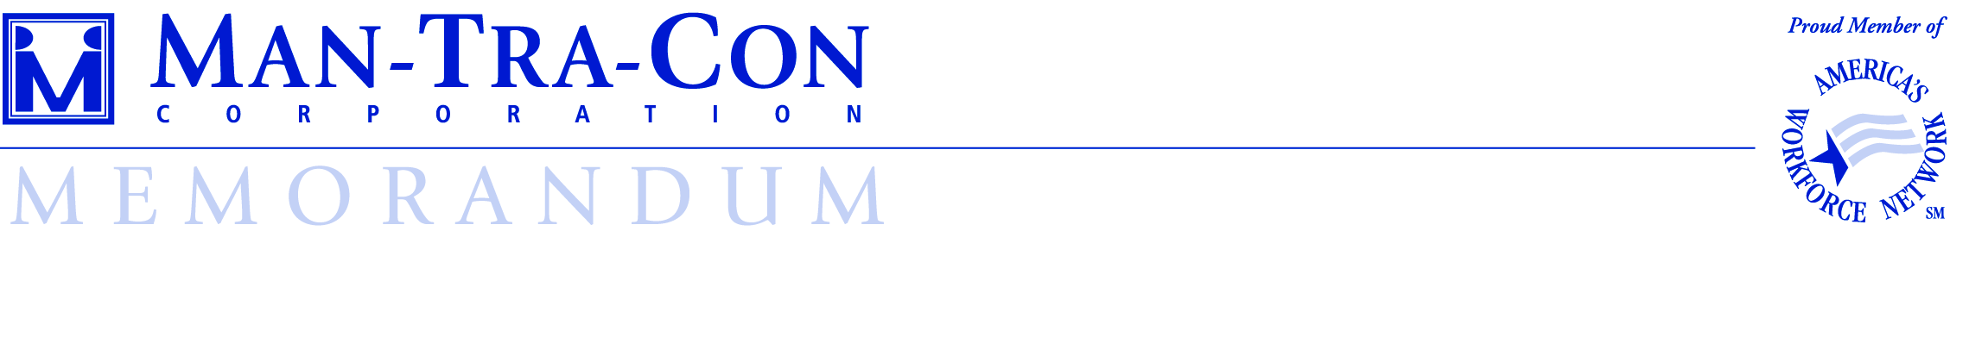

To:______________________________________________________________________
(Print name of participant – Last name, First Name, Middle Initial)

You have been chosen as an NEG – Flood Recovery program participant. You might be asked to work at a worksite which has a drug screening, medical physical and/or background check requirement for its participants. While you are an employee of Man-Tra-Con during this program, you will be required to adhere to the worksite’s drug screening/medical physical/background check requirements if you choose to accept work at a worksite with this requirement(s). The drug screening policy includes an initial screening and could be followed by random drug screenings during your period of placement at the worksite.

By signing this document, you acknowledge that you have been made aware of the possible drug screening, medical physical and/or background check requirements at certain worksites and will accept an assignment at any worksites with this requirement. Your placement at the worksite location is contingent upon this information.

____________________________________________ _______________________
Participant Signature Date

