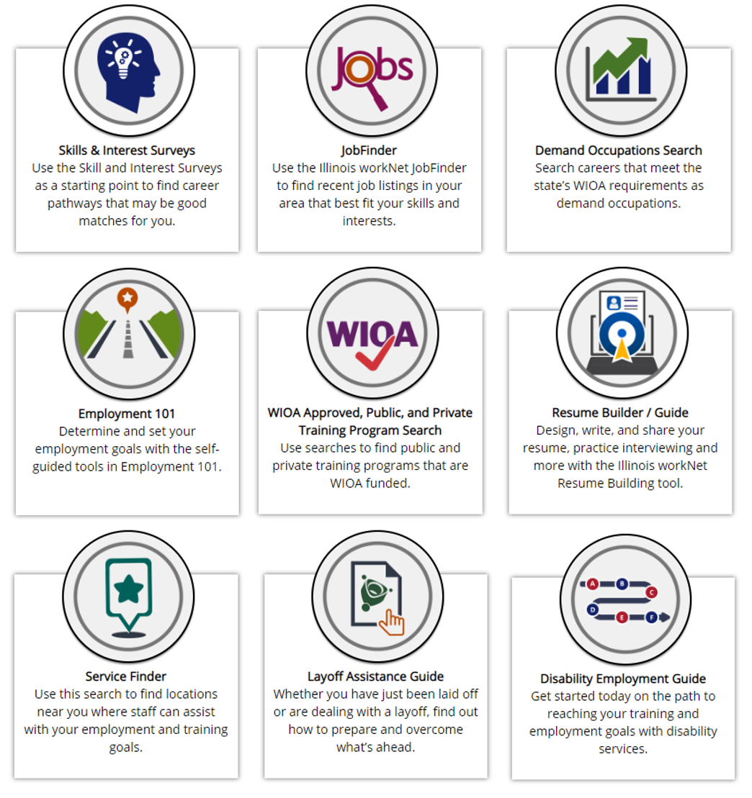
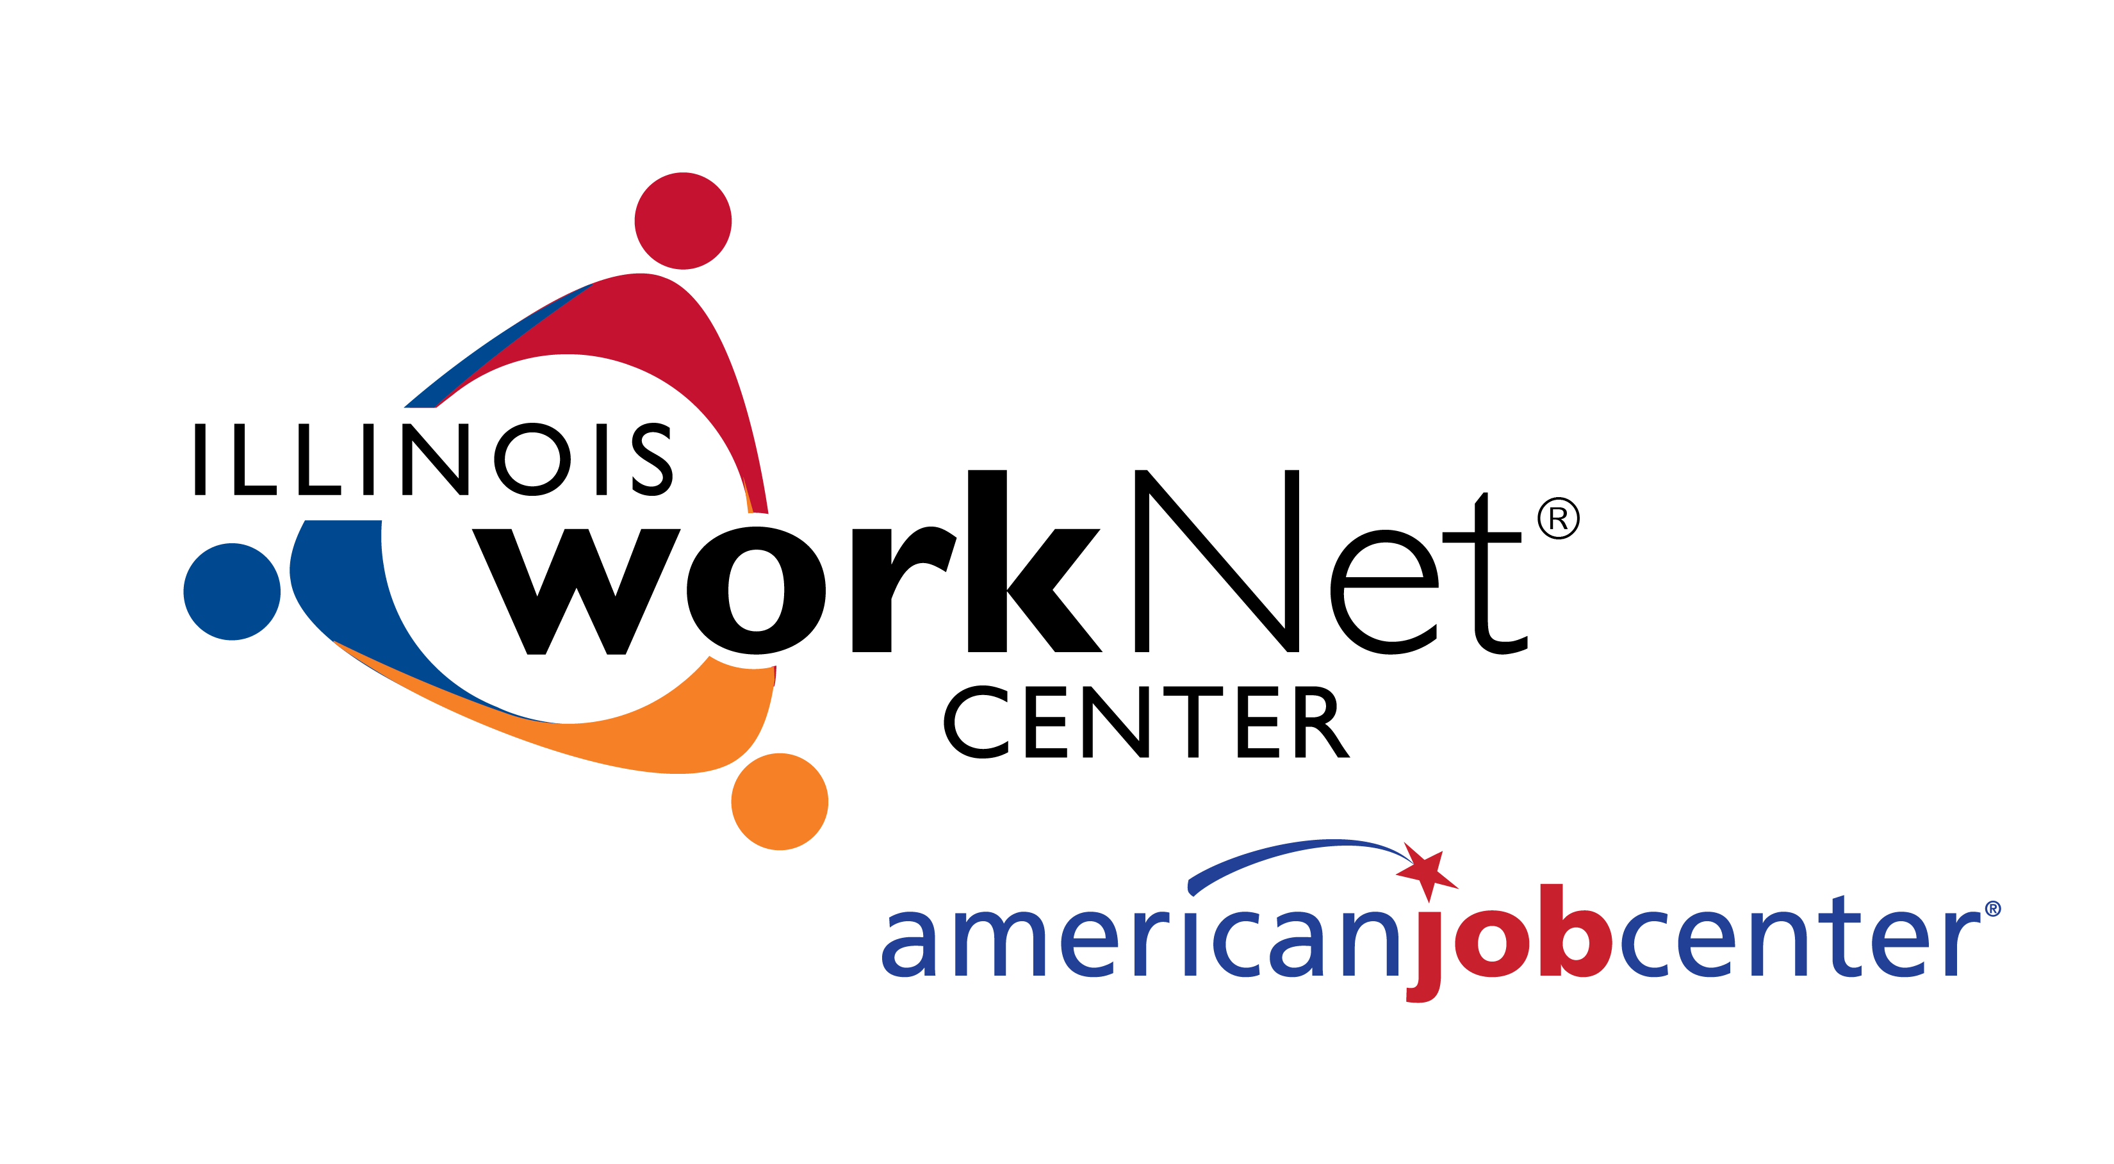
Illinois workNet® is the State’s web portal for workforce development. It provides several tools to connect job seekers to career planning, education and training, and employment resources and tools to help job seekers achieve their career related goals. The online tools and resources available through Illinois workNet are available to all Illinois citizens at no cost. Visit www.illinoisworknet.com today!
illinoisworknet.com

View Additional Illinois workNet Tools

Explore Careers
Careers, Wages, & Trends Search – Search Career Pathways using data such as job openings, wages, skills required, education needed, & more.

Training & Credentials
Apprenticeship Opportunities Search – Search for registered apprenticeship opportunities in Illinois.

Qualify for Jobs
Job Skills Guide – Make sure you have the workplace skills employers are looking for & learn how to improve your skills.
Digital Literacy Guide – Learn about your technology skills, why they matter, & how you can improve your skills.

Job Openings & Recruiting
Featured Employers – See what employers are currently hiring in Illinois.
Starting a Business Guide – Find information & resources for starting & growing your own business.

Network & Connect
Event Calendar – Find job fairs, webinars, workforce related events, & more.
Student & Trade Connections – Search for Student & Trade Associations to join in order to network, connect, & gain knowledge in your career field.
Social Media Guide – Learn how you can use social media to market your skills or promote your business.

Layoff Assistance
Company Specific Layoff Pages – Search webpages for information about specific layoffs to connect those affected to services & resources.

Updates & Help
disabilityworks – Find tools & resources to help individuals with disabilities reach their training & employment goals.
Veteran Assistance Guide – Find tools & resources to help veterans reach their training & employment goals.
Youth Resources Guide – Find tools & resources to help youth identify & reach their training & employment goals.
The Illinois workNet® Center System, an American Job Center, is an equal opportunity employer/program. Auxiliary aids and services are available upon request to individuals with disabilities. All voice telephone numbers may be reached by persons using TTY/TDD equipment by calling TTY (800) 526-0844 or 711. This workforce product was funded by a grant awarded by the U.S. Department of Laborʼs Employment and Training Administration. For more information please refer to the footer at the bottom of any webpage at illinoisworknet.com. – December 2019, v2
Money Management Guide – Find helpful information & resources to help with your current/future money management goals.
Success Story – Share your experience with a workforce development program that has helped you with your training & employment goals.

My Dashboard
Dashboard – Use the dashboard to access assessments & bookmarks, start your resume, update your account, manage subscriptions, & more.

