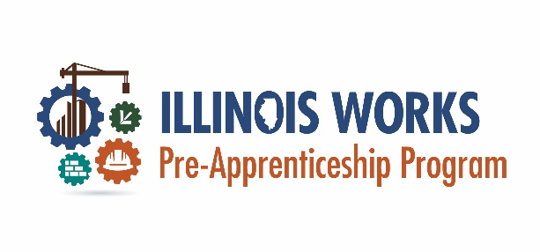
Program:

Organization Role(s)/Title(s):

Title/Role Expectations  knowledge, skills, behaviors, & attitudes | Professional Development | Events  date, time, & cost | Approved Staff  attendance & participation
Sample Internal Professional Development Plan
This document was developed by the Office of Illinois Works for the use by Illinois Works Pre-apprenticeship Program grantees.

