Contents
Overview 1
Purpose 1
Who Enters/Maintains Data 2
Access Participant Progress Page 2
Career Plan Sections 3
Overview 3
Review Assessment 5
Set Goals 5
Add Services/Training 7
Services/Training Step Level Information 8
Status (Default) 8
Service Provider/Instructor 9
Dollar Value of Service/Training 9
Attendance 9
Post-Assessment 10
Earned Credentials 10

Overview

Purpose
In the Illinois Works Reporting System, the Career Plan is a tool that Student Support Services Representatives can use with their Participants to:
- Review assessment results
- Create goals based on assessment results
- Identify steps/services needed to achieve those goals and,
- Document current status and flags when intervention is needed.

Highlights:
- Participant information submitted during the application process is used to populate the Career Plan.
- The career planner reviews the information and identifies recommended next steps that include start/end dates, status, notes, associated costs, and earned credentials (when applicable upon successful completion of the credential).
- The career planner adds recommended steps/services by selecting from a list of steps/services.

Who Enters/Maintains Data
Only staff and Participants that have been given access to the program can view the Career Plan.
- Grantee/Service Providers - Staff can view/edit Career Plans for Participants in their organization.
- Program Managers - Regional level staff have access to view/edit Career Plans for tor all Participants.
- Super Administrators - Illinois Works Staff can view/edit Career Plans for all participants.
- Participants - Participants can access their information from their program tools located in My Dashboard.

Access Participant Progress Page
- Log into www.illinoisworknet.com.
- Select My Dashboard and select Customer Support Center/IWIS under Partner Tools.
- Select the Groups in the top menu.
- Select IL Works.
- Search for the Participant by name
- Select the Participant’s name to access their information.
- Select the Training/Services tab.

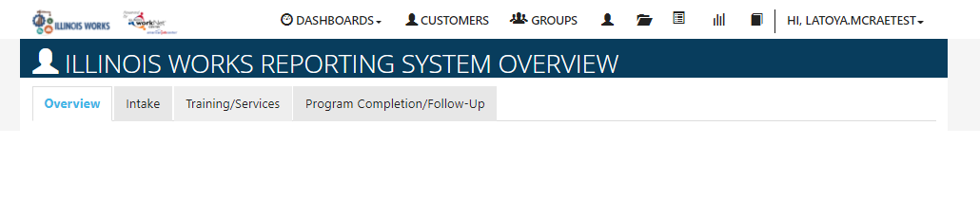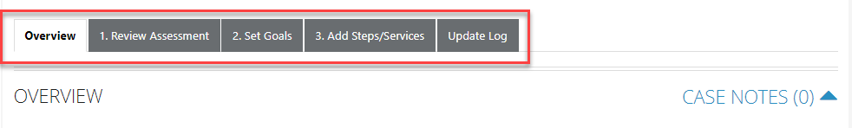

Overview - provides a summary view of assessments, career goals, accomplishments, and the steps related to goals.
- Review Assessment - provides assessment results that are saved in Illinois workNet and an area to write a summary of the assessment results. Note: These assessments are not requirements of ILW, but may be utilized by Grantee/Service Providers if they choose.
- Set Goals - provides an area to identify goals and categorize them as short/long term, and status.
- Add Steps/Services - provides system-generated recommended services/steps that can be added to the plan.
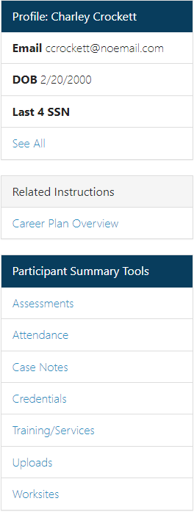
- Update Log - provides a log of Career Plan updates and uploads for the participant Career Plan agreements.

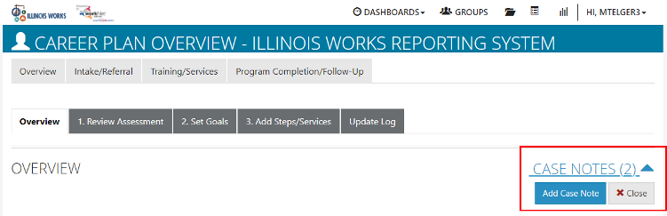
Career Plan Sections

Overview
Case Notes allows career planners to enter case notes to document changes, updates, and other notes.
Profile provides a:
- Summary of participant information
Related Instructions link to the Creating a Career Plan instructions Participant Summary Tools link to the participant’s record of assessments,
attendance, case notes, credentials, training/services, uploads, and worksites.

Note: Profile, Related Instructions, and Participant Summary Tools are located on the left-hand side bar of all participant career plan pages.
Latest Customer Goal/Plan Agreement – This section allows staff to enter whether or not there is confirmation of a Customer Agreement for the participant that they participated in the development of their Career Plan. Note: This is not a requirement for ILW.
- Physical Signature - Use the View/Print IEP/ISS Form button and have the participant and career planner sign the bottom of the document. Then upload the agreement to the Uploads tool. You will finish the physical signature process by selecting the status that reflects a signature was collected and documentation was uploaded/on file.

- Electronic Signature – Use the Send Electronic Request for Customer Agreement option to send a participant an electronic version of their IEP/ISS to digitally sign. The participant will receive an email and an Illinois workNet message with instructions on how to sign the document. Once the document has been signed, the participant’s account will be updated to reflect as such. You will finish the electronic signature process by updating the Latest Customer Goals/Plan Agreement to the status that reflects a signature was collected and documentation was uploaded/on file.

- Unable to Collect Signature – Use the Unable to Get Customer Agreement On File option.
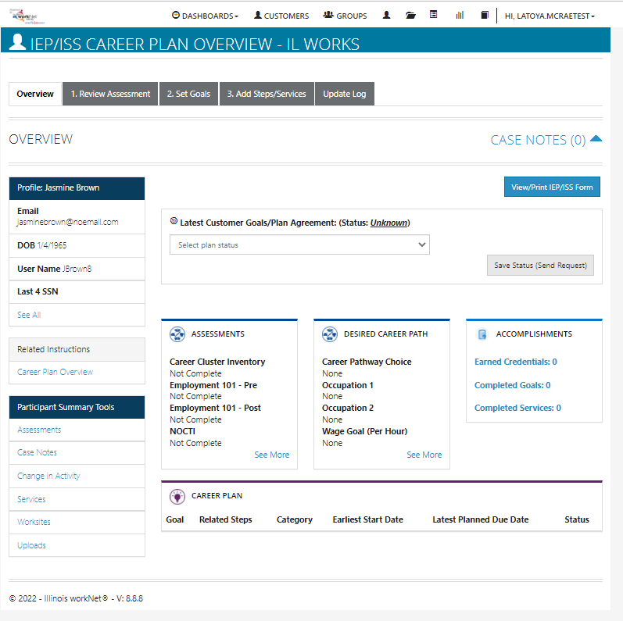Assessments provides a high-level view of completed assessments within Illinois workNet. These assessments are not the required ILW assessments. Select See More to go to the assessment page.
Desired Career Path is part of the Employment Goal assessment. This information can be updated at any time. Select See More to go directly to the Employment Goal assessment section.
Accomplishments provides a quick count of earned credentials, completed goals, and completed services that link to a list of those items.
The Career Plan section is organized by goals. It includes a list of the steps/services associated with each goal. The start and end dates for the goals are automatically generated by the steps/services for that goal. Goal status is set by the career planner and is used to identify goals that are not started, on track, off track, or completed.
The Illinois workNet Center System, an American Job Center, is an equal opportunity
employer/program. Auxiliary aids and serv ices are
available upon request to individuals with disabilities. All voice telephone numbers may be reached by persons using TTY/TDD equipment by

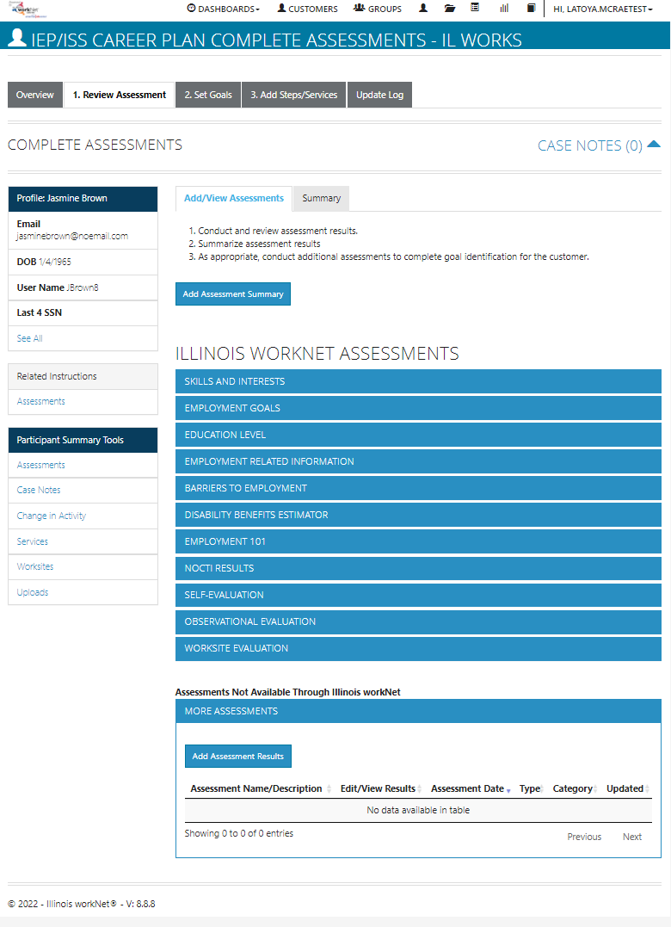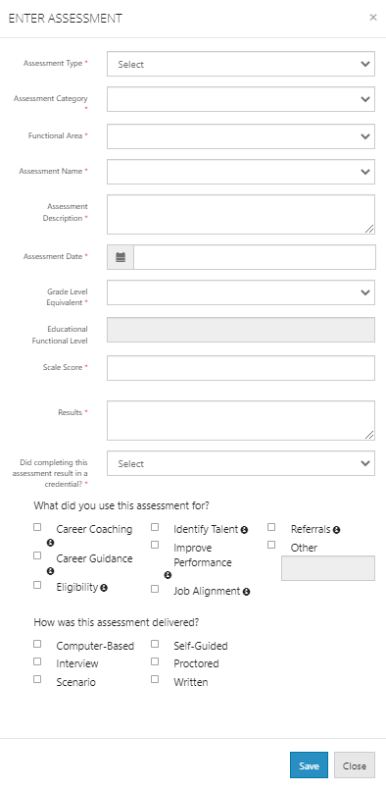Review Assessment
It is important to complete assessments to identify participant skills, interests, goals, and barriers. Some of this information is collected when the participant completes the online application (initial assessment). This information is saved in the Career Plan Complete Assessment & View Results section (Note: Not required for ILW).
  - Go through each of the assessment sections. Information populates in the appropriate sections from the intake assessment.
  - Add an Assessment Summary. Saved assessment summaries are available in the Assessment Summary tab.

Set Goals
Goals should be written to address: barriers, employment goals, education/training, and related stackable credentials that can be earned to advance the participant through their career pathway. Goals should be realistic, measurable, and attainable.

Note: Goals for wrap-around services, student support services, training services, and transition services will be set, but others can be added if needed through the process outlined.

Use completed assessments as a resource to discuss and develop goals with your participant. The participant will need to agree to the overall initial plan. If participant goals are added or marked as off track, the participant will need to agree to the update.

  - Select the Set Goals tab and Add Goal Statement.
  - Enter a Goal Statement that is 144 characters or less.
  - Select a Category.
  - Identify if the goal is a Short-Term or Long-Term goal.
  - Set goal Status as follows:

- Not Started = This status is the default setting. The career planner should update when the participant has started working toward this goal.
- On Track = The participant is continuing to progress through the steps in this section of the plan at an acceptable rate.
- Off Track = The participant is not progressing through the steps in this section of the plan at an acceptable rate. A notification is sent to the participant to let them know the status of their plan has been set to Off Track, and that the career planner would like to work with them to help get them back on track.
- 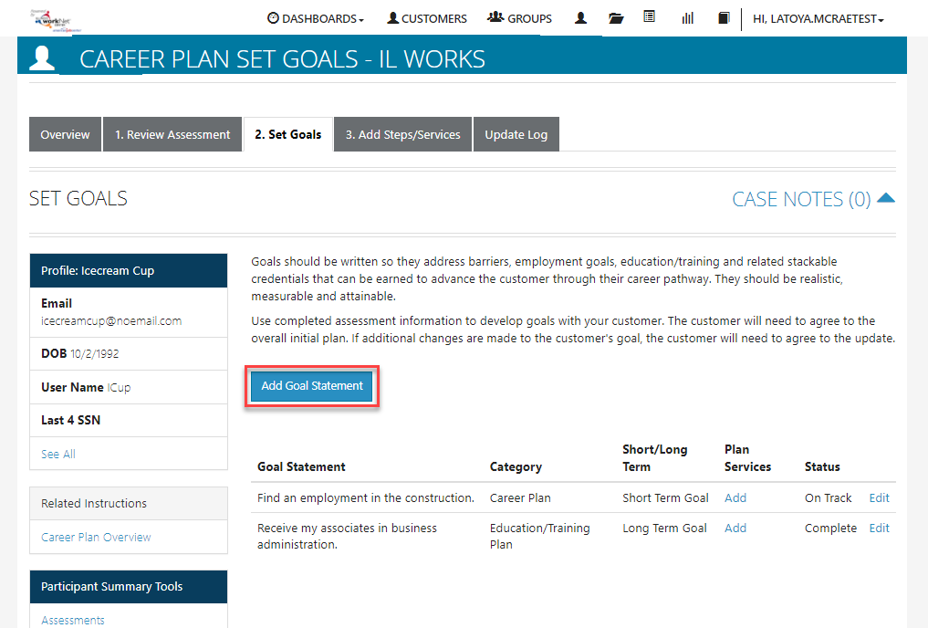Complete = The career planner has verified the participant has completed this section of the plan.
Illinois Works Reporting
System

Add Steps/Services
Start adding planned steps/services for the participant to reach their goals.
  - Select Add Step/Service. A modal will open with the services you can select from. Click Add next to each step you would like to add to this participant’s career plan.
  - Under “Assign Step/Service(s) to a Goal you can edit the services you added. To edit Planned Services (click the pencil icon) and identify the planned start and due dates, how many hours a week the participant plans on working on this goal, step status, and other notes. Then select the Update Customer Service button.
  - The service is added to the goal section under the appropriate goal selected forthe service.
  - 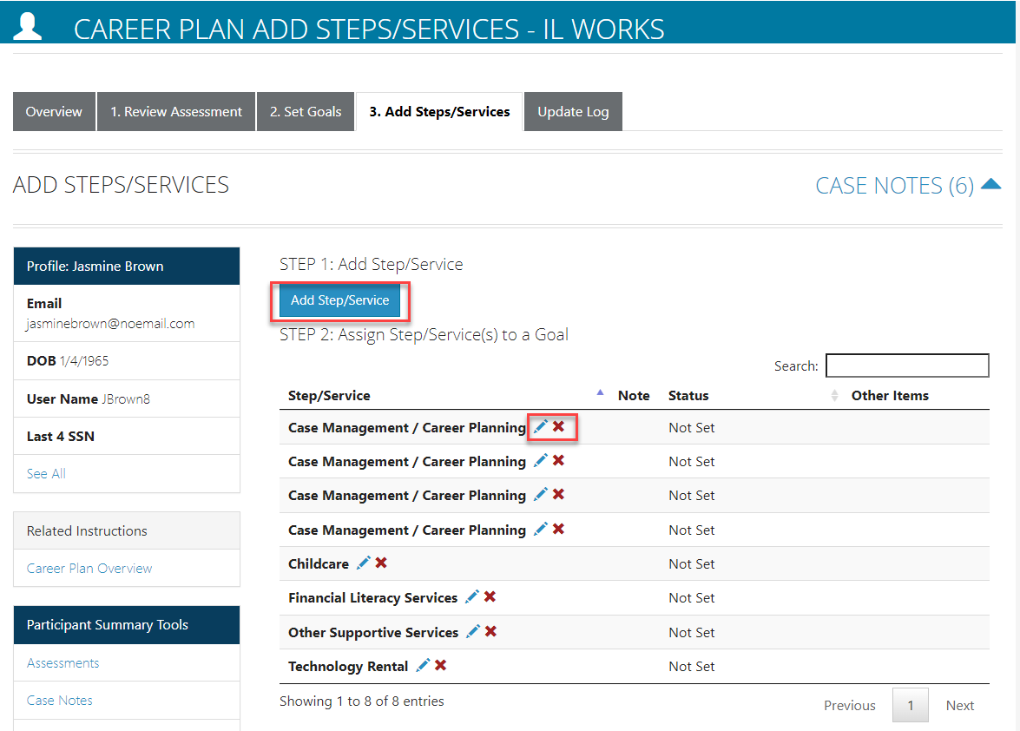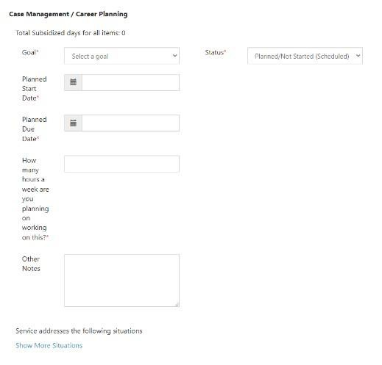You will then be prompted to add a case note.

Manage Step/Services in Goal
To add details to the step/services that have been added for the participant select the appropriate row and then select the pencil icon next to the step/service.
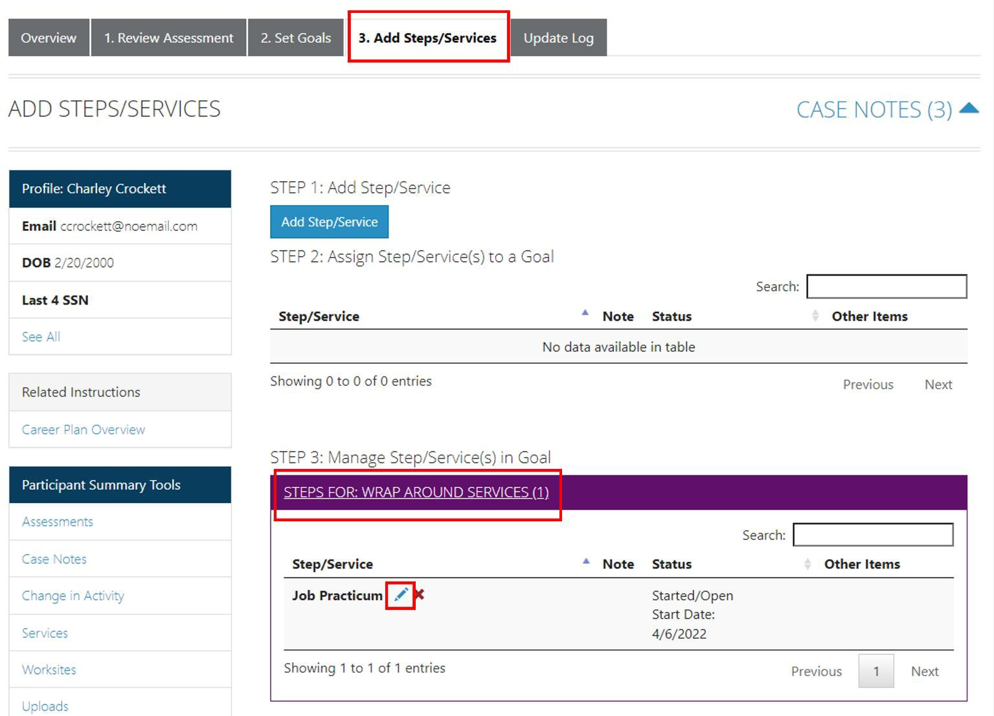

You will then be taken to a page that looks like the screenshot below:

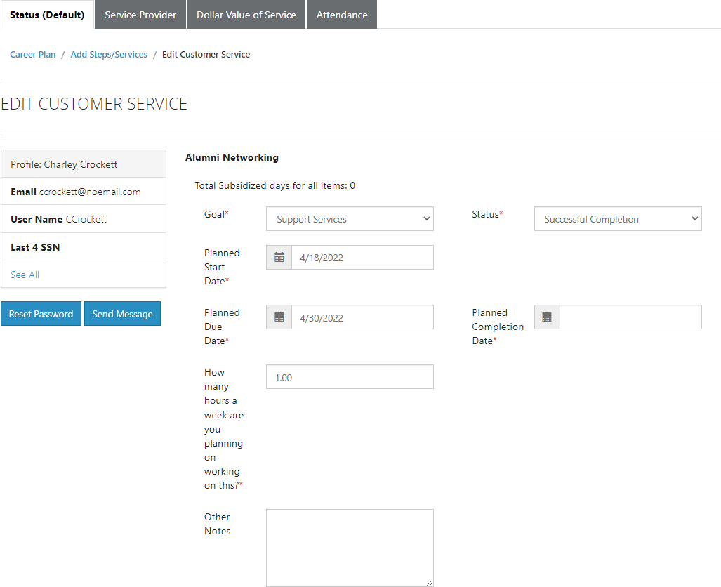

Status (Default)
All services and/or training include the related goal, status, start date, due date, weekly hours, and additional notes. A completion date is required if the status is complete.
Service Provider/Instructor
Identify who is providing the service or training. The Service Provider will be the default provider. If the Service Provider is not providing the service, enter the appropriate provider information.

Dollar Value of Service/Training
Enter the dollar amount related to the service or training. For example, if transportation costs were covered with a bus pass or gas card, the dollar amount can be noted in this step.
Attendance
Enter and verify the attendance of each participant in the program. For example, if a participant is absent, select the absent or make-up session.
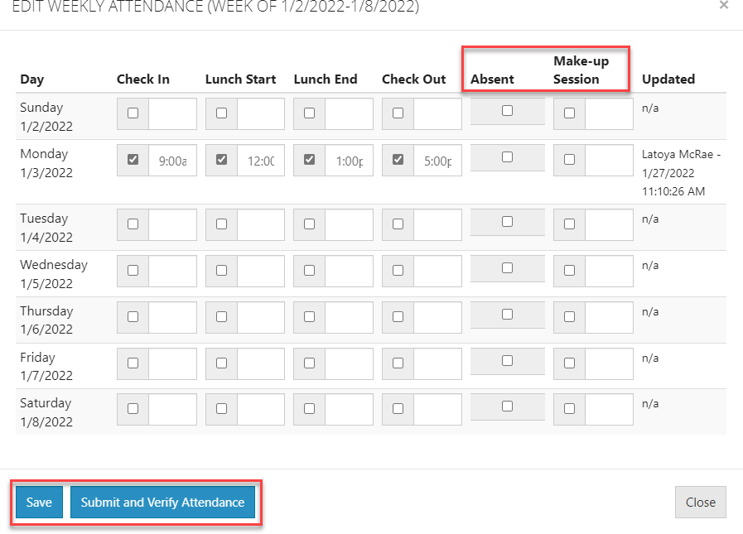
- Select the Attendance tab.
- Under the Week column, select the week to enter the participant’s attendance.
- Enter the attendance for each date.
  - If the participant was absent, click on the Absent box for each day.
  - If the participant made up the session,
enter the time on the Make-up Session.
- Select the Submit and Verify Attendance button at the end of each training session.

Post-Assessment
Service Providers can enter post-assessment by scores (%) for participants to assess their understanding of training modules covered in the program.
Earned Credentials
Note: All ILW programs should enter at minimum a credential for OSHA-10 First-Aid CPR, and their chosen curriculum (NCCER/NABTU).

You will see a listing of the credentials a participant has earned during their participation in the program. You will be able to associate the credential(s) that were identified with the training program when it was entered into the system. If you do not see the correct credential, make sure you have associated the correct training program to the service and that the credential was entered into the system and approved for the training program under your provider information.

