Purpose
The case note feature is a communication tool used to document case notes and send Illinois workNet messages/emails to participants and partners. They can be filtered and exported using the tool.

Who Enters/Maintains Data
- Grantee staff enters case notes into Illinois workNet. Staff can also use the tool to send messages to the participants, partners, and the Illinois workNet Team.
- Participants receive Case Notes sent as messages in their Illinois workNet account messages. They receive Case Notes sent as emails based on the email that is associated with their Illinois workNet account.

Access Participant Case Note Page
- Log into www.illinoisworknet.com.
Additional resources:
Telling the Story in Case Notes Case Note Rubric.pdf
- Select My Dashboard and go to the Partner tools section.
- Select Customer Support Center/IWIS.
- Select Groups in the top menu.
- Select Illinois Works.
- Select the participant’s name to access their information.
- Select the Case Notes link in the Participant Summary Tools.

Add Case Note
- Select Add Case Notes using the Case Note page or in the course of adding participant information throughout the system.
- Select a task. Indicate what caused you to write the case note.
- 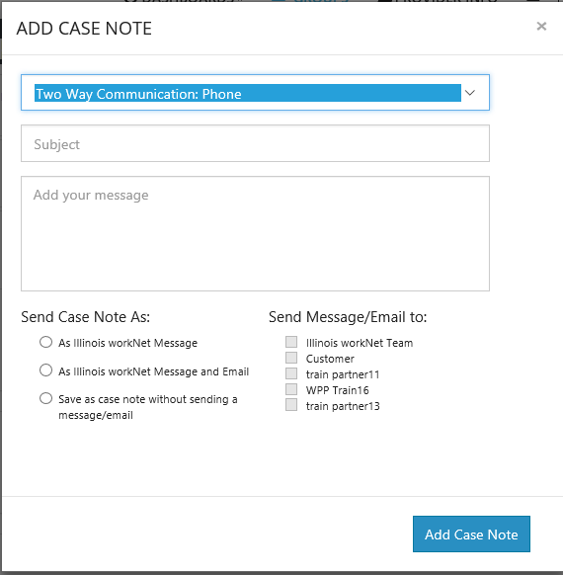Enter the contact date.
- Enter subject and case note.
- Select how to send the Case Note:
  - As an Illinois workNet message. This will alsosave as a Case Note.
  - As an Illinois workNet message and email. This will go to the email associated with the Illinois workNet account. This will also save as a Case Note.
  - Save as a Case Note without sending a message/email.
- If you choose to send it as a message/email, select to whom the message/email should be sent.

Case Notes can be:
- Filtered by date range.
- Sorted at the top of any column.
- Exported into an excel file.
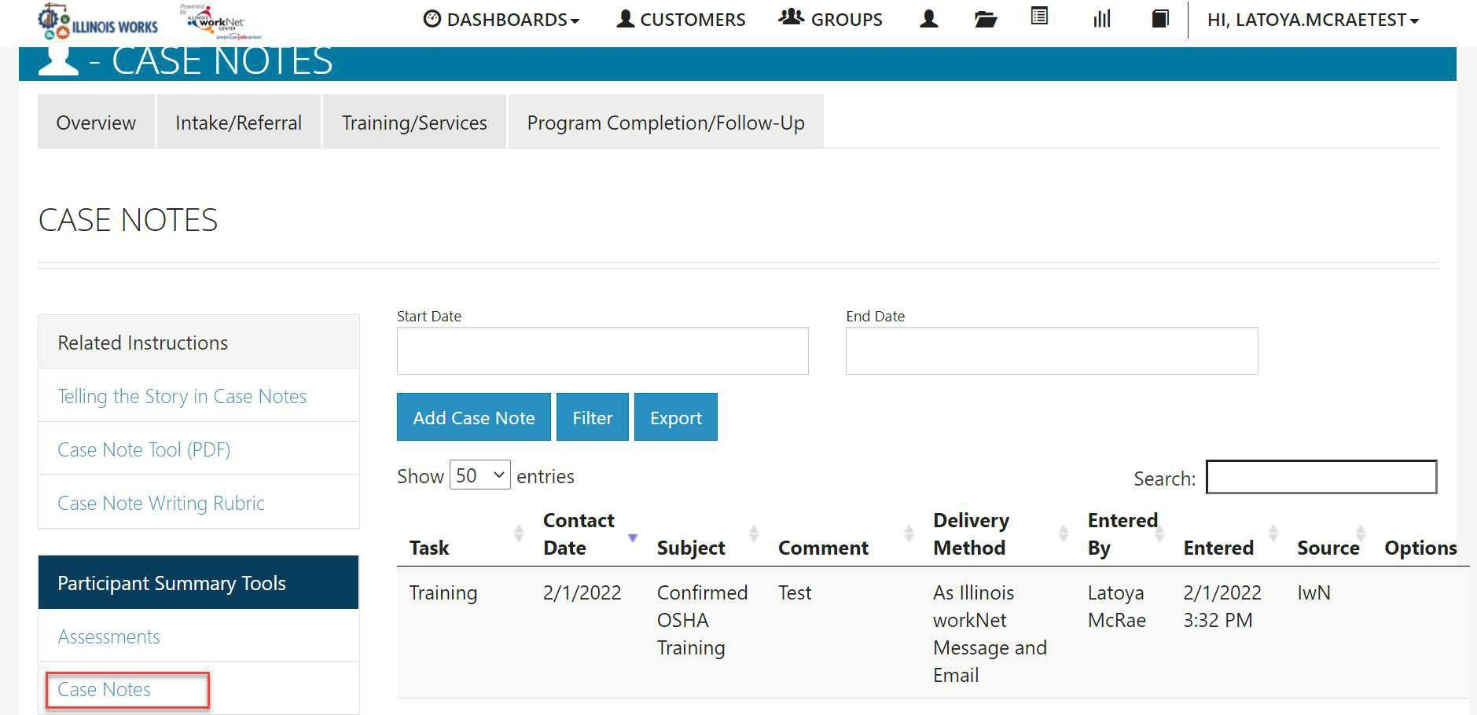

Adding a Case Note from Participant’s Overview Page
On the participant’s overview page you can select Case Notes to open a dropdown view of past case notes for the customer. Select the Add Case Note button to complete a case note.

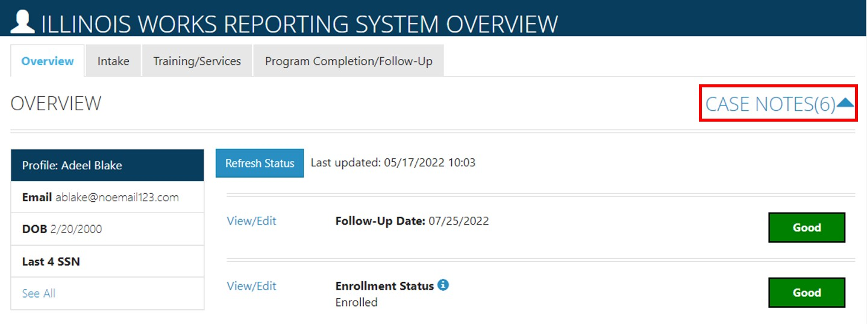

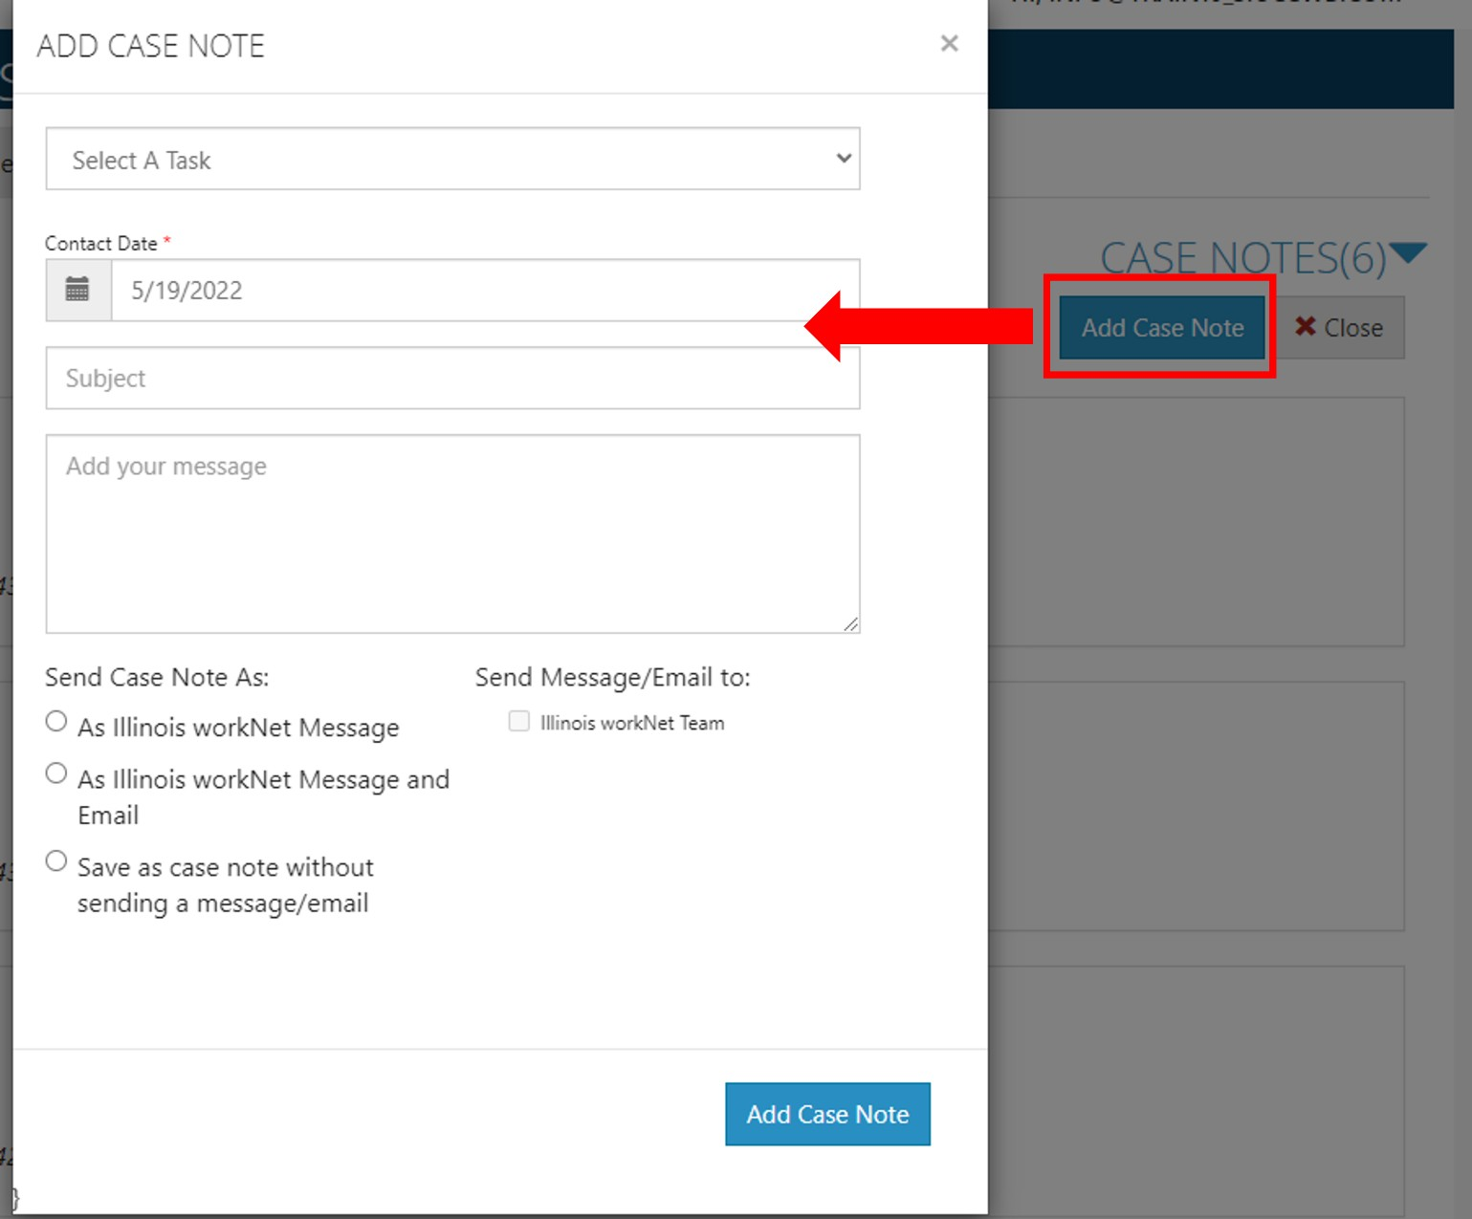

The Illinois workNet Center System, an American Job Center, is an equal opportunity employer/program. Auxiliary aids and services are available upon request to individuals with disabilities. All voice telephone numbers may be reached by persons using TTY/TDD equipment by calling TTY (800) 526-0844 or 711.
This workforce product was funded by a grant awarded by the U.S. Department of Labor’s Employment and Training Administration.

