Overview:
Training program information is a critical component of the set-up process. This information is used to create a provider & credential list in the services/training plan section. When adding a service, you will be able to select the training provider and credential to associate with the service.

Who Enters/Maintains Data:
Grantee Program Administrators associated with an agency/program in the Illinois workNet system can add/update training program information. It is the grantee’s responsibility to add and maintain accurate training program information.
Illinois Works State Level Staff approve the program once the credentials associated with the program have been verified and all related information is complete and accurate.

How to Access IL Works Reporting System:
- Log into www.illinoisworknet.com.
- Select My Dashboard then select and go to the Partner Tools section.
- Select Customer Support Center/IWIS.
- Select the Provider Info (file folder icon) in the top menu.
- Select Training Programs. Note: If you have been provided with access to more than one project/provider, select the appropriate project/provider.
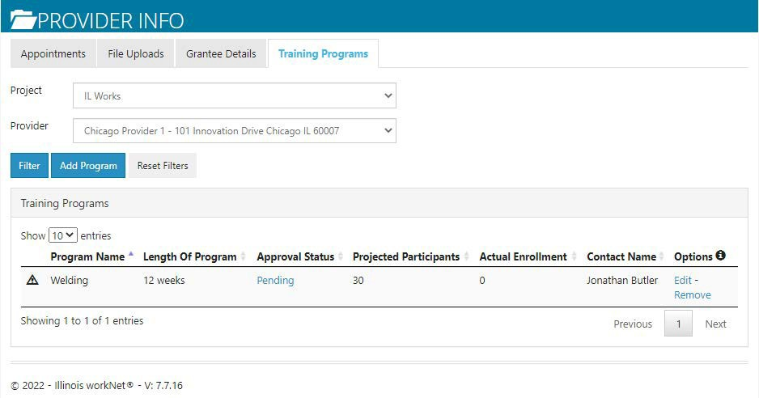

Add/Edit Training Program Information
- Add Program Information: Click Add Program. If you have access to more than one project/provider, you will need to select the appropriate items from the dropdown for the program you are entering.
- Select Pre- Apprenticeship for the program type.
- Select the option to Submit the Training Program for Approval.
- Identify the Program Information
  - Program Name
  - Program Description

  - Provider Name
  - Add the training program location information. This information is used in the suitability review. The system will use the participant’s address and the training program location to provide the distance the participant will need to be able to travel.
  - Enter the Training program CIP Code.
  - Enter time (weeks) to complete the training program (not including remediation).
  - Identify the training program career pathway.
  - Enter the SOC Code for the occupation of the program.
  - Enter the Target Occupation.
  - Enter the Training program NAICS Code to identify an industry for the business.
  - Identify the number of participants you expect to serve for each program.
  - Identify the program contact person. This should be the person who is responsible for maintaining this information. Only those who have access to the Illinois workNetIL Works tools will appear in the drop-down list.
  - Identify minimum age for a program.
i. Click Next Page

- Add any applicable Baseline Requirements:
  - Does your agency offer or have access to a remediation/bridge program?
    - Yes
    - No
  - Institution Sector/Type
    - Secondary
    - Postsecondary (select additional information regarding Sector/Type.)
  - What are the goals of this program? Select all that apply
    - Badge
    - Apprenticeship Certificate
    - Journeyman Certificate
    - Master Certificate
    - Certification
    - Associate Degree
    - Bachelor’s degree
    - Master’s degree
    - Professional Degree
    - Research Degree
    - General Education Diploma
    - Secondary School Diploma
    - License
    - Micro Credential
  - How is the training offered? Select all that apply
    - Classroom Instruction
    - Labs
    - Day Classes

    - Weekend Classes
    - Night Classes
    - Online Classes
    - On-the-Job Training/Apprenticeship
    - Work Experience
  - What are the minimum requirements to enter the program? Select all that apply
    - Math Requirement
• = > 6th Grade
• = < 8th Grade
• = > 8th Grade
    - Reading Requirement
• = > 6th Grade
• = < 8th Grade
• = > 8th Grade
- Degree Requirement
      - H.S. Diploma/GED
      - AS Degree
      - BS Degree
      - MS Degree
      - Doctorate Degree
      - Industry Recognized Credential
    - Fluent English
    - Fluent Spanish
    - Fluent Chinese
    - Fluent Polish
    - Other
  - What is the lifting requirement for program entry?
    - 55 Pounds
    - 50 Pounds
    - 30-40 Pounds
    - 25 Pounds
    - Less Than 25 Pounds
  - What is the standing requirement for program entry?
    - 8 Hours
    - 6 Hours
    - 4 Hours
    - 2 Hours
    - Less Than 2 Hours
  - Are participants required to sit for long periods of time in the related job?
    - Yes
    - Yes, but they can get up from time to time
    - No
  - Which of these tests are participants required to pass? Select all that apply
    - TB Test
    - Hepatitis Screening
    - Test or screening is not required
  - What is the minimum drug test requirement for participants?
    - A drug test is not required
    - Must be currently drug-free and can pass a drug test
    - Must be drug-free for at least 30 days prior to the time they submit the application
    - Must be willing to make changes to be able to pass a drug test
  - What are the vision requirements?
    - Must be able to see without glasses or contacts
    - Vision corrected with glasses or contacts is acceptable
    - Vision is not required
  - What are the appearance requirements? Select all that apply.
    - Needs to have natural hair and make-up
    - Needs to cover tattoos during work hours
    - No appearance requirements
  - What are the taste or smell requirements? Select all that apply.
    - Needs to tolerate cooking smells including unpleasant smells
    - Needs to taste foods prepared by the participant
    - No taste or smell requirements
  - Can the participant have more than 3 motor vehicle tickets/instances in the past three years?
    - Yes
    - No
  - Is a valid driver’s license required for the program?
    - Yes
    - No
  - What kind of background check is required? Select all that apply.
    - Background check is not required for this training/career path
    - Must not be a registered sex offender
    - Must not have a violent felony conviction
    - Must not have a non-violent felony conviction
    - Must not have a misdemeanor conviction within the past 7 years
    - Must not have been on probation within the last 10 years (excluding traffic violations)
  - How can this training program be accessed? Select all that apply.
    - Bus
    - Train
    - Driving
  - What are the primary language(s) spoken for this program? Select all that apply.
    - English
    - Spanish
  - Click Next Page.
- Enter the following information for each credential:
  - Credential details:
- Select Add and Submit Request for Commerce to Approve Credential.
  - Credential Name*
  - Credential Type*
  - Institution/Owner of Credential*
  - Description*
  - Level of Degree (Bachelor’s, Post- secondary, etc.)
  - Occupations
  - Industries
  - Subject Areas
  - Does the customer earn this credential or get prepared to ear this credential upon completion of the program?

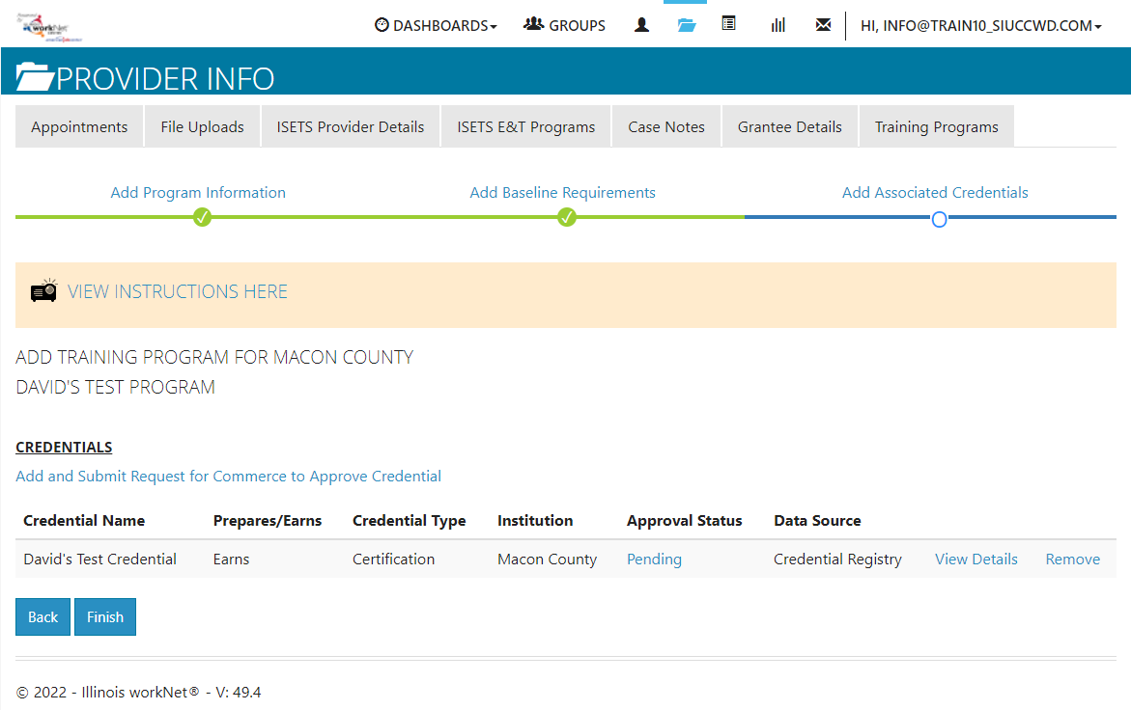

The Illinois workNet Center System, an American Job Center, is an equal opportunity employer/program. Auxiliary aids and services are available upon request to individuals with disabilities. All voice telephone numbers may be reached by persons using TTY/TDD equipment by calling TTY (800) 526-0844 or 711.
This workforce product was funded by a grant awarded by the U.S. Department of Labor’s Employment and Training Administration.
For more information please refer to the footer at the bottom of any webpage at illinoisworknet.com

