Contents
Project Detail – Project Plan 2
Layoff Aversion – Project Plan 4
Project Industries – Project Plan 5
Grantee Information – Project Plan 6
Hard-to-Serve Groups – Project Plan 7
Project Credentials – Project Plan 9
Project Sectors – Project Plan 10
Employee Occupations – Project Plan 12
Occupations Upgrades – Project Plan 13
Employers – Project Plan 14
Training Courses – Project Plan 16
Add Employees 18
Course Registrations 23

This document includes the required fields and on-screen instructions for the Incumbent Worker Tracking System Plans. See the PowerPoint, Illinois workNet® Incumbent Worker Tracking System (IWTS) dated February 16, 2017 for screen shots and instructions to:
- Submit an IWTS plan.
- Add employees and register them in courses.
- Submit quarterly reports.

Project Detail – Project Plan
Complete all fields on this page. For further information, click on the glossary terms and information links next to fields. The grant title is the title used with your approved DCEO grant. If it is not descriptive enough of this project, change the name to convey the project outcome.
After completing all fields, click on the Save button. Then click on Next to go to the next screen.
Title | When a project plan is originally created, the grant title is used as the default project plan title.  However the project plan title must be changed to include the name of the company administering the project (e.g. Jones Manufacturing – Blueprint Design).
Project Grant | Pre-filled based on grant selected from IWDS.
Layoff Aversion At-Risk Documentation Form has been submitted and Approved Via | Select either “It was approved as part of the application” or “Select Fate of Approval” and select a date from the calendar.
Description | Provide a meaningful description for this project.
Grantee | Pre-filled based on grant selected from IWDS.
DCEO Project Contact | Select from drop-down.
Status | The status of your training project is automatically updated.
Accepted Date | This is the date automatically applied once DCEO reviews and changes the project plan status to Accepted.
Project Start Date | Date can’t be prior to the incumbent worker training grant’s start date. This is the date you will begin working with the employer and training providers.
Project End Date | This date cannot exceed your incumbent worker training grant’s end date. This is the date all training for this project will be completed.
Is Green Initiative | Illinois has defined Green to include any occupation that requires additional skills that result in reducing waste or energy consumption, or new occupations for renewable energy. If this project has any training aimed at reducing waste or energy consumption, or for renewable energy jobs, click “Yes.” Otherwise, select “no.”
Project Type | Pre-filled based on grant selected from IWDS.
Does this project have Occupation Upgrades? | Does the training provide a skill upgrade sufficient to qualify the employee for a position of higher responsibility and/or salary?
Incumbent Worker Grant Amount | Enter the total amount of grant funds available to this training project. For formula projects, LWIAs/LWIBs enter the total funds per the waiver you have available for incumbent worker training.
Project Cost | Enter the expected costs for this incumbent worker training project. This will calculate the Funds Available.
Costs on Other Projects | Pre-filled based on if grantee has other IWTS projects.
Balance | IWTS calculates this.
Funds Use | Describe the use of funds for their project. Specifically, what is the budget for the training portion of this project? Do not include employee wages or other match.
Needs And Benefits | Discuss the need for training and the expected benefits that will improve productivity. For example, include the benefits such as opportunities for “backfill” and how they strengthen business relationships.

Layoff Aversion – Project Plan
Selecting an At Risk indicator is required.
From the list below, identify all At Risk Indicators by clicking on the “Add” link:
- Enter the reason under “Indicator Information.”
- Up to 500 characters may be entered.
- Click on the “Update” link.
To edit a previously selected At Risk indicator:
- Click on the “Edit” link for the row.
- Update the information text.
- Click on the “Update” link.
After reviewing the results, click on the “Next” button to advance to the next page.
1 | Declining Sales
2 | Supply Chain Issues
3 | Adverse Industry Market Trends
4 | Changes in Management Philosophy or Ownership
5 | Worker Does Not Have In-Demand Skills
6 | Strong Possibility of a Job if Worker Attains New Skills
7 | Other At Risk Indicators

Project Industries – Project Plan
Selecting a project industry is required.
Definitions
NAICS – The North American Industry Classification System (NAICS) is the standard used by Federal statistical agencies in classifying business establishments for the purpose of collecting, analyzing, and publishing statistical data related to the U.S. business economy.
Use the list below as a starting point to identify all NAICS codes that apply to all of the employers whose workers will receive training as a result of this project. Click on all applicable categories to select all sub-categories (three digit number). For more information on NAICS codes, visit their web site at: http://www.census.gov/eos/www/naics/.
To save all applicable NAICS codes with your plan, each time you select a different industry, click Select checked records.

Grantee Information – Project Plan
Providing Grantee Information is required.
Search Organizations that are already entered in IWTS. If the organization is not already included, click the option to “Add New Site.” Review your organization information as follows:
1. Is this Organization the employer? If the grantee is also the employer, indicate “yes.” If the grantee is not the employer whose employees are receiving training, leave it defaulted to “no.” If “yes” is selected, additional information will need to be provided, including “Is this location a Work Site?”
2. Is this location a Work Site? If you selected that this grantee is also an employer, an additional required field will be “Is this location a Work Site?” Set the latter to “true” if there will be employees to train at this site. Otherwise, leave as the default of “no.”
Ensure the following required fields have been entered:
- Street address
- City
- State
- Zip Code
- Phone Number
- Fax Number
- Agency Type
If any changes are needed, make the changes, then click “Save.”
Next, click on the “Contacts” tab to review the Grantee contacts. Each Grantee must have a primary contact and may also designate additional, secondary, contacts. Each grantee contact will be allowed full access to view and update the project plan and the primary contact will receive project emails.
- First Name
- Last Name
- Contact Type: Primary Contact, Secondary Contact, Employee
- Email Address

Hard-to-Serve Groups – Project Plan
Selecting hard-to-serve groups is required when any employees to get training are in any of these categories.
Definitions:
Disabilities – The definition of disability set forth in the Americans with Disabilities Act of 1990 (ADA) does not distinguish between type, severity, or duration of the disability. It states: “The term ‘disability’ means, with respect to an individual, refers to – a) a physical or mental impairment that substantially limits one or more of the major life activities of such an individual; b) a record of such impairment; or c) being regarded as having such an impairment.” http://www.dol.gov/odep/
Ex-Offenders – Persons who have been incarcerated and released.
Low Income – Families and children are defined as low income if the family income is less than twice the federal poverty threshold. The federal poverty level for a family of four with two children was $22,050 in 2009, $21,200 in 2008, and $20,650 in 2007.
Minorities – The federal definition of minorities includes:
- American Indian or Alaska Native
- Asian
- Black or African American
- Hispanic or Latino
- Native Hawaiian or Other Pacific Islander
Veterans – Persons who served at least one day in the active military, naval, or air service, and who were discharged or released under conditions other than dishonorable. Reference: 38 U.S. C. 101(2). Reference: Electronic Code of Federal Regulations. Active service includes full-time Federal service in the National Guard or a Reserve component. This definition of “active service” does not include full-time duty performed strictly for training purposes (i.e., that which often is referred to as “weekend” or “annual” training), nor does it include full-time active duty performed by National Guard personnel who are mobilized by State rather than Federal authorities (State mobilizations usually occur in response to events such as natural disasters).
Youth – People aged 14 through 21 (Note: The Recovery Act increases the age eligibility to a maximum of 24 years old for those youth served with Recovery Act Funds.):
- low income; and
- within one or more of the following categories:
  - Deficient in basic literacy skills
  - School dropout
  - Homeless, runaway, or foster child
  - Pregnant or parenting
  - Offender
  - Requires additional assistance to complete an educational program or to secure and hold employment (includes a youth with a disability).
Source: Illinois Department of Commerce and Economic Opportunity WIA Policy Letter No. 05-PL-05.
From the list below, identify all hard-to-serve populations the incumbent workers represent by clicking the checkbox next to the name, then click on the “Select checked records” button.
1 | Disabilities
2 | Ex-Offenders
3 | Low Income
4 | Minorities
5 | Veterans
6 | Youth

Project Credentials – Project Plan
Selecting credentials that result from the project is required.
From the list below, identify all credentials that will be earned by incumbent workers who complete training to be offered with this project by clicking the checkbox next to the name and then click on the “Select checked records” button. If no credentials are offered, at minimum “Certificate of Completion” must be selected.
If you believe additional credential options are needed, contact your DCEO grant representative.
1 | Associate Degree
2 | Bachelor’s Degree
3 | Industry-Recognized Credential
4 | Master’s Degree
5 | Other Advanced Degree
6 | Certificate of Completion

Project Sectors – Project Plan
Selecting the applicable Sectors is required. Only one sector can be selected.
Sector | Description
11 | Agriculture, Forestry, Fishing, and Hunting
21 | Mining, Quarrying, and Oil and Gas Extraction
22 | Utilities
23 | Construction
31-33 | Manufacturing
42 | Wholesale Trade
44-45 | Retail Trade
48-49 | Transportation and Warehousing
51 | Information
52 | Finance and Insurance
53 | Real Estate and Rental and Leasing
54 | Professional, Scientific, and Technical Services
55 | Management of Companies and Enterprises
56 | Administrative and Support and Waste Management and Remediation Services
61 | Educational Services
62 | Health Care and Social Assistance
71 | Arts, Entertainment, and Recreation
72 | Accommodation and Food Services
81 | Other Services (except Public Administration)
92 | Government and Public Admin

Employee Occupations – Project Plan
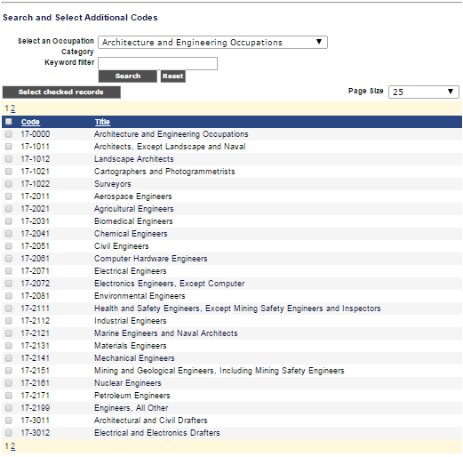
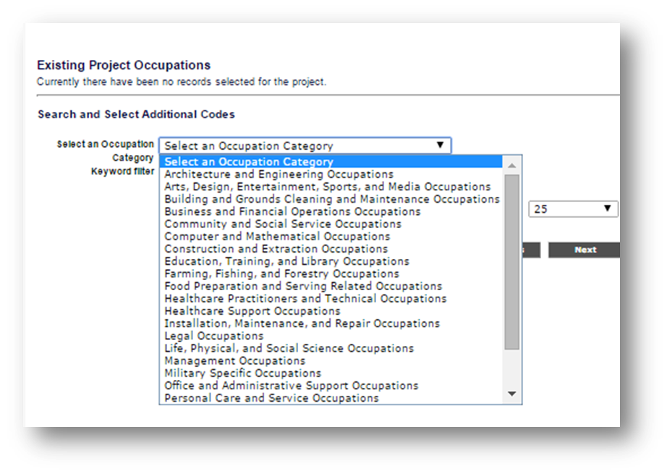
Selecting all applicable employee occupations is required
Begin with Standard Occupation Code categories or enter a keyword.

Occupations Upgrades – Project Plan
In the “Project Detail” section, if the answer to this question “Does this project have occupation Upgrades?” is “yes,” select all applicable occupations. Begin with Standard Occupation Code categories or enter a keyword.

Employers – Project Plan
Identifying the employer, its primary contacts, and required project fields, is required.
The first step to search by Employer Name and FEIN
Select your employer if they are listed or select “Add New” and enter your employer.
If you select an employer that has been used on another project you will have to get approval to use that employer from Commerce. The system will prompt you to submit the request and Commerce will be notified via email. Your project will then be in an “On Hold” status until the employer is approved. Then you will notified by email that your employer has been approved and your project is once again in the “In Process” status and you can continue entering information.
There is a limit of one employer per project, so if you have multiple employers under your grant you will be required to create a separate project for each employer. If you have 5 employers you will have 5 projects.
Identify:
- Organization information.
- Contacts – Primary and secondary.
- Work Sites – Specific locations where the incumbent workers that will receive training go to work each business day.
Organization:
- Name
- Street Address
- Street Address 2
- City
- State
- Zip Code
- Phone and Extension
- Fax
- Agency Type (Select from dropdown)
- Employer Type (Select all that apply)
- FEIN Number
- Is this location a work site? If employees at this location will be trained, click "Yes." Otherwise click "No."
- Owner’s Ethnicity (Check all that apply)
- Enter the match as dollar amount contributed by employer. For this employer, how will the employer match be provided? Include the source and commitment.
- How the employer match will be provided.
Contacts:
- First Name
- Last Name
- Contact Type (Primary Contact, Secondary Contact, Employee)
- Email Address
Work Sites:
- Name
- Street Address
- Street Address 2
- City
- State
- Zip Code
- Phone and Extension
- Fax
- Agency Type (Select from dropdown)
- Employer Type (Select all that apply)
- Enter the total number of employees at this location.
- Provide a meaningful description of the impact of this training at this job site. Describe the impact that the training will have on the employer and its employees. For example, include benefits such as opportunities for "backfill" or employee advancement.

Training Courses – Project Plan
Entry of all training courses is required.
Definitions:
CIP Code – The purpose of the Classification of Instructional Programs (CIP) is to provide a taxonomic scheme that will support the accurate tracking, assessment, and reporting of fields of study and program completions activity. Visit the CIP website to learn more: http://nces.ed.gov/pubs2002/cip2000/.
IWTS Course – A course is a training activity that earns a credential and must be completed to show an incumbent worker outcome. A training plan may include multiple courses. Enter each unique course that earns a credential and must be completed to show an incumbent worker outcome.
IWTS Course Session – This describes the details for each course including instructions for participants, schedule, location, and instructor information. Multiple sessions can be associated with a course.
Incumbent Worker Training (IWTS) Course and IWTS Course Session information is added.
Enter required course information:
- Course title – Enter the name of the training.
- Course description – Describe the training.
- Training provider – Enter the organization that is providing the training.
- Credential to be earned – Select a Credential that you previously added to the project plan.
- CIP Code – Select a CIP Code.
- Click on the “Save” button.
Enter required course session information:
- Click on the “Training Course Sessions” tab.
- Enter Start and End Date for the session.
- Session Title – used to distinguish between multiple sessions of a course. Use a general term like Main Session if there is only one session for the course.
- Schedule – Enter the training schedule, including dates and times.
- Instructor – identify the instructor.
  - First Name
  - Last Name
  - Phone Number
  - Fax
  - Instructor Email
- Location – Enter the address for where training is to occur.
  - Location Name
  - Address 1
  - Address 2
  - City
  - State
  - Zip code
- Click on the “Save” button.
The system will display a confirmation message if the save was successful. The message will also indicate the additional steps necessary to provide complete course information.

Add Employees
There are two options for adding employees who are participating with the IW training:
- Enter employees one at a time.
- Bulk upload employees using, for example, an Excel spreadsheet.
Add employees one at a time.
- Click “Search/Add Person.”
- Enter the search criteria in the box and click “Search.” Note: We search first name, last name, and E-mail address. Please do not enter both First and Last names. Enter only one of them.
- Select “Add” next to the person you want to add. If you cannot find the person you are looking for, click the “Add New Person” button and complete the required fields.
  - First Name
  - Last Name
  - Social Security Number
  - Zip Code
  - Gender
  - Date of Birth
  - Military Status
  - Disability Status
    - Disability Category
  - Ethnicity
  - Employee Occupation
  - Will training upgrade occupation? No or Yes
    - Upgrade Occupation
- Repeat steps 2 and 3 for any additional employees.
- You may also remove employees by clicking the “Remove” link next to the contact’s name.
- Once you have added employees, click the "Next" button.
Bulk upload employees using a spreadsheet.
- Create an xml, excel, or csv file of your employee records.
- Each record MUST include the following fields (for csv & excel files use field name headers):
  - ssn
  - firstName
  - lastName
  - zipCode
  - birthDate
  - ethnicity
  - militaryStatus
  - disabilityStatus
  - disabilityCategory
  - gender
- Click the "Upload Excel, CSV or XML File" button.
- Browse the computer and select file for upload, then click "Open".
- Click the "Upload File" button.
- Click the "View Data" button to verify the data is correct.
- Click the "Import Data" button.
- Take note of the system status. It will alert you of any errors and the number of records imported.
- Close the window.
- Click the "Refresh" button on the Employee screen.
Field Name | Code | Description
Disability Status | 1 | None
 | 2 | Yes
 | 3 | Disability Affecting Employment
 | 4 | Developmental Disability
 | 5 | Learning Disability
 | 6 | Prefer Not To Answer
Disability Category |  | Can be blank unless disability Status equals 2 - 5
 | 1 | Physical Impairment
 | 2 | Mental Impairment
 | 3 | Both
Ethnicity | 1 | White
 | 2 | Black
 | 3 | Hispanic
 | 4 | American Indian or Alaskan Native
 | 5 | Asian
 | 6 | Hawaiian or Pacific Island
 | 7 | Prefer not to answer
Military Status | 1 | Yes
 | 2 | No
 | 3 | Qualified Service Member
 | 4 | Transitioning Service Member
 | 5 | Prefer not to answer
Gender | 1 | Male
Gender | 2 | Female
Gender | 3 | Prefer not to answer
Special Note Regarding Excel files – Ensure the tab name of the first sheet is named "sheet1" before uploading.
For sample file formats, click one of the following links: Excel.xls, CSV.csv, Xml.xml
The occupation for an employee can be updated one at a time by clicking on the “Select” link next to a record, or occupation data can be applied to multiple records at one time.
Employees receiving training need to show the target or upgrade occupation based on the occupations entered with the plan. Only the occupations with the plan will be available.
If not already visible, click the above link (Show panel for doing mass update) to display the options panel.

Occupation Data:
- The starting occupation box uses an Autocomplete function, where you simply start typing an occupation (or SOC code if you happen to know it). After a minimum of three characters, the system will list occupations that contain the characters typed.
- Once you see the target occupation, click on it or scroll down and select it.
- Will Training Update Occupation – If the training will result in an updated occupation, click on the “Yes” radio button.
Note: if you have not entered at least one target or upgrade occupation for the project, this option will not be available.
- If “Yes” is clicked, the dropdown list of available occupations will be displayed.
- Select one of the occupations.
Selecting Target Employees:
- Search for the target employees.
- At minimum, you must select an employer and worksite (Note: A search is automatically invoked on a change in worksite).
- Use the option to only show employees without an assigned occupation.
- Optionally, use the Name filter.
- If there are a large number of employees, you may find it helpful to set the search page to a larger size; for example, 50 or 100.
- Click “Search” to do the search.
- Now click the checkbox to the left of each employee record to which you want to apply the entered occupation data.
- To apply the updates, click on the “Update Checked Records” button.
- Notes:
  - After doing the update, a search is done to refresh the page. If one of the search criteria is to only show employees without an occupation, the just-updated records will NOT appear in the search results!
  - If you selected “No” for “Will Training Update Occupation”, the Completed Training Occupation will be the same as the Starting Occupation.

Course Registrations
This page is used for employees’ course management; that is, adding to a course or removing from a course. You must have added employees and courses before being able to complete this section.
Search options:
- First, select a course.
- A course session is required in order to register an employee for a course. If you want to list employees regardless of the course session, then the course session may be left unselected.
- Optionally, you may select an employer.
- You have the option to view employees from all work sites for the selected employer or to select an individual work site.
- The employee list can be filtered to ease management by “For Employees” – Show:
  - Click on “Only those NOT in course” to show only employees NOT in the course.
  - Click on “Only those IN course” to show only employees registered in the course.
  - Click on “All Employees” to show ALL employees regardless of whether or not they are registered in the course.
- Optionally, you can include a full or partial last name filter to quickly find one employee, or all employees with a last name beginning with a specific letter (“m” for example).
- Then, click on the “Show Employees” button to list applicable employees.
Adding employee(s) to a course:
- Ensure that a course session has been selected.
- Click on one or more check boxes on the left of the search results.
- Optionally, you may select all visible employees by clicking on the check box in the heading line of the employees list.
- Then, click on one of the “Select Checked Records” buttons to add all checked employees to the course.
Removing an employee from a course:
- Employees may be removed from a course, one at a time, by clicking on the “Remove” link on the left of the employee listing.
Note: an employee cannot be removed from a course once any project status records have been created for her or him.

