Purpose:
The Student Support Services Report allows grantees to see their customers’ services that need attention or are past their due dates.

Who Enters/Maintains Data
- Grantees/Career Planners – Complete and update their customer’s completion and post-program tracking information.

Access Student Support Services Report
- Log into www.illinoisworknet.com.
- Select My Dashboard and select Customer Support Center/IWIS.
- Select Groups in the top menu and then select IL Works.
- Select the button for Student Support Services Report.

Enter Completion Status

  - You can filter the report by:
    - Service Provider
    - Service Name
    - Customer Enrollment Status
    - Start and End Date Range
    - Flag Types (These options include: Absent Flags, Post Assessment Flags, Any Flags)

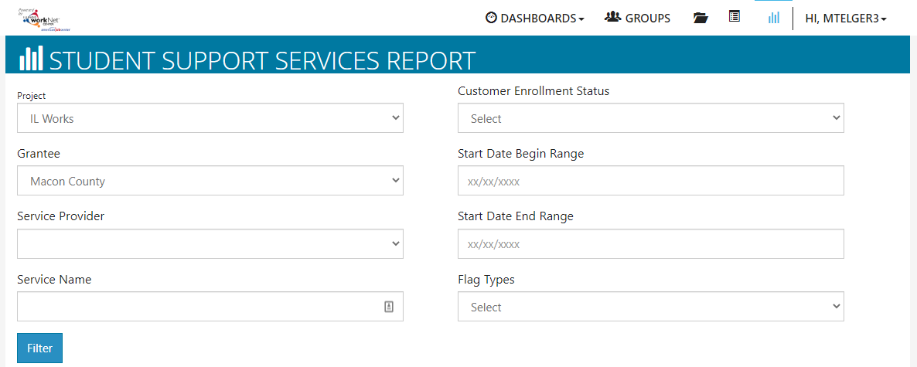

  - Select the Filter button to filter the results based on the selections.
  - Below the filters, a table will generate a list of customers, their training service, and columns for the Absent and Post-Assessment Flags. Note that the training services are hyperlinked. Clicking on this will take you to that service where you can edit and update the service as needed.
  - Once the service has been updated correctly and the customer’s overview page is refreshed, that service should no longer appear on the Student Support Service Report.

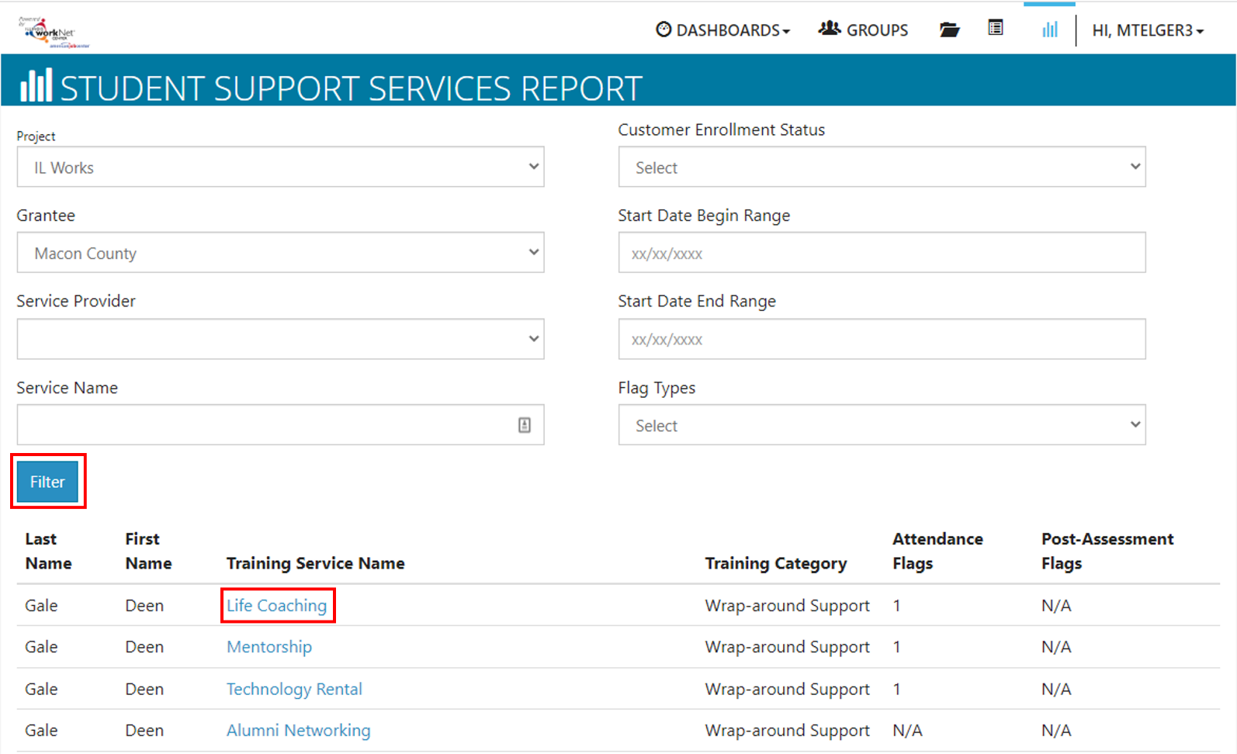

The Illinois workNet Center System, an American Job Center, is an equal opportunity employer/program. Auxiliary aids and services are available upon request to individuals with disabilities. All voice telephone numbers may be reached by persons using TTY/TDD equipment by calling TTY (800) 526-0844 or 711.
This workforce product was funded by a grant awarded by the U.S. Department of Labor’s Employment and Training Administration.
For more information please refer to the footer at the bottom of any webpage at illinoisworknet.com.

