Purpose:
The Completion/Follow-Up tab tracks completion status, completion/exit reasons, and follow-up information.

Who Enters/Maintains Data
- Grantees/Career Planners – Complete and update their customer’s completion and post-program tracking information.

Access Customer Program Completion Page
- Log into www.illinoisworknet.com.
- Select My Dashboard and select Customer Support Center/IWIS.
- Select Groups in the top menu and then select IL Works.
- Select the customer’s name to access their information.
- Select the Program Completion/Follow-Up tab.

Enter Completion Status

  - Click the Add Completion Status button.
  - In the window that pops up select the appropriate completion status from the dropdown menu and enter the information accordingly based on the question prompts and the customer’s status in the program. Note: These options include:
    - Complete
    - Complete & In Transition
    - Incomplete
    - Administrative Withdrawal
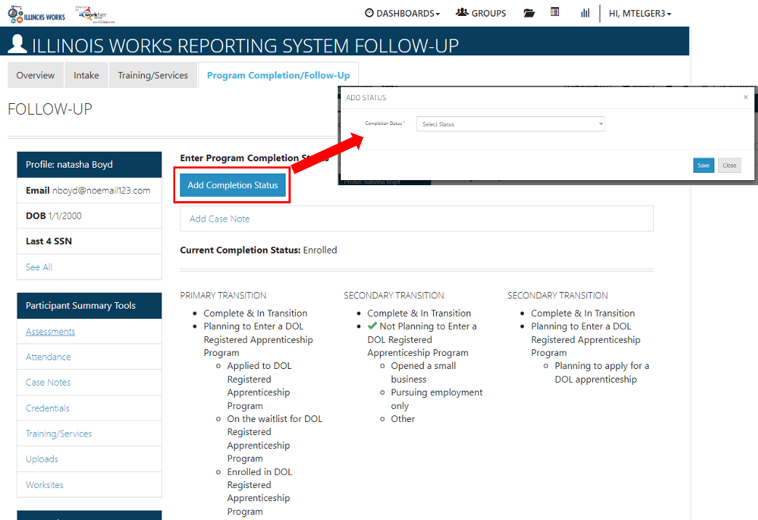

  - Once a selection has been made and saved, the Current Completion Status will appear with the ability to view the baseline, which will open a window with the selections made when updating the completion status.

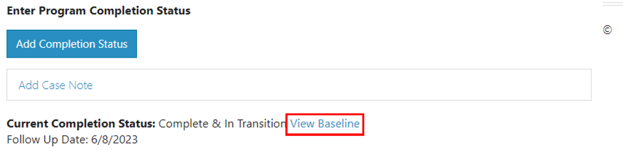

  - For customers who are in transition, you will be asked to upload Transition Documents, which appear below. Note: You will need to click the Choose File button to add your file and click the Upload button to add the document. (Add a statement here about if they are in transition they will be asked to complete question prompts)

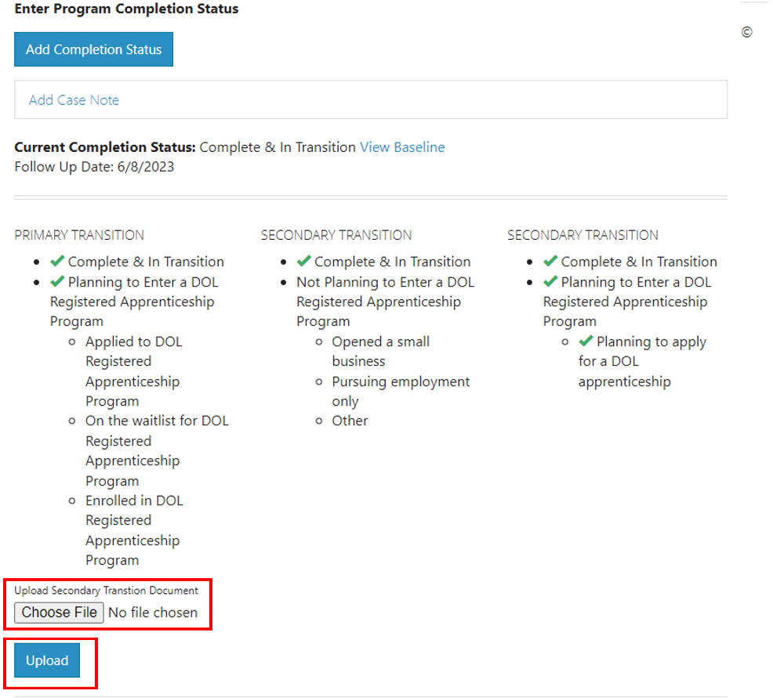

  - Active Tracking can be added below the Transition Documents area. Click the Add Active Tracking button and select the appropriate status from the dropdown menu and enter the information accordingly based on the question prompts and the customer’s status.

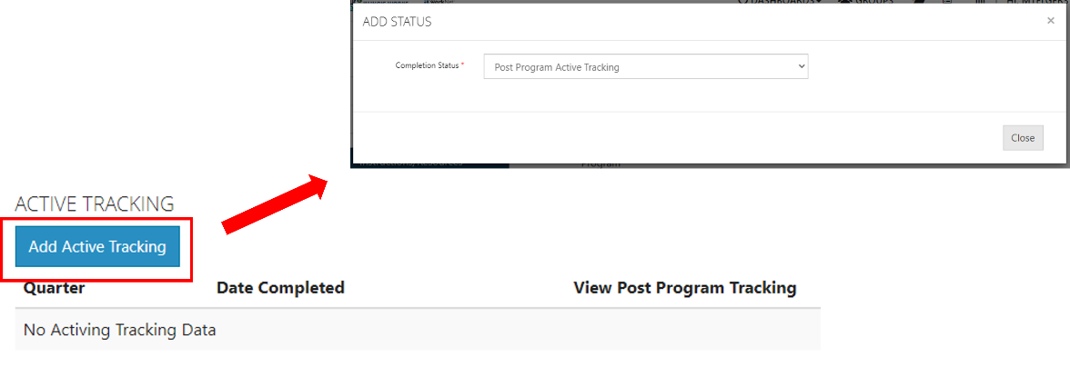

The Illinois workNet Center System, an American Job Center, is an equal opportunity employer/program. Auxiliary aids and services are available upon request to individuals with disabilities. All voice telephone numbers may be reached by persons using TTY/TDD equipment by calling TTY (800) 526-0844 or 711.
This workforce product was funded by a grant awarded by the U.S. Department of Labor’s Employment and Training Administration.
For more information please refer to the footer at the bottom of any webpage at illinoisworknet.com.

