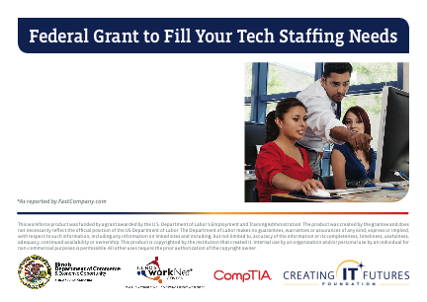

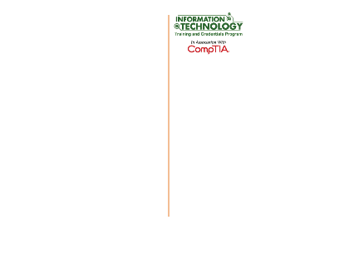

Average cost to recruit, onboard

and train a new IT employee . . . $10,400\*

Cost to recruit, onboard and train an

IT intern through a federal grant. . . . . . $0

[Name of workforce partner] is training IT pros to fill local business needs like yours at no cost.

ABC Company

123 Company Street

Townsville, IL 65432

Through the IT Job-Driven National Emergency Grant, your business can get free help in recruiting, onboarding and training information technology (IT) interns.

As featured by FastCompany.com, “Returns (people seeking second careers) and interns can be an amazing, long-term asset to your company. They can save you thousands or even millions of dollars.”

This grant program offers business candidates with industry-recognized credentials like CompTIA A+, Network+, Security+, MSCA, CCNA and ITIL. They can fulfill typical IT roles such as computer support technician, web developer, help desk support technician, customer service/sales, network engineer and cybersecurity specialist.

If your company is struggling to find well-qualified IT workers, contact (name, address, contact

information, like telephone number and email

address, and URL).