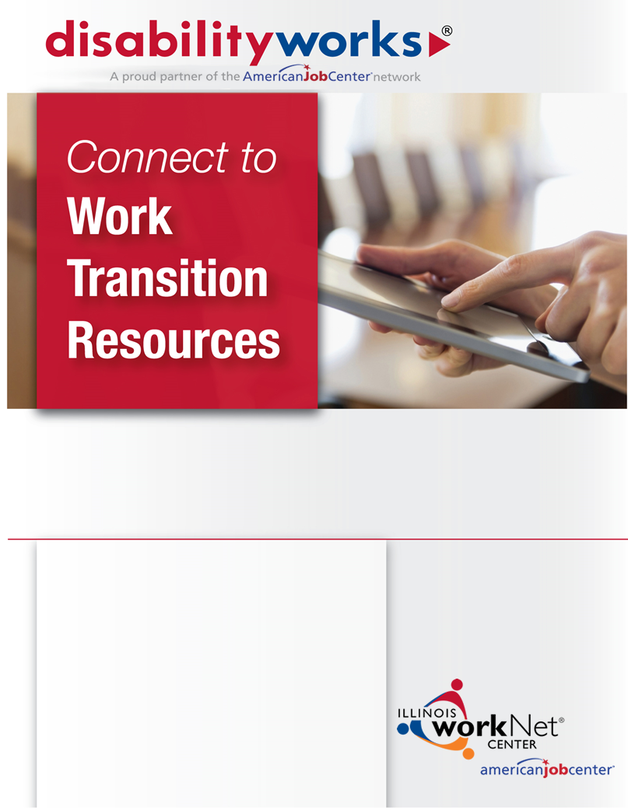

*disabilityworks assists you with…*

Add your organizations contact information here.

* Achieving your training and employment goals.
* Learning how you can earn income and keep some benefits.
* Locating disability support service providers.
* Connecting to resources you need.



**Get started today at** [www.disabilityworks.org](http://www.disabilityworks.org)

|  |  |
| --- | --- |
|  | Make informed choices. Use the Illinois Disability Benefits Estimator to explore potential benefit changes when taking on a job or additional employment. |
|  | Achieve your training and employment goals! The disabilityworks step guide takes you through the steps to successfully achieve employment with resources, tips, and videos. |
|  | Use the resources search to find what you’re looking for. |
|  | Find a disability service location near you by searching your ZIP code. |

This workforce product was funded by a grant awarded by the U.S. Department of Labor's Employment and Training Administration. The product was created by the grantee and does not necessarily reflect the official position of the U.S. Department of Labor. The Department of Labor makes no guarantees, warranties, or assurances of any kind, express or implied, with respect to such information, including any information on linked sites and including, but not limited to, accuracy of the information or its completeness, timeliness, usefulness, adequacy, continued availability, or ownership. This product is copyrighted by the institution that created it. Internal use by an organization and/or personal use by an individual for non-commercial purposes is permissible. All other uses require the prior authorization of the copyright owner.

The Illinois workNet Center System, an American Job Center, is an equal opportunity employer/program. Auxiliary aids and services are available upon request to individuals with disabilities. All voice telephone numbers on this website may be reached by persons using TTY/TDD equipment by calling TTY (800) 526-0844 or 711.