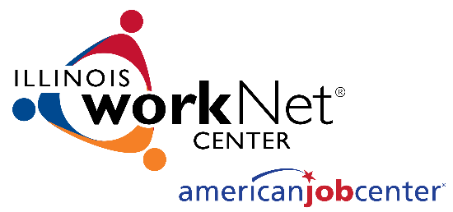
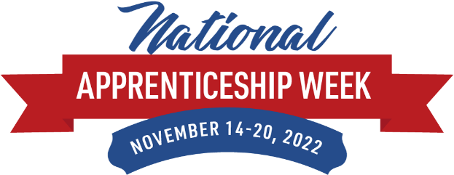

National Apprenticeship Week

Social Media Toolkit

National Apprenticeship Week (NAW) is November 14-20, 2022. Use this social media toolkit to spread the word, share events, and more! Below you will find the official Apprenticeship Illinois social media channels, event information, and shareable content including hashtags, sample posts, and pre-made graphics. We encourage you to use materials as you celebrate NAW. Thanks for celebrating NAW with us!

But first…

Are you following Apprenticeship Illinois on social media? Click each icon to connect with us. We will be increasingly active on social media leading up to and through NAW. Don’t miss an important update, Like and Follow us today!

Tag Apprenticeship Illinois in your posts:
- Facebook: @ApprenticeshipIL
- Instagram: @OfficialApprenticeshipIL
- Twitter: @ILApprentice
- LinkedIn: @ApprenticeshipIllinois

NAW Events
Apprenticeship Illinois is hosting a webinar series every day of the week during NAW, log on from 9:00am-10:00am. We will also amplify local and regional celebrations via the Apprenticeship Illinois website and social media channels. Find a list of events taking place at IllinoisworkNet.com/ApprenticeshipIL/Pages/NAW2022.aspx
- Register your event with:
  - Department of Labor
  - Apprenticeship Illinois

Sharable Content
Hashtags:
#ApprenticeshipIL
#NAW2022

Social Media Posts:
Twitter
The 8th annual National Apprenticeship Week (#NAW2022) is November 14th-20th. This year honors the 85th Anniversary of the National Apprenticeship Act. Celebrate with #ApprenticeshipIL by joining an event & sharing an event. Learn more at IllinoisworkNet.com/ApprenticeshipIL/Pages/NAW2022.aspx

Happy #NAW2022! Head over to #ApprenticeshipIL to find events taking place, a toolkit for celebrating, resources, & info on how to get started in an #apprenticeship program: IllinoisworkNet.com/ApprenticeshipIL/Pages/NAW2022.aspx

You’re invited to #ApprenticeshipIL #NAW2022 events! Learn about the explosive growth in apprenticeships, expansion into non-traditional sectors, strategies for training mentors, employer bootcamp, & apprentices’ stories: IllinoisworkNet.com/ApprenticeshipIL/Pages/NAW2022.aspx

Apprenticeships use the earn & learn model to combine classroom instruction with on-the-job training. Illinois has 543 registered #apprenticeship programs with over 16k active #apprentices. Learn more on #ApprenticeshipIL during #NAW2022. ApprenticeshipIllinois.com

Avoid education debt. Earn & learn through a combination of classroom instruction & job training. #Apprentices gain skills needed to earn a higher income & compete in today's job market. Get started on #ApprenticeshipIL. #NAW2022 ApprenticeshipIllinois.com

93% of #apprentices hold a job upon completing an #apprenticeship program. Currently, there are 543 #RegisteredApprenticeship Programs. #NAW2022 is the time to discover what #ApprenticeshipIL has to offer: ApprenticeshipIL.com

#Apprentices earn while they learn, & complete an #apprenticeship program with credentials, skills, mentorships, & a job! The average starting wage after completing a program is $77,000. Learn how to get started on #ApprenticeshipIL during #NAW2022!

Did you know there has been a 64% increase in new #apprentices over the past 10 years? See what all the hype is about at ApprenticeshipIL.com. #NAW2022 #ApprenticeshipIL

The workforce is growing, is your company growing with it? Create an #apprenticeship program to build a skilled pipeline of workers while saving on turnover costs. Learn the benefits & how to get started on #ApprenticeshipIL. #NAW2022 ApprenticeshipIL.com

There are over 800k apprentices in the U.S. & more than 16K are here in #Illinois. Head over to ApprenticeshipIL.com to see if an apprenticeship is right for you. #NAW2022 #ApprenticeshipIL

Apprenticeships range in various industries like #MFG, construction, energy, healthcare, hospitality, IT, communications, & transportation. Learn more on ApprenticeshipIL.com. #NAW2022 #ApprenticeshipIL

Apprenticeships use job training, classroom lessons, & mentorships. #Apprentices finish a program with credentials, industry experience, essential skills, & job security. Begin your future on ApprenticeshipIL.com. #NAW2022 #ApprenticeshipIL

Facebook & LinkedIn
Happy National Apprenticeship Week! #NAW2022 celebrates the benefits that apprenticeship programs bring to employers, communities, and apprentices. This year honors the 85th Anniversary of the National Apprenticeship Act. #ApprenticeshipIL is hosting webinars each day with topics ranging from apprenticeship growth, expansion in non-traditional sectors, strategies for training mentors, employer bootcamp, and more! Check out the schedule on ApprenticeshipIL.com

National Apprenticeship Week (#NAW2022) is November 14-20, 2022! The weeklong celebration highlights the benefits of apprenticeships for job seekers, employers, and communities. Visit #ApprenticeshipIL to access a Toolkit with shareable social media posts, graphics, Zoom webinar backgrounds, proclamation templates, press releases, and event planning resources. Be sure to submit your event and plan to join an event: IllinoisworkNet.com/ApprenticeshipIL/Pages/NAW2022.aspx

Did you know Illinois has 543 #RegisteredApprenticeship programs? As programs expand across the state, more job seekers are entering apprenticeships. The benefits of becoming an apprentice are endless including getting paid to learn, earning industry-recognized credentials, connecting with prospective employers, being mentored by others in the field, and avoiding education debt. Learn more on #ApprenticeshipIL during #NAW2022! ApprenticeshipIL.com

Hands-on learners benefit from the apprenticeship model which utilizes a combination of on-the-job training with classroom instruction. Apprentices complete a program with industry-recognized credentials, the skills needed to compete in today’s job market, mentorship connections, and a job! #ApprenticeshipIL #NAW2022 IllinoisworkNet.com/ApprenticeshipIL/Pages/NAW2022.aspx

93% of apprentices finish their program with a career. Because apprenticeship programs use on-the-job training strategies, employers train apprentices to learn industry skills and build connections as they complete their program. Hiring an apprentice saves an employer on training costs. #NAW2022 is a great time to discover the benefits of apprenticeships: IllinoisworkNet.com/ApprenticeshipIL/Pages/NAW2022.aspx #ApprenticeshipIL

Apprenticeship programs are expanding across the nation, including here in our state. Learn about available opportunities near you during #NAW2022. #ApprenticeshipIL ApprenticeshipIL.com

#ApprenticeshipIL has over 16,000 active apprentices across the state. As apprenticeship programs expand and develop, new opportunities are available to those interested in the learn-and-earn model. Learn more on ApprenticeshipIL.com. #NAW2022

Completing a registered apprenticeship program can lead to an average salary of $77,000. Because of the learn-and-earn model, apprentices are less likely to go into debt during their training. Celebrate #NAW2022 by learning the facts on #ApprenticeshipIL. ApprenticeshipIllinois.com

The future workforce is growing, is your company growing with it? Create an #apprenticeship program to build a skilled pipeline of workers, save on turnover costs, increase productivity, and recruit a trained workforce. Learn how your company can invest in your community on #ApprenticeshipIL. #NAW2022 ApprenticeshipIL.com

Did you know that there has been a 64% increase in new apprentices over the past ten years? See what all the hype is about on ApprenticeshipIL.com! #NAW2022 #ApprenticeshipIL

There are more than 800,000 apprentices in the U.S. and over 16,000 of them are here in #Illinois! See if an #apprenticeship is right for you on ApprenticeshipIL.com. #NAW2022 #ApprenticeshipIL

Instagram
The 8th annual National Apprenticeship Week (#NAW2022) is November 14th-20th. This year honors the 85th Anniversary of the National Apprenticeship Act. Celebrate the benefits that #apprenticeship programs bring to employers, communities, and apprentices. Access upcoming events and resources on #ApprenticeshipIL.

#ApprenticeshipIL invites you to webinars every weekday of #NAW2022 from 9:00am-10:00am! Learn about growth in apprenticeships, non-traditional sectors, mentor strategies, employer bootcamp, and more!

Across the state, #Illinois has over 16,000 active apprentices and 543 Registered #Apprenticeship programs. Completing a program can lead to an average salary of $77,000. #NAW2022 #ApprenticeshipIL

Graphics:
Download these graphics here.

Replace the picture in the graphic with your own on the blank copy below.
